BIOL 191 Class 3: Macromolecules
 | Example monomer (a molecule) | Example polymer (a macromolecule) | Example cellular structure
Carbohydrates | 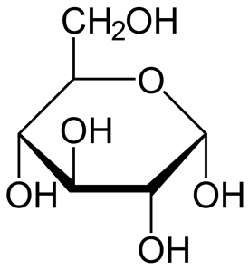  Glucose (a monosaccharide) | Amylose (a type of starch)  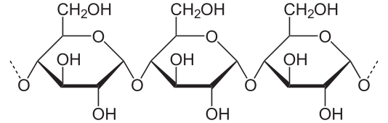 | Starch granules in potato cells  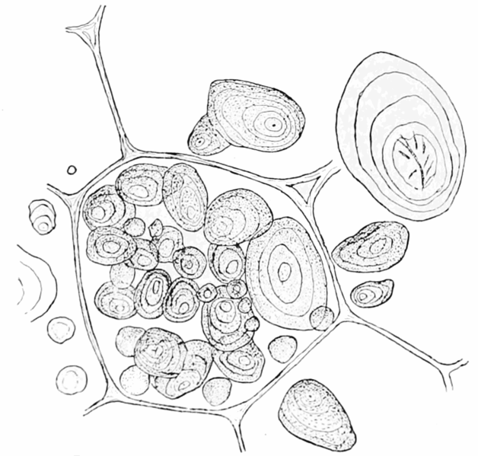
Nucleic acids | A nucleotide
Proteins | An amino acid 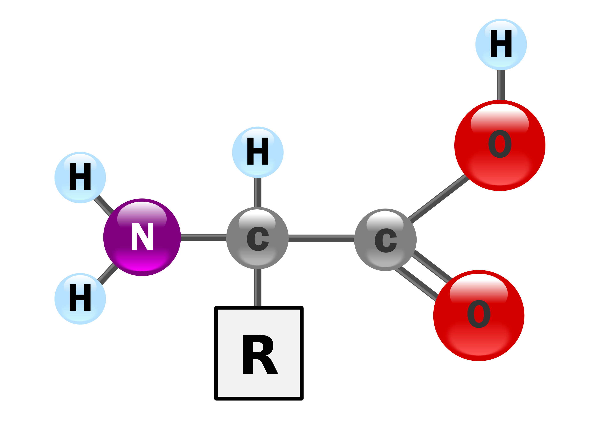  R group= unique to each aa
Lipids do not fit the simple monomer-polymer relationship:
Lipids | Fatty acid  (Contains long hydrocarbon tail)
Images all in public domain: Glucose and Amylose by Neurotiker, Nucleotide by cacycle, Starch granules from Popular Science Monthly (1899-1900), Amino acid by Yassine Mrabet, Saturated Fatty acid by Bruce Blaus. Blausen.com staff (2014). "Medical gallery of Blausen Medical 2014". WikiJournal of Medicine 1 (2)

Carbohydrates
Carbohydrates allow cells to store energy and provide structural support. Below are a few monosaccharides (simple sugars) important for cells. The energy in a candy bar comes from sugars, which are quickly broken down to release energy.
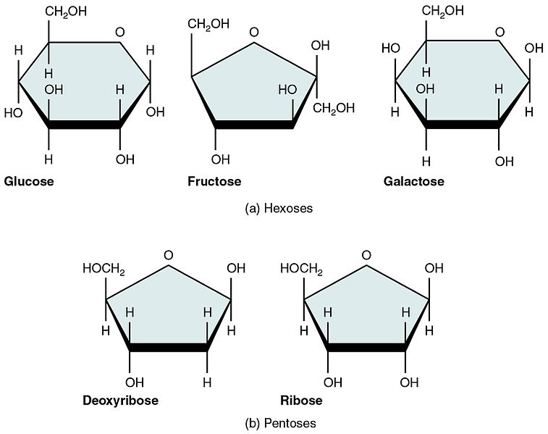

- What do you notice that is common between the naming of the sugars shown to the left?

- Which three elements are present in these sugars?

- Which of these sugars is found in DNA?

Figure 1“Five Important Monosaccharides” by OpenStax. Licensed as CC-BY

- Many sugars are used for energy storage. The figure to the left shows you a molecule of SUCROSE, which is the “table sugar” used for baking.
Sucrose is an example of a ___saccharide. To obtain energy from sucrose, enzymes in your body perform a _______________ reaction.
Image source: “Structure of sucrose” by NEUROtiker. Image in public domain.

- Some chains of sugars serve as structural material for cells. Plants have a cell wall made of the polysaccharide cellulose, which contains long chains of glucose subunits. Cellulose cannot be broken down by most animals, which is one reason wood is such a good building material.
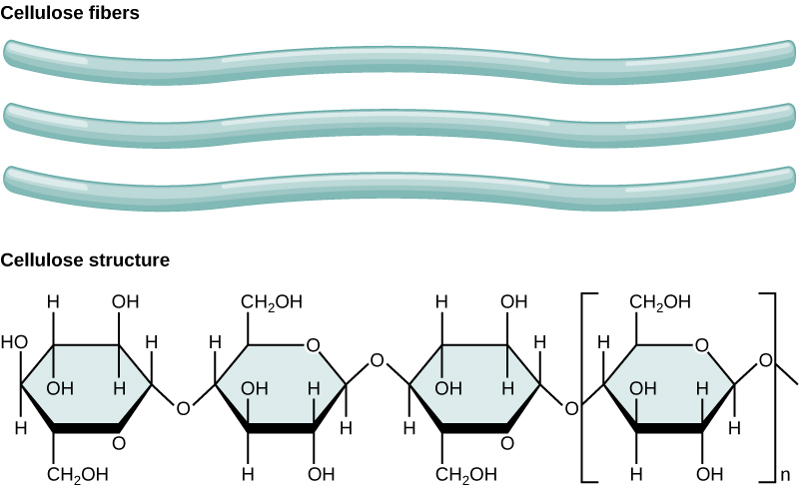
Figure 2. Cellulose by OpenStax. CC-BY
The bonds between glucose monomers are formed through (condensation/hydrolysis) reactions.

Name an organism that can break the linkages between these monomers:

Nucleic acids
Nucleic acids carry information inside cells. Genetic information is stored in DNA, and short-lived copies of this are made in the form of messenger RNA. The structure of DNA allows it to serve as a template with which cells can make a highly precise copy of their genetic information. The figure below shows you the structure of two chains (strands) of DNA nucleotides that interact together to form DNA (deoxyribose nucleic acid).

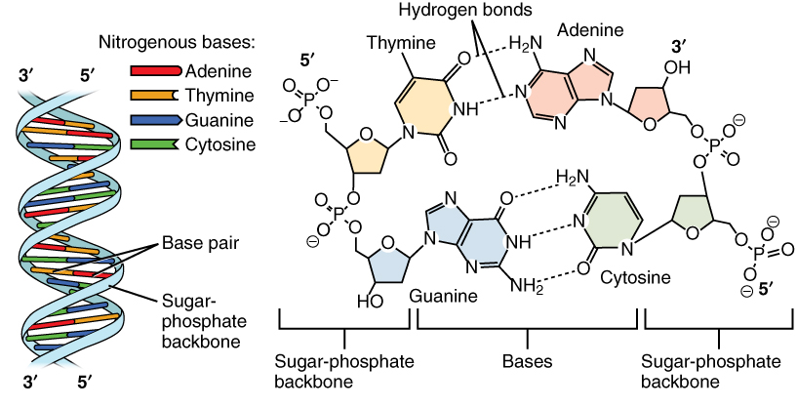
DNA Nucleotides by Open Stax. Licensed as CC-BY

- Every DNA strand has structural polarity (the two ends are different from each other). Put a box around the PHOSPHATE GROUP at the 5’ end of each of the two strands.

- Put a triangle around the DEOXYRIBOSE SUGAR at the 3’ end of each of the 2 DNA strands.
- Circle a single nucleotide on each side of the model of DNA.

- Which part of a nucleotide makes up the rung of the “ladder”?
- When one nucleotide contains adenine, which base does the adenine interact with on the opposite strand of DNA?
- These two strands of DNA are held together by hydrogen bonds between bases. How many hydrogen bonds connect the two bases from Question 10?
- When one nucleotide contains cytosine, which base does the cytosine interact with on the opposite strand of DNA?

- How many hydrogen bonds connect the two bases from Question 12?

