1782 and beyond Section Three: The West Indies legacies at the end of the American Revolution
Implications of George Rodney’s momentous year
In October 1781 even as Cornwallis was on the point of surrendering at Yorktown, the French and Spanish were planning a three stage plan to inflict a possibly even greater defeat on the British in the American Revolutionary war. Known as the de Grasse-Suavedra Convention, it involved defeating the British naval squadron at New York (essentially already achieved at the Virginia Capes), capturing the British Windward islands in the West Indies, and conquering Jamaica.
As the largest and most profitable British sugar island George III had declared, as mentioned before, that he would protect Jamaica and the British West Indies at the risk of Britain herself (http://en.wikipedia.org/wiki/Battle_of_the_Saintes). Indeed recent scholarship by Andrew O’Shaughnessy has suggested that Graves delays in re-fitting his fleet after the Virginia Capes and therefore sailing too late to relieve Cornwallis may have been deliberate. He outlines in “The Men Who Lost America”, page 313, that “Naval strength was the key to the balance of power among the European empires…the loss of a fleet would have had catastrophic implications for Britain. It’s survival was more important that that of the army at Yorktown, which is why Graves seemingly obstructed efforts to relieve Cornwallis”.
Returning to the West Indies in March 1782 therefore with reinforcements of ships and men, Rodney was fully aware of the scale of the danger now facing Britain.

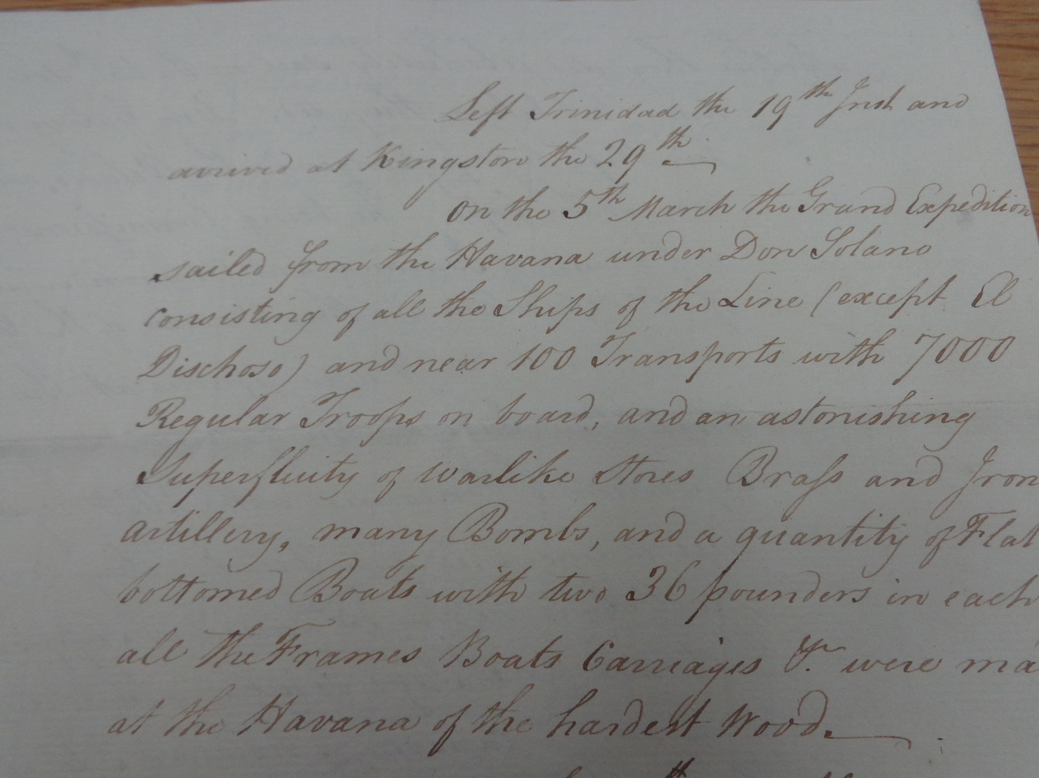
PRO 30/20/21/5/142-143
He received this letter of intelligence from a British agent in Havana, Cuba (the main Spanish naval base in the West Indies). On 5th March “near 100 transports with 7000 Regular Troops on board, and an astounding superfluidity of warlike stores…and a quantity of flat bottomed Boats” (landing craft for invasion troops) had left Havana.
The letter continues that it was reported that the Spanish were “going on an Expedition to Providence (Rhone Island), with 2000 regular troops that is understood as a feint” (to draw the British navy north to New England), but instead “they are to be landed on the north side of Jamaica to keep up a diversion all along that coast” (while the French landed on the south coast).
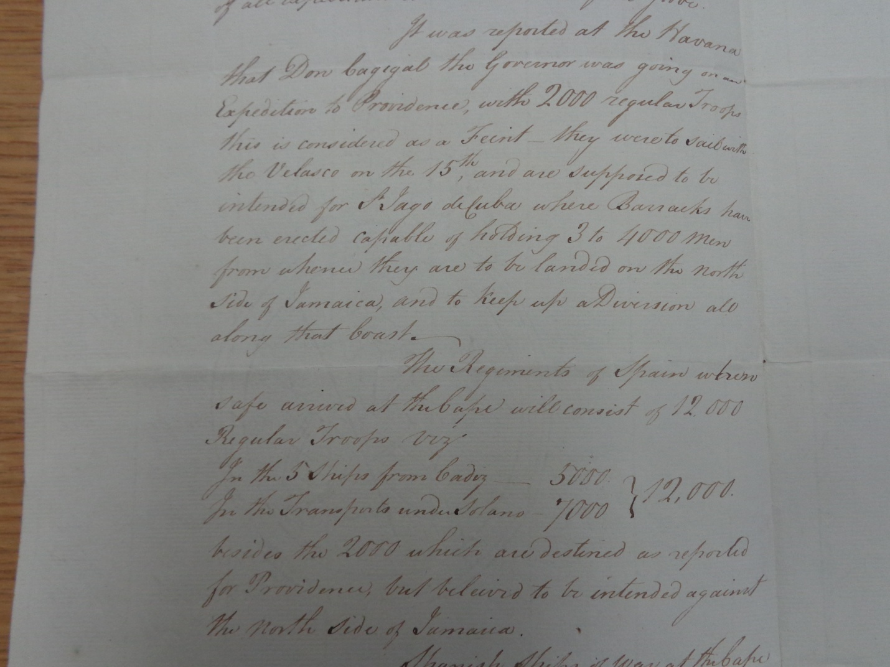
Learning that de Grasse had left Martinique to rendezvous at Haiti to pick up the 15,000 strong French invasion force, before heading for Jamaica, Rodney set sail to intercept him.
With his 36 ships-of-the-line to de Grasse’s 35 the battle looked evenly poised, but the British had one significant recent advantage. Their fleet had copper-sheathed hulls, preventing marine growth and thus increasing their speed. Rodney’s intelligence was so good that he knew exactly which French and Spanish ships had been “copper’d” as this document from May that year shows:
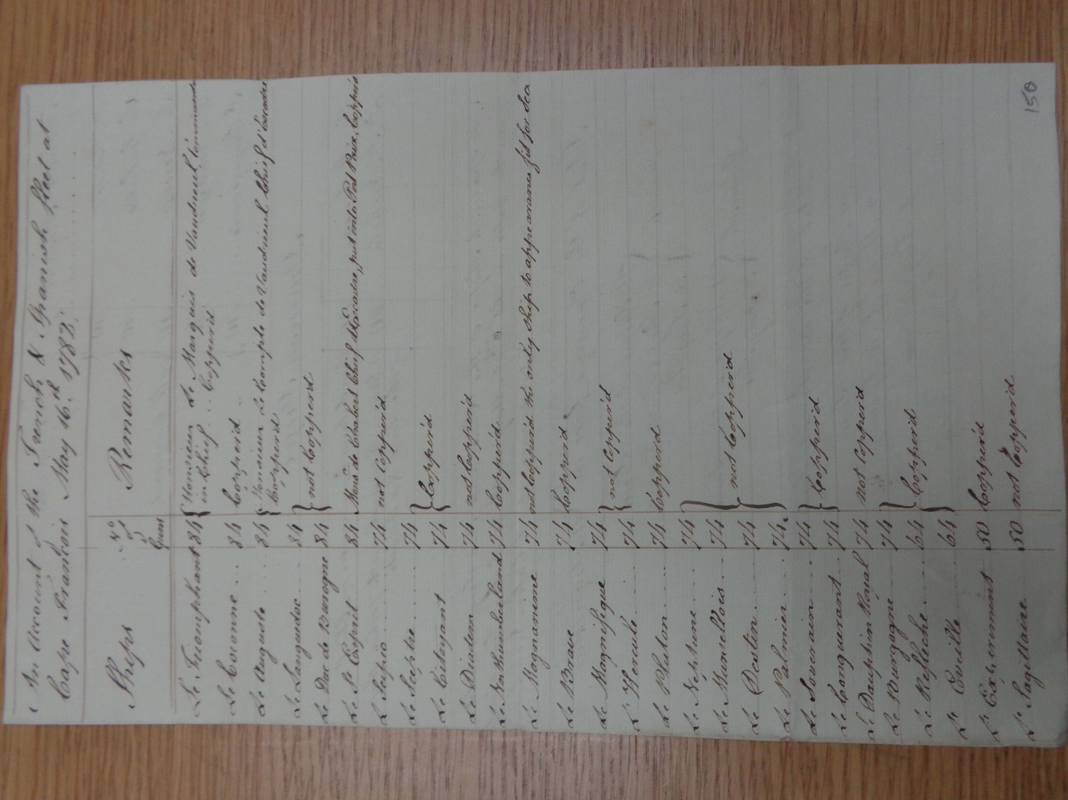
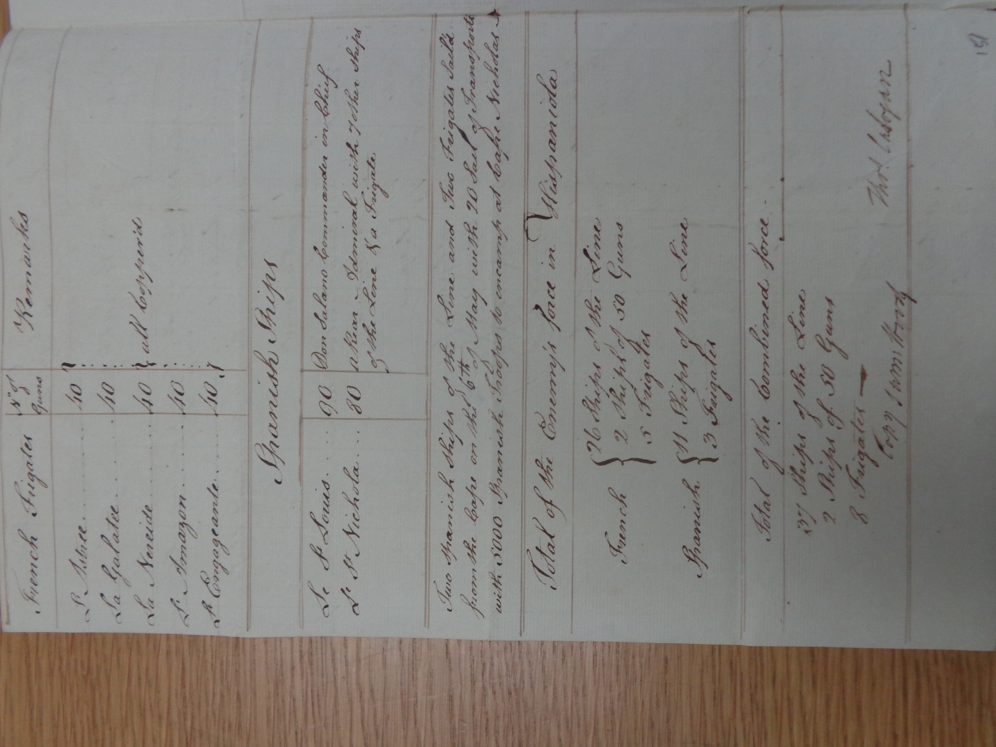
PRO 30/20/21/5/150-151
The resulting four day Battle of the Saintes, south of Guadaloupe, from 9th-12th of April was one of the last significant battles, and certainly the largest sea battle, of the American Revolutionary war. Yet it is rarely mentioned, if at all, in US History courses – even at the college level. However neither the 1783 Treaty of Paris ending the war, nor subsequent developments of British industry and empire can be properly understood without assessing the importance of the British victory at the Battle of the Saintes.
Thomas White in his printed 1830 account “Naval Researches”, looking at the actions of Graves, Hood, Rodney and others, emphasizes the larger sizes of individual French ships. However with the British having more copper-bottomed ships that were faster they had an overall advantage – especially at low-to-calm wind speeds where they could maneuver better.
Meeting first on April 9th the fleets shadowed each other for a few days, but north-west of Dominica/south of Guadaloupe on April 12th Rodney had closed and sought battle. (For a description of naval tactics see: http://www.thedearsurprise.com/napoleonic-era-naval-tactics-25-the-weather-gage/ while this site has an excellent visual presentation of naval warfare in the 1700s: https://prezi.com/shj9ctoztzax/history-of-1700-naval-warfare/)
A traditional passing of the fleets in parallel columns started at 8.30 as this remarkable battle sketch of hastily-laid plans drawn by the hand of Rodney on the morning of April 12th shows. (This document at the National Archives in Kew was held, along with the letter by George Washington and others, in Admiral Rodney’s private small pocket book, complete with all sorts of hand-scribbled notes and worn out pencil.)
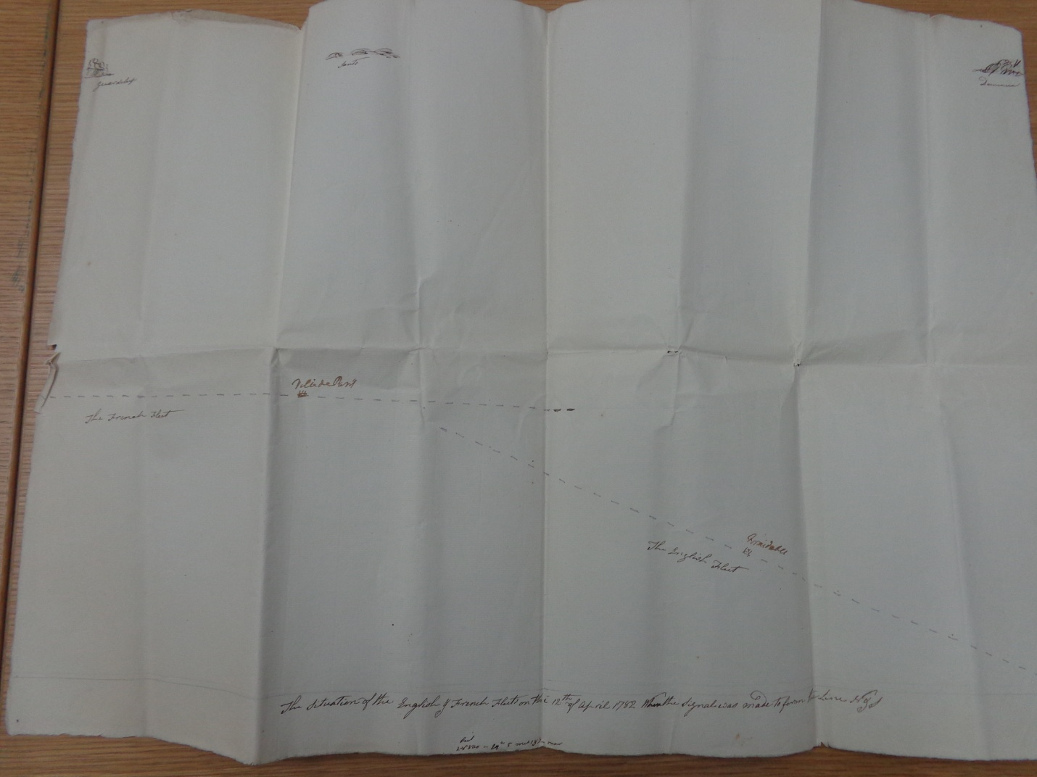
PRO 30/20/21/5/124
However at 9.30am the wind lessened and shifted to the southeast. In the key moment of the battle Rodney instinctively signaled his ships to form two columns and to cut across the French line, a new tactic called “breaking the line”. This allowed his ships to fire broadsides at the front and rear of the French ships – allowing them to “rake” the lesser armored rear of a ship, where, in one broadside at close range, cannonballs could pass through the entire length of the ship killing hundreds and crippling the ship with one blow.
In this manner Hood had crippled de Grasse’s flagship the Ville de Paris, killing over 400 men and injuring many more than that. Indeed when he struck his colors and surrendered, de Grasse was found to be one of only three men on deck uninjured (O’Shaughnessy, ibid, page 315)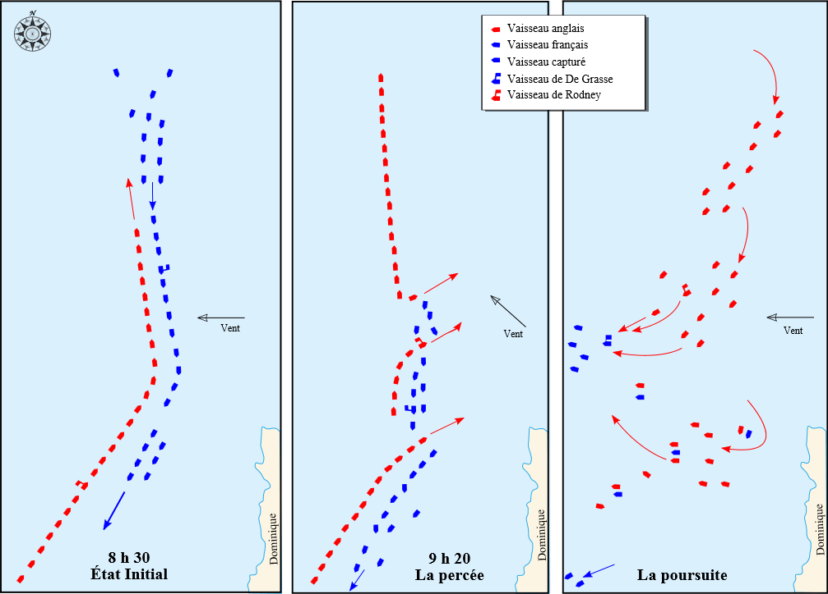
This excellent visualization shows the initial approaches, the key shifting of the wind which allowed Rodney to tack to the northeast and cut the French line with his two columns (note his flagship HMS Marlborough leads the first/upper column in the middle image), then finally the pursuit phase of the shattered French fleet. (http://upload.wikimedia.org/wikipedia/commons/thumb/5/5c/Battle_of_Les_Saintes_map-fr.svg/800px-Battle_of_Les_Saintes_map-fr.svg.png)
The French and Spanish invasion plan of Jamaica had been thwarted and many prisoners taken (see a translation of this document in French concerning the arrangements of French prisoners in Jamaica after the battle in Lesson Plan 4).
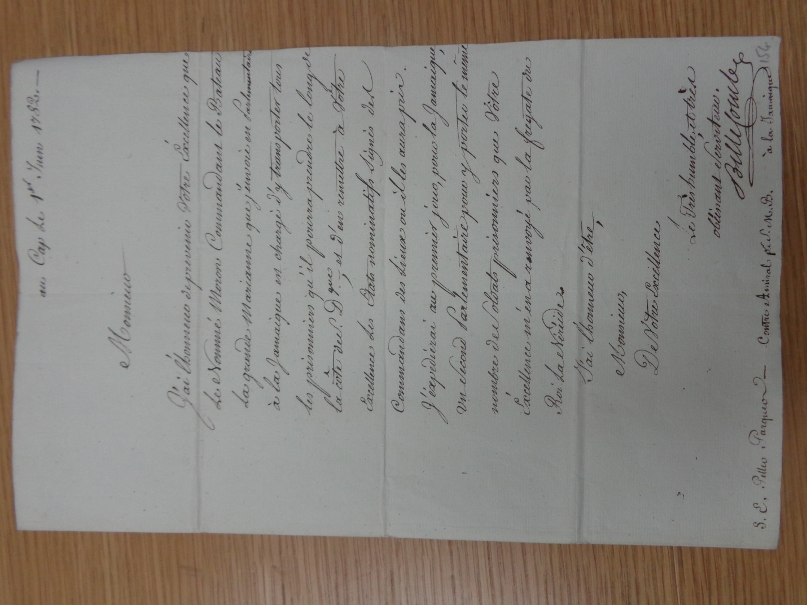
PRO 30/20/21/5/154
However together with the relief of the siege of Gibraltar (Spain’s primary war aim), the implications of the Battle of the Saintes would be far larger. It was the Saintes that largely made the Treaty of Paris the next year possible. Yorktown had decided American independence but the global war could not end till France and Spain had either forced Britain to its knees or been decisively checked. Under increasing financial cost the latter outcome forced France and Spain to the negotiating table. The Saintes allowed Britain and the new United States to make a separate peace deal and for Britain to get much better terms from France.
Indeed one notable impact of its defeat at the Saintes would be that France could no longer avoid facing the crippling debt Louis XVI had incurred in fighting the American Revolution (as his capture of Jamaica and the British West Indies might have allowed him to do). Thus seven years from the start of the American Revolution, defeat at the Saintes in 1782 would see France seven years from the start of its own revolution – when Louis was forced to call the Estates-General to deal with the financial crisis.
In fact British control of the West Indies would allow plans to be proposed even after 1783 to use the islands as a launching point for controlling the Gulf coast areas, notably Louisiana, West and East Florida, with a view to connect these to Canada and the Ohio territories – perhaps even reversing the result of the American Revolution (Dunmore, Governor of the Bahamas from 1787, has such a scheme).
For the British the Battle of the Saintes was greeted with euphoria, and Rodney regarded as a national hero. It largely enabled him to escape from the debacle at St Eustatius (where trade to North America was only temporarily halted before finding other West Indian entry points, and which the French re-took within a year). But it also deflected blame attached to him for the loss of America. 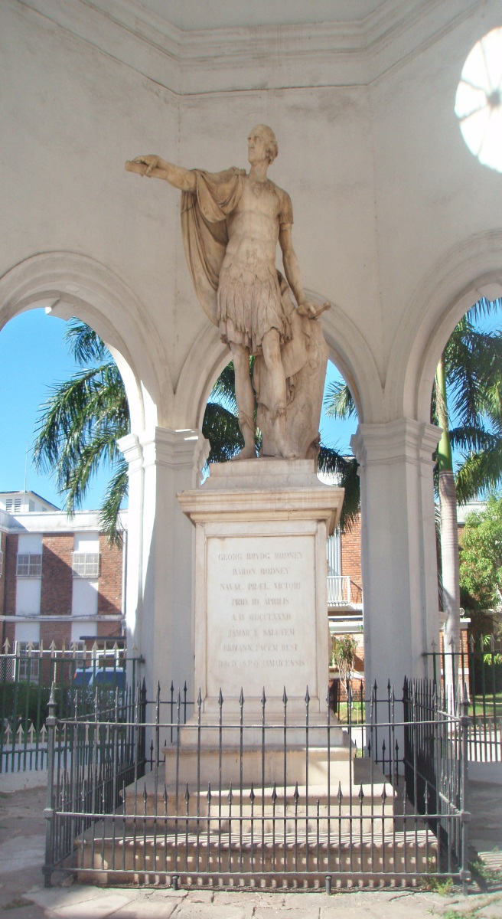 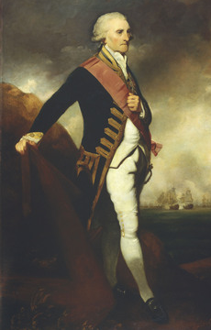

Monuments were erected such as this one of him as a conquering Roman hero in Spanish Town, Jamaica described Rodney as “the brightest jewel in the British diadem”.
(http://en.wikipedia.org/wiki/File:Rodney_monument.jpg and http://4.bp.blogspot.com/-_4x2YhHPz6I/TlxkiEKtAZI/AAAAAAAACJ8/gLsU-TLnuFs/s400/Admiral%2BRodney.png)
Streets and children were named after him and paintings commissioned glorifying his victory at the Saintes. Even Robert Burns even penned an “Ode to Rodney”. In fact such was the adulation that in newspaper cartoons he was depicted as the English patron Saint George slaying the French dragon.
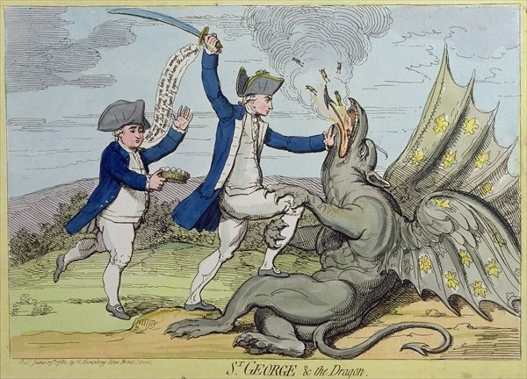
(http://imageweb-cdn.magnoliasoft.net/bridgeman/supersize/nco190402.jpg)
In one way this “slaying of the French dragon” was a foreshadowing of Britain’s victory over Napoleon a generation later and one way Rodney’s actions in the West Indies helped create the foundations of the British Empire. This was because it was his “breaking of the line” tactics, so emphatically used by Nelson at the Battle of Trafalgar in 1805, which saw Britain maintain control of the world’s oceans for the following hundred years – thus allowing and enabling her overseas empire to flourish.
The other way that Rodney’s actions at the Saintes enabled the expansion of the British Empire specifically concerned with wealth saved by the preserving of Jamaica and the British West Indies. The governor of Jamaica recognized what the battle meant for his island as can be seen in his middle paragraph below in the letter from him to Clinton in New York.
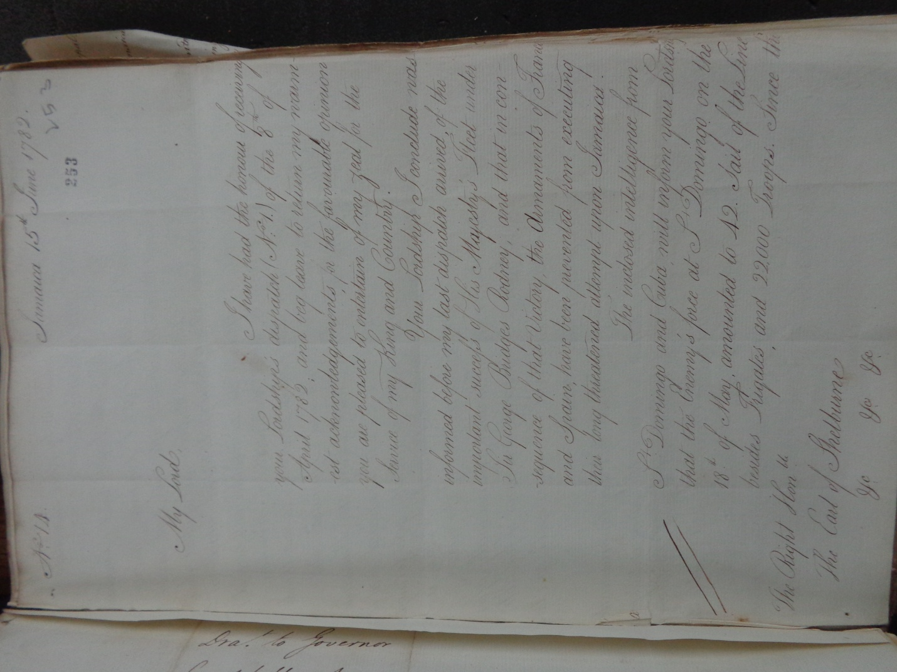
CO 137/82/32
However the wider implications of the West Indies, and their sugar trade built on slavery, to Britain’s Industrial Revolution and Empire, are apparent in Eric Williams groundbreaking work in 1944 “Capitalism and Slavery”.
In chapters such as “British Industry and Triangular Trade” and “British Capitalism and the West Indies” he outlines how the West Indian sugar and slave trade financed the Industrial Revolution in Britain. Later works such as “Sugar and Slavery: and Economic History of the British West Indies” by Richard Sheridan, 1974, and “Africans and the Industrial Revolution in England”, Joseph Inikori, 2002 have echoed this.
A more visual representation of the importance of Jamaica in this can be found in the classic BBC series by James Burke “The Day the Universe Changed” where in episode six “Credit Where It's Due: The Factory And Marketplace Revolution”, historian and scientist Burke begins with a lengthy look at the sugar trade in Jamaica and connects the financial links back as a stimulus to the early Industrial Revolution in Britain.
In a 1994 edition of William's work, while examining the triple stimulus given to the Industrial Revolution by West Indian plantations, Colin Palmer in his foreword concluded that not only was the Caribbean a cause for the Industrial Revolution, but that it was "the principal agent in the construction of the imperial power's prosperity".
While outside the central focus of this study to examine the broader role of the West Indies in creating industry and empire, there is no doubt that the Battle of the Saintes, one of the concluding acts of the American Revolutionary war, did, in maintaining control of Jamaica and the British West Indies, help provide a significant launching point for Britain's Industrial Revolution, and thus for her Empire. Moreover Rodney's duel role in winning that battle, and the tactic he introduced to win it, thus also served a catalysts for those momentous events.
Conclusions on the Central Role of the West Indies in the American Revolution
Before the American Revolution began in 1775, interactions as the hub of Triangular Trade show the West Indies acting as a stimulus for trade and growth in the North American colonies. After the revolution began the West Indies assumed a pivotal role as the supply center for the Continental Army, and showing the interconnections between trade and political and diplomatic interests for neutral and combatant forces alike. With the entry of France, then Spain after 1778 the region became the main theater of conflict for Britain, France and Spain in the American Revolutionary war. The island of St Eustatius became as much a focal point of the war as Boston, New York or Yorktown were - indeed the interconnections between St Eustatius and Yorktown are particularly compelling. In 1781 it's capture lead directly to the British loss at the Virginia Capes, Yorktown itself and thus ensured independence for the new United States.
In 1782 Jamaica and the West Indies remained at the center of the global war with the British victory at the Saintes and all it's implications. Indeed the actions of Rodney alone in the momentous year from early 1781 to early 1782 by itself highlight the central role the West Indies played in the conflict.
As interconnected as Triangular Trade, slavery and sugar were, so too was sugar, the West Indies and North America. Likewise then perhaps as often as the interconnected nature of American Independence, Yorktown and the Virginia Capes are taught, so too perhaps should be the Virginia Capes, St Eustatius and George Rodney. In that way the full importance of the Caribbean in the American Revolution would be illustrated.
And in that, today’s geo-literate students will be able to understand, in the world of the global American Revolutionary War, just how interconnected economic and military realities were. And thus hopefully furthering their understanding today of the critical role of these realities in their modern interconnected world.

