1775-1780 Section One: The West Indies and supplying the American Revolution
The interaction of sugar, trade and war
As the hub of Triangular Trade, by the 1700’s tobacco, coffee and cotton plantations had expanded in the European colonies in the West Indies. But it was sugar, and it’s by-products rum and molasses that were particularly profitable. This is reflected in the comparative numbers of slaves transported to the British colonies in the 1700’s – 840,000 to Jamaica compared to 100,000 to Virginia.(A great resource for students, with primary source documents, on the Caribbean and the Slave Trade can be found at: http://www.nationalarchives.gov.uk/pathways/blackhistory/africa_caribbean/caribbean_trade.htm with additional general slave trade resources being found at the International Slavery Museum, Liverpool: http://www.liverpoolmuseums.org.uk/ism/slavery/ and the BBC website: http://www.bbc.co.uk/education/topics/zgc4jxs)
Refining sugar required large quantities of lumber, mostly absent on Britain’s 13 West Indian colonies, but abundant in it’s 13 North American colonies. New York and New England ports in particular became dependent partly on trading lumber for sugar and molasses. Newport, Rhode Island, for example, dominated the Atlantic molasses trade supplying over 100,000 Africans to the West Indies, and then importing the sugar and it’s by-product molasses to distill into rum. This in turn they sold to enable the purchase of more slaves to produce more sugar and molasses etc… 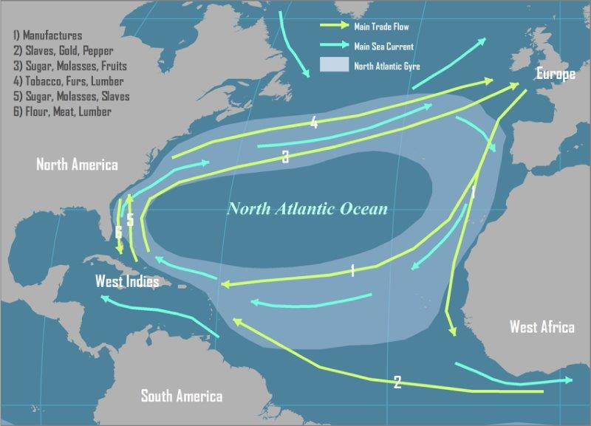
This map, appropriately enough produced by Hofstra University of New York, entitled “The Geography of Transport Systems” shows the interaction of sub-tropical climate, ocean currents, and products and slaves being shipped around the Atlantic. The West Indies is clearly a hub for trade not only to and from Africa and Europe, but also to and from North America. (https://people.hofstra.edu/geotrans/eng/ch2en/conc2en/tradewinds.html)
The North American colonies therefore were seen as less profitable than West Indian ones by Europeans. According to Eric William’s foundational work “Capitalism and Slavery”, 1944 (page 54) which highlights the global importance of the Caribbean, by 1700 the 166 square mile West Indian island of Barbados was worth more than all of New England, New York and Pennsylvania combined. By the late 1700’s larger islands such as Jamaica and Haiti produced more wealth than the entire 13 North American colonies combined. It can come as no surprise to learn then that for example the Governor’s mansion in Spanish Town, Jamaica was far larger than that in Williamsburg, Virginia or that after the Seven Years (French and Indian) War Britain seriously debated in the negotiations with France whether to give them back all of French Canada just conquered rather than the small West Indian island of Guadaloupe.
The primary source document below therefore shows the locations of these highly prized colonies of Britain, France, Spain and the Netherlands in the West Indies. It was color coded by Herman Moll as part of his 1719 map collection (famous for showing California as an island). Of particular note are the portions of the map that show British Jamaica in the west, French Guadaloupe and Martinique, and Dutch St Eustatius in the east.
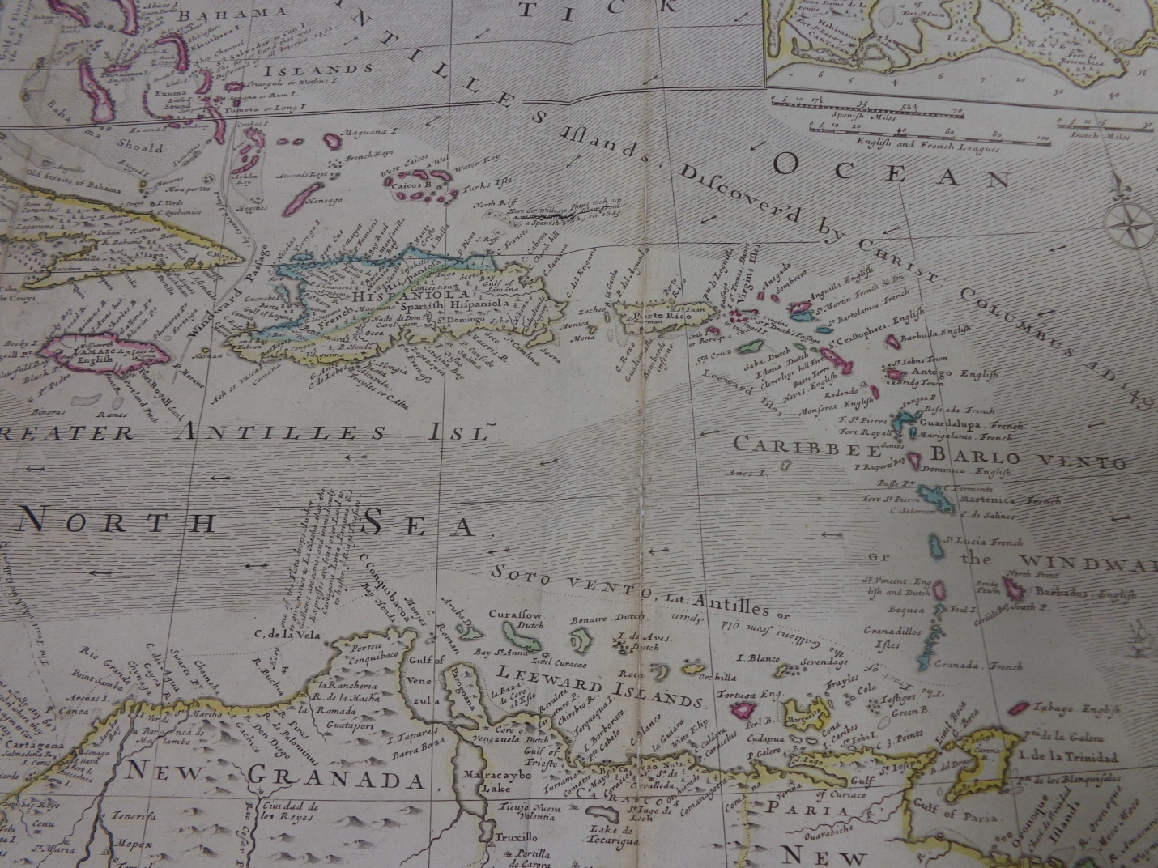
WO 78/419/10
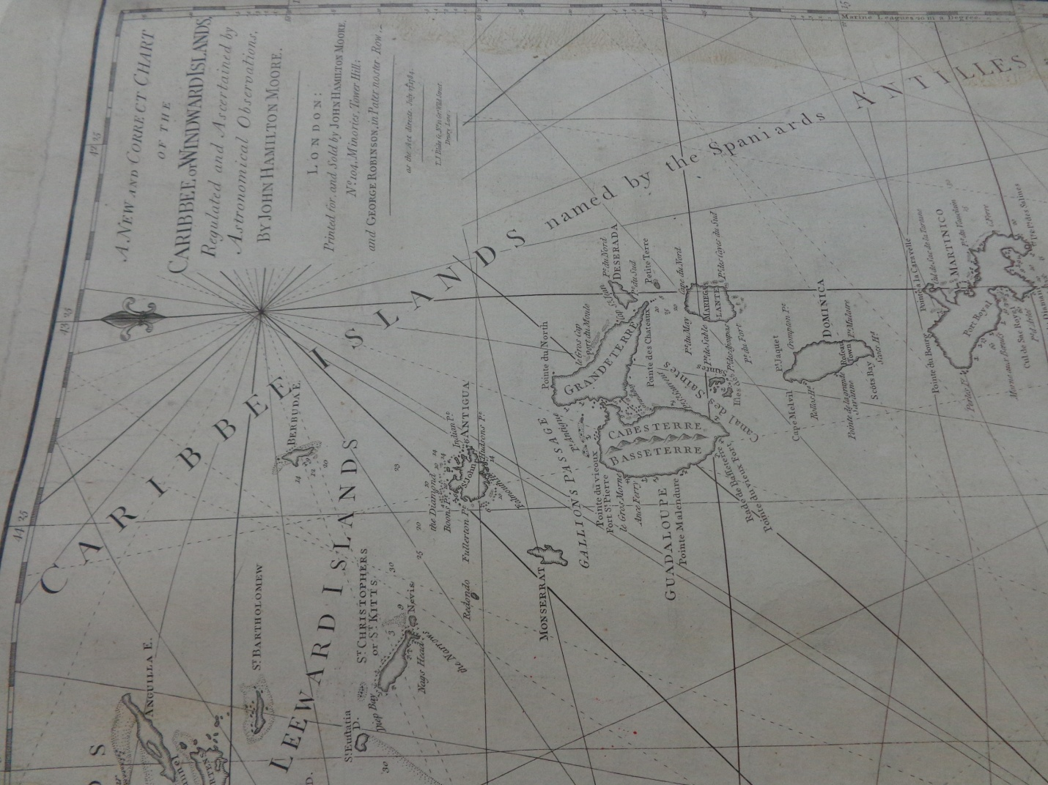

MR 1/567
In this close-up of the latter two by John Hamilton Moore, 1784, the tiny St Eustatius can be seen in the upper left under the “Lee” of the Leeward Islands, while the larger Guadaloupe is in the center and Martinique in the bottom right.
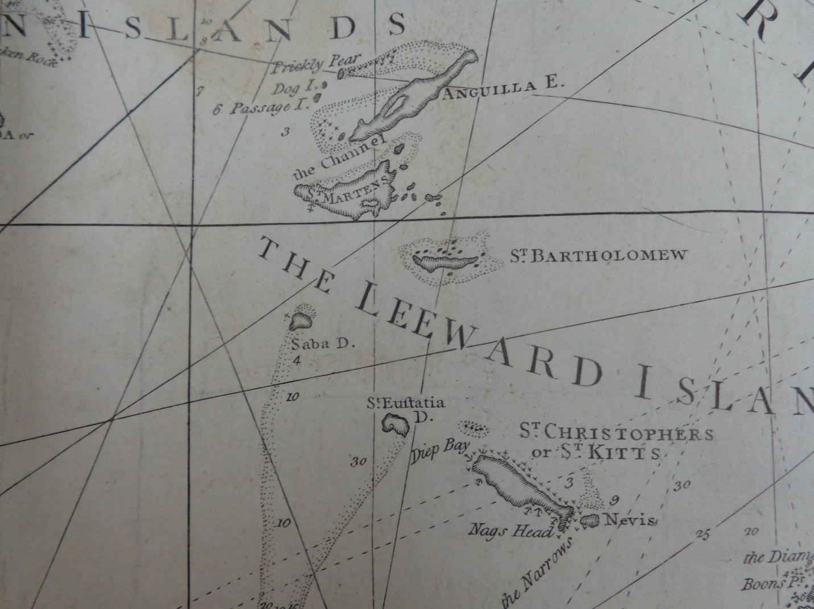
An even closer view of St Eustatius (also MR 1/567), and below of Guadaloupe, and in particular the straights between it and the Isles des Saintes just below it (MR 1/567 again).
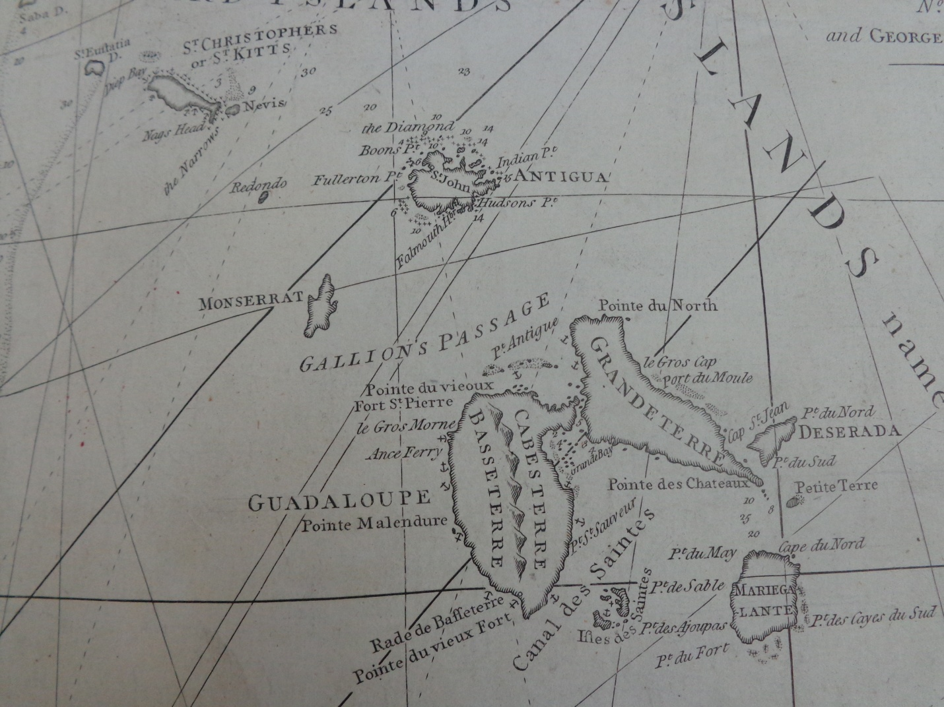
It would be in these two West Indian locations in particular that the events of 1781-82 would unfold, which would prove to be so decisive to the outcome of the American Revolutionary War.
An additional map of interest is a small part of Moll’s collection showing the most important American ports in the early 1700’s. Of note is that four of the twelve ports are in the North American colonies whereas eight are in the West Indies/Caribbean.
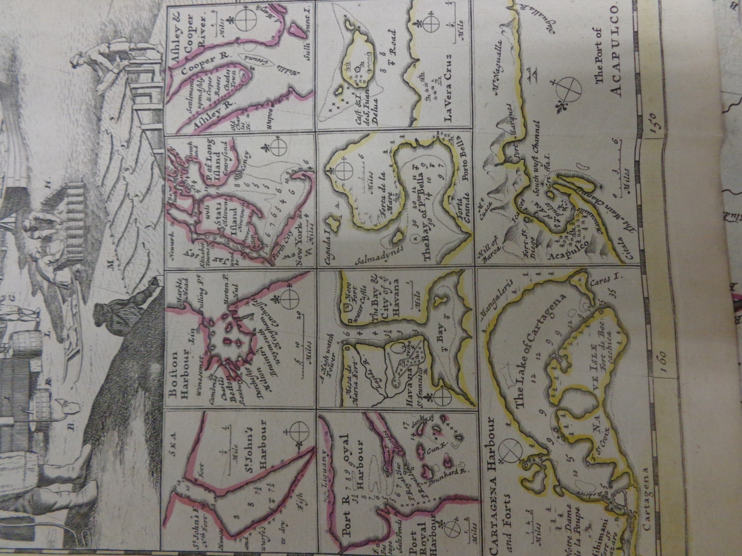WO 78/419/10
By the time of the American Revolutionary War, the West Indies became the main source of supplies for Washington’s Continental army. By 1777 90% of the gunpowder, and by 1780 80% of ships entering Philadelphia and Baltimore, came from the West Indies (Andrew O’Shaughnessy “The Men Who Lost America”, pages 291 and 296). The region was so vital to the war effort that the Continental Congress and individual states had representatives in the neutral ports (initially French, then Dutch). Virginia for example had a supply network in four Caribbean ports. This fit with British assumptions that the southern colonies, with its climate and slave-dependent economy, had more in common with the islands of the West Indies that the northern colonies of Massachusetts and Pennsylvania (James Corbett David “Dumore’s New World”, page 99).
In addition, American familiarity with the Caribbean extended to the Washington, Franklin and Hamilton families, who all had connections to the British West Indies, with Alexander Hamilton being born on St Kitts.
In section two I’ll examine in detail the role of the neutral (till 1780) tiny Dutch island of St Eustatius. However it’s worth mentioning in this context that for a while it was the busiest port in the world, where, for example 235 American ships visited there 1776-77, seven to ten every night, often in fleets of up to 30 ships (O’Shaughnessy, ibid, page 291). Indeed even in the very first year of the war Virginia Governor Dunmore’s “floating town” of ships in the Chesapeake captured a sloop from St Eustatius (James Corbett David “Dumore’s New World”, page 120).
For the British, even before the French entry in 1778, they had a difficult time finding enough warships to protect all the trading vessels from American privateers (in effect state endorsed pirates – a time honored naval tradition dating back to the Spanish Armada and beyond). The Governor of Grenada described them as being “like gnats” they were so numerous (O’Shaughnessy C-Span, Dec 2014: http://www.c-span.org/video/?323046-1/discussion-american-revolution-caribbean; see also WWWB Debra Troxell’s work on the role of American Privateers).
Once the French entered the British, also now engaged in the East Indies, around the coasts of Europe (notably against the Spanish at Gibraltar) and elsewhere, realized the scale of the global war they were in. Accordingly they promptly evacuated Philadelphia in favor of using the troops who had just captured the hard-fought prize, to sail to the West Indies to capture St Lucia in order to shadow the French fleet at their main naval base nearby on Martinique. St Lucia would go on to become the main British naval and army base in the eastern West Indies (with Jamaica in the west). Indeed the British government even considered withdrawing from America in order to protect their colonies in the West Indies and conquer the French and Spanish colonies there. The importance of the West Indies was mirrored by the French whose main objectives were primarily concentrated there – to the disappointment of their American allies who expected more direct aid and action in North America (O’Shaughnessy, ibid, page 294). Indeed the US itself in article seven of the alliance treaty with France agreed that any British islands in the West Indies that were captured should be given to France (full text of the treaty can be found here: http://avalon.law.yale.edu/18th_century/fr1788-2.asp).
It was for the reason of protecting the vital West Indian colonies that George Rodney, once appointed as commander of the main British naval force in the West Indies and North America in 1779, reflected to the senior British army commander in the West Indies his overall strategy for the war. A transcript of the his intriguing letter to General John Vaughn in Jamaica, dated November 1st 1780 can be found in Lesson Plan 1, along with suggested activities.
However a brief overview of this critical document shows how clearly interwoven events in the West Indies and North America were in the overall war. Particularly instructive are his opinions on the how to win the war. Rodney was well placed to offer such comments having risen through the ranks of command in previous global wars against the French 1740-48 (War of Austrian Succession, started incidentally by a trade dispute between Britain and Spain in the West Indies), and 1756-63 (Seven Years War) where had he already played a role in saving the West Indies and North America from French conquest.
We can see the interconnection between events in North America and the West Indies in the first page of this letter, 2nd paragraph:
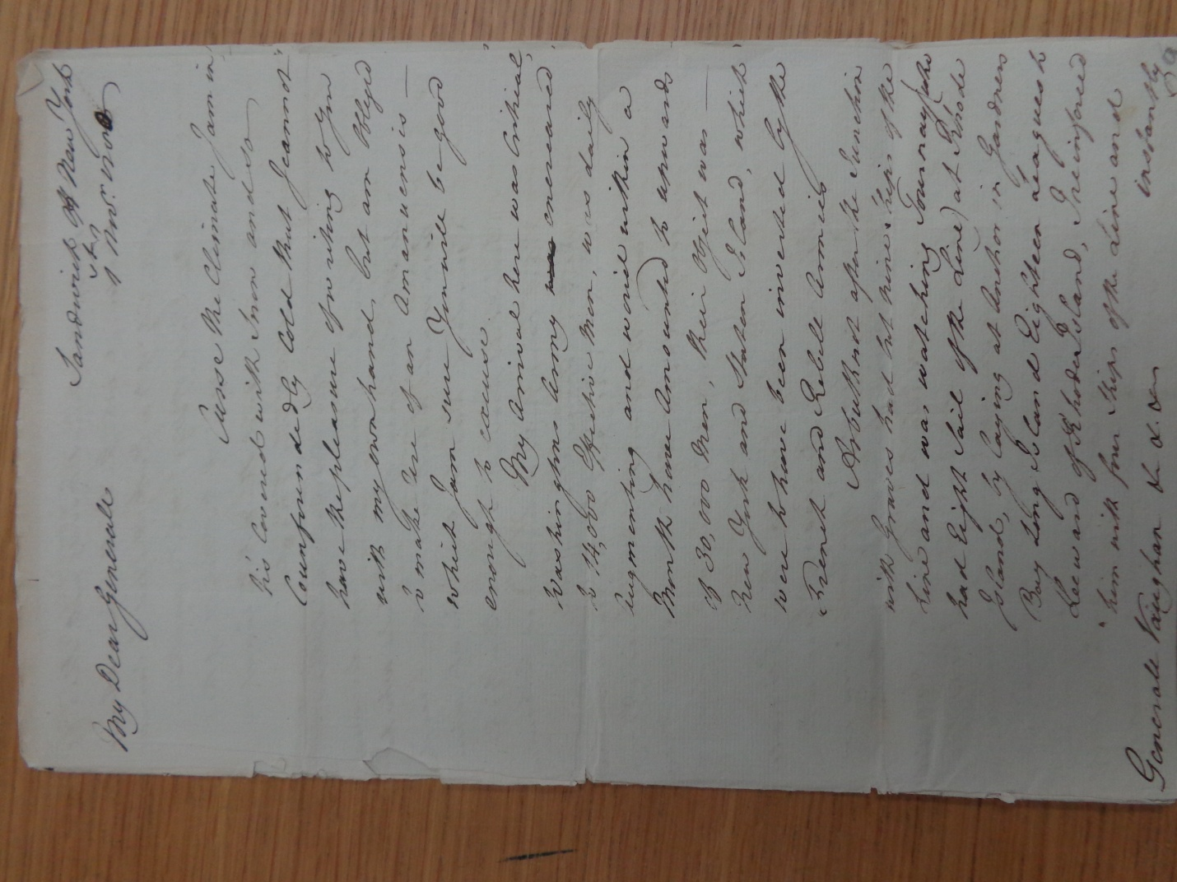
PRO 30/20/21/5-9
Here he notes his arrival from the West Indies in New York, thus ending French and American hopes of besieging the city. The third paragraph on the second page describes his arrival and also his blockade of the French at Newport, Rhode Island and his naval coverage of the northeastern seaboard. This has disheartened the Continental army that has begun to desert and has, along with the defection of Benedict Arnold, led to George Washington and the Continental Congress being at “daggers drawn” against each other.

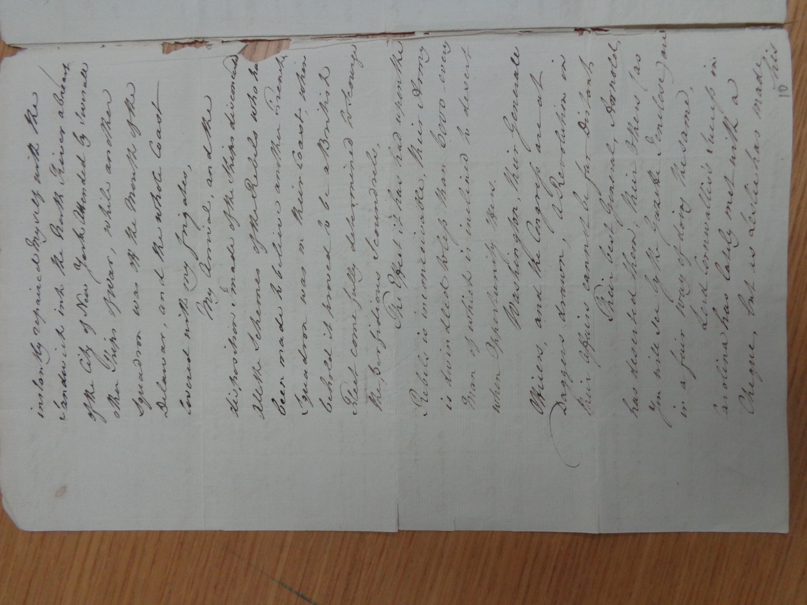
The last paragraph of page two and start of page three talks of Cornwallis’s success in Carolina, while the rest of page three and four lament the vacating of Rhode Island to the French.
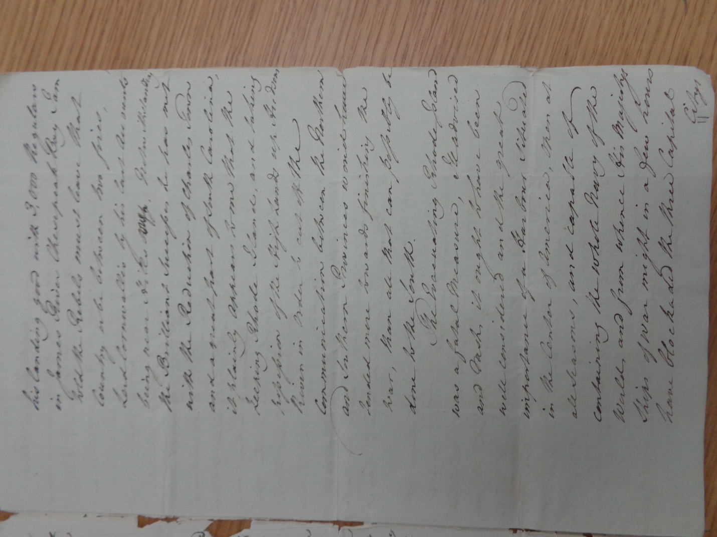
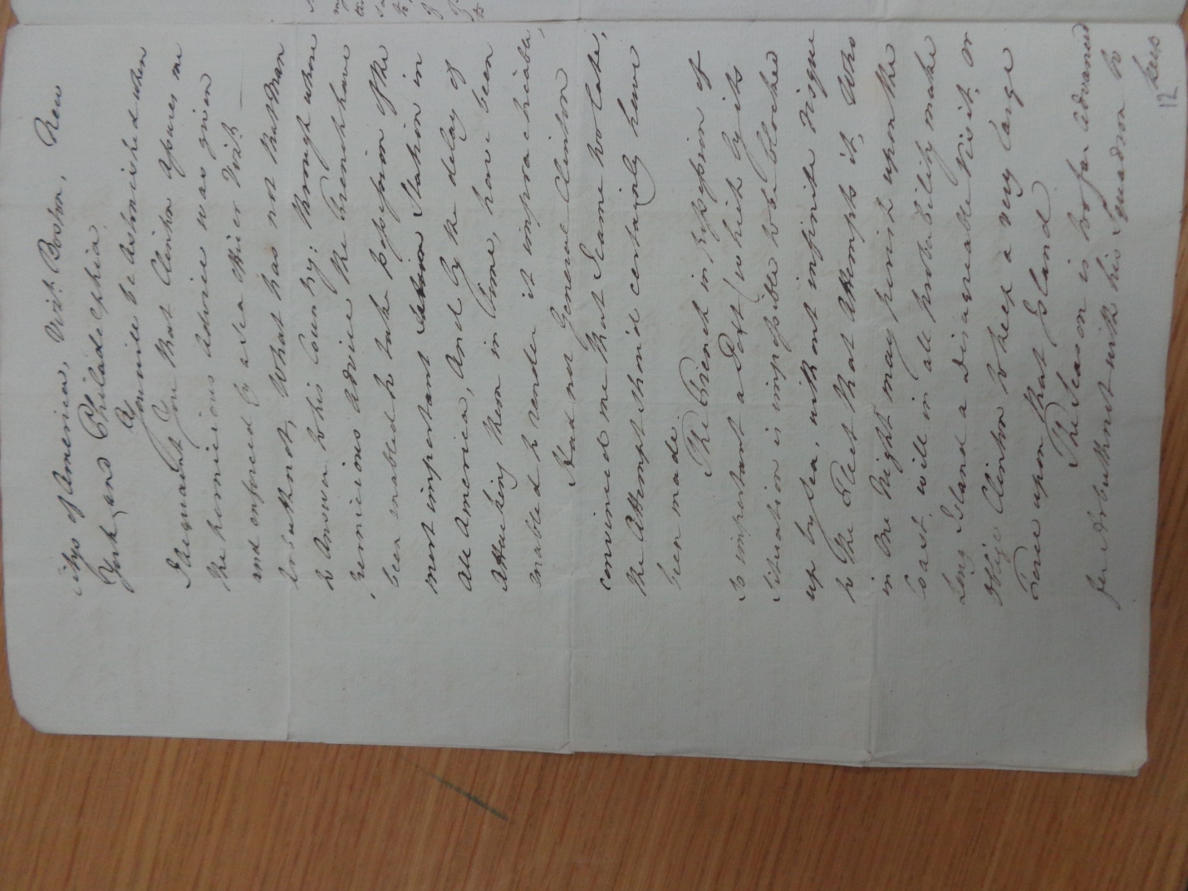
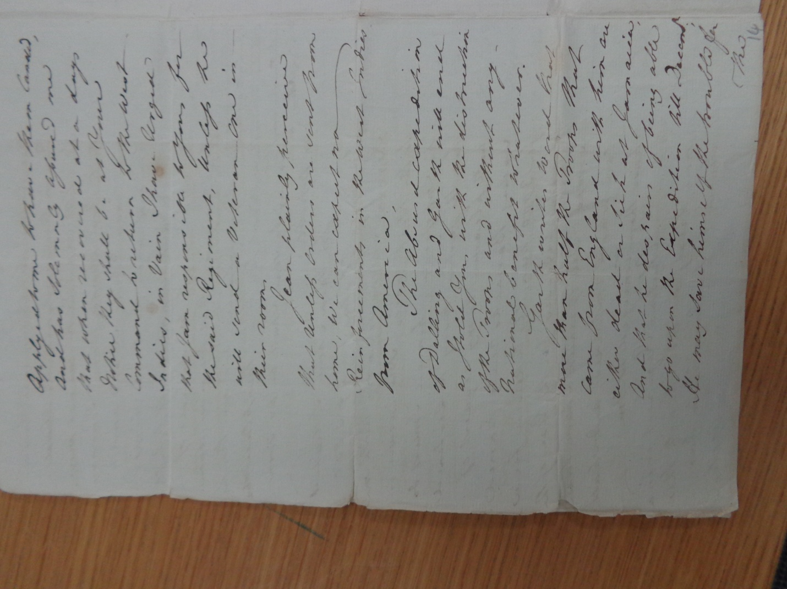
Page five sees Rodney discuss how he will soon leave New York to rendezvous with Admiral Arbruthnot off Martinique. In a side note on this page he describes how he has already ordered Admiral Graves (British commander at the 1781 Virginia Capes/Chesapeake Bay – critical to the battle of Yorktown), to go ahead of him.
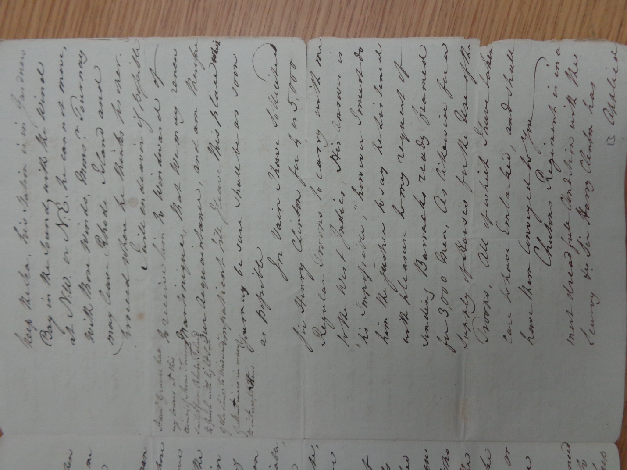
The last two paragraphs of page five discuss his request to overall commander General Clinton to release 4-5,000 soldiers from New York to sail with him to the West Indies. He laments (on page 6 also) the denial of this request to reinforce Vaughn in Jamaica and go on the offensive in the Caribbean. He foresees no hope of future troops begin released from North America to the West Indies.
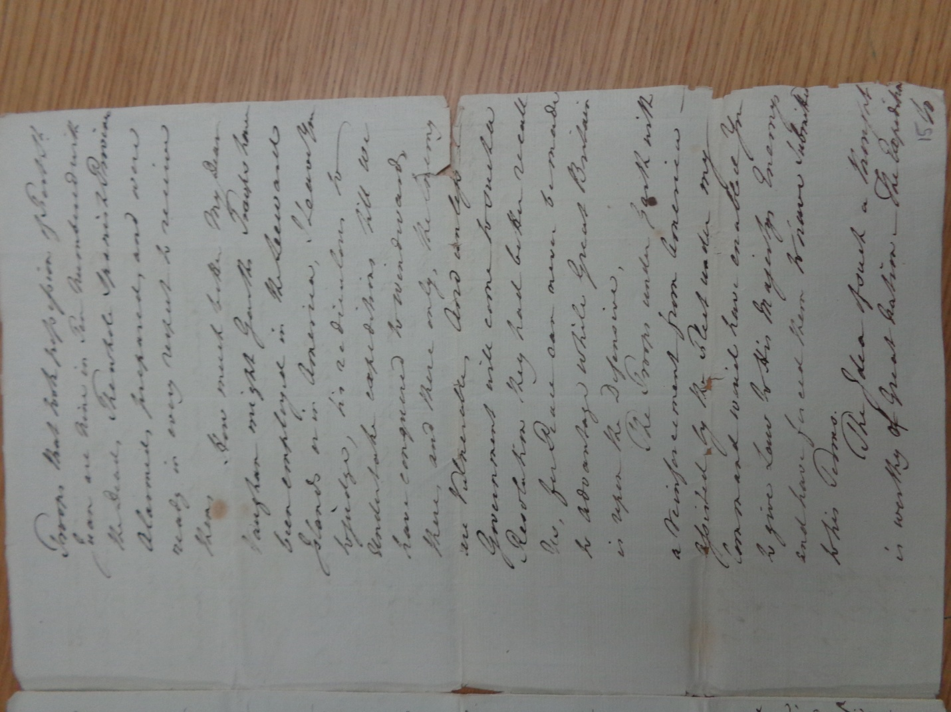
Page seven is the key section of the entire letter where in the second paragraph he describes to Vaughn how the troops should be deployed from North America to the Windward Islands (where many of the French West Indian colonies were) for “there only, the enemy is vulnerable”. He goes on to say that “unless the Government will come to such a resolution they had better recall us, for peace can never be made to advantage where Great Britain is on the defensive”. He adds that such a strategy towards “His Majesties Enemies” would “have forced them to have submitted to his terms”. He concludes in the latter part of the letter that any other strategy would see “the prolongation of the war”.
His closing words have a prophetic tone: “When it is too late then their eyes will be opened, and they will wish they had adhered to nothing but the conquest of the French West India islands.”
Historians (alongside perhaps American and British students today?) can judge whether, had Rodney’s strategy been followed, the result of the American Revolutionary War might have been different. However there is no doubt that in the global war that the American Revolution had become, that the West Indies played a decisive role.

