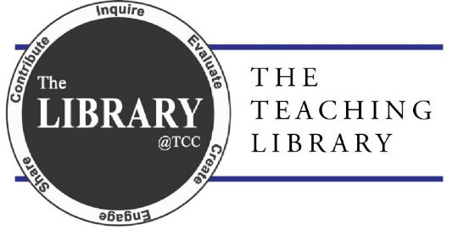

MLA 8: Works Cited

List of core elements
MLA 8 requires researchers to locate all “core elements” provided for a source and list them in the following order with the accompanying punctuation. Note that not all elements are always provided by a source.
- Author – The person or organization that created the source
- Title of source – The specific name of the source. Book titles are in italics, but articles titles, chapter titles, episode titles, etc. are in quotation marks.
- Title of container – When the source forms a part of a larger whole, the larger whole can be thought of as a container that holds a source.
- Other contributers – Editors, directors, translators, narrators, performers
- Version – Edition [updated, expanded, 7th, etc.], cut [film], version [King James]
- Number – Volume, number – vol. 1, no. 5
- Publisher – Organization responsible for producing the source
- Publication date – Date that the source/container was published
- Location – Page number, chapter, section, DOI, website URL or permalink
*NOTE: Access dates are optional. Check with your instructor.

Examples with detailed formatting

Webpage with no author

Formatting:
“Title of webpage.” Title of website, Publication date or date last modified/updated, URL.

Example:
“Depression.” Mayo Clinic, 16 August 2017, www.mayoclinic.org/diseases-conditions/depression/symptoms-causes/syc-20356007.

Article in an online library database

Formatting:
Author(s). “Title of article.” Title of Journal, volume, number, publication date, page numbers. Database name, URL.

Example:
Hannah, Daniel K. “The Private Life, the Public Stage: Henry James in Recent Fiction.” Journal of Modern Literature, vol. 30, no. 3, 2007, pp. 70-94. JSTOR, www.jstor.org.ezproxy.lib.uwf.edu/stable/30053134.
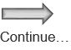

Citation Examples

Webpage with no author
“Depression.” Mayo Clinic, 16 August 2017, www.mayoclinic.org/diseases-conditions/depression/symptoms-causes/syc-20356007.

Website (entire site)
The Purdue OWL Family of Sites. The Writing Lab and OWL at Purdue and Purdue U, 2008, owl.english.purdue.edu/owl.

Article in an online library database
Hannah, Daniel K. “The Private Life, the Public Stage: Henry James in Recent Fiction.” Journal of Modern Literature, vol. 30, no. 3, 2007, pp. 70-94. JSTOR, www.jstor.org.ezproxy.lib.uwf.edu/stable/30053134.

Youtube video
Rotoballer. “RotoBaller MLB: Top Fantasy Baseball Catcher Dynasty League Prospects for 2016.” YouTube, commentary by Raphael Rabe, 27 Mar. 2016, youtube.com/watch?v=_LVD9y3MIB0.

Book, Single author
Mikhail, Mona. Seen and Heard: A Century of Arab Women in Literature and Culture. Olive Branch Press. 2004.

Book, Two authors
Casell, Kay Ann and Uma Hiremath. Reference and Information Services in the 21st Century: An Introduction. Neal-Schuman, 2004.

Book, Three or more authors
Robbins, Chandler S., et al. Birds of North America: A Guide to Field Identification. Golden, 1966.

Government agency as author
United States, U.S. Environmental Protection Agency. Climate Change Indicators in the United States, July 2015, www.epa.gov/sites/default/files/ps/74829.pdf.

Edition of a book
Smith, Joe, and Shelly Hawkins. Ancient Debate for Contemporary Students. 2nd ed., Pearson, 2002.

A work in an anthology or compilation (like an essay, poem, or short story)
Kimball, Jean. "Growing Up Together: Joyce and Psychoanalysis, 1900-1922." Joyce through the Ages: A Nonlinear View, edited by Michael Patrick Gillespie, UP of Florida, 1999, pp. 25-45.

Personal Interview
Smith, Jane. Personal interview. 19 May 2014.

