Module 10 Lab:

Name:___________________________________________ Date:_____________________
This report is my original work.

Module 10 Lab
Lab Part 1: Ecology: How is energy transferred through a community of organisms?
How is energy transferred through a community of organisms? - examine food chains and identify producers, consumers, and decomposers - Glencoe Virtual Lab
Objectives:
- Determine an organism's place in a five-link food chain.
- Explain how, and in what sequence, energy is transferred through different communities of organisms.
- Define abiotic factors and give examples of them. In this Virtual Lab, you will examine various organisms and determine their placement in a five-link food chain
Introduction: The organisms in an ecosystem interact with one another, and with the abiotic factors of the environment, in various ways. Abiotic factors are the nonliving characteristics of the environment. Some examples of abiotic factors include temperature and rainfall. A desert ecosystem's abiotic factors include a small amount of rainfall, and warm daytime and cool nighttime temperatures. A temperate forest's abiotic factors include an average amount of rainfall and a wide temperature range. Some of the most important interactions among species in an ecosystem community involve feeding. All living things need food for energy. When one organism consumes another, energy is transferred from the organism that is eaten to the organism that eats it. Most of the energy an organism takes in is released as heat. Only about 10 percent of the energy available at one level of a food chain transfers to the next. A food chain is often used to describe this transfer of energy through a biological community. Most food chains have four or five links, with each link representing a feeding step. Organisms are placed into a food chain according to their energy source. There are five levels in a food chain: producers, first-order consumers, second-order consumers, third-order consumers, and decomposers. Producers obtain energy from the Sun or from chemicals in the environment. Plants, bacteria, and protists are examples of producers. First-order consumers, or herbivores, obtain energy by eating producers. Rabbits, geese, and termites are examples of first-order consumers. Second-order consumers, or carnivores, obtain energy by eating herbivores. Examples of second-order consumers include wolves, spiders, and frogs. Third-order consumers, or top carnivores, obtain energy by eating other carnivores. Lions, falcons, and killer whales are examples of third-order consumers. Decomposers feed at all levels of a food chain, obtaining energy by breaking down the decaying bodies and wastes of other organisms. Examples of decomposers include mushrooms and molds. Glencoe Virtual Lab
The instructions for the lab are listed in the procedure below. Follow each step of the Procedure below completing Table 1 as you work through the activity. (Procedure Step 8 is required to get credit for this lab. Labs submitted without procedure 8 will receive a ZERO.)
Procedure: Carefully read and follow instructions as you work through the lab.
1.Direct your browser to the link above. Read the information and follow the procedure.
2. Click the Video button. Watch the video and observe how energy moves through a biological community. Write your observations in your Journal.
3. Click a stack of cards to examine five organisms from an ecosystem. The organisms are part of a desert or temperate forest community, and each organism is part of a five-level food chain.
4. Drag a card to the information display area in the upper right part of the screen. Click the appropriate tab along the top of the display area to read information about the organism. Use this information to determine the organism's place in the food chain.
5. Drag the card to its proper place in the food chain.
6. Repeat step 4 with the remaining organisms.
7. To check your work, click the Check button. If an organism is sequenced incorrectly, it will be highlighted in red. Re-examine the organism's habitat, energy, and fact information, and then re-sequence the organism.
8. When you have correctly sequenced each organism in your first food chain and checked your answers, hold your picture ID on the upper right side of computer screen clearly showing your five organisms in their correct place in the food chain. Take a picture of your computer screen clearly showing the organisms in their correct place in the food chain and your photo ID. (The example shows the computer screen without any organisms in the five food chain areas and my picture ID on the right side of the lab screen). You may need to adjust your computer screen brightness (make it less bright) to get a good photo of your ID with the screen. Do not include your keyboard and desk in the picture.
Then save the picture to your computer. Rotate the picture (4 points) if it is not right-side up. Insert the right-side up legible picture of your computer screen with your correctly sorted organisms and your picture ID on the right of the computer screen in the designated box below. This step is required to get credit for the lab. Labs submitted without this step will receive a ZERO.
Example: The example shows a picture of the lab start screen and a photo ID.
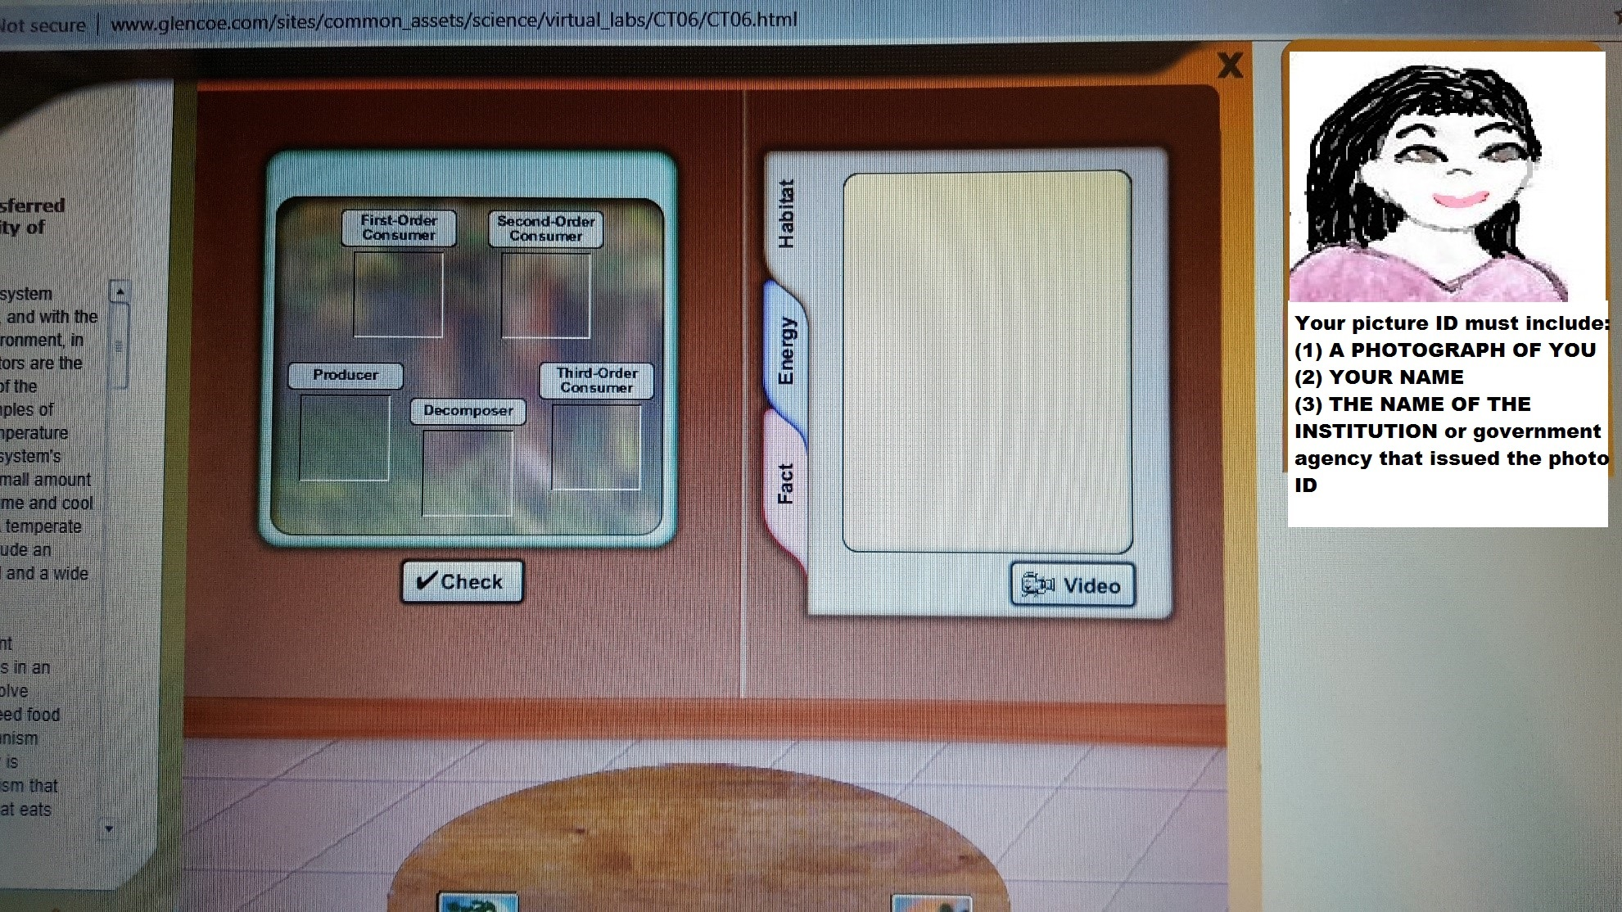
9. Record the community name (Forest or Desert), the organisms' names and placement in the Table 1.
10. Click the Reset button to construct a new food chain. Each organism may belong in more than one food chain. Investigate a total of two Forest food chains and two Desert food chains and record your observations for a total of four food chains.
Note: It is VERY LIKELY that a snake would eat a scorpion and not that a scorpion would eat a snake.
Table 1: Energy Transfer in Communities
Food Chain | Community  (Desert or Temperate Forest) | Producer | First-Order Consumer | Second-Order Consumer | Third-Order Consumer | Decomposer
1

2

3

4

11. Complete the Journal questions: Ecology How is energy transferred through a community of organisms?
Question 1: Would you be likely to find a food chain containing 10 links? Why?

Question 2: What are abiotic factors? How do abiotic factors affect organisms in an ecosystem?

Question 3: What's the difference between a producer and a consumer? Where do producers belong in a food chain?

Question 4: What is a decomposer? Why are decomposers important to ecosystems?

Question 5: Compare a food chain to a food web.

Question 6: Why are there fewer top carnivores than herbivores in most land ecosystems?

Modified from Glencoe Virtual Lab How is energy transferred through a community of organisms?
This work is licensed under a Creative Commons Attribution-NonCommercial-ShareAlike 4.0 International License.

Lab Part 2: Investigation: Interpreting Ecological Data and Estimating Population Size?
Populations Notes: https://www.biologycorner.com/bio2/notes_populations.html (The Biology Corner)
Population Growth and Regulation Notes: 19.2 Population Growth and Regulation (Concepts of Biology)
The Human Population Notes: 19.3The Human Population (Concepts of Biology)
Objectives:
- Read and demonstrate an understanding of population graphs
- Estimate the size of a sample population using the mark-recapture technique and the random sampling technique and compare them to other methods of population estimating.
- Compute population data using mathematical equations
Introduction from Biology Corner Investigation: How Do Biologists Estimate Population Size?
Read and take notes on the complete introduction below before you start the procedure.
Mark and Recapture
In this procedure, biologists use traps to capture animals and mark them in some way. The animals are then returned unharmed to their environment. Over a period of time, the animals are trapped again, with researchers recording how many of the original tagged individuals are recaptured. The ratio of animals trapped with the tags and the animals trapped that were not tagged is used to estimate the overall population number.
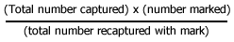
Random Sampling
A technique called random sampling can be used to estimate population size. In this procedure, the organisms in a few small areas are counted and projected to the entire area. For instance, if a biologist counts 10 squirrels living in a 200-square foot area, she could predict that there are 100 squirrels living in a 2000 square foot area. This is a simple ratio.
Biology Corner resources were modified for use in this lab.
Publisher: Biologycorner.com;
This work is licensed under a Creative Commons Attribution-NonCommercial 3.0 Unported License.
Procedure: Read and follow the directions in each section below:
1. Direct your browser to the first link above. Carefully read and take notes on the Biology Corner Populations Notes.
2. Direct your browser to the second link above. Carefully read and take notes on the Concepts of Biology Population Growth and Regulation Notes
3. Direct your browser to the second link above. Carefully read and take notes on the Concepts of Biology The Human Population Notes
4. Look at the Graph 1: Rabbits Over Time and answer the questions below the graph.
Graph 1: Rabbits Over Time
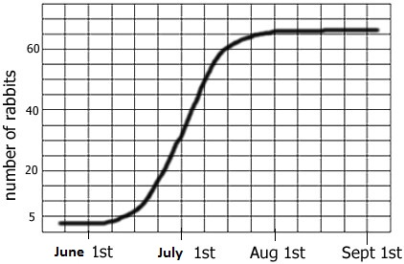

a. This graph overall shows ____________________________ growth or a ______ shaped growth curve.

b. The carrying capacity for rabbits is ____________________________

c. If this graph ended shortly after July 1st, it would show ________________________________growth or a ___________shaped growth curve.

5. Look at the Graph 2: Mexico and US and answer the questions below the graph.

Graph 2: Mexico and US
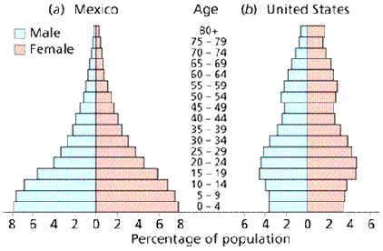

a.In Mexico, what percentage of the population is between 0-4 years of age? ______________________

b. In the US, what percentage of the population is between 0-4 years of age? ______________________

c. Which population is growing the fastest? ______________________________

d. Which age group has the smallest number in both countries? ______________________________

Mark and Recapture
6. Look at Chart 1: Trapping Geese. Read the information on Mark and Recapture in the lab introduction. Look over the example calculation below the chart. Do the calculations, complete the Estimated Total Population column of the chart, and answer the questions below the chart.
Chart 1: Trapping Geese
In order to estimate the population of geese in Northern Wisconsin, ecologists marked ten geese and then released them back into the population. Over a six year period, geese were trapped and their numbers recorded.
Year | Geese Trapped | Number with Mark | Estimated Total Population
1980 | 10 | 1 | 100
1981 | 15 | 1
1982 | 12 | 1
1983 | 8 | 0
1984 | 5 | 2
1985 | 10 | 1
First calculation:
Ten geese were trapped in 1980, and only one was marked.
(10 captured) x (10 originally marked) / (1 recaptured with mark) =
(10 x 10) /1 =100
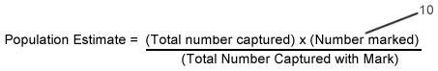
a. Use the formula above to calculate the estimated number of geese for each year of the study area and complete the Estimated Total Population column of the chart

b. If more of the geese found in the trap had the mark, would the estimated number of geese in the area be more or less? _______________

Random Sampling
Scientists cannot possibly count every organism in a population. One way to estimate the size of a population is to collect data by taking random samples. In this activity, you will look at how data obtained from random sampling is used to estimate the size of a population.
7. Look at Chart 2: Mushroom Plots. Read the information on Random Sampling in the lab introduction.
Chart 2: Mushroom Plots
Another ecologist uses a different method to estimate the number of mushrooms in a forest. She plots a 10x10 area and randomly chooses 5 plots, where she counts the number of mushrooms in each plot and records them on the grid.
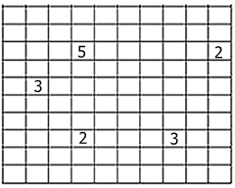

a. How many total plots are in the grid? _______. Show calculations for your answer? _____________________________________________

b. Compute the average number of mushrooms you would expect to find in each plot based on the number of plots where the ecologist actually

counted the mushrooms.____________________

c. Explain how you calculated the average_______________________________________________________________________________

_________________________________________________________________________________________________________________

d. Calculate the number of mushrooms in the forest based on the grid data: ___________________________________________________

8. Look at Chart 3: Snakes & Mice. The data shows populations of snakes and mice found in an experimental field.
Chart 3: Snakes & Mice
Year | Snakes | Mice born | Mice died
1960 | 2 | 1000 | 200
1970 | 10 | 800 | 300
1980 | 30 | 400 | 500
1990 | 15 | 600 | 550
2000 | 14 | 620 | 600
2001 | 15 | 640 | 580

a.During which year was the mouse population closest to zero population growth? ___________

b. Explain your answer above. ____________________________________________________________________________________

_____________________________________________________________________________________________________________

c. What is the approximate carrying capacity for mice? __________

Biology Corner resources were modified for use in this lab.
Publisher: Biologycorner.com;
This work is licensed under a Creative Commons Attribution-NonCommercial 3.0 Unported License.

