Module 9 Lab:

Name:___________________________________________ Date:_____________________
This report is my original work.

Module 9 Lab
Lab Part 1A: Introduction to Fish
Fish Notes – Biology Corner https://www.biologycorner.com/bio2/notes_fish.html
Notes/PP: Fish C12 Fish Biology Corner
https://docs.google.com/presentation/d/1XRfwRw0STKRZMOKCZhMnOhPEccsI2rfAGWgfcBj99Nk/edit#slide=id.g2cdab6d39e_0_64
Fish Notes / Anatomy https://www.youtube.com/watch?v=fNlQzE5QVoo&t=18s Review: Video/Notes: Vertebrate Diversity: The Fish Craig Savage 15.16 min
Objectives:
- What are Fish?
- Identify and give the functions of the structures and tissues of fish.
- Match the organisms to their correct phylum and class.
Procedure: Carefully read and follow instructions as you work through the lab.
1.Direct your browser to the links above in the order they are listed. Read the information, watch the videos or slides, take notes, and study the information in each link.
2. Use the Fish Notes – Biology Corner https://www.biologycorner.com/bio2/notes_fish.html to identify the fins (anal fin, caudal fin, dorsal fin, pectoral fin, and pelvic fin) of the fish below:

____________________1. The fin (C) on the side of the fish just behind its head

____________________2. The fin (A) that runs along the middle of the dorsal or upper surface of the fish

____________________3. The “<” shaped fin (B) on the tail or posterior end of the fish

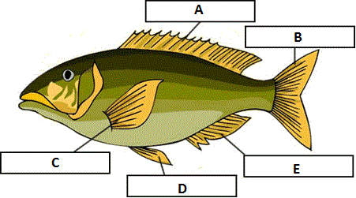
3. Use the Notes/PP: Fish C12 Fish Biology Corner (The kidney and muscle are mislabeled/reversed on the Digestive System slide in this link.)
https://docs.google.com/presentation/d/1XRfwRw0STKRZMOKCZhMnOhPEccsI2rfAGWgfcBj99Nk/present?ueb=true&slide=id.g2cdab6d39e_0_64
The organs and structures already labeled on the diagram below are correct. Complete the diagram by identifying the fish organs and structures (anus or vent, liver, intestine, stomach, kidney, heart)

________________ 4. The pink organ or structure behind the gills

________________ 5. The long, dark organ or structure (A) above the swim bladder indicated by a line from the box above the center of the fish diagram

________________ 6. The organ or structure indicated by a line from the leftmost box (B) nearest the tail and just below the fish diagram on the left side.

Resources for this lab were modified from Biology Corner. https://www.biologycorner.com/worksheets/dragonfly/30-2_fishes.html
Publisher: Biologycorner.com; follow on Google+
This work is licensed under a Creative Commons Attribution-NonCommercial 3.0 Unported License.
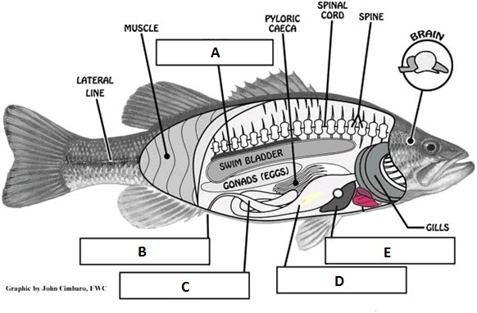

4. Multiple Choice: Put the letter of the correct answer in the blank to the left of the question.

_______7. The part of the brain that is responsible for voluntary activities is the:
a. medulla oblongata b. olfactory lobe c. cerebrum d. cerebellum

_______8. In fish circulation, blood moves from the atrium to:
a. the rest of the body b. the ventricle c. the gills d. the liver

Resources for this lab were modified from Biology Corner. https://www.biologycorner.com/worksheets/dragonfly/30-2_fishes.html
Publisher: Biologycorner.com; follow on Google+
This work is licensed under a Creative Commons Attribution-NonCommercial 3.0 Unported License.

This work is licensed under a Creative Commons Attribution-NonCommercial 3.0 Unported License.
Lab Part 1B: Introduction to Amphibians
Amphibian Notes – Biology Corner https://www.biologycorner.com/bio2/notes_amphibians.html
Amphibian Notes / Anatomy https://www.youtube.com/watch?v=L2i8zPRLf-c : Video/Notes: Vertebrate Diversity: Amphibians Craig Savage 14.31 min
Objectives:
- What are Amphibians?
- Identify and give the functions of the structures and tissues of amphibians.
- Match the organisms to their correct phylum and class.
Procedure: Carefully read and follow instructions as you work through the lab.
1.Direct your browsers to the two links above in the order they are listed. Read the information, watch the videos or slides, take notes, and study the information in each link.
2. Direct your browser to the Alternative to the Frog Dissection – Biology Corner https://www.biologycorner.com/worksheets/frog_alternative.html and scroll down to the section called Gallery 1 - External Anatomy of the Frog. (Click on the left icon to show captions, you may need to pause and advance manually)
3. Direct your browser to the Glencoe Virtual Frog Dissection link: http://glencoe.mheducation.com/sites/dl/free/0078802849/383954/BL_16.html and go over the external anatomy of the frog.

4. Answer the External Anatomy of the Frog Journal Questions below:
External Anatomy Question 1. Describe the dorsal and ventral surface of the frog.

External Anatomy Question 2. What is a tympanic membrane and where is it located on a frog?

External Anatomy Question 3. Describe the front and back limbs of the frog.

5. Direct your browser to the Alternative to the Frog Dissection – Biology Corner https://www.biologycorner.com/worksheets/frog_alternative.html and scroll down to the section called Gallery 2 – Frog Dissection. (Click on the left icon to show captions, you may need to pause and advance manually)
6. Direct your browser to the Glencoe Virtual Frog Dissection link: http://glencoe.mheducation.com/sites/dl/free/0078802849/383954/BL_16.html and go over the internal anatomy of the frog.

When the abdominal cavity of the frog is opened, many organs of the digestive, respiratory, and urogenital systems can be observed. Read the descriptions of the organs below, answer the journal questions, and label the diagram as you work through the dissection.
- Leading from the mouth is a tube (esophagus) that connects to the stomach.
- The lungs are located above the liver on each side of the heart.
- The largest organ is the liver, and it consists of multiple lobes (right lobe of the liver, left anterior lobe of the liver, left posterior lobe of the liver). The liver has several jobs related to digestion and detoxification.
- Tucked under the liver is the gall bladder, which stores bile that is produced by the liver.
- The gall bladder connects to the duodenum of the small intestine.
- The duodenum connects to the curly part of the small intestine known as the ileum. The ileum is where nutrients are absorbed into the blood.
- The spleen is an organ that has an immune function and is found within the coils of the intestine.
- The ileum connects to the large intestine and the cloaca. Water is reabsorbed in the large intestine and wastes are stored at the cloaca before exiting the anus.
- At the lowest part of the abdominal cavity is a thin pouch (urinary bladder) for storing urine.
- The stomach can be viewed if you lift the liver and is often curved, this is the first site of chemical digestion in the frog.
- Within the curve of the stomach is a gland called the pancreas. The pancreas is involved in the digestion and the uptake of sugars.
- The coils of the small intestine are held together by a thin membrane called the mesentery.
- A female frog will have tiny curling tubes (oviducts) deep in the abdominal cavity that carry eggs.
- Also deep within the cavity are bean shaped organs, the kidneys which filter wastes from the blood, creating urine which is then stored in the bladder.
7. Match the organs listed in bold above to the corresponding number on the diagram below:

______________________________1. ______________________________3.

______________________________5. ______________________________9.

______________________________11. ______________________________13.
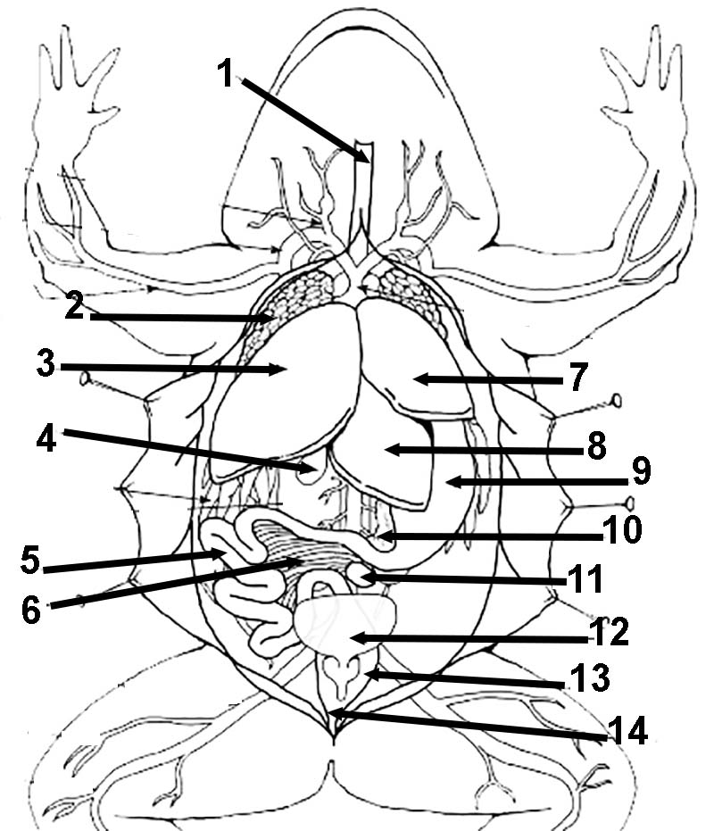

7. Answer the Internal Anatomy of the Frog Journal Questions below:

Internal Anatomy Question 1. Describe the inside of the frog's mouth. What structures are visible and what are their functions?

Internal Anatomy Question 2 – after reading each description below, write down the name of the structure or organ in the space to the left of the description.
_________________________ Carries eggs in female frogs
_________________________ First site of chemical digestion
_________________________ Stores solid waste, eggs, sperm
_________________________ Filters blood, makes urine
_________________________ Digestion, uptake of sugar
Publisher: Biologycorner.com; Resources for this lab were modified from Biology Corner
This work is licensed under a Creative Commons Attribution-NonCommercial-ShareAlike 4.0 International License.
Lab Part 2A: Introduction to Birds
Bird Notes – Biology Corner https://www.biologycorner.com/bio2/notes_birds.html
Bird Notes / Anatomy https://www.youtube.com/watch?v=aOlGsH-ZpOo Review: Video/Notes: Vertebrate Diversity: The Birds Craig Savage 16.02 min
Objectives:
- What are Birds?
- Identify and give the functions of the beaks and feet of birds.
Procedure: Carefully read and follow instructions as you work through the lab.
1.Direct your browser to the links above in the order they are listed. Read the information, watch the videos or slides, take notes, and study the information in each link.
2. You can also use this Google Slides document which shows photos of these birds and video clips.
3. Use the bird illustrations and the descriptions of bird beaks and feet below the table to complete the table.
What Does a Bird's Beak and Feet Tell You About Its Diet?
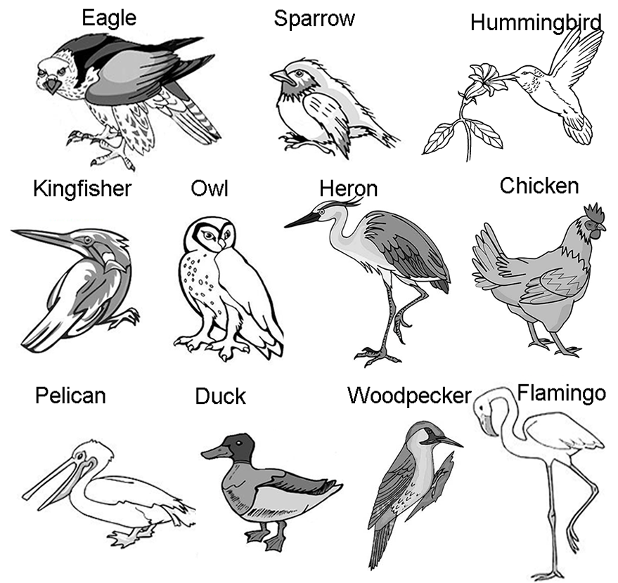
TABLE: What Does a Bird's Beak and Feet Tell You About Its Diet?
Bird | Type of Feet | Type of Beak | Probable Diet | Probable Habitat
Chicken
Duck
Eagle
Sparrow
Flamingo |  |  | shrimp
Heron
Short and thick - seed cracking
Long and thin, slightly curved - eating nectar
Strong, chisel like - drilling
Sharp, curved and pointed - tearing flesh
Long and flattened - straining algae and plants
Spear shaped - spearing fish
FEET
3 toes in front, 1 behind - perching
2 toes in front, 2 behind - climbing
Powerful curved talons - grasping prey
Webbed - swimming
Long and thin - wading
Thick and stout - running
4. Complete the Analysis Questions below:
Analysis Question 1. What features of a hummingbird make it adapted for its style of feeding?

Analysis Question 2. Imagine an ideal flying predator. What type of beak and feet would it have?

Analysis Question 3. Different birds may have similar beaks and diets. Loons, herons, and kingfishers, for instance, all have long sharp pointed beaks for spearing fish. Their feet, however, are quite different. Describe how the loon, heron, and kingfisher differ in the method by which they hunt for fish (use their feet to help you answer.)

Analysis Question 4. Owls have large eyes that enable them to see well at night. Both the hawk and the owl hunt similar things: small rodents or snakes. How do the hawk and the owl avoid competing with each other?

Analysis Question 5. In the two previous questions, you were asked to analyze how birds reduce competition with each other when they hunt similar prey and live in similar habitats. This idea among ecologists is known as the "Competitive Exclusion Principle" which suggests the no two species can occupy the same NICHE. Use your book other resources to define the word: niche and provide examples from this activity of a bird's niche.

Publisher: Biologycorner.com; Biology Corner resources were modified for use in this lab.
This work is licensed under a Creative Commons Attribution-NonCommercial-ShareAlike 4.0 International License.
You can also use this Google Slides document which shows photos of these birds and video clips.

Lab Part 2B: Animal Symmetry, Phyla and Classes
Animal Notes - Concepts of Biology https://cnx.org/contents/s8Hh0oOc@11.1:BtKmWZ4Y@2/Introduction
Objectives:
- Identify the correct symmetry, phylum, and class for the organisms in the chart.
Introduction from Concepts of Biology
Procedure: Carefully read and follow instructions as you work through the lab.
1.Direct your browser to the link above. Read the information, watch the videos or slides, take notes, and study the information in each link.
2. Complete the table Animal Symmetry, Phyla, and Class
Animal Symmetry, Phyla, and Class
 | Animal | Symmetry | Phylum | Class
 | Snail
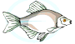 | Fish
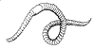 | Earthworm
 | Anemone
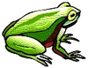 | Frog
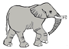 | Elephant
Publisher: Biologycorner.com; Modified from Biology Corner
This work is licensed under a Creative Commons Attribution-NonCommercial-ShareAlike 4.0 International License.
Images on this page collected from a variety of clipart sites.

Animal Phylum Matching
Instructions: Put the letter of the matching phylum description in the blank to the left of the phylum name.
_____Platyhelminthes |  | A.These marine animals have plates with spines and endoskeleton
_____Chordata | 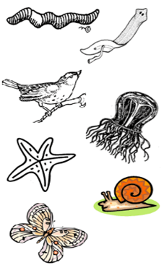 | B. Three body parts, jointed legs, tough exoskeleton, chiton
_____Mollusca |  | C. Soft, thin, flat bodies
_____Arthropoda |  | D. Soft bodied animals usually have a shell
_____Echinodermata |  | E. Long tube-like animals divided into segments
_____Annelida |  | F. Jelly-like animals that have a bell or umbrella shape
_____Porifera |  | G. Animals that have a notochord that supports the body (or backbone)
_____Nematoda |  | H. Sessile filter feeding animals
_____Cnidaria |  | I. Slender tube-like, nonsegmented
Publisher: Biologycorner.com; Modified from Biology Corner
This work is licensed under a Creative Commons Attribution-NonCommercial-ShareAlike 4.0 International License.

