Module 8 Lab:

Name:___________________________________________ Date:_____________________
This report is my original work.

Module 8 Lab
Part 1: The Nature of Science: How are mollusks, worms, arthropods, and echinoderms classified? Glencoe Virtual Lab
Notes:
- Annelid Notes – Biology Corner https://www.biologycorner.com/bio1/notes_annelids.html
- Arthropod Notes - Biology Corner https://www.biologycorner.com/bio1/notes_arthropods.html
- Mollusk Notes – Biology Corner https://www.biologycorner.com/bio1/notes_mollusks.html
- Echinoderm Notes - Concepts of Biology https://cnx.org/contents/s8Hh0oOc@11.1:qTaQgTIL@3/Echinoderms-and-Chordates

Lab: The Nature of Science: How are mollusks, worms, arthropods, and echinoderms classified? http://www.glencoe.com/sites/common_assets/science/virtual_labs/LS14/LS14.html Glencoe Virtual Lab
Introduction: Read and take notes on The Nature of Science: How are mollusks, worms, arthropods, and echinoderms classified?
To classify an animal, a scientist must identify the characteristics it has in common with other animals. For example, all animals that do not have a backbone are classified as invertebrates. They are further classified by examining the complexity of their body plans. Invertebrates with complex body plans have evolved body tissues, organs, and organ systems. Invertebrates with simple body plans lack developed body structures. Mollusks, worms, arthropods, and echinoderms are all invertebrates with complex body plans. A phylum is the second-highest classification category in the animal kingdom. Most phylum names are Latin in origin. Invertebrates with complex body plans are classified into four different phyla: mollusks belong to the phylum Mollusca; segmented worms belong to the phylum Annelida; arthropods belong to the phylum Arthropoda; echinoderms belong to the phylum Echinodermata.
In this Virtual Lab you will examine and classify species of mollusks, worms, arthropods, and echinoderms into the appropriate phyla.
Objectives:
- Identify features of mollusks, worms, arthropods, and echinoderms.
- Classify species of invertebrates into the appropriate phyla.
The instructions for the lab are listed in the procedure below. Follow each step of the Procedure below completing Table 1 as you work through the activity. (Procedure Step 7 is required to get credit for this lab. Labs submitted without procedure 7 will receive a ZERO.)
Procedure:
1. Direct your browser to each Note link (1-4) above. Carefully read and take notes on each phylum.
2. Direct your browser to the Lab link: How are mollusks, worms, arthropods, and echinoderms classified?
Glencoe Virtual Lab http://www.glencoe.com/sites/common_assets/science/virtual_labs/LS14/LS14.html
3. Drag an animal from the bottom of the screen to the animal fact display area on the right part of the screen where the picture of several invertebrates is displayed. The animal’s common name, a larger image of the animal, and information about the animal appears in the display area. Use this information to help classify the animal into its phylum.
4. Click a phylum name above one of the four sorting areas to access information about the phylum. Use this information to classify the animal you selected into its phylum. Click the phylum name again to remove the information from the phylum sorting area.
5. Drag the animal to the sorting area of the phylum to which you think it belongs.
6. Repeat steps three, four, and five with the other animals. When classifying more animals, remember that some phylum sorting areas may remain empty. Other sorting areas may contain two, three, or even four animals. Fill in the Table as you work and make corrections if needed when you check your work.
7. Click the Check button to check your work after you have sorted all of your animals into a phylum. If animals are sorted incorrectly, they are highlighted in yellow. Reexamine the animal and the phylum characteristics and classify the animal into another phylum. Check your work again. Once you have all five animals sorted correctly, hold your picture ID on the upper right side of computer screen clearly showing your five animals in their correct phylum areas. Take a picture of your computer screen clearly showing the animals in their respective phyla and your photo ID. (The example shows the computer screen without any animals in the four phylum areas and my picture ID on the right side of the lab screen). You may need to adjust your computer screen brightness (make it less bright) to get a good photo of your ID with the screen. Then save the picture to your computer. Rotate the picture (4 points) if it is not right-side up. Insert the right-side up legible picture of your computer screen with your correctly sorted animals and your picture ID on the right of the computer screen in the designated box below. This step is required to get credit for the lab. Labs submitted without this step will receive a ZERO.
Example: The example shows a picture of the lab start screen with the animals covered and a photo ID.
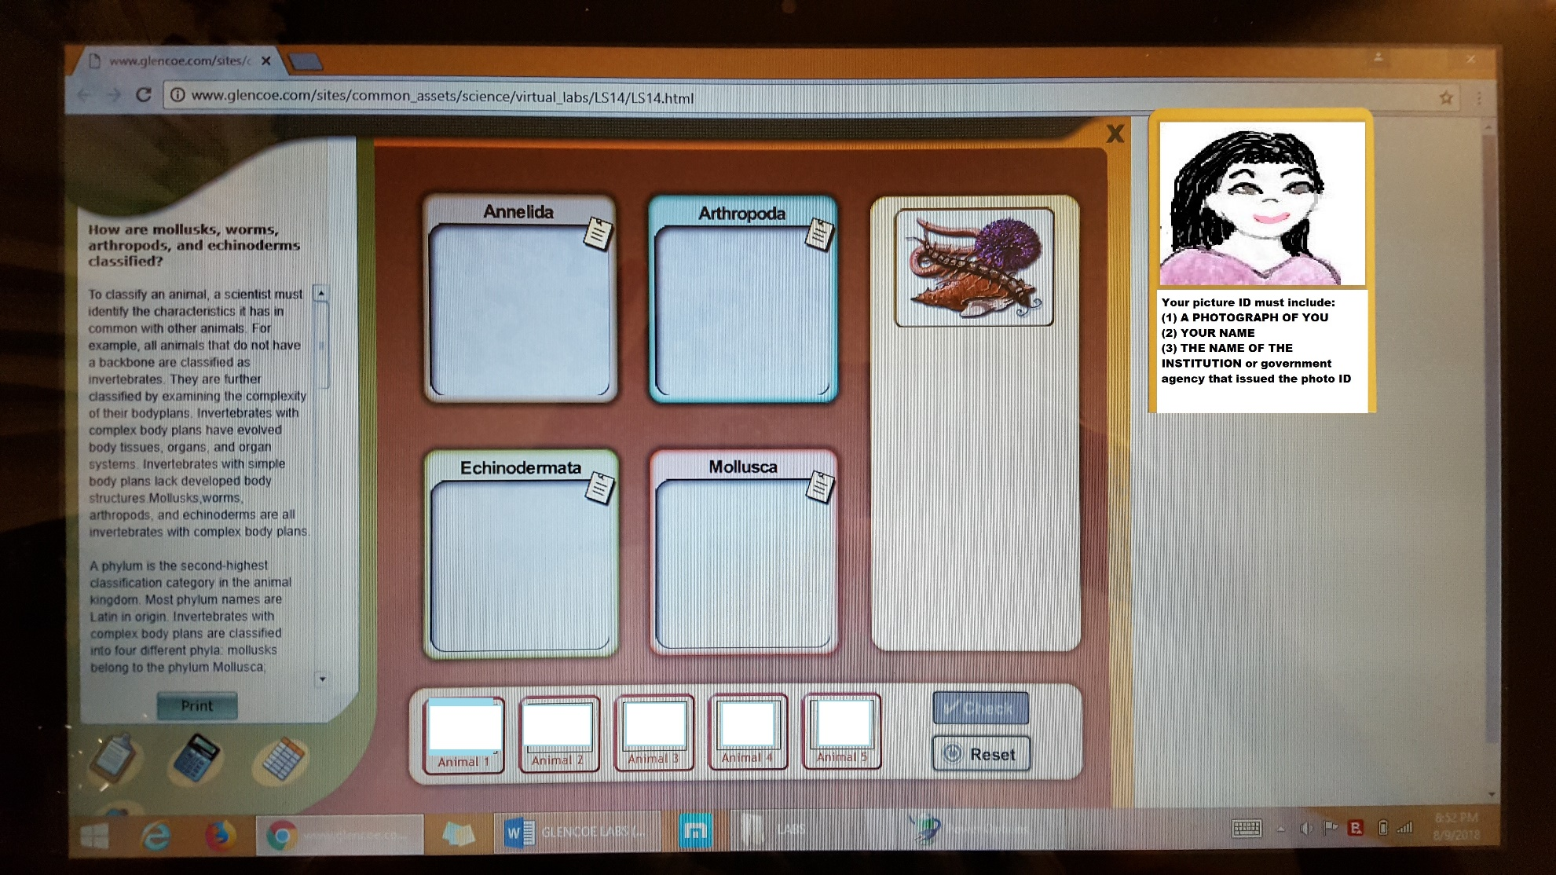

Insert your right-side up legible picture of your computer screen with your correctly sorted animals and your picture ID on the right of the computer screen in the designated box below. This step is required to get credit for the lab. Labs submitted without this step will receive a ZERO.

8. Table: When you have correctly classified the five animals, record the animal’s name, phylum, and phylum characteristics in the table.
Animal | Common Name | Phylum | Animal Observations and Characteristics
1
2
3
4
5
Complete the Journal Questions: List the general characteristics for the following phyla:
1.Phylum Mollusca:

2. Phylum Annelida:

3. Phylum Arthropoda:

4. Phylum Echinodermata:

5. Of the four invertebrate phyla in this Virtual Lab, which do you think are more closely related? Why?

Resources were modified from the Glencoe Virtual Lab for use in this lab.
How are mollusks, worms, arthropods, and echinoderms classified? - classification exercise, group organisms
This work is licensed under a Creative Commons Attribution-NonCommercial-ShareAlike 4.0 International License.

Lab Part 2: Introduction to Annelids and Mollusks
Annelid Notes – Biology Corner https://www.biologycorner.com/bio1/notes_annelids.html
Mollusk Notes – Biology Corner https://www.biologycorner.com/bio1/notes_mollusks.html
Unit 14 - Annelids, Mollusks, and Arthropods VanceBiology 19.49 min
VanceBiology
Objectives:
- What are Annelids?
- What are Mollusks?
- Identify and give the functions of the structures and tissues of annelids and mollusks.
- Match the organisms to their correct phylum and class.
Introduction from Biology Corner
Direct your browsers to the links above in the order they are listed. Read the information, watch the videos or slides, take notes, and study the information in each link.

Direct your browser to the Virtual Lab Earthworm Dissection Glencoe McGraw Hill website below.
http://glencoe.mheducation.com/sites/dl/free/0078802849/383950/BL_14.html Virtual Lab Earthworm Dissection
The instructions for the lab are listed on the right side of the screen and the labeling procedures below. Carefully read and follow those instructions while you work through the lab. Read the sections in the Lab Manual, practice labeling the earthworm in the lab, check your work and match the indicated earthworm structures to their names below the diagram on this lab sheet.

Earthworm Anatomy –
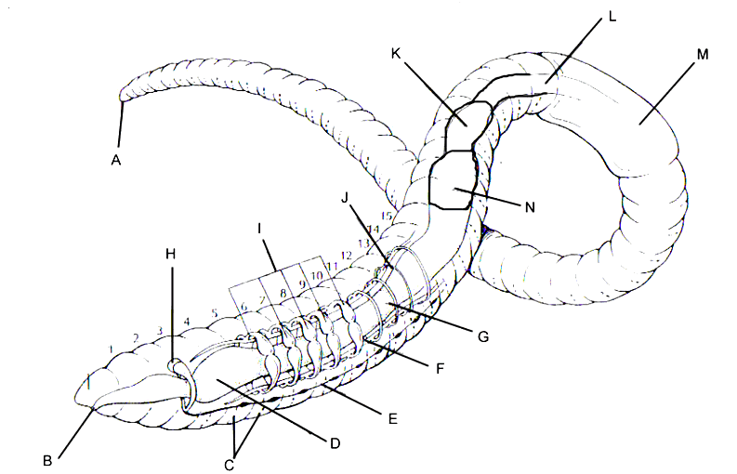

Insert the names of the indicated earthworm structures above by typing their names in the spaces by the corresponding letter of the structures below: (gizzard, aortic arches, clitellum, pharynx, brain, esophagus, dorsal blood vessel, ventral blood vessel, anus, crop, mouth, setae, ventral nerve cord, intestine)
A. _________________________ F. __________________________ K. ___________________________
B. _________________________ G. __________________________ L. ___________________________
C. _________________________ H. __________________________ M. ___________________________
D. _________________________ I. ___________________________ N. ___________________________
E. _________________________ J. ___________________________
Publisher: Biologycorner.com; Resources from Biology Corner were modified for use in this lab.
This work is licensed under a Creative Commons Attribution-NonCommercial-ShareAlike 4.0 International License.

1.Give the function of the following earthworm structures or organs:
Gizzard

Aortic arches

Clitellum

Pharynx

Brain

Anus

Crop

Setae

Intestine

2. Give an example and describe the three main groups of annelids below:
Class Oligochaeta:

Class Hirudinea:

Class Polychaeta:

Publisher: Biologycorner.com; Modified from Biology Corner
This work is licensed under a Creative Commons Attribution-NonCommercial-ShareAlike 4.0 International License.

Comparing Mollusks Chart

Using what you know about the three major classes of mollusks, complete the chart below by putting an “X” in the correct column or columns for each characteristic.
Characteristic | Type of Mollusk
 | Gastropods | Bivalves | Cephalopods
1. Intelligent, well developed nervous system
2. Has no distinct head
3. Has an open circulatory system
4. External shells present in some species
5. Bite prey with beak
6. Uses gills for both respiration and food collection
7. All species are carnivorous predators
8. Uses a radula for feeding
9. Can change color for camouflage
10. Can form pearls
11. Use a type of jet propulsion for movement
12. Has bilateral symmetry
13. Has a two part hinged shell
14. Is an invertebrate
15. Some species are venomous
Publisher: Biologycorner.com; Resources for this lab are from Biology Corner.
This work is licensed under a Creative Commons Attribution-NonCommercial 3.0 Unported License.

