Module 7 Lab:

Name:___________________________________________ Date:_____________________
This report is my original work.

Module 7 Lab

Part 1: How are arthropods classified?
https://www.biologycorner.com/bio1/notes_arthropods.html Arthropod Notes - Biology Corner
http://glencoe.mheducation.com/sites/dl/free/0078802849/383951/BL_18.html - How are arthropods classified? Glencoe Virtual Lab
Introduction: How are Arthropods Classified?
In this investigation you will compare and contrast characteristics among the five classes of arthropods. You will also classify various species of arthropods into one of the five classes based on examination of anatomical characteristics. Arthropoda is the most diverse animal phylum. Two out of every three animals living on Earth today are arthropods.
Arthropods thrive in a wide variety of habitats. They can be found deep in the ocean, high in the mountains, in polar regions, in the tropics, and just about everywhere in between. They are adapted to living in air, on land, and in freshwater and saltwater environments.
Phylum Arthropod is divided into five classes: Arachnida, Chilopoda, Crustacea, Diplopoda, and Insecta. Arthropods can be identified as belonging to one of the five classes by examining their physical characteristics.
Objectives:
- Compare and contrast external anatomical characteristics among the five classes of arthropods.
- Classify selected species of arthropods as belonging to one of the five classes: Arachnida, Chilopoda, Crustacea, Diplopoda, or Insecta.
- Recognize the adaptive significance of particular arthropod characteristics.
Carefully read and follow the instructions in the procedure below while you perform, click, drag, and check work on the lab in the right side of the screen.
Procedure:
1. Direct your browser to the first link above. Carefully read and take notes on the Biology Corner Arthropod Notes.
2. Direct your browser to the second link above: How are arthropods classified? Glencoe Virtual Lab
Hold your picture ID on the upper right side of computer screen showing the start screen of this lab with the four arthropod specimen jars that were randomly assigned to you and take a picture of your computer screen clearly showing the names of the arthropods on the four specimen jars and your photo ID. (The example shows a picture ID on the right of the start screen of the lab). You may need to adjust your computer screen brightness (make it less bright) to get a good photo of your ID with the screen. Make sure the picture clearly shows the names on the specimen jars and your photo ID. Then save the picture to your computer. Rotate the picture (4 points) if it is not right-side up. Insert the right-side up legible picture of your computer screen with your four specimen jars and your picture ID on the right of the computer screen in the designated box below. This step is required to get credit for the lab. Labs submitted without this step will receive a ZERO.
Example: This example shows a picture of the lab start screen with the specimen names covered and a photo ID.
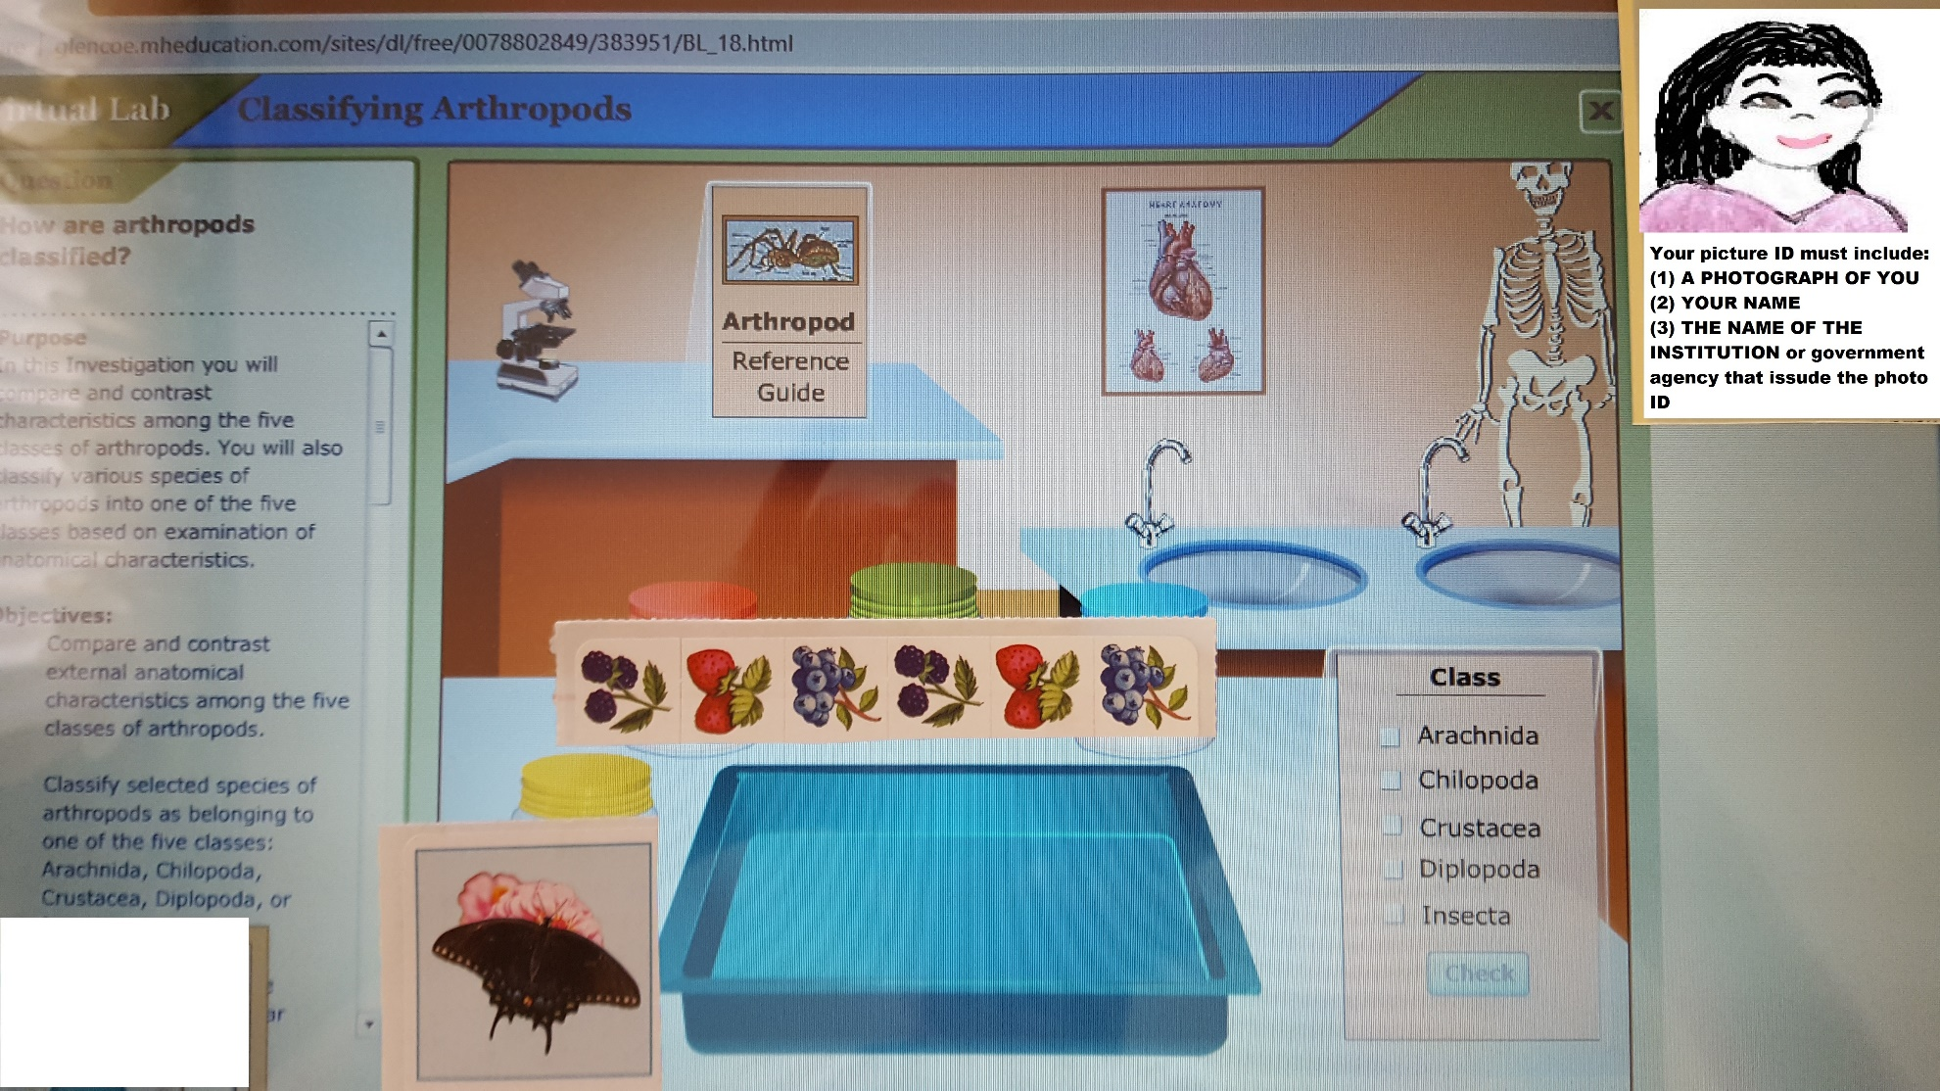

Insert the right-side up picture of your computer screen with your four specimen jars and your picture ID on the right of the computer screen in the designated box below:

Procedure: Follow each step of the Procedure completing the Table: Classification of Arthropods as you work through the activity.
Note: You will classify the four arthropods on the start screen in this investigation. The four specimens will be randomly assigned by the computer to the specimen containers.
3. List the scientific names of the specimens you were assigned in alphabetical order by scientific name in the scientific name column of the table. The scientific name is listed on each specimen jar.
4. Click on the Arthropod Reference Guide and read More Information to read general information about arthropods.
5. Select a specimen to examine by clicking on one of the specimen jars near the dissecting tray. Make sure you entered its scientific name in your table. The selected specimen will appear on the dissecting tray. Note: Arthropods on the dissecting tray are not necessarily drawn to scale.
6. Move the mouse pointer over the specimen and watch for highlights. If an area highlights as the mouse passes over it, click to see a detailed view of that area.
As you examine the specimen on the tray and collect information about the specimen’s physical characteristics, enter the information about the arthropod in the Table.
7. Click the Arthropod Reference Guide to get more information about each of the five classes of arthropods. The Reference Guide will open to the Table of Contents page.
Use the Table of Contents choices and the forward and back pointers to move between pages of the reference guide. There are five sections in the guide, one for each class. Each section has two pages. The first page contains text describing the characteristics of the selected class. The second page shows an illustration of a typical specimen from the selected class. Move the pointer over the illustration to see labels and descriptions of the different parts of a typical specimen. The illustration of a typical specimen will show you the names of typical structures for members of that class. Move back and forth between the arthropod on the tray and the typical specimen and fill in the appropriate chart sections. Note: Arachnids have pedipalps NOT pedipulps
8. Based on your examination for the selected specimen and your review of the Arthropod Reference Guide, decide which class the selected specimen belongs to. Select the Class button that corresponds to your guess, and then click Check. When you correctly identify the class of the arthropod and check your answer, the common name will appear under the tray.
9. Then list the common name of the arthropod in the space under its scientific name in the table. Go back to the Arthropod Reference Guide Description and Typical Specimen to help you check and fill out the other sections of the table for the class of each organism before you go to the next specimen.
10. Repeat the process for each of the four specimens.
11. Answer the journal questions.

Table: Classification of Arthropods
Scientific Name  Common Name | Class | Body Section Names and Number (1, 2, 3, >3) | Number of Walking Legs  (6, 8, > 8) | Number of Antennae (0, 2, or 4) | Claws Present?  (Yes or No) | Other Appendages, Eyes, or Structures?  (If so, give names of the appendages, eyes, or structures ) | Mouthparts  Present?  (Mandibles, Chelicerae, Pedipalps, Pincers, or other)
Journal Questions:
1.Many species of arachnids are predators, but have no teeth or jaws. How do they obtain nutrients from their prey?

2. Arthropods are the most diverse group of animals. Describe some characteristics of arthropods that may have contributed to their great evolutionary success.

3. What are some advantages and disadvantages of having an exoskeleton?

4. Which of the five classes of arthropods is the most diverse? Explain.

5. For each of the following characteristics, indicate below whether the trait is common to Phylum Arthropoda or specific to certain classes of arthropods: wings, chewing mouthparts, jointed appendages, number of legs, segmented bodies, type of respiratory structure, exoskeleton.
List of traits common to all animals in Phylum Arthropoda:

List of traits specific to only certain arthropod classes:

Virtual Labs Created by Glencoe resources were modified for use in this lab.

This work is licensed under a Creative Commons Attribution-NonCommercial-ShareAlike 4.0 International License.
Lab Part 2: Introduction to Flatworms and Roundworms
Flatworm notes (The Biology Corner)
Phylum Platyhelminthes (Lumen Learning)
Roundworm notes (The Biology Corner)
Phylum Nematoda (Lumen Learning)
Unit 14 - Platyhelminthes & Nematodes Vanita Vance 8.24 min
Objectives:
- What are flatworms?
- What are roundworms?
- Identify and give the functions of the structures and tissues of flatworms and roundworms.
- Identify parasitic worm diseases, symptoms, and modes of transmission.
Direct your browsers to the links above in the order they are listed. Read the information, watch the videos or slides, take notes, and study the information in each link.
The instructions for the lab are listed in the procedures below. Carefully read and follow those instructions while you work through the lab.
Introduction from Biology Corner
FLATWORMS https://www.biologycorner.com/worksheets/dragonfly/27-1_flatworms.html
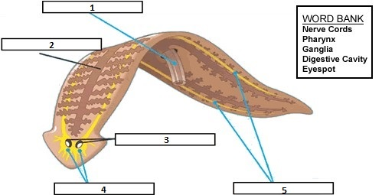

Procedure 1. Observe the flatworm diagram above and type the letter of the term in the blank next to its matching description.
- Nerve Cords
- Pharynx
- Ganglia
- Digestive Cavity
- Eyespot
_____1. The pinkish, tubular structure in the center of the ventral surface of the worm connected by a single blue line to a box in the upper left corner of the diagram.
_____2. The brown branched structure connected by one black line to the second box down from the upper left corner of the diagram.
_____3. The two oval shaped black and white structures connected by two black lines to a box near the lower center of the diagram
_____4. The bright yellow structure connected by two blue lines to the box in the lower left corner of the diagram.
_____5. The two, long, bright yellow structures connected by two blue lines to the box in the lower right corner of the diagram.
Biology Corner resources were modified for use in this lab.
This work is licensed under a Creative Commons Attribution-NonCommercial-ShareAlike 4.0 International License

ROUNDWORMS https://www.biologycorner.com/worksheets/dragonfly/27-2_roundworms.html
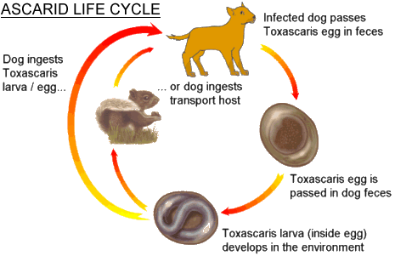
Procedure 2. Use your flatworm and roundworm notes and the figure above to answer the following questions:
Ascarid Questions:
1. How are the eggs released from the host’s body?

2. How do the worms get back into the host animals (dogs, people, etc.)?

Tapeworm Questions:
3. Give the name and describe the anterior end of an adult tapeworm.

4. What are proglottids?

5. How are tapeworm zygotes released from the host’s body?

Journal Questions:
1. What type(s) of symmetry do flatworms and roundworms have?

2. The muscular tube near the mouth of a flatworm that aids in getting food is called the

3. What are ganglia?

4. What structures detect light in some flatworms?

5. What are hermaphrodites?

Biology Corner resources were modified for use in this lab.
This work is licensed under a Creative Commons Attribution-NonCommercial-ShareAlike 4.0 International License
Procedure 3. Complete the table below for any five of the ten worms listed (Ascaris or Roundworms, Filarial Worms, Flukes, Hookworms, Pinworms or Threadworms, Planaria, Soil Nematodes, Tapeworms, Trichinella Worms, Turbellarians)
Worm Name | Phylum | Free Living or  Name of Disease | Route of Infection | Disease Description or Symptoms
Biology Corner resources were modified for use in this lab.
This work is licensed under a Creative Commons Attribution-NonCommercial-ShareAlike 4.0 International License
When you are finished with your lab, save it as a pdf and upload to the Lab 7 Assignment Link in Canvas.

