Module 6 Lab:

Name:___________________________________________ Date:_____________________
This report is my original work.

Module 6 Lab
Part 1: Introduction to Animals: Sponges and Cnidarians
15.2 Sponges and Cnidarians notes (Concepts of Biology)
Introduction to the Animal Kingdom notes (The Biology Corner)
Sponges and Cnidarians notes (The Biology Corner)
Sponges & Cnidaria VanceBiology 12.57 min
Objectives:
- What are animals?
- What are sponges and cnidarians?
- Identify and give the functions of the structures and tissues of sponges and cnidarians.
Direct your browsers to the links above in the order they are listed. Read and study the information in each link.
The instructions for the lab are listed in the procedure below. Carefully read and follow those instructions while you work through the lab.
Introduction from Biology Corner Sponges: Read and take notes on the complete introduction below before you start the procedure.
Since sponges look like plants, it is understandable why early biologists thought they were plants. Today, we know that sponges are simple, multicellular animals in the Kingdom Animalia, Phylum Porifera. This phylum is thought to represent the transition from unicellular animals to multicellular animals. Most (but not all) sponges are asymmetrical and have no definite shape. Sponges, like all animals, are eukaryotic - meaning their cells have a nucleus. Porifera in Latin means "pore-bearer" and refers to the many pores or openings in these animals. Because of these pores, a sponge can soak up and release water. At one time, real sponges were used for cleaning and bathing. Today, most are artificially made.
All adult sponges are sessile, meaning they are attached to some surface. Since they cannot move, sponges cannot pursue their food. Instead, they are filter feeders, meaning they obtain their food by straining the water for small bits of food like bacteria, algae or protozoans.
Sponges exhibit less specialization (adaptation of a cell for a particular function) of cells than most invertebrates. The primitive structure of a sponge consists of only two layers of cells separated by a non-living jelly like substance. The outer layer of the sponge is made up of flat epithelial-like cells called pinacocytes.
The inner layer consists of collar cells whose function is to circulate water through the sponge. They do this by swishing their flagella which pulls water through the incurrent pore - water then travels out the osculum at the top of the sponge. As water passes through the sponge in this way, cells absorb food and oxygen and waste is excreted.
In the jelly-like substance between the epidermis and the collar cells are cells called amoebocytes - because they look like amoebas. The job of the amoebocytes is to travel around distributing food and oxygen to the cells of the epidermis. Because of the amoebocytes, scientists believe that sponges evolved from protists.
The body of the sponge would collapse if it did not have some type of supporting structure. Some sponges have a soft network of protein fibers called spongin. Others have tiny, hard particles called spicules. Many of these spicules also stick out of the epidermis and provide the sponge with protection. Most sponges have a combination of spicules and spongin, the ratio often determines how soft or hard the sponge is.
Reproduction for sponges can be accomplished both sexually and asexually. There are three ways for a sponge to reproduce asexually: budding, gemmules, and regeneration. Sponges can simply reproduce by budding, where a new sponge grows from older ones and eventually break off. Sponges can also reproduce by regeneration, where missing body parts are regrown. People who harvest sponges often take advantage of this by breaking off pieces of their catch and throwing them back in the water, to be harvested later. Finally, sponges can reproduce by creating gemmules - which is a group of amoebocytes covered by a hard outer covering.
Sexual reproduction occurs when one sponge releases sperm into the water. This sperm travels to another sponge and fertilizes its eggs. The larva form will then swim to another location using its flagella where it will grow into an adult sponge. Most sponge species are hermaphrodites, they can produce both eggs and sperm. Biology Corner resources were modified for use in this lab.
Publisher: Biologycorner.com;
This work is licensed under a Creative Commons Attribution-NonCommercial 3.0 Unported License.

Procedure: Match the letters on the SPONGE diagram (the first diagram below) to the corresponding sponge structures listed below:
Put the corresponding letter from the sponge diagram in the space to the right of the name of the indicated structure.
Adult Sponge Amoebocyte Osculum Choanocyte (collar cell) Pinacocytes
Gemmule Spicule Bud Ostia (incurrent pore)
Procedure: Match the letters on the HYDRA diagram (the second diagram below) to the corresponding hydra structures listed below:
Put the corresponding letter from the hydra diagram in the space to the right of the name of the indicated structure.

Gastrovascular cavity Tentacle Cnidocyte Ectoderm

Endoderm Mesoglea Ovary/Teste Bud
Nematocyst Mouth Basal Disk

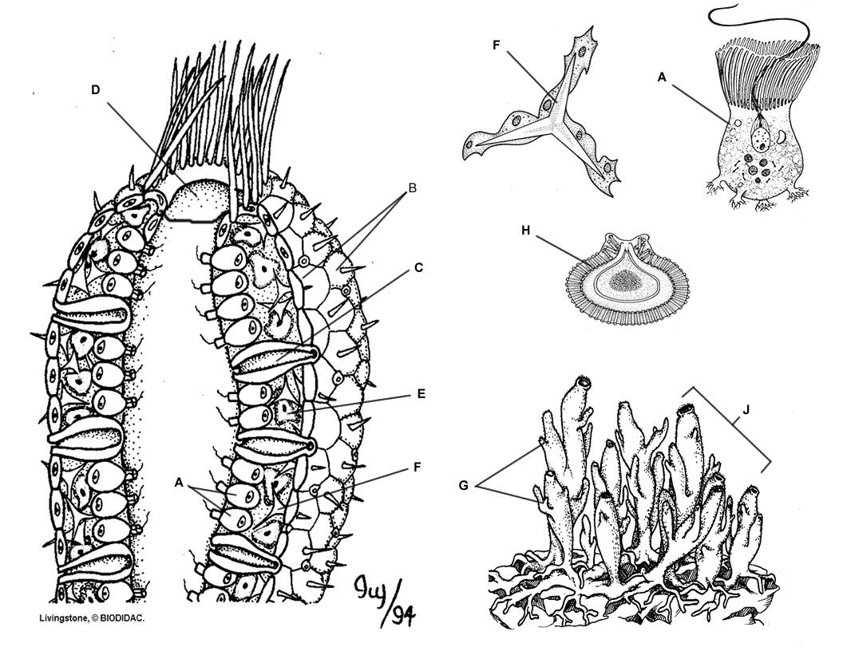
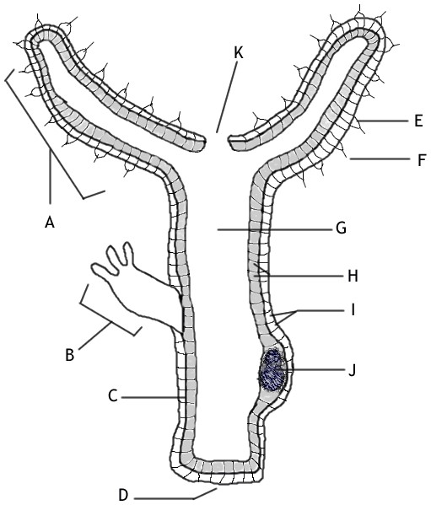Publisher: Biologycorner.com;
This work is licensed under a Creative Commons Attribution-NonCommercial 3.0 Unported License.
Read the introduction to the lab and click on this link to watch the Sponges & Cnidaria VanceBiology 12.57 min and
Cnidarians 14.43 minutes Then answer the questions below:
1. List the phylum for sponges ___________________ and cnidarians _____________________ .
2. What does it mean to be sessile? _____________________________________________________________ .
3. What structure helps circulate water through the sponge? _______________________________________.
4. What two substances give a sponge support? ___________________________ and _____________________________________.
5. What is a gemmule? _______________________________________________________________________________________ .
Watch the Video: Cnidarians Sponges & Cnidaria VanceBiology 12.57 min and Cnidarians 14.43 minutes and answer the questions below:

Questions:
1. Describe how an anemone moves and consumes food.
2. Which probably came first: sponges or cnidarians?

3. Describe how two anemones would fight each other over a section of rock.

4. Which animals are dominant in the deep sea?

5. How does the Stomphia anemone avoid being eaten by a sea star?

Publisher: Biologycorner.com; Biology Corner resources were modified for use in this lab.
This work is licensed under a Creative Commons Attribution-NonCommercial 3.0 Unported License.
https://www.biologycorner.com/worksheets/hydra_anatomy.html

Lab Part 2: Introduction to Animals: How do sponges, cnidarians, flatworms, and roundworms obtain food?
Introduction to the Animal Kingdom notes (Biology Corner)
How do sponges, cnidarians, flatworms, and roundworms obtain food? - explore a reef Glencoe Virtual Labs
Objectives:
- What are animals?
- Identify the feeding systems of sponges, cnidarians, flatworms, and roundworms.
- Determine how the bodies of sponges, cnidarians, flatworms, and roundworms are suited to specific methods of obtaining food.
Direct your browser to the first link above. Read and study the information.
Direct your browser to the second link above.
The instructions for the lab are listed in the procedure below. Carefully read and follow those instructions while you work through the lab on the right side of the screen.
Introduction: Read and take notes on the Introduction to Animals.
Procedure: Follow each step of the Procedure below completing Table 1 as you work through the activity.
(Procedure Step 3 is required to get credit for this lab. Labs submitted without procedure 3 will receive a ZERO.)
Introduction to Animals: How do sponges, cnidarians, flatworms, and roundworms obtain food?
An animal is a many-celled eukaryotic organism that must find and digest its own food. To classify an animal, a scientist first determines if it has a backbone. Animals with backbones are vertebrates, and animals without backbones are invertebrates. About 97 percent of all animal species are invertebrates. The earliest animals were invertebrates found in warm, shallow water that covered most of Earth's surface. These invertebrates had simple body plans, lived in water, and obtained most of their food, oxygen, and other materials directly from their surroundings. Invertebrates with simple body plans, such as sponges, cnidarians, flatworms, and roundworms, still exist. This indicates that these organisms have successfully adapted to their environment. In this Virtual Lab you will investigate invertebrates with simple body plans in a coral reef habitat. You will examine how sponges, cnidarians, flatworms, and roundworms obtain food.
Procedure: Follow each step of the Procedure completing the Table as you work through the activity.
1. Click the Video button. Watch the video to learn about coral reefs.
2. Move the cursor over the coral reef and discover coral reef invertebrates with simple body plans. Note: Some invertebrates live inside the bodies of vertebrates.
3. Click on an organism to see a closer view. Hold your picture ID on the upper right side of computer screen showing the first organism you chose and take a picture of the organism and your photo ID. (The example shows a picture ID on the right of the start screen of the lab). You may need to adjust your computer screen brightness (make it less bright) to get a good photo of your ID with the screen. Make sure the picture clearly shows the animal, the information on the screen, and your photo ID. Then save the picture to your computer. Rotate the picture if it is not right-side up. Insert the right-side up picture of your computer screen with your first lab animal and your picture ID on the right of the computer screen in the designated box below. This step is required to get credit for the lab. Labs submitted without this step will receive a ZERO.
Example: The example shows a picture of the lab start screen with a photo ID.
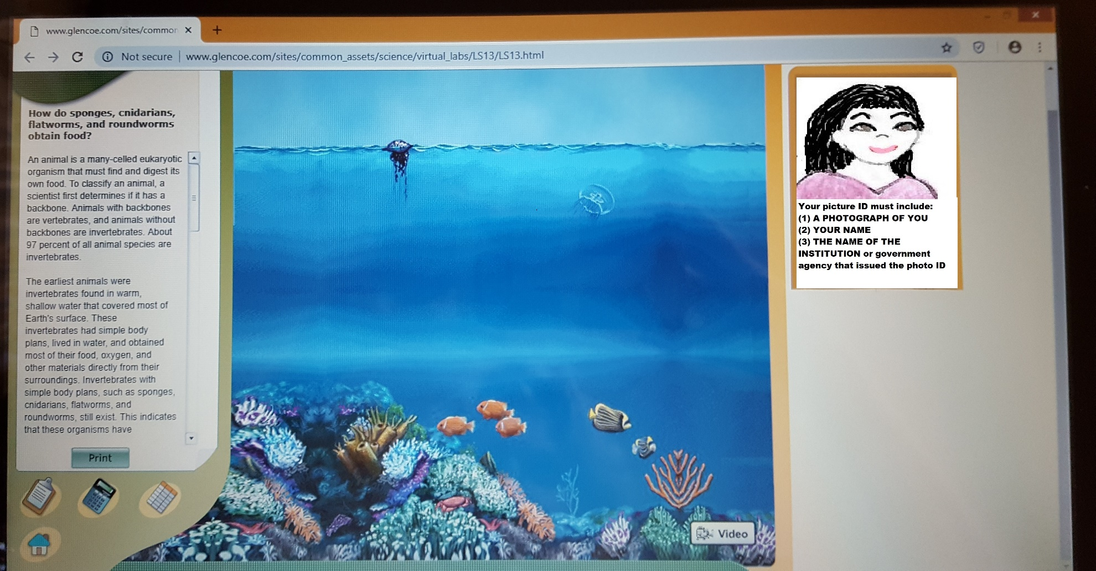

Insert a legible right-side up picture of your computer screen with your first lab animal and your picture ID on the right of the computer screen in the designated box below. This step is required to get credit for the lab. Labs submitted without this step will receive a ZERO.

4. Observe the animal (and the animation or picture of the feeding system of the invertebrate on the lab screen if available) and enter its name in the table below. Then go to YouTube at YouTube.com and search for a short video (less than 5 minutes long) showing the animal you clicked on feeding. Enter the title of the YouTube video and enter its URL under the title in the same box as the title in the table. Example: I searched for “sand striker worm feeding “and entered the information in this table:
 | NAME OF ORGANISM | TYPE OF FEEDER | YouTube Title  YouTube URL
1 | Sand Striker (bobbit worm) | Predator | This Terrifying Worm Snatches Fish from the Ocean Floor https://www.youtube.com/watch?v=K_7ByiYbCYM
5. Click one of the Types of Feeders information tabs to get a general description of how predators, scavengers, parasites, or filter-feeders obtain food. Repeat this step with the remaining Types of Feeders information tabs.
Compare the type of feeders described in the information tabs to the type of feeder displayed in the animation, picture and/or the YouTube you found.
6. Identify the type of feeder for your first invertebrate. Record your data in the Table.
7. Click the Coral Reef button to return to the coral reef. Repeat the Virtual Lab until you have investigated five invertebrates.

 | NAME OF ORGANISM | TYPE OF FEEDER | YouTube Title  YouTube URL
1
2
3
4
5
8. Complete the Journal questions.
Question 1: Describe each of the four types of feeders identified in this activity. Explain how various invertebrates have adapted to feeding in their environment.

Question 2: Early scientists classified sponges as plants. Based on your observations of the sponge's feeding system, why do you think scientists now classify sponges as animals?

Question 3: Jellyfish cannot swim rapidly, yet they are efficient predators. How are they adapted to predatory life despite their lack of speed?

Question 4: Why are scavengers usually found in the lower part of the coral reef habitat?

Question 5: How do internal parasites keep from being washed out of their host's bodies in body fluids or wastes?

Virtual Labs Created by Glencoe resources were modified for use in this lab.

This work is licensed under a Creative Commons Attribution-NonCommercial-ShareAlike 4.0 International License.

