Module 5 Lab

Name:___________________________________________ Date:_____________________
This report is my original work.
Module 5 Lab
Part 1: What are the functions of the parts of a flower: Identify and give the functions of the parts of a flower.
http://www.glencoe.com/sites/common_assets/science/virtual_labs/LS11/LS11.html
In this Virtual Lab you will identify the parts of a flower and examine their roles in the processes of pollination and fertilization. What are the functions of the parts of a flower? - labeling exercise
Objectives:
Identify the main parts of a flower and the functions of each.
Identify the overall function of flowers.
Describe the processes of pollination and fertilization in a flowering plant.
Direct your browser to the link above. The instructions for the lab are in the white panel on the left side of the screen. Carefully read and follow those instructions while you perform, click, drag, and check work on the lab in the right side of the screen.
Introduction: Read and take notes on the complete introduction covering the parts of a flower and their functions before you start the procedure. Use your notes from the 14.4 Seed Plants: Angiosperms
chapter of your Concepts of Biology textbook.
Procedure: Follow each step of the procedure and answer the journal questions.
(Procedure Step 6 is required to get credit for this lab. Labs submitted without procedure 6 will receive a ZERO.)
1. To select a blossom to investigate, click the Cherry Blossom or Orange Blossom button and enter the name of the flower in the space above the table.
2. Click the Magnified Part up and down arrows to choose a flower part to identify.
3. Determine the name of the darker colored area on the selected flower part. Click the Name up and down arrows to select the name.
4. Determine the function of the selected flower part. Click the Description/Function up and down arrows, and select the description/function.
5. Move the cursor over the flower. Click the location where you think the selected part belongs (You may need to move your cursor to another area showing the same structure to get it to show that it is correct on the anther and filaments. They show up on the left side of the flower.)
If the selected flower part's name, description/function, and location on the flower are correct, the flower part will color in and its label will appear. Enter the description and function in the table below in the spaces to the right of the flower part.
If the selected flower part's name, description/function, and/or location on the flower are incorrect, reexamine your selections and try again.
6. When ALL parts of the flower have been correctly identified, click the labels to review the information about each part. Check to be sure your entries in the Table for the description and function of each flower part are correct. Take a picture of your computer screen with your photo ID when you have ALL parts of the flower you chose CORRECTLY identified. The photo should CLEARLY show the flower with all its parts labeled and your photo ID in the upper right corner of the screen. This step is required to get credit for this lab. Labs submitted without this step will receive a ZERO. The example picture shows the screen with a flower, a flower part and a description (not necessarily correct), and a photo ID. (Click on the example picture if you can’t see it.)
Example
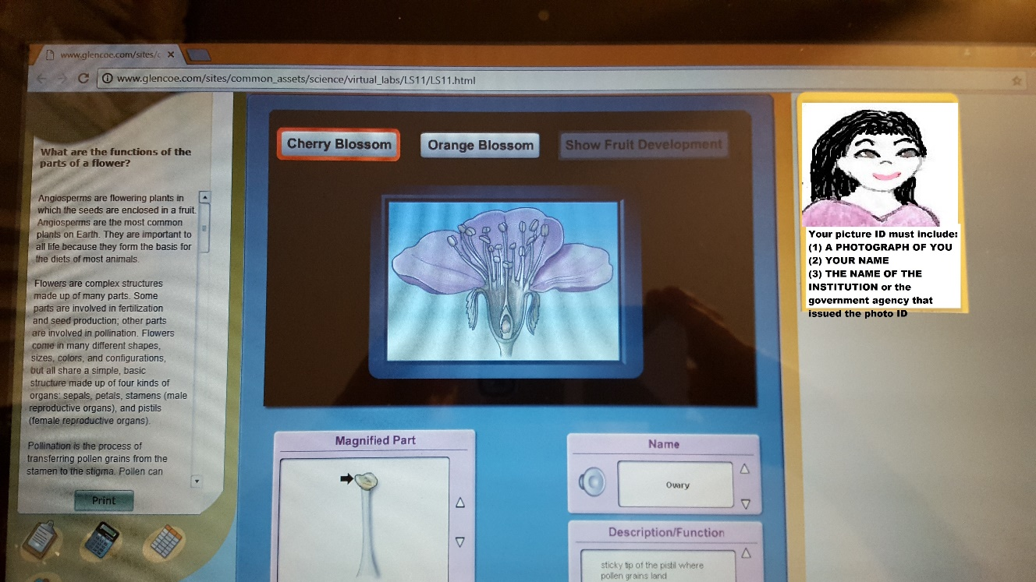

Insert the picture of your computer screen with all the parts of the flower you chose CORRECTLY identified and your photo ID on the right side of your computer screen. Your photo should fill the blue space below as much as possible without being distorted and be oriented like the photo above.

FLOWER PART TABLE: Which flower did you select:______________________________________
Name of Flower Part | Description | Function
Stigma
Style
Ovule(s)
Ovary
Pistil
Anther
Filament
Stamen
Petals
Sepal
7. Click the Show Fruit Development button to observe how the flower develops into a fruit.
8. Complete the Journal questions.
Journal: Measurement: What are the functions of the parts of a flower?
Question 1: Which parts of the flowers are important in pollination? Describe their role in the process.

Question 2: Which parts of the flower are involved in fertilization and fruit development?

Question 3: Many types of flowers produces fruits that are fragrant and sweet tasting. Describe how these characteristics of fruits may be important for dispersal.

Question 4: Many types of flower are brightly colored, fragrant and produce sweet nectar. Describe how these characteristics affect the process of pollination.

Question 5: Most species of plants produce flowers containing both stamen and pistils. Why is producing flowers with both male and female reproductive structure an advantage for the plant?

Virtual Labs Created by Glencoe resources were modified for use in this lab.

This work is licensed under a Creative Commons Attribution-NonCommercial-ShareAlike 4.0 International License.
Part 2: Plant Organs / Scientific Keys: In this part of the lab you will be using a scientific key to identify trees by the characteristics of their leaves. A leaf is a plant organ.
Direct your browser to and go over the following resources before you begin this lab:
Useful information for identifying trees from the American Museum of Natural History:
Leaf Arrangement, Leaf Type, Types of Compound Leaves, Leaf Shape, Leaf Margins
Identifying the Trees https://www.biologycorner.com/bio2/notes_tree.html provides leaf description information including leaf arrangements, shapes, and margins.
Go over this information on Leaf Identification from the Missouri Botanical Garden
http://www.mbgnet.net/sets/temp/lftypes.htm and http://www.mbgnet.net/sets/temp/lftypes2.htm (You are not responsible for all the botanical terms on this website, but you are responsible for the botanical terms used in the actual lab key to identify trees.)
Biology Dictionary https://biologydictionary.net/dichotomous-key#ftoc-dichotomous-key-definition provides a definition and information on scientific keys.
Publicly available examples of dichotomous keys can be found here:
Trees of the Pacific Northwest
Amoeba Sisters Dichotomous Key
Mark Drollinger Bird Key
Oregon State University http://oregonstate.edu/trees/dichotomous_key.html provides more information about dichotomous keys and how to use them.
Objectives:
- List and describe plant organs and systems.
- What are scientific keys and how are they used?
- List other characteristics of trees that could be used to identify them.
A scientific key is an instrument used to identify organisms that uses steps with two choices. Each step narrows the range of characteristics until a final choice can be made.
In this lab you will use the leaves of trees and a Key to Trees (using leaves). There are eleven steps in this key with two choices in each step. Step 1 choices are 1A or 1B. Step 2 choices are 2A or 2B, etc.
Procedure:
1. Go to the TREE PICTURES PDF in Module 5 and pick out any TWO of the trees from the leaf pictures. You will use the KEY TO PLANTS USING LEAVES below to identify TWO of the trees from the leaf pictures.
2. Choose a tree and list the NUMBER ON THE PICTURE OF THE LEAF in the space below the key for your first tree. Use the KEY TO PLANTS USING LEAVES to identify the first tree you chose from the leaf pictures.
3. Then list the NUMBER and LETTER for each choice you make to reach the name of the tree in the space for that purpose.
4. Then list the SCIENTIFIC NAME of the tree in the space for the name of the tree.
Your answer should look something like this:
#16 1B, 7A, 14B Maka thea
_____________ ____________________________________ _______________________
Number on Tree Picture Number and Letter of Steps Chosen Name of Tree
5. Choose a second tree and repeat steps 2 – 4.
KEY TO PLANTS USING LEAVES
(Chris Haynes, Biology Instructor, Shelton State Community College*)
1A. Leaves needlelike or scalelike………………………………………………………….…2
1B. Leaves broad with flattened blade, not needlelike or scalelike………………………..7
2A. Leaves scalelike……………………………………………………..Juniperus virginiana.
2B. Leaves needlelike…………………………………………………………………………..3
3A. Needles twisted, 4 inches or less in length Pinus virginiana
3B. Needles straight-not twisted, 4 inches long or longer. 4
4A. Needles 4 to 10 inches long 5
4B. Needles 12 inches or longer Pinus palustris
5A. Needles in clusters of three only Plnus taeda

5B. Needles in clusters of three and two on the same tree 6
6A. Needles mainly 4 to 6 inches long Pinus echinata
6B. Needles mainly 6 to 10 inches long Pinus elliotti
7A, Leaves divided into multiple leaflets .…………………………………………………... 8
7B. Leaves composed of one complete blade, no leaflets 9
8A. Leaves with 5 to 7 leaflets …………………………….. Carya ovata
8B. Leaves with 9 or more leaflets ……………… .. Juglans nigra
9A. Leaf margin saw toothed…………………… ……………………………………………10
9B. Leaf margin smooth or entire 11
10A. Saw toothed margin composed of very fine teeth only, no large, deep notches……
........................................................................................ . Fagus grandifolia
10B. Saw toothed margin composed of very fine teeth on larger deep notches ………………………………………………………………………………….…..Acer rubrum
11A. Leaf very thick and tough, upper surface glossy …..Magnolia grandiflora.
11B. Leaf very thin and fragile, upper surface not glossy Cornus florida
*Used with permission from Chris Haynes

Your First Tree:

_____________ ____________________________________ _______________________
Number on Tree Picture Number and Letter of Steps Chosen Name of Tree

Your Second Tree:

_____________ ____________________________________ _______________________
Number on Tree Picture Number and Letter of Steps Chosen Name of Tree

- Complete the Journal Questions
Journal Questions:
- List and describe the plant organs.

- List and describe the plant systems.

- If you had to make a scientific key for identifying plants by their flowers, what characteristics would you use?

- List other characteristics that could be used to identify them.

- What does the term dichotomous mean?

When you are finished with your lab, save it as a pdf and upload to the Lab 5 Assignment Link in Canvas

