MODULE 4 LAB
Name:___________________________________________ Date:_____________________
This report is my original work.

Module 4 Lab
Seedless Vascular Plants: What is the life cycle of a simple plant? - label a chart/model showing a fern life cycle
http://www.glencoe.com/sites/common_assets/science/virtual_labs/LS10/LS10.html
In this Virtual Lab you will investigate an alternation-of-generations life cycle by sequencing eight stages in the life cycle of a fern plant.
Objectives:
‡ Describe the life cycle of a fern plant.
‡ Define an alternation-of-generations life cycle.
‡ Sequence stages and events in the life cycle of a fern plant.
Direct your browser to the link above. The instructions for the lab are in the white panel on the left side of the screen. Carefully read and follow those instructions while you perform, click, drag, and check work on the lab in the right side of the screen.
Introduction: Read and take notes on the complete introduction covering the fern life cycle in the panel on the left of your screen before you start the procedure. Use your notes from the 14.1 The Plant Kingdom chapter of your Concepts of Biology textbook.
Procedure Step 6 is required to get credit for this lab. Labs submitted without procedure 6 will receive a ZERO. Take a photo of your computer screen with your picture ID when you have correctly completed the fern life cycle. The photo should show the fern life cycle and your ID in the upper right corner of the screen.

Procedure: Follow each step of the procedure and answer the journal questions.
1. Drag one of the eight images of stages in the fern life cycle to the Fern Life Cycle display area (upper right side of the screen). Observe the name, image, and description of the stage.
2. Click the Hear button to hear additional information about the stage in the fern life cycle. Watch the animations that play for the following stages: Release of Spores, Spore Germination, and Fertilization.
3. Sequence the stage in the life cycle of a fern plant by dragging the image of the stage to an empty space in the circular sequencing area.
4. Repeat the first three steps of the procedure with the remaining stages. When sequencing the rest of the stages, think about what stages happen before and after the stage you are trying to sequence.
5. Click the Check button to check your work after you have sequenced all eight stages in the fern life cycle. If a stage is sequenced incorrectly, it is highlighted yellow. Reexamine an incorrectly sequenced stage by dragging it to the Fern Life Cycle display area. Then drag the stage to a different space in the sequencing area.
6. When all the stages are sequenced correctly, hold your picture ID on the right side of the computer screen and take a picture showing your ID on the right side of the computer screen with the correctly sequenced stages. (The example shows a picture ID on the start screen of the lab). You may need to adjust your computer screen brightness (make it less bright) to get a good photo of your ID with the screen. Then, insert the picture of your computer screen with lab results and your picture ID in the box below the example picture. Click on the example picture if you can’t see it clearly. This step is required to get credit for the lab. Labs submitted without this step will receive a ZERO.
Example
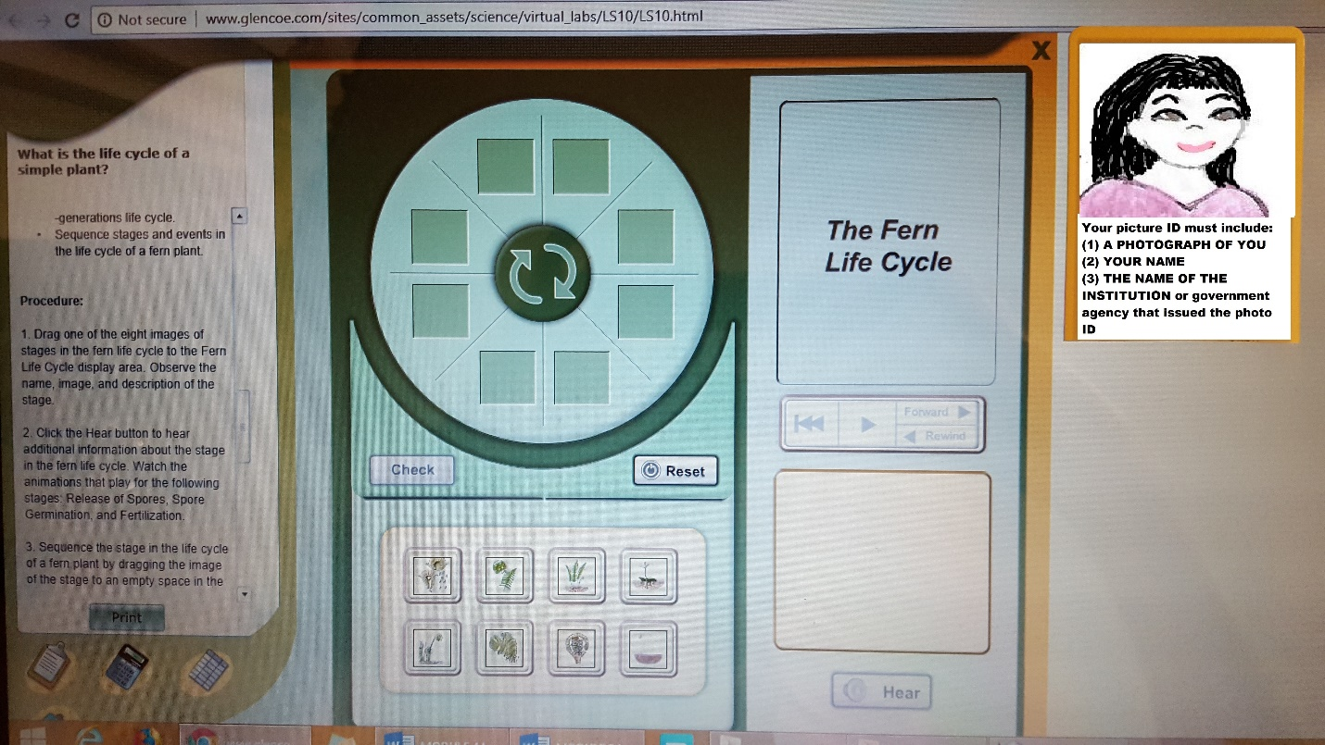

Insert the picture of your computer screen showing your ID on the right side of the computer screen with your correctly completed fern life cycle. Your photo should fill the blue space below as much as possible without being distorted.
Then view a complete slide show of the life cycle of a fern plant by clicking the Play button. Click the Pause button to pause at any stage. Click the Forward button to advance to the next stage; click the Back button to go back one stage; click the Rewind button to go back to the beginning of the slide show.
7. Complete the Journal Questions: Plants - What is the life cycle of a simple plant?
Question 1: What is meant by an alteration-of-generations life cycle?

Question 2: What is the main function of the mature gametophyte?

Question 3: What is the main function of the mature sporophyte?

Question 4: Discuss how a fern plant can reproduce both sexually and asexually.

Question 5: Based on what you know about fern reproduction, why do you think ferns tend to inhabit moist environments?

Question 6: List and describe the three surviving groups of seedless, nonvascular plants.

Question 7: List and describe the four groups of seedless, vascular plants.

Virtual Labs Created by Glencoe resources were modified for use in this lab.
resources were modified for use in this lab.
This work is licensed under a Creative Commons Attribution-NonCommercial-ShareAlike 4.0 International License.

When you are finished with your lab, save it as a pdf and upload to the Lab 4 Assignment Link in Canvas

