Module 3 Lab

Name:___________________________________________ Date:_____________________
This report is my original work.

Module 3 Lab
Protista / Fungi: How can microscopic protists and fungi be characterized? - observe and classify protists
http://www.glencoe.com/sites/common_assets/science/virtual_labs/LS09/LS09.html
Objectives:
Classify microscopic protists and fungi.
Compare and contrast animal-like, plant-like, and fungus-like protists as well as sac and zygote fungi.
Direct your browser to the link above. The instructions for the lab are in the white panel on the left side of the screen. Carefully read and follow those instructions while you perform, click, drag, and check work on the lab in the right side of the screen.
Introduction: Read and take notes on the complete introduction covering classification in the panel on the left of your screen before you start the procedure. Use your notes from the Protists and Fungi chapters of your Concepts of Biology textbook and your notes from the other readings and videos in the module.

Procedure: Follow each step of the Procedure completing the table and answering journal questions.
Procedure:
1. Click the Microscopic Slide Box to get a magnified view of a protist or fungus. Read the field notes to gather general information about the organism. Record the name of the organism in Table.
2. Click the Habitat button to gather information about the organism's habitat. Record the habitat information in Table 1. Once you have recorded the first organism’s scientific and common names and clicked on the habitat button in the lab, hold your picture ID on the computer screen and take a picture showing your ID on the right side of the computer screen with the FIRST ORGANISM you are classifying. Make sure your photo includes the magnified view of the organism on the slide by the microscope and the organism name and habitat information on the screen. (The example shows a picture ID on the start screen of the lab). You may need to adjust your computer screen brightness (make it less bright) to get a good photo of your ID with the screen. Then, insert the picture of your computer screen with lab results and your picture ID in the box below. This step is required to get credit for the lab. Labs submitted without this step will receive a ZERO.

Example
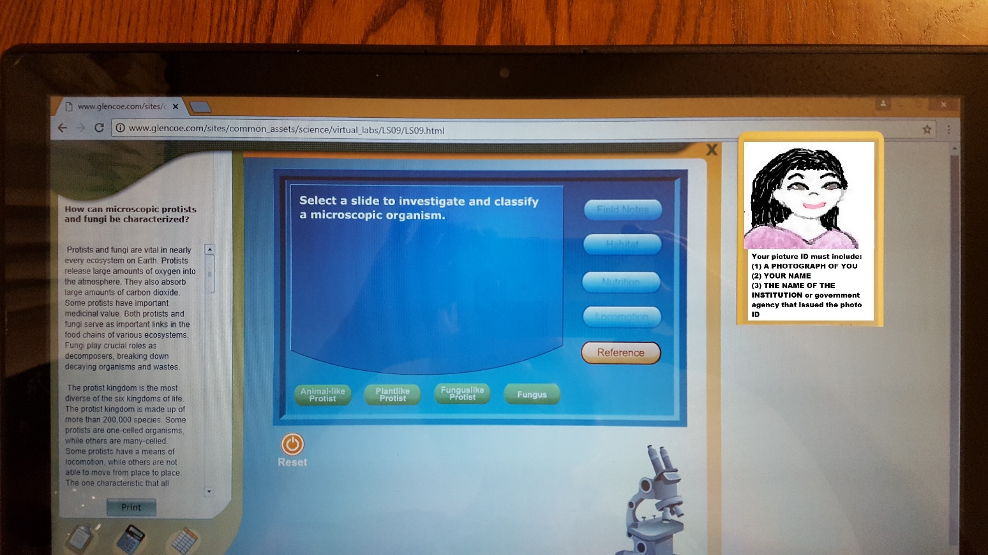

Insert the picture of your computer screen showing your ID on the right side of the computer screen with the FIRST ORGANISM you are classifying. Make sure your photo includes the magnified view of the organism on the slide by the microscope and the organism name and habitat information on the screen. Your photo should fill the blue space below as much as possible:

3. Click the Nutrition button to find out if the organism makes its own food or obtains it from another source. Record the nutrition information in the Table.
4. Click the Locomotion button to determine if the organism is able to move from place to place. Record the locomotion information in the Table.
5. Click the Reference button to examine information about animal-like protists, plant-like protists, fungus-like protists, and fungi.
6. Determine to which of the four groups the organism belongs. Click the appropriate button: Animal -like Protist, Plantlike Protist, Funguslike Protist, or Fungus.
If you correctly classified the organism, record the name of the classification group (Animal-like Protist, Plant-like Protist, Fungus-like Protist, or Fungus) in the Table: Microscopic Protists and Fungi.
If you incorrectly classified the organism, review the field notes, habitat, nutrition, locomotion, and reference information and try again.
7. Repeat the procedure until you have five different organisms classified and put in the table.
8. Classify the other four organisms in the same way. Some group sorting areas may remain empty while others contain multiple organisms.
Table 1: Microscopic Protists and Fungi - Scientific names (genus and/ or species) should be written correctly.
Notes:
The Paramecium habitat button does not provide the correct information for its habitat and it does not have chloroplasts.
Organism | Scientific Name | Classification Group | Description | Habitat | Nutrition | Locomotion | Reproduction
Organism A
Organism B
Organism | Scientific Name | Classification Group | Description | Habitat | Nutrition | Locomotion | Reproduction
Organism C
Organism D
Organism E
9. Complete the Journal questions using information from the lab and using the Protists and Fungi chapters from your Concepts of Biology textbook as well as other reading and video resources in the module.
JOURNAL: The Living Cell How can microscopic protists and fungi be characterized?
Question 1: Different types of protists move in different ways. Describe how protists move.

Question 2: What are some of the advantages of having the ability to move?

Question 3: How are protists beneficial and how are they harmful? Give examples.

Question 4: How are fungi beneficial and how are they harmful? Give examples.

Question 5: Explain why Kingdom Protista is sometimes called the “catch-all kingdom”.

Virtual Labs Created by Glencoe resources were modified for use in this lab.

This work is licensed under a Creative Commons Attribution-NonCommercial-ShareAlike 4.0 International License.
When you are finished with your lab, save it as a pdf and upload to the Lab 4 Assignment Link in Canvas

