Module 2 Lab

Name:___________________________________________ Date:_____________________
This report is my original work.

Module 2 Lab
Part 1: Viruses

Science Prof Online Virtual Microbiology Classroom http://www.scienceprofonline.com/virtual-micro-main.html
LEARNING OBJECTIVES

These lecture learning objectives are from a study guide based on the Virus Structure Lecture PowerPoint Show:
Student's Virus Structure PowerPoint Show
Student's Virus Structure PowerPoint PDF Printout

Understand what viruses are and how they differ from living organisms.
Be able to describe the four types of genetic material that viruses contain. How is the genetic material of viruses different from that of living organisms? How is it similar?
Understand the difference between an enveloped and non-enveloped virus.
What are the three main structural elements that viruses can have? Which of these structural elements is not present in all viruses?
Describe the different shapes of viruses.
Introduction: Read and take notes on the complete introduction covering classification in the panel on the left of your screen before you start the procedure. Use your notes from the Protists and Fungi chapters of your Concepts of Biology textbook and your notes from the other readings and videos in the module.

Procedure: Drawings must be completed and submitted as follows: Draw and label the specified structures in a landscape view. Sign your name and put the date in the upper right corner of the sketch. Then put your photo ID under your name and date on the upper right corner of the sketch, and take a picture of the sketch. This step is required to get credit for the lab. Labs submitted without this step will receive a ZERO.
Example:
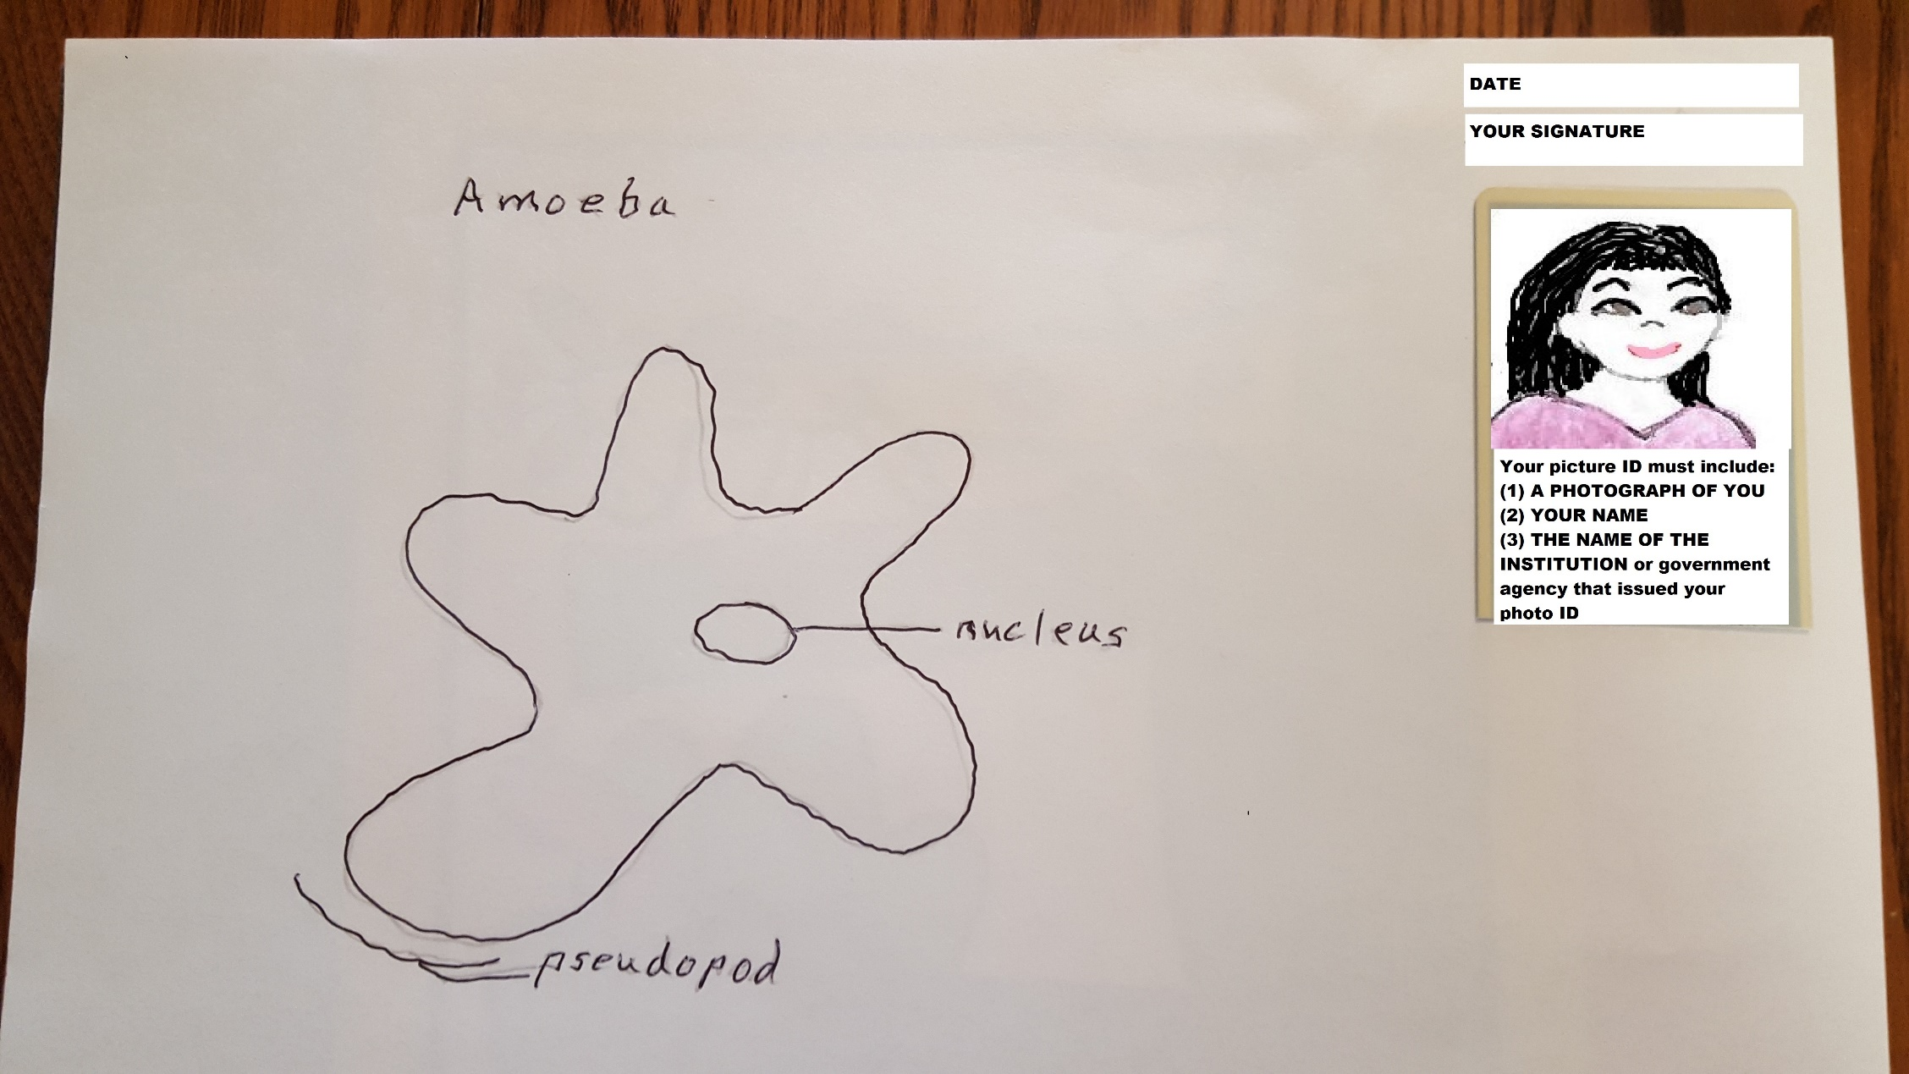

Virus Structure:
- Draw and label the parts of an ENVELOPED ANIMAL VIRUS. Sign your name and put the date in the upper right corner of the sketch. Then put your photo ID under your name and date on the upper right corner of the sketch, and take a picture of the sketch.
Insert the picture of your labeled sketch in the indicated space below. Your photo should fill the blue space below as much as possible:

- Draw and label the parts of an ENVELOPED PLANT VIRUS. Sign your name and put the date in the upper right corner of the sketch. Then put your photo ID under your name and date on the upper right corner of the sketch, and take a picture of the sketch.
Insert the picture of your labeled sketch in the indicated space below. Your photo should fill the blue space below as much as possible:

3. Draw and label the parts of a BACTERIOPHAGE VIRUS. Sign your name and put the date in the upper right corner of the sketch. Then put your photo ID under your name and date on the upper right corner of the sketch, and take a picture of the sketch. Insert the picture of your labeled sketch in the indicated space below. Your photo should fill the blue space below as much as possible:

Read and study the Virus Structure Lecture PowerPoint Show: and Viruses from your textbook. Then answer the Journal Questions in the spaces below:
Journal Questions:
1. What are viruses and how are they different from living organisms?
2. Describe the four types of genetic material that can be in viruses.
3. What are the three main structural elements that may make up viruses? Which of these structural elements is not present in all virus?
4. How are viruses primarily classified (sorted out by scientists)?

This assignment is modified from the Virtual Cell Biology Classroom (http://www.scienceprofonline.com/virtual-cell-main.html ) on the free science education website Science Prof Online (ScienceProfOnline.com). Visit the website to find more science education resources such as lecture PowerPoints, practice test questions, review questions, science photos, videos and assignments.

Part 2: Bacteria
Science Prof Online

These lecture learning objectives are a study guide based on the VMC Prokaryotic Cell Lecture PowerPoint Show and Concepts of Biology 13.1 Prokaryotic Diversity
Objectives:
What is a cell (and what is not)?
​Know the two basic types of cells.
​​Know the structural parts of a prokaryote and the function of those structures.
Understand the importance of the prokaryotic cell wall. What makes a Gram+ cell different than a Gram- cell; how the differences impact control of microorganisms.
Know the basic bacterial shapes.
Know the different types of glycocalyces and the advantage that they provide to bacteria that have them.
Know the different types of surface appendages on prokaryotic cells.
Understand the difference between vegetative cells and endospores. What advantage do endospores provide to bacteria?
Know the basic shapes and arrangements of prokaryotic cells.
Know the importance of bacteria (good and bad) discussed in the power point lecture and the textbook chapter. Pay particular attention to the microbes below:
- Streptococcus and bacterial slime layer
​ - Clostridium bacteria and endospores
- Neisseria gonorrhoeae and bacterial fimbriae

​

Prokaryotic Cell Diagram

Identify the numbered structures and provide a brief definition of the parts of the prokaryotic cell in the spaces below.

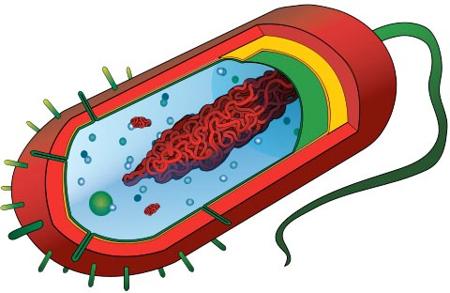
8
5
7
Image: Prokaryotic Cell by Mariana Ruiz
6
1
4
3
2

1. -

2. -

3. Cell Wall -

4. -

5. -

- Plasmid -

- Ribosome -

- Fimbria - 1

Read and study the Prokaryotic Cell Lecture PowerPoint Show and 13.1 Prokaryotic Diversity
from your textbook. Then answer the Journal Questions in the spaces below:
Journal Questions:
1. What are prokaryotes and why are they classified as living organisms?
2. Describe the two types of genetic material that can be in bacteria.
3 What makes a Gram+ cell different from a Gram- cell; how do the differences impact control of microorganisms?
4. Describe two types of bacterial glycocalyces. How do they differ?
5. What are endospores and why are they important?
6. Discuss how bacteria are beneficial.

7. Discuss how bacteria are harmful.
This assignment is modified from the Virtual Cell Biology Classroom (http://www.scienceprofonline.com/virtual-cell-main.html ) on the free science education website Science Prof Online (ScienceProfOnline.com). Visit the website to find more science education resources such as lecture PowerPoints, practice test questions, review questions, science photos, videos and assignments.
When you are finished with your lab, save it as a pdf and upload to the Lab 2 Assignment Link in Canvas

