Module 1 Lab:

Name:___________________________________________ Date:_____________________
This report is my original work.

Module 1 Lab

Part 1: Exploring and Classifying Life: How are living things classified into groups?

http://www.glencoe.com/sites/common_assets/science/virtual_labs/E07/E07.html - 6 kingdoms, classification exercise

Objectives:
- Compare and contrast the six kingdoms of living things according to their physical and behavioral similarities and differences.
- Correctly identify the kingdom classifications of a variety of organisms.

Direct your browser to the link above. The instructions for the lab are in the white panel on the left side of the screen. Carefully read and follow those instructions while you perform, click, drag, and check work on the lab in the right side of the screen.
Introduction: Read and take notes on the complete introduction covering classification in the panel on the left of your screen before you start the procedure.

Procedure: Follow each step of the Procedure completing Table 1 (on page 2) as you work through the activity.

(Procedure Step 5 is required to get credit for this lab. Labs submitted without procedure 5 will receive a ZERO.)
- Click and drag an organism from the upper right of the screen down to the magnifying glass. The organism's common name, a larger picture of the organism, and information about the organism appear. Record the organism's number of cells, type of cells, locomotion, nutrition, and scientific name in the table below.
- Click a kingdom name to see information about the kingdom. Use this information to classify the organism you selected into its kingdom. Click the kingdom name again to remove the information from the kingdom's sorting area.
- Click and drag the organism to the kingdom where you think it belongs. Click the Check button to see if you have classified the organism correctly. If a yellow highlight appears around the organism, reexamine the organism and the kingdom characteristics and move the organism to another kingdom.
- When you have correctly classified an organism, record its kingdom and characteristics in the Table. Some of the organisms do not have common names or scientific names listed.
- Classify the other four organisms in the same way. Some kingdom sorting areas may remain empty while others contain multiple organisms. Once you have all of the first five organisms in their correct kingdoms, hold your picture ID on the computer screen and take a picture showing your ID on the right side of the screen with the organisms you classified in their kingdoms (The example shows a picture ID on the right of the start screen of the lab). You may need to adjust your computer screen brightness (make it less bright) to get a good photo of your ID with the screen. Then, insert the picture of your computer screen with lab results and your picture ID on the right of the computer screen in the designated box below. This step is required to get credit for the lab. Labs submitted without this step will receive a ZERO.
Example:
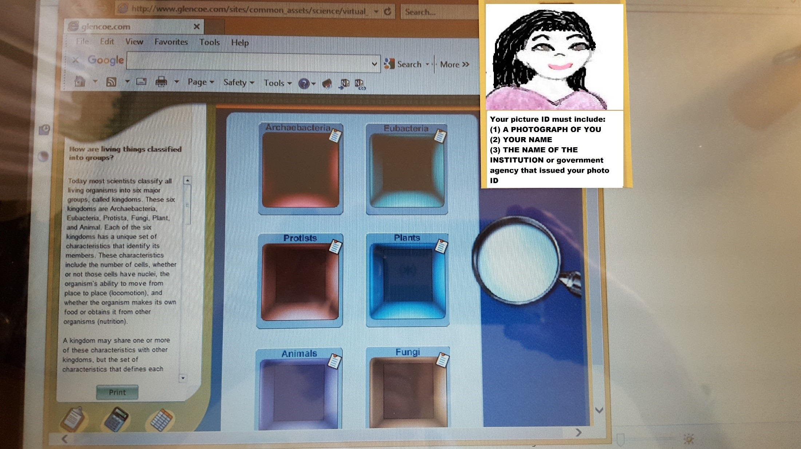
Insert your picture of your computer screen with the first five organisms classified in their correct kingdoms and your photo ID below. Your photo should fill the blue space below as much as possible:

Insert photo here.

Table 1
Table 1 | Scientific Name | Common Name | Number of Cells | Type of Cells | Locomotion | Nutrition | Kingdom
Organism 1
Organism 2
Organism 3
Organism 4
Organism 5

- Now answer the Journal questions below:
Question 1: Many people organize books, videos, and CDs in their homes to make it easier to find what they're looking for. Describe another type of classification system you have seen or used.

Question 2: How are animals and plants different? How are they the same? Be specific.

Question 3: Working as an assistant in a laboratory, you discover an organism that you believe might be a new species of plant or fungus. What are some differences between plants and fungi, and what clues might help you classify this organism?

Virtual Labs Created by Glencoe resources were modified for use in this lab.
resources were modified for use in this lab.
This work is licensed under a Creative Commons Attribution-NonCommercial-ShareAlike 4.0 International License.

Part 2: Exploring how prey species adapt to a changing environment: How can natural selection be modeled?
http://www.glencoe.com/sites/common_assets/science/virtual_labs/LS06/LS06.html - models how prey species adapt to a changing environment.

Objectives:
- Explain the role of mutation in the evolution of species.
- Describe how natural selection can change the characteristics of a population.
- Predict how different environmental conditions might affect a population.

Direct your browser to the link above. The instructions for the lab are in the white panel on the left side of the screen. Carefully read and follow those instructions while you perform, click, drag, and check work on the lab in the right side of the screen.

Introduction: Read and take notes on the complete introduction covering natural selection in the panel on the left of your screen before you start the procedure.

Procedure: Follow each step of the Procedure completing the table and answering journal questions.
(Procedure Step 4 is required to get credit for this lab. Labs submitted without procedure 4 will receive a ZERO.)
- Choose a mutation to investigate by clicking the arrow at the bottom of the Mutations window. Select animals with Large Body/Long Legs, Small Body/White Fur, or Claws for Climbing.
- Click the arrow at the bottom of the Conditions window and select condition a or b that will affect the survival of the selected animals.
- Click the Begin Natural Selection button to observe what happens to the animals after five generations given the selected condition. Note: The small number of animals shown is intended to represent the whole population.
- Click the Population Graph button to open a graph of data for the entire population´s changes over five generations. The yellow (orange) line represents the population of animals with the mutation (mutant animals). The blue line represents the population of animals without the mutation (normal animals).
Once you have your first graph of data for the entire population´s changes over five generations, hold your picture ID on the right side of the computer screen and take a picture showing your ID on the screen to the right of the graph with the mutation and conditions you chose. The example shows a picture ID on the screen with one of the graphs. The mutation and condition are covered, but your picture should show them. You may need to adjust your computer screen brightness (make it less bright) to get a good photo of your ID with the screen. Then, insert the picture of your computer screen with one of your graphs and your picture ID on the right of the computer screen in the designated box on your LAB ANSWER SHEET. This step is required to get credit for the lab. Labs submitted without this step will receive a ZERO.
Example:
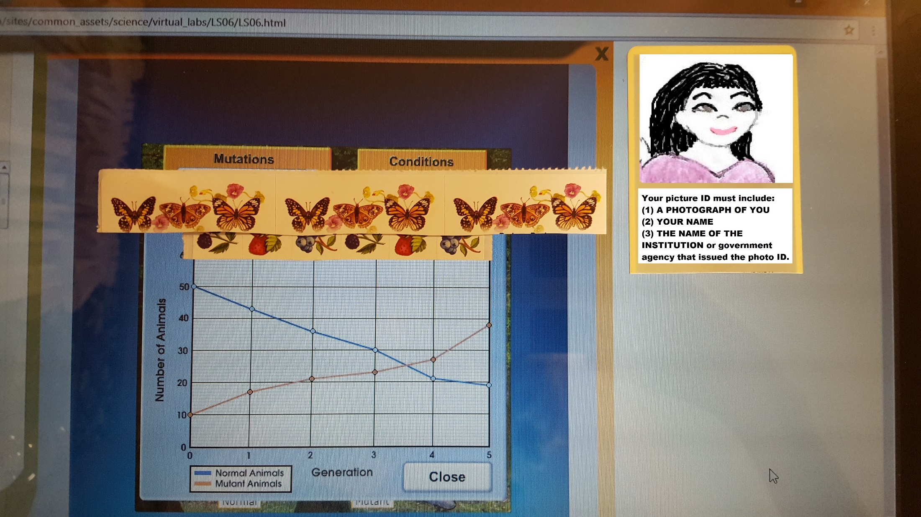

Insert your picture of your computer screen with the first graph of data for the entire population´s changes over five generations s and your photo ID below. Your photo should fill the blue space below as much as possible:

Insert photo here

In the Table below record the values from the Population Graph and then estimate and record the numbers you think would occur in generation six.
5. Repeat the Virtual Lab and investigate the other condition that goes with the first mutation you chose, and then investigate ONE more mutation and the TWO conditions that go with it. In other words, your chart should have a total of EIGHT rows and SEVEN columns filled in.

 |  | Generation 0 | Generation 1 | Generation 2 | Generation 3 | Generation 4 | Generation 5 | Generation 6
Normal Body/ New Predator | 1/a Normal
Large Body/Long Legs / New Predator | 1/a Mutant
Normal Body / Restricted Food | 1/b Normal
Large Body/ Long Legs / Restricted Food | 1/b Mutant
Normal Body/Brown Fur / New Predator | 2/a Normal
Small Body/White Fur / New Predator | 2/a Mutant
Normal Body/Brown Fur / Snow Cover | 2/b Normal
Small Body/White Fur/ Snow Cover | 2/b Mutant
Normal Claws / New predator | 3/a Normal
Claws for Climbing / New predator | 3/a Mutant
Normal Claws / Restricted Food | 3/b Normal
Claws for Climbing / Restricted Food | 3/b Mutant

5. Complete the Journal questions
JOURNAL: Measurement: How can natural selection be modeled?

Question 1: Look at the information you recorded in your Table for a particular Mutations/Conditions combination. Highlight it in the table above. Give the name of the mutation and the environmental condition, and describe how this population of animals changed over time.

Question 2: Using your understanding of natural selection, explain why that population changed the way it did.

Question 3: Invent a new type of mutation and a new environmental condition that might affect this population of animals. How might natural selection operate on a population with this new mutation and new condition? How would the population change over time?

Question 4: Scientists have discovered by looking at fossil records that the ancestors of giraffes had shorter necks than giraffes today. Make a hypothesis about how long necks evolved in giraffes through the process of natural selection.

Virtual Labs Created by Glencoe resources were modified for use in this lab.
resources were modified for use in this lab.
This work is licensed under a Creative Commons Attribution-NonCommercial-ShareAlike 4.0 International License.
When you are finished with your lab, save it as a pdf and upload to the Lab 1 Assignment Link in Canvas.

