Mitosis and Meiosis Review

 | Mitosis | Meiosis
Purpose
Which cells do this? (Somatic cells? Germ cells? Both?)
Number of divisions
Number of cells produced
Chromosome number of daughter cells (haploid or diploid? 2n or 1n?)
Type of cells produced
Pairing of homologous chromosomes? (yes or no)
If yes, when?
Genetic variation increased? (yes or no) If yes, HOW?

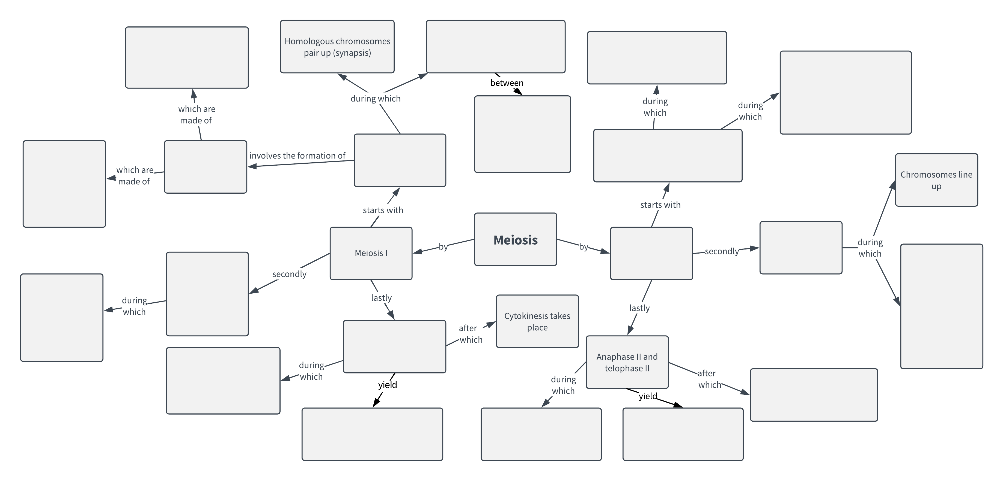
- Meiosis II
- Metaphase I
- Metaphase II
- Prophase I
- Prophase II
- Anaphase I and telophase I
- Tetrads
- 4 chromatids
- 2 homologous chromosomes
- 2 haploid cells
- 4 haploid cells
- Non-sister chromatids
- Independent Assortment
- Crossing over occurs
- Chromosomes are still made of sister chromatids
- Sister chromatids are attached to opposite poles
- Cytokinesis takes place
- Sister chromatids separate
- Homologous chromosomes separate
- Spindle fibers attach to kinetochores

