Open Educational Resources:
A Fact Sheet for Adult Educators

The 5Rs*
Another way to think about OER is through the Five R Framework, developed by David Wiley. It supports a deeper understanding of what it means to consider an object (i.e., resource) an OER.
- Retain – the right to make, own, and control copies of the content
- Reuse – the right to reuse the content as verbatim or in its unaltered form
- Revise – the right to adapt, adjust, modify, or alter the content itself
- Remix – the right to combine the original or revised content with other content to create something new
- Redistribute – the right to make and share copies of the original content, your revisions, or your remixes with others
* This material is based on original writing by David Wiley, which was published freely under a Creative Commons Attribution license at: http://opencontent.org/blog/archives/3221

What are Open Educational Resources (OER)?
OER are teaching, learning, and research resources that reside in the public domain or have been released under an intellectual property license that permits sharing, accessing, repurposing (including for commercial purposes), and collaborating with others.
Adult educators use free resources to enhance teaching and learning that may not be OER. A resource is open when it can be revised or remixed with other open resources or self-generated content to produce new material that directly targets adult learners’ needs.

Some key values of OER:
- are abundant, customizable, free, and convenient to integrate into lessons
- help meet the demand for high-quality content while enhancing instructional practices and student learning
- help students achieve their learning goals by providing flexible and accessible supplements to instruction
- encourage lifelong learning habits in students and also help educators do their job better by augmenting instruction and helping teachers learn about new topics

Where are OER found?
OER Commons
www.oercommons.org
Merlot
www.merlot.org/merlot/index.htm
Creative Commons Search
http://search.creativecommons.org
National Science Digital Library
https://nsdl.org/
What are some types of OER?
- Activities
- Lesson Plans
- Videos and Podcasts
- Simulations
- Games
- Images and Illustrations
- Applications (apps)
To learn more visit:
OER Research Hub
http://oerresearchhub.org/

- Assessments
- Full courses
- Online textbooks

OER in Action

How to Use OER?

Classroom Scenario
You are teaching Mathematics to Intermediate HiSET students. Some students are struggling with proportional reasoning so you decide to plan a lesson.
While searching for materials, you find an almost perfect lesson plan as an OER. However, you would like for students to work in groups so that they have opportunities to discuss what they are doing and thus develop their reasoning and critical thinking skills. You rewrite the lesson plan because it is an OER.
Another problem you notice is that there are no extension activities to challenge students who are more advanced. You add some optional activities, including some OER, to extend the learning and meet student needs.

Image adapted from Wikimedia Commons, the free media repository

Searching for Open Education Resources (OER)?
“The hands-on activities and resources I located through OER Commons greatly enhanced my students’ learning experiences. It showed them a practical use for math, and encouraged them to see their own abilities to understand something by which they’d been intimidated for most of their lives”
— Adult Educator
One effective strategy for finding OER is to use OER repositories, such as OER Commons. Using effective Internet search strategies will narrow down the results list. Check out these tips from Connie Rivera on Tech Tips for Teachers. Join online communities and subscribe to blogs and mailing lists.
What are open licenses?
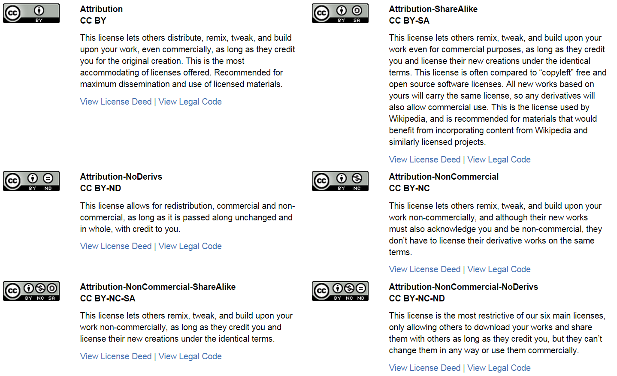
A license is the legal identification for what a user can and cannot do with someone else’s work. An open license allows one to reuse, share, and adapt the work. The most common open licenses are the Creative Commons licenses shown below. Read the fine print!
From Creative Commons: https://creativecommons.org/licenses/

