ClimeTime Attribution Information and Open License Language
Prior to applying an open license to your work, make sure that it is either original work created by your organization’s staff, or your contractors, or you have written permission to include any external material. Remember to properly attribute all resources in your document that are not original work.

Best Practices in Attribution
The purpose of attribution is to give credit to the original creator of a resource (content, image, video, etc.) you are using.
Attribution is a legal requirement of using openly licensed works and should be found on the same page as the resource being used or in a way that clearly identifies the resource as coming from a different source.
Your attribution should include:
- Title: title of the resource (if known)
- Author: name of the creator (copyright holder – may be an organization)
- Source: URL where the resource is hosted (plus optional link to the author)
- License: the type of open license the resource is available under, including a link to the relevant license
Example:

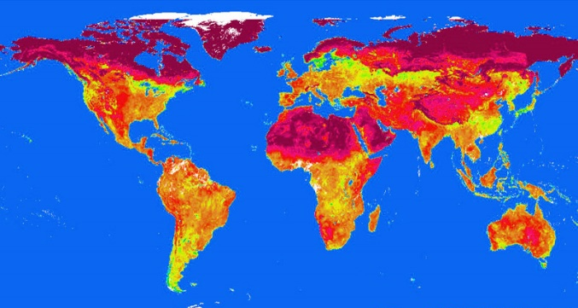
Climate by AJC1 | CC BY NC SA 2.0
Title: Climate
Author: AJC1
Source: URL linked
License: Creative Commons Attribution-NonCommercial-ShareAlike 2.0 (CC BY NC SA)

Additional Resources
Open Attribution Builder | Washington State Board for Community and Technical Colleges
Best practices for attribution | Creative Commons
Quickstart Guide: Openly Licensed Images and Attribution | Office of Superintendent of Public Instruction
Citation vs. Attribution | Lauri Aesoph adapted from Quill West, Pierce College
For additional guidance on adapted materials or materials where multiple sources are being used, please visit the OSPI Interactive Copyright and Licensing Guide.

PowerPoint Generic License
Note: Vary text size and font with need. Place in slide deck where it makes most sense – most often last slide.
Alt text for image: Creative Commons Attribution License (CC BY).
Except where otherwise noted, this work by {Insert Organization Name and Hyperlink} is licensed under a Creative Commons Attribution License. All logos and trademarks are property of their respective owners.
This presentation may contain or reference links to websites operated by third parties. These links are provided for your convenience only and do not constitute or imply any affiliation, endorsement, sponsorship, approval, verification, or monitoring by our organization. Please confirm the license status of any third-party resources and understand their terms of use before reusing them.

Web Site Generic License
Except where otherwise noted, content by {Insert Organization Name} on this site is licensed under a Creative Commons Attribution License. All logos and trademarks are property of their respective owners.
Alternate material licenses with different levels of user permission are clearly indicated next to the specific content in the materials.
If any work is adapted, note the substantive changes and re-title, removing any {Insert Organization Name} logos. Provide the following attribution: “This resource was adapted from original materials provided by {Insert Organization Name}. Original materials may be accessed on the {Insert Organization Name} website.”
Specific resources may have different attribution directions. If so, please follow those instructions. We also ask that you apply an open license to the new derivative work, with the least restrictive open license possible that is not in conflict with existing licenses. This will allow the public to realize the educational impact from the substantial investments the state, the federal government, and private foundations have made in educational resources created by {Insert Organization Name} employees and their collaborators.

Word Document Generic License
Note: Vary text size and font with need. Place in document where it makes most sense.
- In body of document, choose first and/or last page (or title page of each unit/module/separately downloadable chunk of content).
- If placed in footer, remove hyperlinks to avoid conflict with accessibility scan.

Example 1: License on First and/or Last Page
Alt text for image: Creative Commons Attribution License (CC BY).
Except where otherwise noted, this work by {Insert Organization Name and Hyperlink} is licensed under a Creative Commons Attribution License. All logos and trademarks are property of their respective owners.

Example 2: License in Footer
Except where otherwise noted, this work by {Insert Organization Name} is licensed under a Creative Commons Attribution License. All logos and trademarks are property of their respective owners.
View license at: http://creativecommons.org/licenses/by/4.0/.

Example 3: First and/or Last Page and Footer (good for large documents)
Use First and/or Last Page Example in body of work and put the small logo in the footer. Make sure the image is not hyperlinked.
Alt text for image: Creative Commons Attribution License (CC BY).

Additional Guidance Language (optional)
Include whichever combination of statements below that are applicable to the work:
- This work has been created in partnership with ... We express our gratitude to all the contributors to this effort. Without their support and expertise, this resource would not be possible.
- Funding provided by…
- Please be aware that any adaptations should be considered carefully so as not to impact this thoughtfully crafted content design.
- Alternate material licenses with different levels of user permission are clearly indicated next to the specific content in the materials.
- If this work is adapted, note the substantive changes and re-title, removing any {ProjectName} logos. Provide the following attribution:
This resource was adapted from original materials provided by {Insert Organization Name}. Original materials may be accessed {HyperlinkToOriginalWork}.
- We ask that you apply an open license to any derivative work, with the least restrictive open license possible that is not in conflict with existing licenses. This will allow the public to realize the educational impact from the substantial investments the state, the federal government, and private foundations have made in educational resources.
- This resource may contain links to websites operated by third parties. These links are provided for your convenience only and do not constitute or imply any endorsement or monitoring by {Insert Organization Name}. Please confirm the license status of any third-party resources and understand their terms of use before reusing them.

For more information
Barbara Soots Email: barbara.soots@k12.wa.us
Open Educational Resources Program Manager Twitter: @OSPI_OER
Learning and Teaching Department OER Project Website
Office of Superintendent of Public Instruction <http://www.k12.wa.us/oer/>

NOTE:
The contents of this document are not legal advice. Suggestions for license type are based on the Washington Office of Superintendent of Public Instruction (OSPI) open policy that states:
… As a condition of receiving a grant, and where not in conflict with stated policies, if any, of the funding agency or organization, all original works of authorship produced by grants from state, federal, private foundation or other funds managed by OSPI will carry a Creative Commons Attribution License, version 4.0 or later (CC BY).
OSPI Copyright and Open Licensing Policy
Except where otherwise noted, this work by Office of Superintendent of Public Instruction is licensed under a Creative Commons Attribution 4.0 International License. All logos and trademarks are property of their respective owners.

