Enzymes Help Us Digest Food

Introduction to Sugars and Enzymes
The food you eat contains many different types of molecules, including two types of sugar molecules: monosaccharides and disaccharides.

Three examples of monosaccharides are:
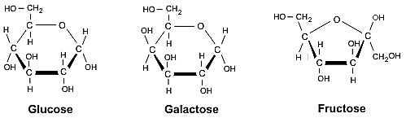

Two examples of disaccharides are:

1. Each disaccharide is made up of two __________________________ .

Monosaccharides from the food you eat are absorbed from your gut into your blood and carried to all the cells in your body. Each disaccharide molecule must be broken down or digested into its monosaccharide components before it can be absorbed into the blood.

2. When a sucrose molecule is digested, which monosaccharides are produced?

Sucrose ___________________ + ____________________

An enzyme speeds up a chemical reaction which converts a substrate molecule or molecules to a product molecule or molecules. Without an enzyme, many reactions occur at an extremely slow rate – too slow to sustain life.

The enzyme that speeds up the digestion of lactose is called lactase. Notice that the name of the enzyme lactase combines the suffix -ase with part of the name of the substrate lactose. Lactase and most other enzymes are proteins.

3. The following equation shows the digestion of lactose.

Lactase
Lactose Glucose + Galactose

Use E to indicate the enzyme, S to indicate the substrate, and P to indicate the products. Circle the molecule that is a protein and use asterisks to indicate the molecules that are sugars.

Each enzyme has an active site where the substrate molecule binds.

4. Circle the active site in the lactase enzyme in the figure.

After the enzyme has acted on the substrate and the products are released from the enzyme, the enzyme returns to its original state, so the enzyme is ready to act on another substrate molecule. Thus, an enzyme molecule can be reused over and over. For example, a single molecule of the enzyme lactase can speed up the digestion of many many molecules of lactose.

Experiment 1 - Is an enzyme needed to digest lactose?
Can the same enzyme digest lactose and sucrose?

To test whether an enzyme is needed to digest lactose, you will test whether lactose breaks down to glucose and galactose in two different conditions:
(1) with no enzyme and
(2) when the enzyme lactase is present.

5. Predict what you think will happen to lactose with and without enzyme. For each column, circle the equation that describes what you think will happen.

Prediction with No Enzyme |  | Prediction with the Enzyme Lactase
No Enzyme  Lactose Glucose + Galactose  Or  No Enzyme  Lactose Lactose  (no glucose produced) |  | Lactase  Lactose Glucose + Galactose  Or  Lactase  Lactose Lactose  (no glucose produced)

6. To test whether the same enzyme can  digest lactose and sucrose, you will test  whether sucrose breaks down to glucose  and fructose when lactase is added. Circle the equation that describes what you think will happen. |  | Lactase  Sucrose Glucose + Fructose  Or  Lactase  Sucrose Sucrose  (no glucose produced)

To test whether your predictions are correct, you will set up these three experiments and use glucose test strips to test whether glucose has been produced.

Procedure
- One member of your group (experimenter 1) should label test tube 1 and add 10 mL of lactose solution.
- A second member of your group (experimenter 2) should label test tube 2 and add 10 mL of lactose solution and 1 mL of lactase solution. Put on a glove, put your thumb on the top of the tube and turn the tube upside down several times to mix the two solutions.
- A third member of your group (experimenter 3) should label test tube 3 and add 10 mL of sucrose solution and 1 mL of lactase solution. Put on a glove, put your thumb on the top of the tube and turn the tube upside down several times to mix the two solutions.
- Wait 3 minutes to allow time for the lactose or sucrose to break down to glucose and galactose or fructose.
- While you are waiting, each experimenter should get a test strip. Prepare a piece of paper with a labeled place for each test strip. In the next step, if a test strip changes color, this will indicate that glucose is present. Record the original color of your test strip. _______________
- After the 3 minute wait, each experimenter should use a glucose test strip to test for glucose in the solution in his or her test tube. Your teacher will give you the instructions for using your glucose test strip.
- Record your results in the table in question 7 below.
- Clean your test tubes.

Results
7. Record your results in this table.

 | Tube 1  10 mL of lactose solution | Tube 2  10 mL of lactose solution  + 1 mL of lactase solution | Tube 3  10 mL of sucrose solution  +1 mL of lactase solution
.
Test strip color
after 3 min. wait

Was there any
change in the color
of the test strip?
Conclusion | ___ no glucose produced  ___ some glucose produced | ___ no glucose produced  ___ some glucose produced | ___ no glucose produced  ___ some glucose produced

Interpretation
8. Was lactose digested when the enzyme lactase was present? ___ yes ___ no

9. Compare the results for Tube 1 and Tube 2. What do you conclude about whether the enzyme lactase is needed to digest the sugar lactose?

10. In Tube 2, there were over 10,000 lactose molecules for each lactase molecule. How can a single lactase molecule break down many many lactose molecules? (Hint: See page 2.)

11. A catalyst is defined as a substance that increases the rate of a chemical reaction without itself undergoing any permanent chemical change. Is the enzyme lactase a catalyst?
Explain why or why not.

12. Did lactase digest sucrose? How do you know?

13. Does the same enzyme digest lactose and sucrose? ___ yes ___ no

Your results illustrate a general principle called enzyme specificity. Each enzyme acts on only a single substrate or several chemically similar substrates.

14a. Which part of an enzyme do you think is responsible for enzyme specificity? Explain your reasoning.

14b. In this figure, notice that the two upper substrate molecules have the same shape, but the lowest substrate molecule has a different shape.  Label the enzyme lactase. For each substrate molecule, indicate whether it is lactose or sucrose. | 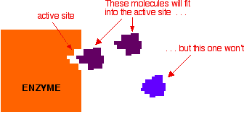

Because of enzyme specificity, our bodies need lots of different enzymes to digest different types of food molecules. For example, our small intestine has the enzyme lactase to digest lactose and a different enzyme to digest sucrose.

15. What do you think is the name of the enzyme that digests sucrose? (Hint: See page 1.)

16. Complete the following equation to show the digestion of sucrose. Include the enzyme and the products.

Sucrose

The Digestive System and Lactose Intolerance

Molecules like sugars and protein enzymes are much much smaller than a whole person. For example, a person is roughly a billion times longer than a protein molecule like an enzyme. So where are these tiny molecules located in our bodies?

This diagram shows a simplified outline of the human digestive system, including the small intestine where enzymes like lactase and sucrase break down food molecules into smaller molecules. These small molecules are absorbed into the blood and carried by the blood to all the cells in the body. Most digestion occurs in the small intestine.  21. In this diagram, use D with arrows to show how disaccharides like lactose and sucrose get from food to the small intestine.  - Use E to indicate the location of the enzymes, lactase and sucrase. | Digestive System  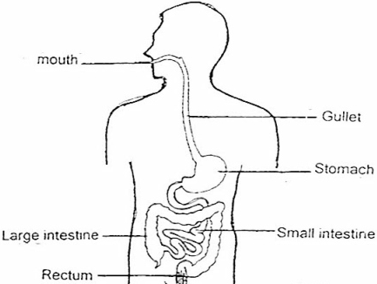  Esophagus

22a. Suppose a person drinks a glass of milk. If the cells in the person’s small intestine make lactase, very little lactose reaches the large intestine. Where did the lactose from the milk go?

22b. Suppose that the cells in a person's digestive system do not make lactase. What do you think would happen to the lactose molecules in the milk that person drinks?

Human babies and the babies of all other mammals depend on milk for their nutrition. Almost all babies produce the enzyme lactase to digest lactose, which is the main sugar in milk.

In contrast, many adults produce very little lactase, so they can only digest a little bit of lactose at a time. When a person who produces very little lactase consumes large amounts of lactose in a short time period, most of the lactose is not digested in the small intestine and lactose reaches the large intestine where it is digested by bacteria. This can result in symptoms such as diarrhea, flatulence, and discomfort. This condition is called lactose intolerance.

23a. A person who is lactose intolerant can drink lactose-free milk to gain the benefits of the protein, calcium and vitamin D that milk provides. Explain how a manufacturer can use lactase to make lactose-free milk.

23b. Do you think lactose-free milk contains glucose? ___ yes ___ no
If yes, where did the glucose come from?

Partially adapted from “Lactase Investigation” in the School District of Philadelphia Biology Core Curriculum, by Drs. Ingrid Waldron and Jennifer Doherty, Department of Biology, University of Pennsylvania, © 2016. Teachers are encouraged to copy this Student Handout for classroom use. This Student Handout, Teacher Preparation Notes with instructional suggestions and background information, and comments are available at http://serendipstudio.org/sci_edu/waldron/#enzymes.

