1. Name and define this symbol, , used in the Boolean Logic system we studied. (4 points)
2. Define the inverse, converse, and contrapositive of. (6 points)

Inverse:

Converse:

Contrapositive:

For the following true/false questions construct a truth table if needed. (1 point)

1. T or F: A conditional statement and the contrapositive of the same statement are logically equivalent.
2. T or F: The inverse of a conditional statement and the converse of the same statement are logically equivalent.
3. T or F: The inverse of a conditional statement and the contrapositive of the same statement are logically equivalent.
4. Fill in the following truth table. (6 points)

|  |  |  |  |  |  |
| --- | --- | --- | --- | --- | --- |
|  |  |  |  |  |  |
|  |  |  |  |  |  |
|  |  |  |  |  |  |
|  |  |  |  |  |  |
|  |  |  |  |  |  |

1. Define **tautology** and give an example with a truth table of a **tautology**. (4 points)
2. Construct a truth table for  (8 points)

Matching: match a statement on the left with a statement on the right that are form a logical equivalence. A choice may be used more than once or not at all. (2 points each)

1. _______ A. 

B. 

1.  _______ C. 

D. 

1.  _______ E. 

F. 

1.  _______
2.  _______
3. Draw a logic gate diagram for each of the following statements (3 points each)
   1. 
   2. 
   3. 
4. Rewrite the statement to a logically equivalent statement that eliminates the use of the conditional and biconditional. (4 points each)
   1. 
   2. 
5. Simplify  using logical equivalences or a truth table and then draw a logic gate diagram of the simplified statement. (8 points)

Simplified statement:

Circuit Diagram:

1. Write the logic statement for the following logic gate diagram. (6 points)

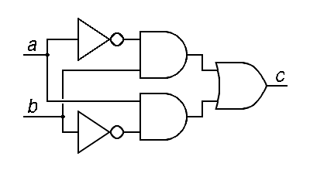

1. Use this logic gate diagram to answer the following questions. (4 points each)

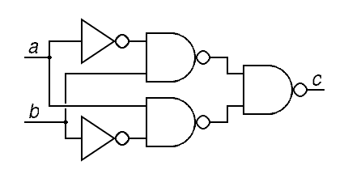

* 1. Write the logic statement the circuit represents.
  2. Create a truth table for the statement.
  3. Find a simpler statement that is logically equivalent to the statement in part a.
  4. Draw a logic gate diagram of the statement in part c.