On May 14, 1607 a group of roughly 100 members of a joint venture called the Virginia Company, founded the first permanent English Settlement in North America on the banks of the James River. Famine, disease and conflict with local native American tribes in the first two years, brought Jamestown to the brink of failure before the arrival of a new group of settlers and supplies in 1610.
Tobacco became Virginia´s first profitable export, and a period of peace followed the marriage of Colonist John Rolfe to Pocahontas, the daugther of an Algonquian chief. During the 1620s, Jamestown expanded from the area around the original James Fort into a new town built to the east, it remained the capital of the Virginia Colony until 1699.
There Were 3 Groups...
FIRST GROUP
Came from England and landed in Virginia and founded a city called Jamestown.
English came after spaniers because of the stories of gold they have heard.
Known variously as James Forte, James Towne, and James Cittie, the new Settlement initially consisted of a wooden fort built in a triangle form around a storehouse for weapons and other supplies, a church and a number of houses.
By the Summer of 1607, Newport went back to England with two ships and 40 crewmembers to give a report to the king and to gather more supplies and colonists.
Pocahontas was the daughter of Powhatan, the paramount chief. Her childhood was a little different from that of most girls in the settlement. She learned how to perform what was considered to be women´s work, which included foraging for food and firewood, farming, and searching for the plant materials used in building thatched houses. "Pocahontas" was a childhood nickname that probably referred to her frolicsome nature; according to the Colonist William Stracney, it meant "little wanton" or "playful one" .
Historical records do not suggest that Smith and Pocahontas were lovers. But, later on she got married to John Rolfe who had cultivated a new strain of tobacco there, and spent much of his time tending to his crop. They got married on April 5, 1614 and they had a boy named Thomas Rolfe on January 30, 1615.
Their marriage brought a temporary climate of peace between the Jamestown colonist and Powhatan´s tribes for 8 years.
In March 1617, Rolfe and Pocahontas boarded a ship to return to Virginia; the ship had sailed only as far as Gravesend on the river Thames, when Pocahontas became gravely ill. She was taken ashore and died in John Rolfe´s arms at the age of 22.

SECOND GROUP
They were known as the PURITANS. They Were protestants who believed that the reforms of church of England did not go far enough in their view, the liturgy was still too catholic.
They came to america because they were tired of church in England, they didn´t like the catholic way their church was turning into.
Arriving in New England, the Puritans established the Massachussetts Bay Colony in a town they named Boston. They established a new church in USA, his leader was William Bradford, they arrived in a ship called "Mayflower".
Life was hard, but in this stern and unforgiving place, they were free to worship as they chose.
The Bible was central to their worship. Their church services were simple. The organ and all musical instruments were forbidden. Puritans sang psalms a capella. The colony survived, but over time its religious fervor diminished. The puritans themselves found it difficult to maintain a society in a State of creative uncertainty.
In 1679, a puritan synod met to deliberate the causes of widespread spiritual malaise, blame was assigned to an increase in swearing; a tendency to sleep at sermons; the spread of sex and alcohol, especially in taverns, where women were known to bare their arms, and upon occasions even their breasts, and most marked increase in lying and lawsuits.
THIRD GROUP
Was leadered by John Winthrop (1587-1649) who was a devoutly religious. Puritan elder that led a large migration of puritans from England to America in 1629 and became the first governor of massachusetts Bay Colony one year later.
Some historians believe that Winthrop along with other Puritans, were attempting to stablish a puritan refuge built upon the notions of puritan idealism.

The Thirteen Colonies
In 1606, King James I divided the Atlantic seaboard in two, giving the southern half to the London Company and the Northern half to the Plymouth Company. The first English settlement in North America had actually been established some 20 years before, in 1587 when a group of colonists led by Sir Walter Raleigh settled on the island of Roanoke.
In 1606, just a few months after James I issued its charter, the London Company sent 144 men to Virginia on three ships : The Godspeed, the Discovery and the Susan Constant. they reached the Chesapeake Bay in the Spring of 1607 and headed about 60 miles up the James River, where they built a settlement they called Jamestown. But it was not until 1616 when the settlers learned how to grow tobacco. The first slaves arrived in Virginia in 1619,
Lord Baltimore was a Catholic, and he hoped that his colony would be a refuge for his persecuted coreligionists. Maryland became known for its policy of religious toleration for all.
10 years later, a wealthy syndicate known as the Massachusetts Bay Company sent a much larger (and more liberal) group of Puritans to establish another settlement. With the help of natives, the colonists soon got the hang of farming, fishing and hunting, and Massachusetts prospered.
Some Puritans that considered Massachusetts too restrictive, formed the colony of Rhode Island, where everyone enjoyed complete "liberty in religios concernments." To the North of the Colony, a handful of adventurous settlers formed the Colony of New Hampshire.

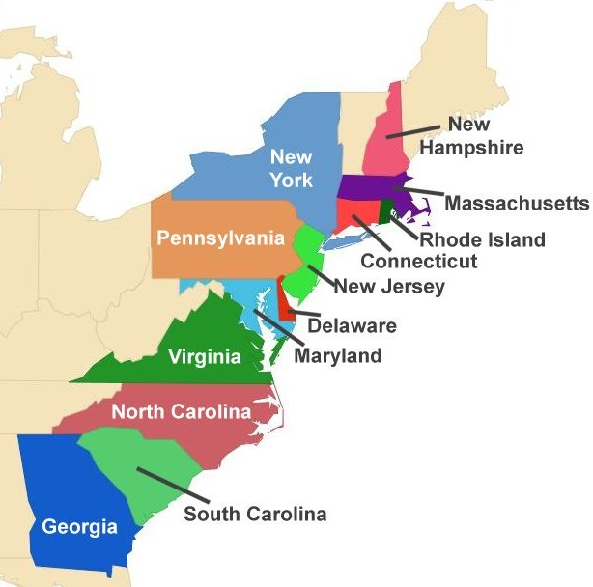

Romanticism (1800-1840)
Some famous exponents were :
Washington Irving
James Fenimore Cooper
Edgar Allan Poe
Nathaniel Hawthorne

Washington Irving. Is Called the father of America Short Stories. He is best known by the stories :
"The legend of the Sleepy Hollow" It is about Ichabod Crane who is a Schoolmaster.
"Rip Van Winkle" It´s about a man who falls asleep for 20 years.

Irving was the author of these 2 famous stories that are included in his book "The sketch book of Geoffrey Crayon, Gent."

He was the youngest of 11 brothers, he born in New York, and when he started to write his stories, he used a nickname : Dietrich Nickerbocker, and also he used : Geoffrey Crayon.

His followers found a club called "The Nickerbockers"

So, let´s work on Rip Van Winkle!!!

