Group Members: ______________________________________________________________________
__________________________________________________________ Date Started: ______________
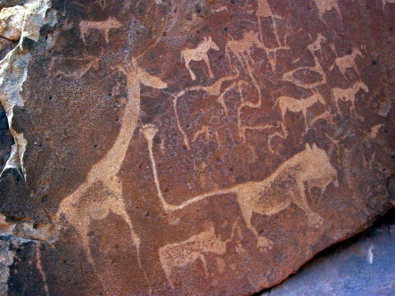
Requirements:
BUILD a device that will…
IMITATE a real, wild animal
including its behavior and environment.
Also RESEARCH and EXPLAIN important facts about your animal.

Your animal and presentation must …
- Look like the real animal. (close enough for someone else to recognize what it is.)
- Be presented like a “Discovery Channel” video, with some explanations (written or spoken).
- Be based on scientific information that you find and record on these pages.
- Include moving parts, sound, props, and/or scenery that match the animal’s real life.
- Have some parts that are controlled by a WeDo program (saved on the computer).
- Use at least one electronic WeDo part with input or output (motor or sensor).
- Last at least 30 seconds, up to a minute.
Your animal and presentation may …
- Borrow ideas from the Internet and the WeDo notebook.
- Move in any way you can devise.
- Use a real person to move or control some (but not all) parts of the scene.
- Use any parts in the WeDo kit (including extra sensors or motor, and LEGO person).
- Use art supplies (construction paper, markers, etc.) to make scenery, props, or body parts.
Your animal and presentation must NOT …
- Change any programming or LEGO parts once the program is running.
- Require a real person to move everything.
- Borrow parts from any other WeDo kits.
- Simply copy any other projects.

First Animal Ideas: (What animals might you like to build? What would they do?)

Research and New Ideas: (include facts you learn about each animal, sources you use,
and ideas you come up with for behavior, scenery, props, etc.)

Teacher Approval
to Continue: _____
Final Choice – Scientific Species Name: ______________________
Final Animal Plans: (include animal body parts, movement, scenery/props, and program blocks)

Tests / Revisions: (What did you change? Why? What worked or not? Any new ideas?)

Final Design and Presentation Plan: (sketch and describe!) (may attach separate sheet)

Group Member Sign-Off: ______________________________________ Date Finished: _____________
__________________________________________ _________________________________________
Video recorded on ______________________ by _____________________
Scoring Rubric & Sign-offs: (give up to 5 points for each category)
Rating Category | By Classmate:  ______________ | By Classmate:  _______________ | By Lab Manager:  _______________ | By Ms. G:  ______________
Scientific Facts and Details
Well-Built /
Good Design
Meets All Requirements
Full Team Participation
Good Video/ Presentation
Total Points:

