LEGO WeDo Robotics & Mechanisms Activity:
LEGO Parts vs. Regular Objects
Your assignment is to make a “flash card” similar to the EXAMPLES below. Use the Internet (teacher’s website) and your WeDo set to find pictures and definitions. Add details, labels, and color if you can.
Your assigned word is: __________________________________
Side 1: Word + Definition
EXAMPLE:
brick
a small rectangular block
typically made of hard clay,
used in building

Side 2: Pictures of LEGO part(s) VS. regular, everyday, real-life part(s)
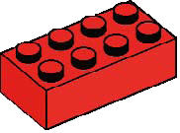
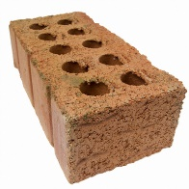
EXAMPLE:
LEGO brick

regular bricks

Word Bank:

axle
beam
belt
bushing
gear
motor
plate
pulley
hub
roof
tire
turntable

