Pumpkin Plotting
Point | X | Y | (x,y)
A | $$x+16=4$$ | $$y-9=2$$
B | $$3x=-27$$ | $$-\frac{y}{9}=-2$$
C | $$\frac{x}{6}+5=4$$ | $$4y-14=30$$ | Connect to A and stop
D | $$9x-9=45$$ | $$-y+2=-9$$
E | $$3x+2x+5=50$$ | $$\frac{y}{3}+2=8$$
F | $$x-24=-12$$ | $$\frac{y}{5.5}=2$$ | Connect to D and stop
G | $$-4x=12$$ | $$10y-11=19$$
H | $$\frac{1}{3}x+4=5$$ | $$4y-13y=-27$$
I | $$2.5x+5=5$$ | $$12y+29=-19$$ | Connect to G and stop
J | $$5\left(x-3\right)=-75$$ | $$1.5y-3.4=-15.4$$
K | $$-12x=-144$$ | $$\frac{y}{4}+10=8$$
L | $$11x=132$$ | $$3.5y+2.12=-39.88$$
M | $$-\frac{x}{2}-14=-8$$ | $$10y+55=-65$$ | Connect to J and stop
Create Your Own Pumpkin Design
- Design a picture on a coordinate plane that only has lines (no curves). The design must have at least 10 points.
- Figure equations that equal the x and y values of all the points of your picture. (Make sure to meet the equation requirements.)
- Enter the Pumpkin Contest-Carve or paint your design onto a pumpkin. A winner from each class will receive a prize. All pumpkins must be submitted to the contest by October 30th.
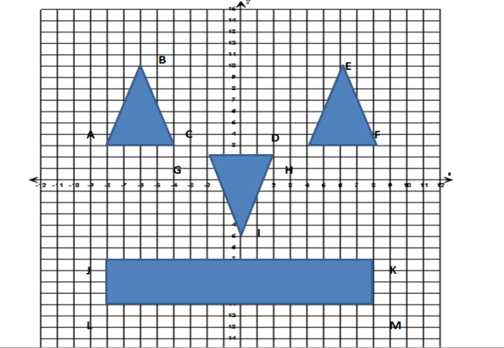

Equation Requirements
- Includes at least 20 equations (2 equations for each point)
- 5 include multiplication
- 5 include division
- 10 2-step equations
- 5 include negative numbers
Create Your Own Pumpkin Design
- Design a picture on a coordinate plane that only has lines (no curves). The design must have at least 10 points.
- Figure equations that equal the x and y values of all the points of your picture. (Make sure to meet the equation requirements.)
- Enter the Pumpkin Contest-Carve or paint your design onto a pumpkin. A winner from each class will receive a prize. All pumpkins must be submitted to the contest by October 30th.
Equation Requirements
- Includes at least 20 equations (2 equations for each point)
- All 2-step or multi-step equations
- 3 include distributive property
- 5 include division
- 5 include multiplication
- 5 have variables on both sides
- 5 have negative numbers

