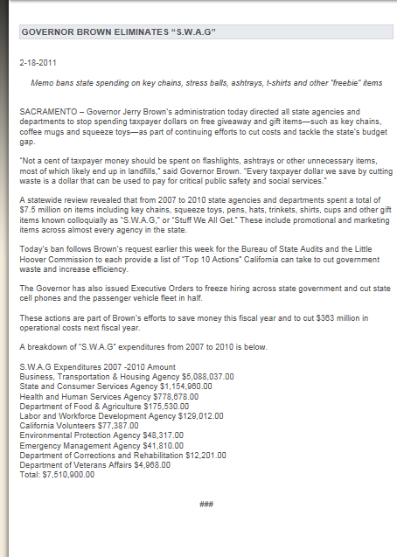
November 09, 2011
We Can't Wait: President Obama to Sign Executive Order to Cut Waste and Promote Efficient Spending; White House to Announce 2011 SAVE Award Finalists
WASHINGTON, DC – This morning, President Obama will sign an Executive Order that will cut waste and promote more efficient spending across the federal government. With this Order, the President is directing agencies to reduce spending on travel; limit the number of information technology devices (e.g. cell phones, smartphones, tablets, laptops) that can be issued to individual employees; stop unnecessarily printing documents that can be posted online; shrink the executive fleet of the federal government; and stop using taxpayer dollars to buy swag -- the plaques, clothing, and other unnecessary promotional items that agencies purchase. Overall spending in the areas covered by the Executive Order will be reduced by 20 percent, saving billions.
This Executive Order builds on the progress that has already been made through the Campaign to Cut Waste. At President Obama’s direction this Administration has taken up an unprecedented effort to downsize the Federal real estate footprint, and is on track to save $3.5 billion in Federal real estate costs by the end of Fiscal Year 2012. The Administration has cracked down on waste in contracting, cutting contracting spending for the first time in more than a dozen years and slashing spending on “no bid contracts” by $5 billion.
The Executive Order will set bold but achievable goals that are informed by the results of the work of the Campaign to Cut Waste, launched by President Obama and Vice President Biden earlier this year. In September, the Vice President convened the first Cabinet Campaign to Cut Waste meeting and asked the Cabinet to identify wasteful and inefficient spending on travel, executive fleet, publications, office equipment, and other areas. Several of the spending reductions identified by agencies in response to the Vice President’s request are highlighted below. The President’s directive today builds on that work.
In addition to today’s Executive Order signing, the White House will announce this year’s SAVE (Securing Americans Value and Efficiency) Award finalists. The SAVE Award was launched in 2009 to seek ideas from frontline federal employees to make government more effective and efficient and to ensure that taxpayer dollars are spent wisely. This year, the Office of Management and Budget (OMB) received nearly 20,000 ideas from across the country. To honor these finalists, OMB Director Jack Lew, OMB Deputy Director of Heather Higginbottom, and Federal Chief Performance Officer and OMB’s Deputy Director for Management Jeff Zients will host a video teleconference with the SAVE Award finalists which will be live-streamed at obamawhitehouse.archives.gov/Save-Award at 11 AM. With the announcement of the four finalists, voting will now begin to select the SAVE Award winner. Anyone can vote for his or her favorite idea on obamawhitehouse.archives.gov/Save-Award. The winner of this year’s SAVE Award will come to the White House to present their idea to the President.
The four finalists are: Matthew Ritsko, a NASA employee from Maryland, who suggested the creation of a tool “lending library” to avoid duplicative purchases of expensive tools; Eileen Hearty, a Housing and Urban Development (HUD) employee from Colorado, who suggested that it’s unnecessary to travel to inspect superior-rated properties each and every year; Kevin Korzenieski, a Treasury employee in D.C. who suggested that we stop purchasing U.S. Code books for all new attorneys given the availability of the information online; and Faith Stanfield, a Social Security Administration (SSA) employee from Ohio, who suggested SSA stop printing and mailing OASIS magazine – which currently is distributed to nearly 90,000 SSA employees -- and simply make it available online.
“From the day I took office, I’ve said we’re going to comb the federal budget, line by line, to eliminate as much wasteful spending as possible. That’s what the Campaign to Cut Waste is all about. We can’t wait for Congress to act – we can’t wait for them to get our fiscal house in order and make the investments necessary to keep America great. That’s why today, I’m signing an Executive Order that will build on our efforts to cut waste and promote more efficient spending across the government – we’re cutting what we don’t need so that we can invest in what we do need,” said President Obama.
“In September, I asked all Cabinet secretaries to report on wasteful and inefficient spending at their agencies. Certain spending – like purchasing promotional water bottles, paying for unused cell phones, and booking unnecessary travel – is unacceptable. Today’s executive order will stop wasteful spending and make sure we use taxpayer dollars efficiently and responsibly,” said Vice President Biden.
Within 45 days, agencies will develop plans to reduce combined costs in the following areas to 20 percent below Fiscal Year 2010 levels by Fiscal Year 2013.
1) Reduce Spending on Travel and Conferences: The Executive Order directs agencies to decrease travel and conference-related spending. Increasingly, travel will be limited to circumstances where the activity can only be performed away from the employee’s primary office (e.g., a diplomatic mission or enforcement inspection). Employees will continue attending local meetings and conferences in person but expand their use of teleconferencing or videoconferencing technology to participate in meetings or conferences that would normally require travel. If agencies are hosting or sponsoring conferences, they will use conference space controlled by the federal government wherever possible. Each agency will designate a senior-level official to be responsible for reducing travel costs. Examples of steps currently being taken are:
The IRS plans to utilize teleconferencing and webinars when possible, as an alternative to travelling to conferences and training sessions. This and other efforts will result in 27% less spending on travel in Fiscal Year 2012.
The Department of Energy is reducing travel costs by reducing the number of conferences, utilizing video teleconferencing, and issuing non-refundable airline tickets when travel does not require changes. This initiative will save $15.7 million in Fiscal Year 2012.
NASA is reducing travel costs by approximately $17 million in Fiscal Year 2012 by reducing the number of attendees at meetings and conferences, encouraging rental car sharing, and reducing foreign travel.
2) Cut Duplicative and Unnecessary Employee Information Technology Devices: Some federal employees are issued more devices (e.g. cell phones, smartphones, laptops, tablet personal computers) than they need to fulfill their duties. In other cases, IT devices are purchased but go unused. The Executive Order directs each agency to limit the number of devices issued to employees and establish new policies to ensure they are not paying for IT equipment that isn’t being used. Examples of steps currently being taken are:
The Department of Homeland Security previously spent millions of dollars each year by paying for unused cell phones and air cards. The agency now conducts annual audits of use and has saved $10.5 million to date.
The Department of Commerce saved $1.8 million to date and will save a total of $3 million this year by disconnecting 2,648 wireless lines showing no usage for the past three months – including those assigned to retirees and former staff -- as well as by optimizing rate plans.
3) End Unnecessary Printing and Put It Online: In the digital age, it is frequently unnecessary to spend money on printed documents in addition to making information available online for the public. The Executive Order directs agencies to provide written information electronically and limit the production of hard copy documents. Examples of steps currently being taken are:
The Department of the Treasury plans to reduce spending on printing by increasing the number of paperless transactions it conducts with the public. In total, Treasury expects this initiative will reduce printing costs by up to 24 percent in Fiscal Year 2012. Treasury’s initiative to increase the number of paperless transactions it conducts with the public is expected to save more than $500 million and 12 million pounds of paper over its first five years alone.
Last year, Trudy Givens won the President’s SAVE Award for her suggestion that we stop printing and shipping excess Federal Registers to Federal Government Offices, which costs millions of dollars per year, when the content is available online. As a result, the Obama Administration cut the number of copies that Federal agencies receive by 85 percent within the past year, and continues to cut back even more.
4) Limit Motor Vehicles: The Federal Government spends $9 million per year on vehicles just to shepherd itself around Washington DC. The Executive Order limits executive transportation across the federal government and directs agencies to improve the performance of the Federal fleet. Examples of steps currently being taken are:
The Department of Commerce is reducing the number of fleet drivers to one for all senior departmental officials, including the Secretary. Reductions in drivers and vehicles are expected to generate $100,000 in annual savings.
5) Stop Swag – or Government Promotional Handouts: The Executive Order directs agencies to stop wasting taxpayer money on non-essential items used for promotional purposes, such as clothing, mugs, and non-work related gadgets.
For instance, several months ago the Department of the Treasury issued a directive to all of its bureaus to avoid purchasing any goods that could be considered frivolous or unnecessary, and to ensure that all purchases have a clear nexus with the Department’s mission and operations.

