CONCEPTUAL CHEMISTRY COURSE
WRITTEN AND COMPILED BY:
Michael Crebbin
Jonathan Frostad
Mackenzie Neal
Zachary Sawhill
Gary Thayer
Malia Turner

Table of Contents
Table of Contents 2
Attribution 3
Unit 1: Structure and Properties of Matter 4
Unit 2: Nuclear Processes 18
Unit 3: Life Cycle of Stars 30
Unit 4: Bonding and Bond Energy 40
Unit 5: Mass Conservation 63
Unit 6: Carbon Cycling and Climate Change 84
Unit 7: Reaction Rates 122
Unit 8: Equilibrium 135
Unit 9: Properties of Water 151
Unit 10: Managing Resources 166
Unit 11: Properties of Substances and intermolecular Forces 173

Attribution
The team developing these materials combine 100 years of teaching experience. They were powered by many pounds of chocolate, not a few cups of coffee, and the desire to create an engaging NGSS aligned course for all chemistry students. In the creation process experiments were tested, classrooms were disrupted, and messes were made. This group included teachers with many years of experience and those just entering the field. Team members included several with expertise in science standards and test development at both state and national levels. This course was developed in align to Next Generation Science Standards as adopted by the State of Washington. The team received a one day training from Ambitious Science Teaching on modeling which is incorporated throughout. Team members were also granted a workshop for POGIL (Process Oriented Guided Inquiry Learning). The team developed a working template using the 5E model (Engage, Explore, Explain, Extend/Elaborate, Evaluate) for developing lesson plans and utilized the cK-12 Foundation’s open education textbook system.
This chemistry resource was written with the financial support of Washington State Office of Superintendent of Public Instruction’s Open Education Resource Grant and Oak Harbor Public Schools. Without the support of these organizations the creation of these materials would not have been possible.
These resource materials contain links to content produced by other organizations which may use a different license. Please confirm the license status of these third-party resources and understand their terms of use before reusing them. Links to third-party websites are provided for your convenience only and do not constitute Oak Harbor Public School’s endorsement, sponsorship, warranty or approval of such linked websites or any product, service or content offered on such linked websites.
Prior to making this course publicly available, we have reviewed its contents extensively to determine the correct ownership of the material and ensure the appropriate open licenses or copyright permission is in place. We will promptly remove any material that is determined to be violating the rights of others. If you believe that a portion of this unit infringes another's copyright, contact Oak Harbor Public Schools at pszalai@ohsd.net or (360) 279-5011.
Except where otherwise noted, this work by Oak Harbor Public Schools is licensed under a Creative Commons Attribution 4.0 License. All logos and trademarks are property of their respective owners.
Content purchased by Oak Harbor Public Schools and under All Rights Reserved copyright is referenced but not included in this document. It is marked with the $$ symbol.
Links to third-party websites are provided for your convenience only and do not constitute Oak Harbor Public Schools’ endorsement, sponsorship, warranty or approval of linked websites or any product, service or content offered on such linked websites. Please confirm the license status of these third-party resources and understand their terms of use.

Unit 1:
Structure and
Properties of Matter
Return to Table of Contents
Except where otherwise noted, this work by Oak Harbor Public Schools is licensed under a Creative
Commons Attribution 4.0 License. All logos and trademarks are property of their respective owners.
Content purchased by Oak Harbor Public Schools and under All Rights Reserved copyright is referenced but not included in this document. It is marked with the $$ symbol.
Links to third-party websites are provided for your convenience only and do not constitute Oak Harbor Public Schools’ endorsement, sponsorship, warranty or approval of linked websites or any product, service or content offered on such linked websites. Please confirm the license status of these third-party resources and understand their terms of use.

Unit 1: Structure and Properties of Matter

Standard
HS-PS1-1: Use the periodic table as a model to predict the relative properties of elements based on the patterns of electrons in the outermost energy level of atoms.

Model
Question: Why do elements that look similar react differently in water?
Materials:
- Water
- Beakers
- Protective Shield
- Magnesium
- Calcium
- Sodium
- Aluminum
Procedure:
- Allow students to make initial observations of the physical properties of each substance.
- Place a small sample of each element into a beaker of water for students to observe the reaction.
Learning Objective:
- I can communicate my existing ideas about atomic structure.

Engage
Kesler Stations$$: Periodic Table and Reactivity
Learning Objectives:
- I can determine an atom’s chemical properties based on valence electrons.
- I can describe how elements are classified on the periodic table.

Explore
PhET Simulator Worksheet: Build an Atom!
Living by Chemistry$$: Create a Table Card Sort and Breaking the Code Questions
Learning Objectives:
- I can describe how the organization of the periodic table is based on reactivity and atomic mass.
- I can predict the characteristics of a missing element on the periodic table based on its position on the periodic table.

Explain
- Reading: CK-12 - Atomic Number Note: You must register for a free account with CK-12 to access materials
Learning Objectives:
- I can identify the components of the nucleus.
- I can identify the number of protons, electrons and neutrons in an element. I can describe an element’s location based on its atomic number.
- Reading: CK-12 - Valence Electrons
Learning Objectives:
- I can determine the number of valence electrons an element has based on its location.
- I can describe how valence electrons determine reactivity.
- Reading: Build an Atom Notes
Learning Objective:
- I can identify components and properties of subatomic particles.
- Reading: Breaking the Code Notes
Learning Objective:
- I can describe properties and trends used to organize the periodic table.

Extend/Elaborate
Revisit Model
Redraw a model of a sodium atom. Include the following:
- number of protons
- total number of electrons
- valence electrons
- nucleus
- energy shells
Include an explanation about why sodium is so reactive using the words period and group.
Learning Objective:
- I can revise a model to add detail about atomic structure.

Evaluate: Structure and Properties of Matter
Unit 1 Task
Select one of the following elements from the chart below to complete your task:
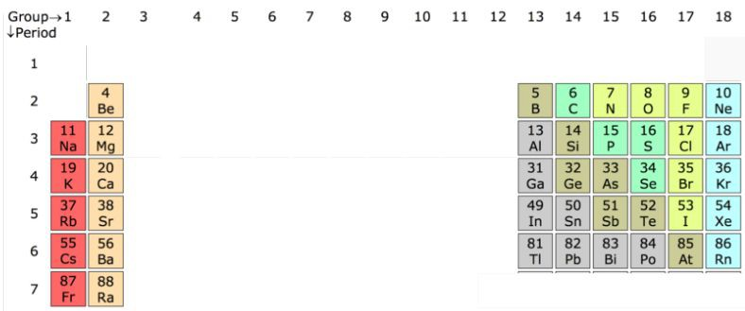
Unit 1 Test

Unit 1 - Structure and Properties: Student Resources
Elements Reacting with Water
PhET Simulator: Build an Atom!
Build an Atom Notes
Breaking the Code Notes
Task: Structure and Properties of Matter
Task Rubric: Structure and Properties of Matter
Test: Structure and Properties of Matter

Elements Reacting with Water
Name _________________________________________________ Date ______________ Period ____________
Name of Element | BEFORE: Draw what you think will happen when the element is put into water | AFTER: Draw what happened after the element was put in water.

Name of Element | Draw a MODEL: Draw what you think the atoms of the element and water looked like when the sample was put into water.

PhET Simulator: Build an Atom!
Name _________________________________________________ Date ______________ Period ____________
- Go to the Build an Atom simulation on the PhET website and click Play, then select Atom.
- Use the tools to build any three, different types of atoms and fill in the information about them below:

Element Name:
________________________
# of protons: _____________
# of neutrons: ____________
# of electrons: ____________
Sketch:
Atomic #: _______________
Mass #: _________________
Symbol on Periodic Table: ____
Element Name:
________________________
# of protons: _____________
# of neutrons: ____________
# of electrons: ____________
Sketch:
Atomic #: _______________
Mass #: _________________
Symbol on Periodic Table: ____
Element Name:
________________________
# of protons: _____________
# of neutrons: ____________
# of electrons: ____________
Sketch:
Atomic #: _______________
Mass #: _________________
Symbol on Periodic Table: ____

- Which subatomic particle determines the identity of the atom? What evidence does the simulator give you for this?
- Create a Hydrogen (H) atom (1 proton, 1 neutron, 1 electron). Follow the directions, observe what happens and complete the table below. (You need to RESET back to your original Hydrogen (H) atom (1 proton, 1 neutron, 1 electron) after you make each change!)
Observe and record ALL changes to the original Hydrogen (H) atom
when each subatomic particle is added!
Add a Neutron  (to original atom) | Add an Electron  (to original atom) | Add a Proton  (to original atom)
How does it change the: | How does it change the: | How does it change the:
Overall charge: __ __ | Overall charge: ________ | Overall charge: ___
Mass: __________  Atomic Number: | Mass: __________  Atomic Number: | Mass: __________  Atomic Number:
Type of Atom: ____ | Type of Atom: ______ | Type of Atom: ______

- Based on what you’ve observed, which two particles appear to determine the mass of the overall atom? Which particle doesn’t seem to have a measurable impact on the mass? Explain why you think this is!
- Based on what you’ve observed, summarize the relationship between how protons, neutrons and electrons affect the overall charge of an atom.
- If you’ve been paying attention, you should have noticed that the term I on appears from time to time. Experiment with the simulator and list the two ways you can create a positive ion and a negative ion:
- Two ways to create a positive ion:
- Two ways to create a negative ion:
- What do you think the term ion means?
- Click Symbol at the very bottom of the simulator window. Pick three, new atoms to create. Display a sketch of the atom as well as how it would appear on the Periodic Table:

Element Name:
______________________
Sketch of Atom
How would it appear on the
periodic table?
Element Name:
______________________
Sketch of Atom
How would it appear on the
periodic table?
Element Name:
______________________
Sketch of Atom
How would it appear on the
periodic table?

- Click Game at the bottom of the simulator window. Play the four games- can you get all five stars each time?! ☺

Build an Atom Notes
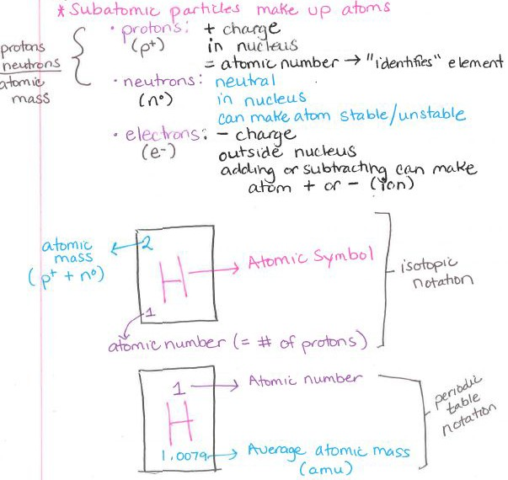
Image by Oak Harbor Public Schools | CC BY

Breaking the Code Notes
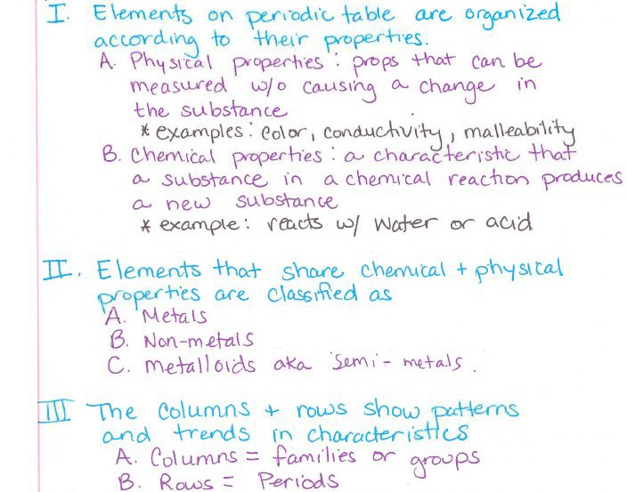
Image by Oak Harbor Public Schools | CC BY

Task: Structure and Properties of Matter
Part 1: Location on the Periodic Table
- What is the name of your element?
- Fill in the symbol for your element in the correct location.
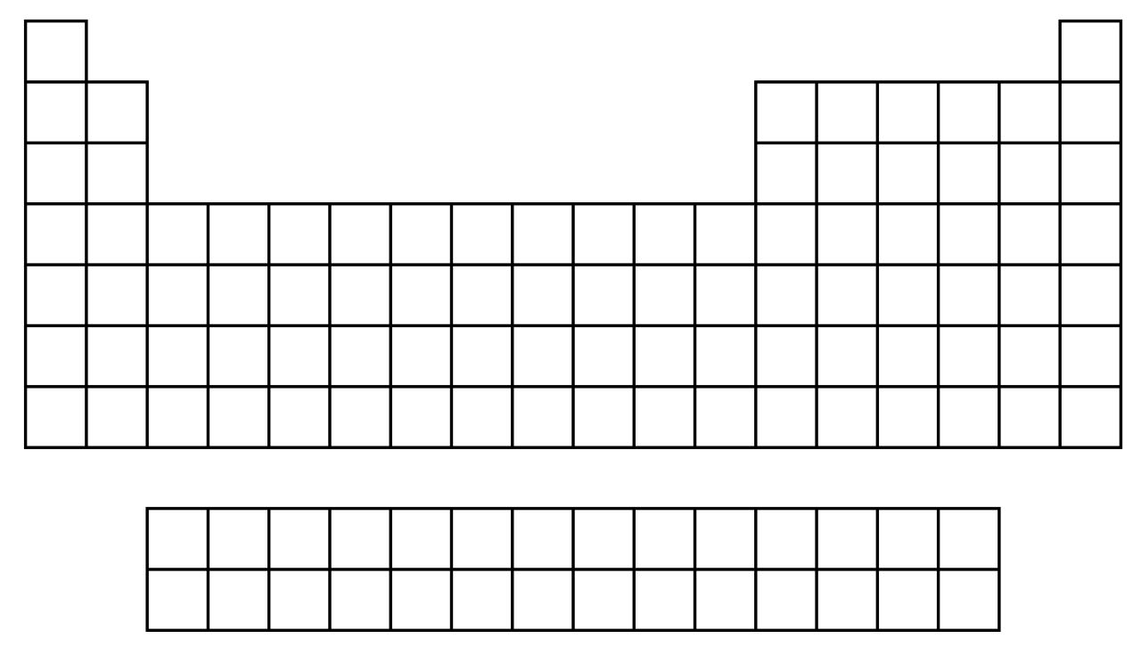
Part 2: Location versus Properties of Atoms
- Identify the number of each part of an atom of your element.
- Explain how the location of your element provides information about:
- Protons
- Total electrons
- Electrons in the outermost energy level
Part 3: Trends on the Periodic Table
- On the blank periodic table, fill in the symbol of another element in the same period as your element
  - Compare the atomic structure of your element to the other element
  - Compare the reactivity of your element to the other element
- On the blank periodic table, fill in the symbol of another element in the same group as your element
- Compare the atomic structure of your element to the other element
- Compare the reactivity of your element to the other element

Task Rubric: Structure and Properties of Matter
Learning Evidence | Points
Correct location of element on the Periodic Table
Correct number of protons, electrons and number of electrons in outermost shell
Correct explanation of how location indicates number of protons
Correct explanation of how location indicates total number of electrons
Correct explanation of how location indicates number of outer level electrons
Compare the structure of your element to an element in the same period
Compare the reactivity of your element to an element in the same period
Compare the structure of your element to an element in the same group
Compare the reactivity of your element to an element in the same group
Total | /9

Test: Structure and Properties of Matter
Name: Period:
- How many protons does carbon (C) have?
  - 4
  - 12
  - 14
  - 6
- What is similar between arsenic (As) and selenium (Se)? Select all that apply.
- number of outermost electrons
- number of protons
- number of total electrons
- reactivity
- nothing
- Which element has 85 protons?
  - krypton (Kr)
  - radium (Ra)
  - astatine (At)
  - rubidium (Rb)
- Which element has 7 outermost electrons?
  - bromine (Br)
  - neon (Ne)
  - nitrogen (N)
  - potassium (K)

- What is similar between oxygen (O) and sulfur (S)? Select all that apply.
- number of outermost electrons
- number of protons
- number of total electrons
- reactivity
- nothing
- How many total electrons does silicon (Si) have?
  - 28
  - 4
  - 3
  - 14
- How many outermost electrons does barium (Ba) have?
  - 6
  - 137
  - 56
  - 2
- Which of the following elements is most reactive?
  - sodium (Na)
  - aluminum (Al)
  - magnesium (Mg)
  - silicon (Si)

Unit 2:
Nuclear Processes
Return to Table of Contents
Except where otherwise noted, this work by Oak Harbor Public Schools is licensed under a Creative
Commons Attribution 4.0 License. All logos and trademarks are property of their respective owners.
Content purchased by Oak Harbor Public Schools and under All Rights Reserved copyright is referenced but not included in this document. It is marked with the $$ symbol.
Links to third-party websites are provided for your convenience only and do not constitute Oak Harbor Public Schools’ endorsement, sponsorship, warranty or approval of linked websites or any product, service or content offered on such linked websites. Please confirm the license status of these third-party resources and understand their terms of use.
Unit 2: Nuclear Processes

Standard
HS-PS1-8: Develop models to illustrate the changes in the composition of the nucleus of the atom and the energy released during the processes of fission, fusion, and radioactive decay. (fission, fusion, radioactive decay)

Model
Materials:
- Geiger counter
- Radioactive samples as available
- White plate
- Orange Fiestaware plate (U)
- Trinitite sample (Pu)
- Smoke detector (Am)
Procedure:
- Ask students to predict which item is most radioactive.
- Hold each item in close proximity to the Geiger counter.
- Students should draw a model of the uranium atom showing neutrons, protons and electrons.
- Students should draw a model of the atom after it has changed.
- Demonstrate what is happening in the model to make it radioactive.
Learning Objective:
- I can communicate my existing ideas about decay processes in the nucleus of an atom in terms of changing neutrons and protons.

Engage
POGIL Activities for High School Chemistry $$ : POGIL Isotopes
Isotope Notes
Learning Objectives:
- I can determine the number of protons and neutrons in an atom based on the isotope symbol.
- I can describe the similarities and differences in isotopes of an element.

Explore
Living by Chemistry$$: Nuclear Quest Game
Nuclear Quest Notes
Learning Objectives:
- I can explain the different processes involved in nuclear changes and the conditions required for those processes.
- I can explain the connection between nuclear changes and changes in atomic identity.

Explain
- Reading: CK-12 - Isotopes Note: You must register for a free account with CK-12 to access materials
Learning Objectives:
- I can write elements in isotopic notation.
- I can identify the number of neutrons in different isotopes.
- Reading: CK-12 - Nuclear Decay Processes
Learning Objective:
- I can differentiate between 3 different types of decay.
- Reading: CK-12 - Nuclear Fission Processes
Learning Objective:
- I can explain the process of fission.
- Reading: CK-12 - Nuclear Fusion
Learning Objective:
- I can explain the process of fusion.
- Reading: Types of Nuclear Decay Notes

Extend/Elaborate
Revisit Model
Redraw model of radioactive decay Include the following:
- Radioactive nucleus of uranium
- Arrow indicating change
- Alpha particle
- Thorium-234 nucleus

Learning Objective:
- I can revise a model to add detail about decay processes in the nucleus of an atom.
Worksheet
Living by Chemistry$$: “Old Gold” fusion and fission worksheet
Learning Objectives:
- I can explain how different elements are formed through nuclear reactions.
- I can write a mup question balanced nuclear chemical equation.
- I can describe the mechanism behind a nuclear chain reaction.

Evaluate: Nuclear Processes
Unit 2 Task
Unit 2: Test

Unit 2 - Nuclear Processes: Student Resources
Isotope Notes
Nuclear Quest Notes
Types of Nuclear Decay Notes
Task: Nuclear Processes
Task Rubric: Nuclear Processes
Test: Nuclear Processes

Isotope Notes
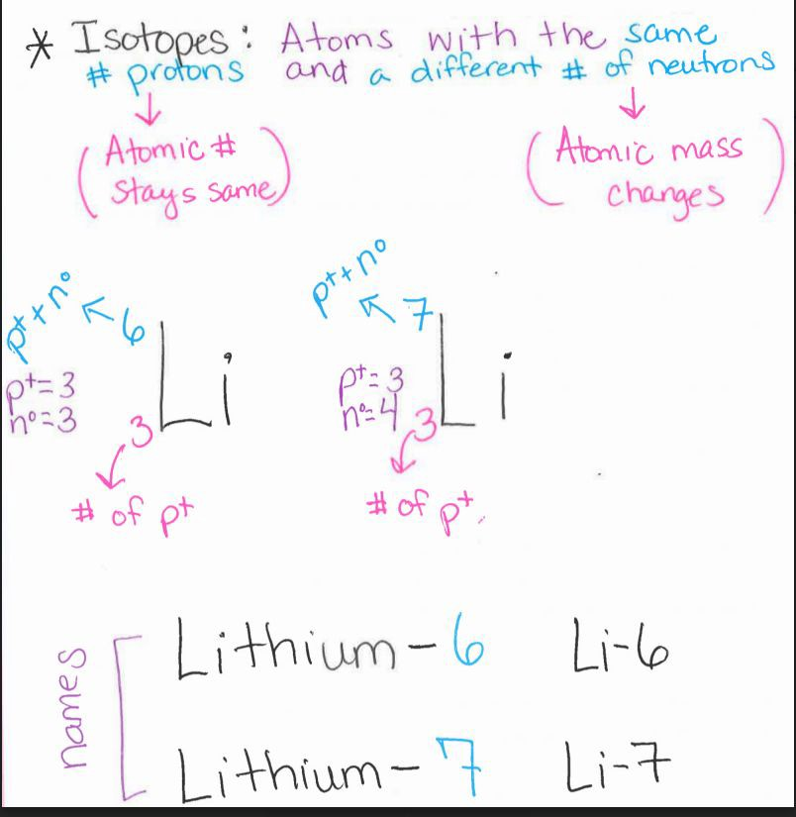
Image by Oak Harbor Public Schools | CC BY

Nuclear Quest Notes
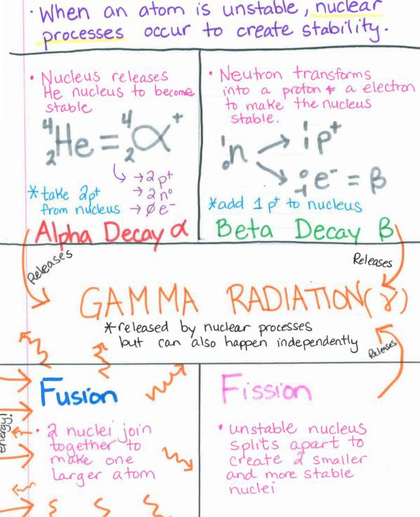
Image by Oak Harbor Public Schools | CC BY

Types of Nuclear Decay Notes
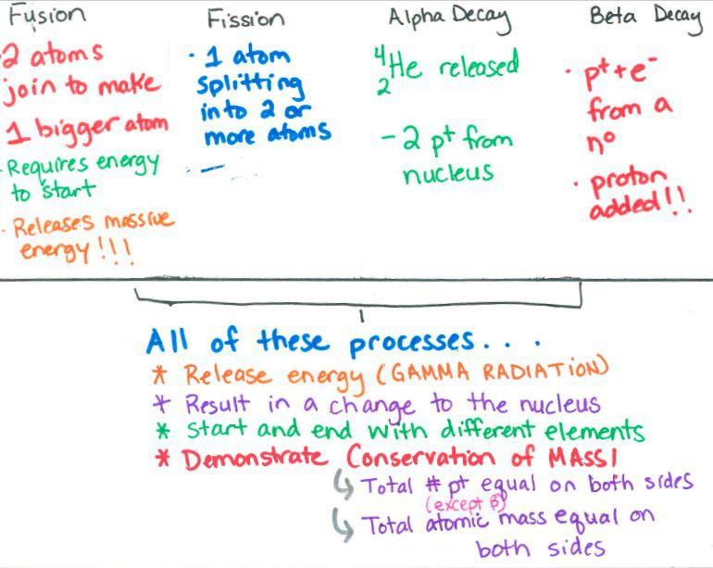
Image by Oak Harbor Public Schools | CC BY

Task: Nuclear Processes
Part 1: Modeling Fusion
For your chosen element:
- Create a new model that shows a nuclear fusion reaction that can produce your element.
- Describe how your model demonstrates what happens to the total number of neutrons plus protons & the energy of the system during the fusion reaction.
Part 2: Modeling Fission
For your chosen element:
- Create a new model that shows a nuclear fission reaction that could happen to your element.
- Describe how your model demonstrates what happens to the total number of neutrons plus protons & the energy of the system during the fission reaction

Task Rubric: Nuclear Processes
Learning Evidence | 1 Point
Model shows the correct number of neutrons in the nucleus before nuclear decay happens.
Model shows how nuclear decay happens including changes in numbers of protons and neutrons & flow of energy including gamma radiation.
Model correctly identifies the type of decay shown in (alpha or beta).
Model accurately shows a fusion process that could produce the element.
Accurate description of what happens to the total number of neutrons plus protons & the energy of the system during the fusion reaction.
Model accurately shows a nuclear fission reaction that could happen to your element.
Accurate description of what happens to the total number of neutrons plus protons & the energy of the system during the fission reaction.
Total | /7

Test: Nuclear Processes
Name: Period:
- The diagram below shows radon changing into radium and helium. What is the total mass of the products?
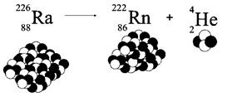
  - 4
  - 218
  - 222
  - 226
- What type of radioactive decay does not emit either protons or electrons?
  - alpha
  - beta
  - gamma
  - delta
- The diagram shows radioactive decay of radon. What happens to energy in this reaction?
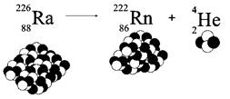
  - Large amounts of energy are released by this nuclear reaction.
  - Nuclear energy is transformed into chemical energy.
  - No energy is absorbed or released by this reaction.
  - Energy is absorbed by this reaction.
- What process does this image represent?
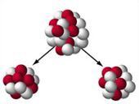
  - Radioactive decay because neutrons are separating from an atom.
  - Fusion because an atom separates to make two atoms.
  - Fusion because two atoms combine to become a larger atom.
  - Fission because an atom separates to make two smaller particles.
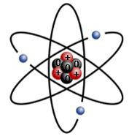
- An atom of which element is modeled in the diagram below?
The model uses + for protons and 0 for neutrons.
  - lithium
  - nitrogen
  - carbon
  - boron
- The type of radioactive decay shown in the diagram emits a helium atom. What type of radioactive decay is this?
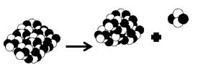
  - gamma
  - beta
  - alpha
  - epsilon

Unit 3:
Life Cycle of Stars
Return to Table of Contents
Except where otherwise noted, this work by Oak Harbor Public Schools is licensed under a Creative
Commons Attribution 4.0 License. All logos and trademarks are property of their respective owners.
Content purchased by Oak Harbor Public Schools and under All Rights Reserved copyright is referenced but not included in this document. It is marked with the $$ symbol.
Links to third-party websites are provided for your convenience only and do not constitute Oak Harbor Public Schools’ endorsement, sponsorship, warranty or approval of linked websites or any product, service or content offered on such linked websites. Please confirm the license status of these third-party resources and understand their terms of use.
Unit 3: Life Cycle of Stars

Standards
HS-ESS1-1: Develop a model based on evidence to illustrate the life span of the sun and the role of nuclear fusion in the sun’s core to release energy that eventually reaches Earth in the form of radiation.
HS-ESS1-3: Communicate scientific ideas about the way stars, over their life cycle, produce elements.

Model
Question: How does the sun work?
- Model the life cycle of a Human.
- Model the life cycle of a Star:
- After watching the video of the sun, describe which part of your model demonstrates where the sun is in the cycle. Video from Guardian News and Media
Learning Objective:
- I can communicate my existing ideas about life cycles of stars.

Engage
POGIL Activities for High School Chemistry$$: Life Cycle of Stars
Life Cycles of Stars Notes
Learning Objectives:
- I can draw and label a diagram that shows five stages of the life cycle for three types of stars.
- I can compare the life spans of five types of stars.
- I can describe how the core temperature of a star changes over its life cycle

Explore
POGIL Activities for High School Chemistry$$: How the matter of the universe is created in stars
How the matter of the universe is created in stars Notes
Learning Objectives:
- I can describe the basic process of fusion that occurs in a star to create new types of atoms.
- I can describe the relationship between the stage of a star’s life cycle and the types of elements produced at that stage, based on evidence from analyzing a star life cycle diagram and basic data table.
- I can describe how the mass of a star affects the masses of elements produced over the entire lifespan of low-to-average mass stars, large mass stars, and very large mass stars.

Explain
- Reading: CK-12 - Star Life Cycles Note: You must register for a free account with CK-12 to access materials
- Reading: CK-12 - Star Power
- Video: The Elements: Forged in Stars | PBS Learning Media - NOVA
- Kesler Stations$$: Life Cycle of a Star
Learning Objectives:
- I can describe the life cycle of stars, including stages & different forms of star death.
- I can explain how the process of nuclear fusion creates heavy elements inside of stars.

Extend/Elaborate:
Revisit Model
Add the following to your model:
- Fusion of hydrogen
- Main sequence
- Nebula
- Red giant
- Average mass star
- Fusion of elements up to #26 (Fe)
- White dwarf
- Planetary nebula
Learning Objective:
- I can revise a model to add detail about the life cycle of stars.

Evaluate: Life Cycle of Stars
Unit 3 Task
Unit 3 Test

Unit 3 – Life Cycle of Stars: Student Resources
Notes: Life Cycles of Stars
Notes: How the Matter of the Universe is Created in Stars
Task: Life Cycle of Stars
Task Rubric: Life Cycle of Stars
Test: Life Cycle of Stars

Life Cycles of Stars Notes
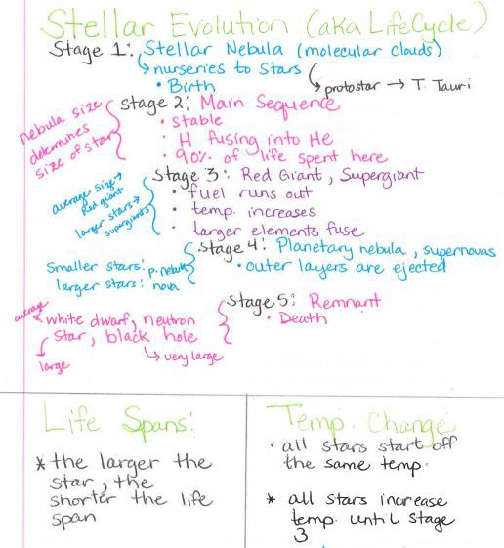
Image by Oak Harbor Public Schools | CC BY

How the Matter of the Universe is Created in Stars Notes
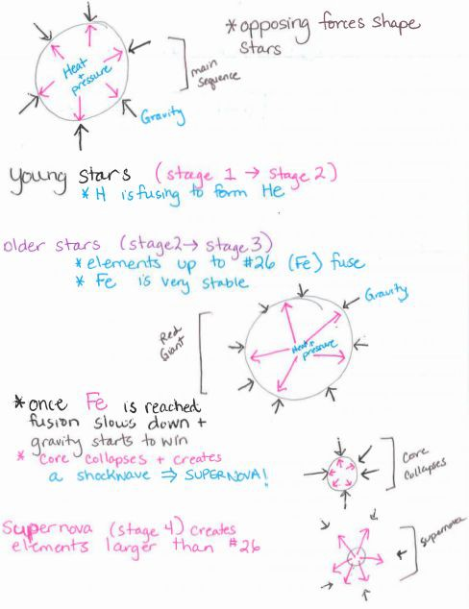
Image by Oak Harbor Public Schools | CC BY

Task: Life Cycle of Stars
Part 1: Modeling fusion in the Sun
Create a model of the sun to illustrate the following:
- Life span of the sun.
- What determines the life span of the sun.
- The role of nuclear fusion in the sun’s core to release energy
- How energy is transferred from the sun to Earth in the form of radiation.
Part 2: Explaining origin of elements
- Write a paragraph that explains the relationship between the life cycle of the stars, the production of elements, and the conservation of the number of protons plus neutrons in stars.
- Write a paragraph that describes which elements are formed by which processes (Big Bang, fusion in star cores, death of stars).
Part 3: Explaining origin of your element
- Using the format of your choice, describe the process that formed your chosen element.
- If formed in the core of a star, identify the star’s mass and stage of development.
- If formed during the death of a star, identify the type & size of the star and the process of its death.

Task Rubric: Life Cycle of Stars
Learning Evidence | 1 Point
Model identifies the sun’s fuel.
Model shows the products of the fusion processes in the sun.
Model indicates the approximate life span of the sun and the reason for that life span
Model shows how energy released by the sun reaches earth
Explains the relationships between the life cycle of the stars, the production of elements, and the conservation of the number of protons plus neutrons in stars.
Describes which elements are formed from high-energy collisions of protons and neutrons during the Big Bang/ early universe before any stars existed.
Describes which elements are formed by fusion in star cores.
Describes which elements are formed by star death.
Describes the process which formed the chosen element.
- If formed in a star, identify the star’s mass and stage of development.
- If formed during the death of a star, identify the type & size of the star and the process of its death.
Total | /9

Test: Life Cycle of Stars
Name: Period:
- What is the approximate life span of the sun?
  - 100 million years
  - 10 billion years
  - 5 million years
  - 100,000 years
- What happens during nuclear fusion?
  - Chemical bonds are broken, forming new compounds and releasing energy.
  - Atoms disintegrate completely, forming individual atomic particles and releasing energy.
  - Atoms combine, forming heavier elements and releasing energy.
  - Large atoms split, forming lighter elements and releasing energy.
- The energy released from fusion reactions in the core of a star should cause the star to explode. What prevents a star from exploding?
  - Gravitational force
  - Electromagnetic force
  - Weak nuclear force
  - Strong nuclear force
- Which process forms elements heavier than iron?
  - Death of a star
  - Fusion in star cores
  - Cosmic ray interaction
  - The Big Bang

- What happens during nuclear fusion?
  - The total number of atoms remains the same.
  - The total number of neutrons and protons remains the same.
  - The total number of neutrons and protons increases.
  - The total number of neutrons and protons decreases
- Which element below is formed by fusion in star cores?
  - Hydrogen
  - Gold
  - Helium
  - Uranium
- What do all stars begin as?
  - Nebula
  - White Dwarf
  - Red Giant
  - Supernova
- How is the energy that warms the surface of Earth and powers life on Earth transferred from the sun?
  - Heat energy from combustion reactions in the sun is conducted through space to Earth.
  - Atoms of hydrogen and helium from the core of the sun are transported to Earth by solar winds.
  - Electromagnetic radiation released from fusion reactions carries energy from the sun to Earth.
  - Kinetic energy of atoms is carried from the core of the sun to Earth's atmosphere by convection.

Unit 4:
Bonding and Bond Energy
Return to Table of Contents
Except where otherwise noted, this work by Oak Harbor Public Schools is licensed under a Creative
Commons Attribution 4.0 License. All logos and trademarks are property of their respective owners.
Content purchased by Oak Harbor Public Schools and under All Rights Reserved copyright is referenced but not included in this document. It is marked with the $$ symbol.
Links to third-party websites are provided for your convenience only and do not constitute Oak Harbor Public Schools’ endorsement, sponsorship, warranty or approval of linked websites or any product, service or content offered on such linked websites. Please confirm the license status of these third-party resources and understand their terms of use
Unit 4: Bonding and Bond Energy

Standards
HS-PS1-2: Construct and revise an explanation for the outcome of a simple chemical reaction based on the outermost electron states of atoms, trends in the periodic table, and knowledge of the patterns of chemical properties.
HS-PS1-4: Develop a model to illustrate that the release or absorption of energy from a chemical reaction system depends upon the changes in total bond energy.

Model
Question: How does a chainsaw/engine work?
Materials:
- Gas powered chainsaw
Procedure:
- Take students outside to watch the starting of a chainsaw.
Learning Objective:
- I can describe how a steam engine works.

Engage
Kesler Stations$$: Chemical Bonds
Learning Objectives:
- I can describe how elements form bonds.
- I can investigate how valence electrons relate to chemical bonds. I can differentiate between ionic and covalent bonding.

Explore
Bond Energy
Learning Objectives:
- I can determine which fuel causes the steam powered boat to travel the greatest distance.
- I can illustrate that the release or absorption of energy from a chemical reaction system depends on the changes in total bond energy.
- I can describe the relationship between chemical bonds and energy.

Explain
- Reading: CK-12 - Molecular Formula Note: You must register for a free account with CK-12 to access materials
- Reading: CK-12 - Electron Dot Diagrams
- Reading: CK-12 - Octet Rule
Learning Objective
- I can explain the outcome of a simple chemical reaction based on the outermost electron states of atoms.
- Reading: CK-12 - Ionic Bond
- Reading: CK-12 - Covalent Bond
Learning Objective
- I can identify the numbers and types of bonds in products and reactant.
- Reading: CK-12 - Combustion Reaction
Learning Objective:
- I can discuss how patterns of attraction allow the prediction of the type of reaction that occurs.
- Reading: CK-12 - Bond Energy
- Reading: Bond Energy Notes
- Reading: CK-12 - Potential Energy Diagrams
- Reading: CK-12 - Endothermic Reactions
- Reading: CK-12 - Exothermic Reactions
Learning Objectives:
- I can explain that the release or absorption of energy from a chemical reaction system depends on the changes in total bond energy.
- I can identify/ speculate what type of bond (single, double, triple) is present in the fuel burned based on the info in the bond energy table.

Extend/Elaborate
Revisit Model
Make adjustments and add detail. Include the following:
- endothermic
- exothermic
- bonding
- activation energy
Learning Objective:
- I can revise a model based on evidence to illustrate or predict relationships between components of a system

Evaluate: Bonding and Bond Energy
Unit 4: Task
Unit 4: Test

Unit 4 – Bonding and Bond Energy: Student Resources
Chainsaw Model
Bond Energy
Investigation: Steam Boat
Bond Energy Notes
Task: Bonding and Bond Energy
Test: Bonding and Bond Energy

Chainsaw Model
Explain how you think a chainsaw/engine works.
Draw a model of the chainsaw system.
A system is a group of related parts that make up a whole and can carry out functions its individual parts cannot. Your model should include:
- The main parts of the chainsaw system (include only big, general parts, not detailed mechanical parts)
- The inputs and outputs of matter (What kind of matter goes into the system & what kinds come out?)
- The inputs and outputs of energy (What form of energy goes into the system & what forms come out?)
- An explanation of where and how any transformations of matter or energy are happening
Research “Greenhouse Gases”: What is a greenhouse gas?
List three examples of greenhouse gasses.
Describe one example of how a greenhouse gas is produced by human activity

Bond Energy
What fuel makes the boat go farthest?
Model 1: Energy of bonds in a reaction system
In Model 1 natural gas (methane) is burned by combining methane (CH4) with oxygen (O2) and lighting the flame. This results in the production of carbon dioxide (CO2) and water (H2O). 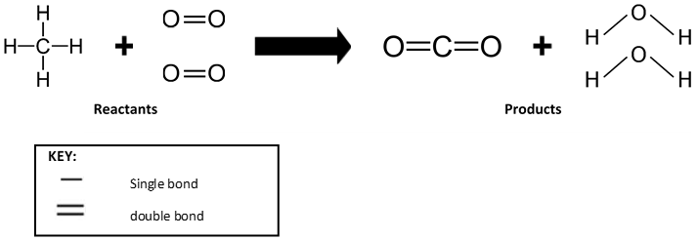
- What do the symbols H, C, and O stand for?
- What does one line stand for?
- What do the two lines between the oxygen and carbon represent?
- What are the chemical formulas for the reactants?
- What are the chemical formulas for the products?
- Based on Model 1, describe how the bonds around the carbon atom change from reactants to products.

Read This:
During chemical reactions, electrons move around and bonds change. For a chemical reaction to occur, some bonds must be broken and other bonds must be formed. An input of energy to the system is always required to break a bond. That is why methane must be lit with a match to start the flame burning.
As bonds are formed to make the products, energy is released.
- Identify which bonds are broken in the reaction in Model 1.
- Identify which bonds are formed in the reaction in Model 1.
- Describe where the energy will go when the bonds are formed to make the products.
Model 2: Graphs of energy moving in a reaction system
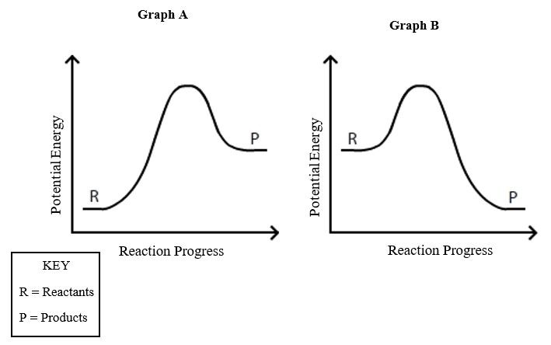
- What does the x-axis on the graphs in Model 2 represent?
- What does the y-axis on the graphs in Model 2 represent?

- On Model 2, for both graphs, label where chemical bonds are broken.
- On Model 2, for both graphs, label where chemical bonds are formed.
- Explain why both graphs have a “bump” in energy rather than just a steady increase or decrease.
- In which graph, A or B, is more potential energy found in the products?
- In which graph, A or B, is more potential energy found in the reactants?
Model 3: Diagrams of energy moving in a reaction system
- The reaction systems represented by Graph A and Graph B are shown in the beaker diagrams above. Draw an arrow labeled “energy” on each diagram to show whether energy leaves the beaker and enters the surroundings or vice versa.
Conclusions
- In System A, is the total energy of the system and surroundings the same before and after the reaction? Explain your answer.
- Explain which of the graphs in Model 2 represents a chemical reaction that would provide energy to power the steam boat.

Investigation: Steam Boat
Objective: Determine which fuel causes the steam-powered boat to travel the greatest distance.
Safety:
- Safety goggles must be worn.
- Exhaust pipes must be completely filled with water and the boat must be placed into the container (while keeping the water in the engine and exhaust pipes) before lighting any fuel. Failure to keep the system full of water will cause permanent damage to the boat engine.
Materials:
- Steam powered boat
- Fuel holder
- Fuel source you select
- Lighter
- Container
Procedure:
- Choose a fuel that you think will power the boat for the longest distance around a circular container.
- Measure the mass the fuel holder and your chosen solid fuel. No nut products.
- Set up the boat in the container as demonstrated by your teacher.
- Line the boat up at the starting point on the container. Ignite your fuel.
- Count the number of laps that your boat completes. Include the total number of laps and any completed quarters (as marked on the container).
- Measure the mass of fuel holder and fuel after running boat.
- Record the number of laps your boat completed on your group data table for trial 1.
- Repeat steps 4-7 two more times for trials 2 & 3.
- Calculate the average number of laps for the three trials and record the average on the class data table provided by your teacher.
- Clean up all materials.
Data Table:
 | Trial 1  1 | Trial 2 | Trial 3 | Average
Mass of fuel & holder before burning
Number of laps
Mass of fuel and holder  after burning |  |  |  | NA
Mass of fuel burned
Laps/grams fuel
Analysis:
- Refer to class data to answer the following question:
  - Which fuel caused the steam-powered boat to travel the greatest distance? Support your answer.
- Using Model 1 as a reference, create a model showing the combustion reaction of your fuel.
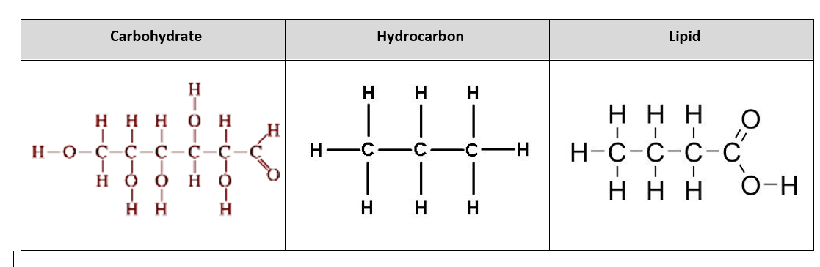
Draw your chemical reaction here:
- Copy the reaction from Model 1 in the space above, but replace the methane (CH4) molecule with the molecule from the table at the top that matches your fuel type.
- Draw the correct number of each reactant and product to show that atoms are conserved in the reaction.
- Label the reactants and products in the reaction.
- Identify which bonds are broken in the reaction.
- Identify which bonds are formed in the reaction.

- Use Model 2 as a guide to complete the following:
  - Sketch an energy graph for a combustion reaction.
  - Draw a line representing the energy change for the fuel that traveled the greatest distance.
  - On the same graph, in a different color, include a line for the fuel that traveled the least distance.
  - For both lines, include labels for the type of fuel, the reactants, and the products.
- Use questions 17 and 18 as a guide to complete the following:
- Create a model showing the energy transfer between the system and surroundings for your boat during the combustion of your fuel.

Bond Energy Notes
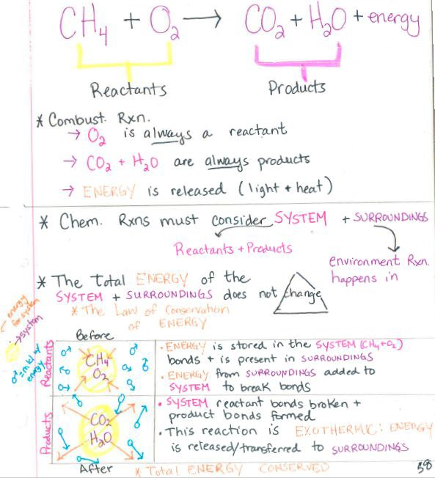
Image by Oak Harbor Public Schools | CC BY

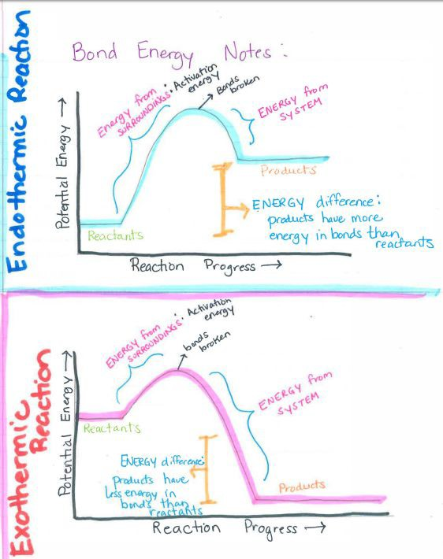
Image by Oak Harbor Public Schools | CC BY

Task: Bonding and Bond Energy
Technical Manual Chapter 1 - Bonding & Bond Energy
For this task, you will write the first chapter of the Operator's Manual for the Steam-Powered Boat that your team will construct. You don’t have to have a design for your heat engine picked out yet, but you do need to pick a fuel that you will burn.
Step 1. Choose a fuel
Select a fuel from the following list:

Carbohydrates
- Potato chips
- Wood/paper
Hydrocarbons
- Petroleum jelly
- Candle wax
Lipids
- Butter
- Vegetable oil

This first chapter of your manual will explain how the concepts of chemical bonding and bond energy play a role in the operation of a heat engine burning the fuel you have chosen.
This chapter will contain three parts. Each part is described in detail on the following pages.

Part 1: Explanation of the chemical reaction when burning your fuel
- For the chemical reaction of your group’s chosen fuel, construct an explanation of the burning of the fuel that:
Includes complete chemical equation including correct chemical formulas for products and reactants.
0 - Inadequate | 1 - Below | 2 - Approaching | 3 - Meets | 4 - Exceeds
Chemical equation is missing | All chemical formulas are incorrect  OR  Chemical Equation does not have carbon dioxide | One or more chemical formulas are incorrect.  AND  One or more reactants or products is in wrong location or missing | One chemical formula is incorrect  OR  Reactant or product is in wrong location or missing | All requirements are present
Identifies the types of bonds (ionic or covalent) found in each reactant and product.
0 - Inadequate | 1 - Below | 2 - Approaching | 3 - Meets | 4 - Exceeds
Did not identify any type of bonds. | All types of bonds identified are incorrect. | Two or more of the bond types are incorrect or missing. | One of the bond types is incorrect or missing. | All bond types are identified correctly.
Explains how the type of bond in each reactant and product is determined based on the numbers of valence electrons and positions on the periodic table.
0 - Inadequate | 1 - Below | 2 - Approaching | 3 - Meets | 4 - Exceeds
Explanation is missing | Explanation not mention anything about valence electrons or position on the periodic table | Explanation has two or more errors in the number of valence electrons or the position on the periodic table | Explanation has one error in the number of valence electrons or the position on the periodic table | Explanation given is correct for all reactants and products

Part 2: Graph of Chemical Reaction Energy
- For the chemical reaction of burning your group’s chosen fuel, make a graph of the energy of the system as the reaction proceeds.
Critical elements for your graph
    - Horizontal axis labeled correctly
    - Vertical axis labeled correctly
    - Label(s) for energy transfer(s) into and/or out of the system
    - Reactants placed correctly on graph
    - Products placed correctly on the graph
    - Description of the bonds that are breaking during the reaction
    - Description of the bonds that are forming during the reaction.
Make a graph of the energy of the system as the reaction proceeds.
0 - Inadequate | 2 - Below | 4 - Approaching | 6 - Meets | 8 - Exceeds
Graph is missing | Four or more critical elements are incorrect or missing | Two or three of the listed critical requirements are incorrect or missing | One of the listed critical elements is incorrect or missing: | All critical elements are present and correct.

Part 3: Energy of the system
For the chemical reaction of burning your group’s chosen fuel:
- Make two sketches comparing the motion of molecules of the system and surroundings before and after the reaction.
  - Sketch 1: reactants and the surroundings before the reaction
  - Sketch 2: products and the surroundings after the reaction
- Describe the total energy of the system and its surroundings before and after the reaction.
- Sketch 1 : Before the reaction
0 - Inadequate | 1 - Below | 2 - Approaching | 3 - Meets | 4 - Exceeds
Sketch is missing | A sketch is present but is missing a majority of the requirements | Missing reactant molecule  AND  Missing energy or surroundings | Missing reactant molecule  OR  Missing energy  OR  Missing surroundings | Shows motion of reactant molecules and the system.  Describes the total energy of the system and surroundings.
- Sketch 2 : After the reaction
0 - Inadequate | 1 - Below | 2 - Approaching | 3 - Meets | 4 - Exceeds
Sketch is missing. | A sketch is present but is missing a majority of the requirements. | Missing product molecule  AND  Missing energy or surroundings | Missing product molecule  OR  Missing energy  OR  Missing surroundings | Shows motion of product molecules and the system.  Describes the total energy of the system and surroundings.

Test: Bonding and Bond Energy
Name: Period:
- Based on the valence electrons, which of the following elements would likely form an ionic bond with bromine?
  - Oxygen
  - Calcium
  - Phosphorus
  - Argon
- What are the reactants in the chemical equation: NaCl + AgNO₃ → AgCl + NaNO₃
  - AgCl and NaNO₃
  - NaCl and AgCl
  - AgNO₃ and NaNO₃
  - NaCl and AgNO₃
- Which bond(s) is/are formed in the following reaction? Select all that apply. Na₂S + HCl → NaCl +
  - H₂S
  - H —Cl
  - H—S
  - Na—S
  - Na—Cl
- What happens to the energy of the system over the course of the chemical reaction shown in the energy graph?
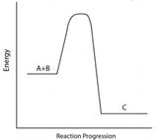
  - energy enters the system
  - energy remains the same
  - energy leaves the surroundings
  - energy leaves the system
- Which bond(s) is/are broken in the following reaction? Select all that apply. H₂ + Cl₂ → HCl
  - H —H
  - H—Cl
  - Cl—Cl
  - No bonds are broken
- Which of the following compounds are held together by covalent bonds?
  - CO
  - Na₃N
  - LiF
  - MgCl₂
- In a hydrocarbon combustion reaction, energy is released into the surroundings. What happens to the movement of the molecules surrounding the reaction?
  - The molecules surrounding the reaction will slow down
  - The molecules surrounding the reaction will move faster
  - The molecules surrounding the reaction will split apart
  - The molecules surrounding the reaction will join together
- What type of bond would calcium and chlorine make?
  - metallic
  - hydrogen
  - covalent
  - ionic
- Which of the following compounds is held together by ionic bonds?
  - SO₂
  - MgCl₂
  - CH₄
  - NH₃
- Based on the valence electrons, which of the following elements would likely form a covalent bond with bromine?
  - Argon
  - Nickel
  - Oxygen
  - Calcium
- Which of the following is required to break bonds?
  - the addition of a catalyst
  - the combustion of a molecule
  - the input of energy from the surroundings
  - the release of energy to the system and surroundings
- What are the products in the chemical equation: NaCl + AgNO₃ → AgCl + NaNO₃
  - NaCl and AgCl
  - AgNO₃ and NaNO₃
  - NaCl and AgNO₃
  - AgCl and NaNO₃
- What type of bond would nitrogen and oxygen make?
  - metallic
  - covalent
  - ionic
  - hydrogen
- What happens to the overall energy of the system and surroundings during a chemical reaction?
  - decreases
  - increases
  - stays the same

Unit 5:
Mass Conservation
Return to Table of Contents
Except where otherwise noted, this work by Oak Harbor Public Schools is licensed under a Creative
Commons Attribution 4.0 License. All logos and trademarks are property of their respective owners.
Content purchased by Oak Harbor Public Schools and under All Rights Reserved copyright is referenced but not included in this document. It is marked with the $$ symbol.
Links to third-party websites are provided for your convenience only and do not constitute Oak Harbor Public Schools’ endorsement, sponsorship, warranty or approval of linked websites or any product, service or content offered on such linked websites. Please confirm the license status of these third-party resources and understand their terms of use
Unit 5: Mass Conservation

Standard
HS-PS1-8: Develop models to illustrate the changes in the composition of the nucleus of the atom and the energy released during the processes of fission, fusion, and radioactive decay. (fission, fusion, radioactive decay)

Model
Question: What happens to a piece of flash paper when it burns?
Materials:
- Flash paper
- Electronic balance
- Watch glass
Procedure:
- Place watch glass on electronic balance Tare balance with watch glass
- Add flash paper to watch glass Students observe mass of paper Light the paper on fire
- Complete drawing and questions on the worksheet
Learning Objective:
- I can communicate my existing ideas about conservation of mass.

Engage
ADI Physical Science Lab 4$$: Conservation of Mass including Investigation Proposal C
Learning Objective:
- I can design an investigation to determine if mass is conserved in a chemical reaction.

Explore
Kesler Stations$$: Balancing Chemical Equations
POGIL$$: Relative Mass and the Mole
POGIL$$: Mole Ratios

Learning Objectives:
- I can recognize whether a chemical equation is balanced or not. I can relate balanced equation the law of conservation of mass. I can use the mole to convert from atoms to grams.
- I can calculate the mass of any component of a reaction, given any other component. I can relate balanced equation the law of conservation of mass.

Explain
Reading: CK-12 Chemical Equations
Reading: CK-12 Balancing Equations
Reading: CK-12 Molar Mass
Reading: CK-12 Avogadro’s Number
Reading: CK-12: Conversions Between Moles and Atoms
Reading: CK-12: Conversions Between Moles and Mass
Reading: CK-12: Conversions Between Mass and Number of Particles
Reading: CK-12: Mole Ratios
Reading: CK-12: Mass-Mole and Mole-Mass Stoichiometry
Reading: CK-12: Mass-Mass Stoichiometry
Law of Conservation of Matter Notes
Balancing Equations Notes
Conversion Notes
Balancing and Mole Graphic Organizer Review
Stoichiometry Notes
Learning Objectives:
- I can recognize whether a chemical equation is balanced or not.
- I can relate balanced equation the law of conservation of mass. I can use the mole to convert from atoms to grams.
- I can calculate the mass of any component of a reaction, given any other component.
- I can relate balanced equation the law of conservation of mass.

Extend/Elaborate
- Bottle Rocket Investigation
Materials:
- Piezo electric bottle launcher system
- Uniform size and shape plastic beverage bottles
- Hydrogen tank or source of hydrogen
- Large sink
Procedure
Students predict what ratio of hydrogen to air will move the rocket farthest along the floor.
Show students how to collect air by displacement of water from a bottle.
Students develop an investigation to determine to test their prediction.
- ADI Chemistry $$: Lab 14: Molar Relationships
Student Challenge: What are the Identities of the Unknown Compounds?
Learning Objective:
- I can identify unknown substances using molar masses.
- Revisit Model
Include the following:
- Conservation of matter
- Conservation of mass
Learning Objective:
- I can revise a model to add detail about conservation of mass in chemical reactions.

Evaluate: Mass Conservation
Unit 5: Task Task Answers
Unit 5: Test

Unit 5 – Mass Conservation: Student Resources
Mass Conservation Model
Law of Conservation of Matter Notes
Balancing Equations Notes
Conversion Notes
Stoichiometry Notes
Balancing and Mole Graphic Organizer
Bottle Rocket Investigation
Bottle Rocket Lab Report Rubric
What are the Identities of Unknown Compounds
Unit 5 Task: Mass Conservation
Values and Answers for Task Unit 5
Unit 5 Test: Mass Conservation

Mass Conservation Model
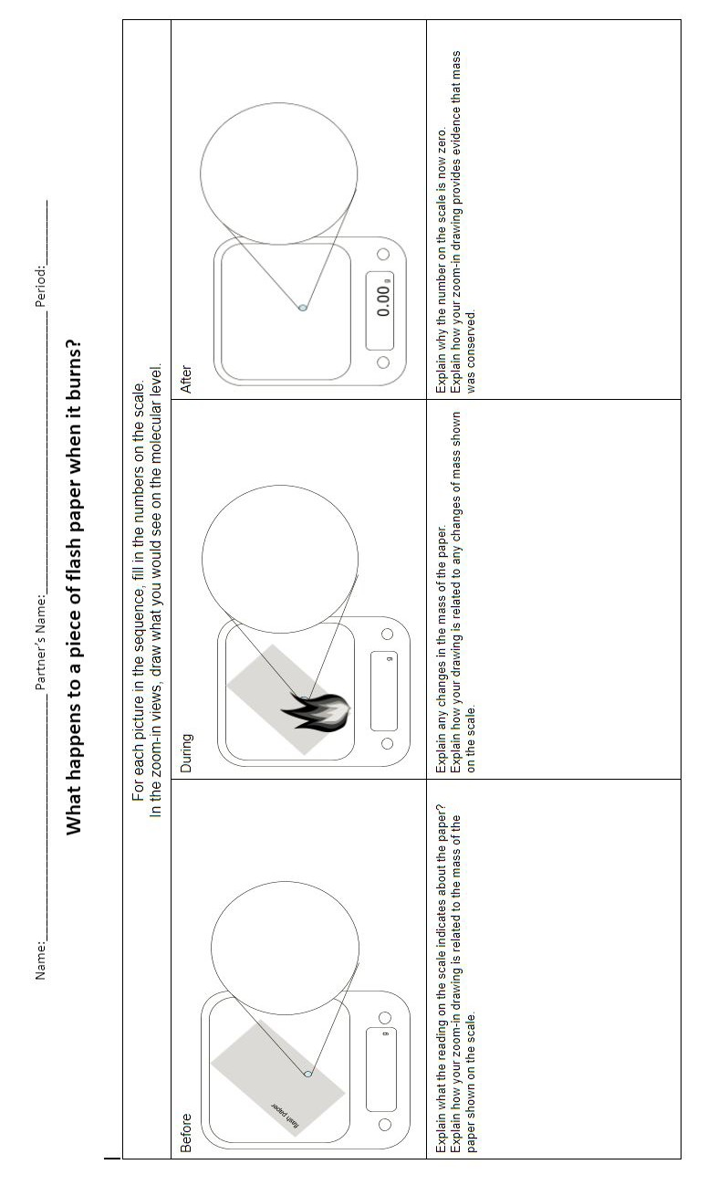

Law of Conservation of Matter Notes
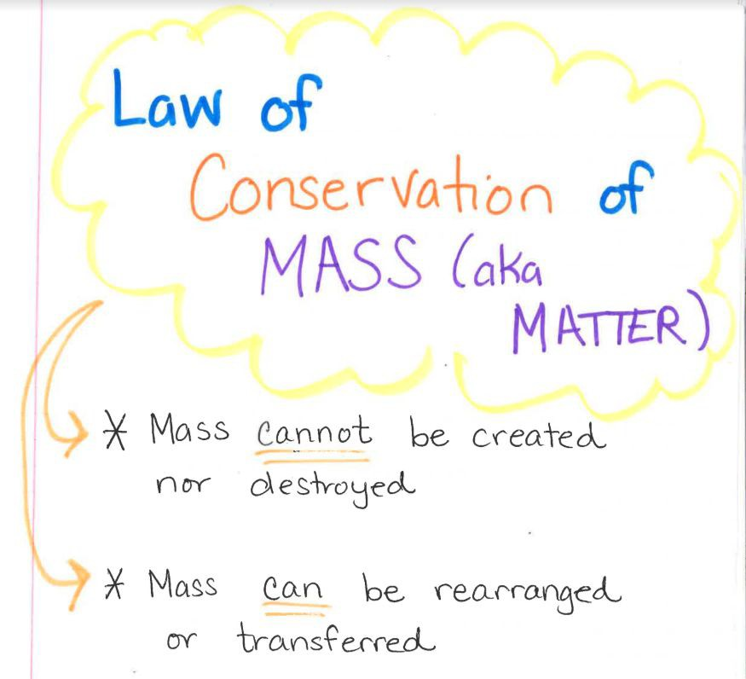
Image by Oak Harbor Public Schools | CC BY

Balancing Equations Notes
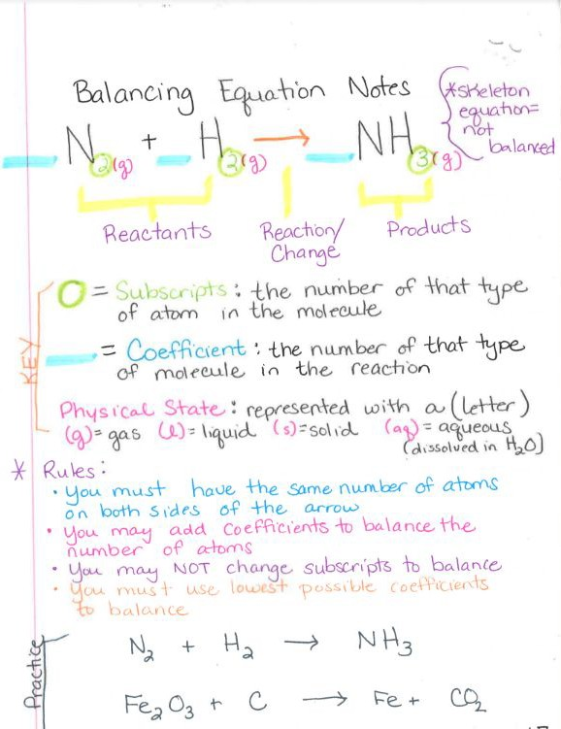
Image by Oak Harbor Public Schools | CC BY

Conversion Notes
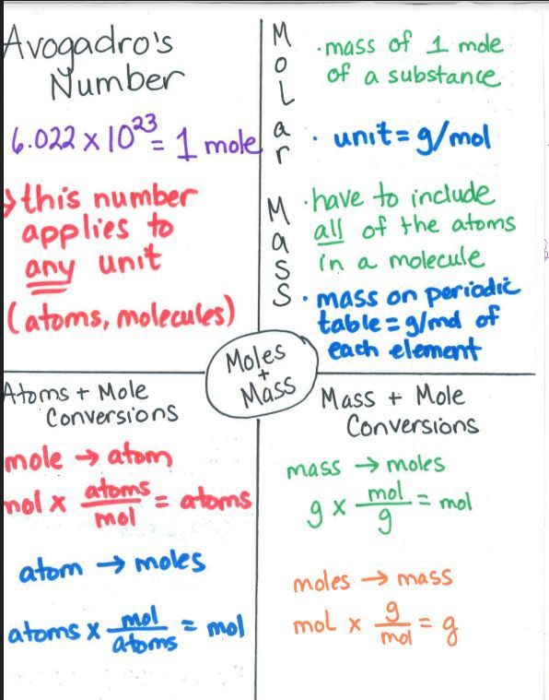 Image by Oak Harbor Public Schools | CC BY

Stoichiometry Notes
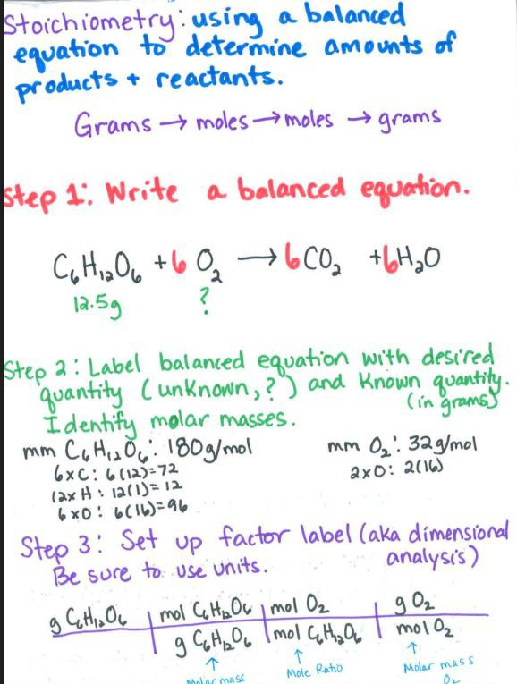
Image by Oak Harbor Public Schools | CC BY

Balancing and Mole Graphic Organizer and Review
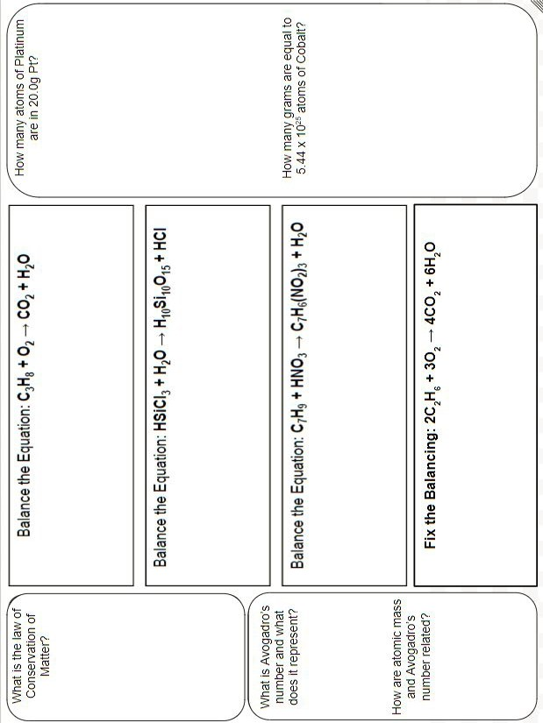

Bottle Rocket Investigation
Question: How does the ratio of H2 to O2 affect the distance a bottle rocket travels?
Hypothesis:
Materials:
Procedure:

Data:
Distance Traveled (in m) versus Ratio of Hydrogen:Oxygen
Ratio | Trial 1 (m) | Trial 2 (m) | Trial 3 (m) | Average (m)
Conclusion:

Bottle Rocket Lab Report Rubric
Attribute | Evidence | 1 point each
Question | Question includes both manipulated and responding variables to be examined in the investigation. | NA
Hypothesis | Must answer the given investigative question including the effect of the manipulated variable on the responding variable and indicate of the effect. (i.e. will increase, will decrease)
 | Prediction Reason This part of the hypothesis is a reasonable explanation of the process that produces the change in the responding variable
Materials | A list of the required materials needed to perform the procedure must be listed in this section. (be sure to include instruments needed to measure the responding variable) | NA
Procedure | Controlled Variables At least two controlled (kept the same) variables must be identified by highlighting in green.
 | Only one manipulated (changed) variable is identified by highlighting in pink.
 | The responding (dependent) variable is identified by highlighting in yellow.
 | Record Measurements: How measurements are recorded is identified by highlighting in blue.
 | Repeated trials. Plan for including multiple trials is identified by highlighting in orange.
 | Logical Steps: The steps of the procedure are detailed enough to repeat the procedure effectively. This should be a numbered list. Indicate which steps to repeat as part of the procedure.) | NA
Data | A data table for the manipulated and responding variables | NA
 | The data table shows data for repeated trials
 | The table shows averages calculated from all repeated trials
Conclusion | A conclusive statement is given—Answer the investigative question. Describe the effect of the Manipulated Variable on the Responding Variable.
 | Data from the data table to prove the conclusive statement is given — quote data from the LOWEST condition tested
 | Data from the data table to prove the conclusive statement is given — quote data from the HIGHEST condition tested
 | Explanatory language is used to connect or compare the supporting data to a correct conclusion—use words like “highest” and “lowest”
 | A scientific explanation for the observed results is given – explain why or how the MV caused the change in the RV.
 | Total | /14
 | Percentage

Guiding Question: What are the Identities of the Unknown Compounds?
Bag #1= .125 mol Bag #2= .0500 mol Bag #3= .0100 mol
Task
You will be given three sealed bags. Each bag will be filled with a different powder. Your task will be to identify the powder in each bag. The unidentified powders could be any of the following compounds:
- Sodium hydrogen carbonate, NaHCO3
- Sodium carbonate, Na2CO3
- Sodium chloride, NaCl
Materials
- You may use any of the following materials during your investigation:
- Sealed plastic bags of unknown compounds
- Empty plastic bag
- Electronic balance
- Periodic table
- calculator

Task: Mass Conservation
Technical Manual Unit 5 - Mass Conservation
For this task, you will write the second chapter of the Operator's Manual for the Steam-Powered Boat that your group will construct. You don’t have to have a design for your heat engine picked out yet, but you do need to analyze the combustion reaction that your fuel undergoes in your engine.
This chapter will include three parts described below:
Part 1: Balancing equations and explaining conservation of mass
  - Write a balanced chemical equation for the combustion of the fuel you will use in your steam-powered boat.
0 - Inadequate | 1 - Below | 2 - Approaching | 3 - Meets | 4 - Exceeds
Chemical equation is missing | All chemical formulas are incorrect  OR  Chemical Equation is missing either a product or reactant | One or more chemical formulas are incorrect.  AND  One or more of products or reactants are not correctly balanced | One chemical formula is incorrect  OR  One or more of products or reactants are not correctly balanced | All requirements are present
- Use the numbers of each type of atom in the reactants and products to explain whether mass is conserved during the reaction
0 - Inadequate | 1 - Below | 2 - Approaching | 3 - Meets | 4 - Exceeds
Did not identify if mass is conserved. | Incorrectly identifies if mass is conserved  AND  Does not support claim using numbers of atoms in products and reactants | Incorrectly identifies if mass is conserved  OR  Does not support claim using numbers of atoms in products and reactants | Correctly identifies if mass is conserved, but one or more of the atoms is incorrect. | Correctly identifies if mass is conserved and all numbers and types of atoms are correctly identified.

Part 2: Calculating molar mass and mole conversions
  - Determine and list the molar mass of each product and reactant.
0 - Inadequate | 1 - Below | 2 - Approaching | 3 - Meets | 4 - Exceeds
Determination of molar mass is missing | Three of the molar masses are incorrect | Two of the molar are incorrect | One of the molar masses is incorrect | All requirements are present and correct
- Calculate the number of grams of water in moles of water. (Your instructor will give you the number of moles)
1 - Point - Units | 1 - Point -Data | 1 - Point - Relationship | 1 -Point - Substitution | 1 - Point - Solution
Correct units are used throughout the calculation and in the final answer | Identifies all known and unknown variables | All units are used throughout calculation.  Dimensional analysis | Substitution of all variables is correct | Final answer is correct
- Calculate the number of molecules of oxygen present in grams of oxygen. (Your instructor will give you the number of grams).
1 - Point - Units | 1 - Point -Data | 1 - Point - Relationship | 1 -Point - Substitution | 1 - Point - Solution
Correct units are used throughout the calculation and in the final answer | Identifies all known and unknown variables | All units are used throughout calculation  Dimensional analysis | Substitution of all variables is correct | Final answer is correct

Part 3: Applying Stoichiometry
- Calculate how many grams of carbon dioxide will be produced from grams of your fuel. (Your instructor will give you the number of grams).
1 - Point - Units | 1 - Point -Data | 1 - Point - Relationship | 1 -Point - Substitution | 1 - Point - Solution
Correct units are used throughout the calculation and in the final answer | Identifies all known and unknown variables | All units are used throughout calculation  Dimensional analysis | Substitution of all variables is correct | Final answer is correct

Values and Answers for Task Unit 5
Set | Moles of Water (Part 2B) | Grams of Water | Grams of Oxygen (Part 2C) | Molecules of Oxygen | Grams of Hydrocarbon (C3H8) Part 3 | Grams of CO2 produced | Grams of lipid (C4H8O) Part 3 | Grams of CO2 produced | Grams of carbohydrate (C6H12O6) Part 3 | Grams of CO2 produced
A | 0.5 | 9.01 | 5 | 9.41E+22 | 5 | 14.97 | 5 | 9.99 | 5 | 7.33
B | 1.5 | 27.03 | 10 | 1.88E+23 | 10 | 29.94 | 10 | 19.98 | 10 | 14.66
C | 2 | 36.04 | 15 | 2.82E+23 | 15 | 44.91 | 15 | 29.97 | 15 | 21.99
D | 2.5 | 45.05 | 20 | 3.76E+23 | 20 | 59.88 | 20 | 39.96 | 20 | 29.31
E | 3 | 54.06 | 25 | 4.70E+23 | 25 | 74.85 | 25 | 49.95 | 25 | 36.64
F | 3.5 | 63.07 | 30 | 5.64E+23 | 30 | 89.82 | 30 | 59.94 | 30 | 43.97
G | 4 | 72.08 | 35 | 6.58E+23 | 35 | 104.79 | 35 | 69.93 | 35 | 51.30
H | 4.5 | 81.09 | 40 | 7.53E+23 | 40 | 119.76 | 40 | 79.92 | 40 | 58.63
I | 5 | 90.1 | 45 | 8.47E+23 | 45 | 134.72 | 45 | 89.91 | 45 | 65.96
J | 5.5 | 99.11 | 50 | 9.41E+23 | 50 | 149.69 | 50 | 99.90 | 50 | 73.28
K | 6 | 108.12 | 55 | 1.03E+24 | 55 | 164.66 | 55 | 109.89 | 55 | 80.61
L | 6.5 | 117.13 | 60 | 1.13E+24 | 60 | 179.63 | 60 | 119.88 | 60 | 87.94
M | 7 | 126.14 | 65 | 1.22E+24 | 65 | 194.60 | 65 | 129.87 | 65 | 95.27
N | 7.5 | 135.15 | 70 | 1.32E+24 | 70 | 209.57 | 70 | 139.86 | 70 | 102.60
O | 8 | 144.16 | 75 | 1.41E+24 | 75 | 224.54 | 75 | 149.85 | 75 | 109.93
P | 8.5 | 153.17 | 80 | 1.51E+24 | 80 | 239.51 | 80 | 159.84 | 80 | 117.26
Q | 9 | 162.18 | 85 | 1.60E+24 | 85 | 254.48 | 85 | 169.83 | 85 | 124.58
R | 9.5 | 171.19 | 90 | 1.69E+24 | 90 | 269.45 | 90 | 179.82 | 90 | 131.91
S | 10 | 180.2 | 95 | 1.79E+24 | 95 | 284.42 | 95 | 189.81 | 95 | 139.24
T | 10.5 | 189.21 | 100 | 1.88E+24 | 100 | 299.39 | 100 | 199.80 | 100 | 146.57

Test: Mass Conservation
Name: Period:
- What is the law of conservation of matter as it applies to chemical reactions?
  - The sum of the masses of the products is equal to the sum of the masses of the reactants.
  - The amount of matter destroyed must equal the amount of matter created.
  - Mass is conserved during reactions by some elements changing into different elements.
  - The amount of each atom remains constant but the overall mass of the system may change.
- What is the meaning of the word "mole" in chemistry? (Check all that are correct)
- Avogadro’s number of anything
- an abbreviation for the word molecule
- 6.02 x 10²³ things
- a unit of mass in the SI system
- the number of atoms in 1 gram of any substance
- What needs to be done to the following equation to make it demonstrate the Law of Conservation of Mass? CH₄ + O₂ → CO₂ + H₂O
  - This equation already follows the Law of Conservation of Mass.
  - Add 2 hydrogen atoms (product) and 1 oxygen atom (reactant).
  - Add coefficients to some of the compounds to balance the number of atoms.
  - Remove 2 hydrogen atoms (reactant) and 1 oxygen atom (product).
- What is the mass of one mole of water (H₂O)?
  - 3 g/mol
  - 17 g/mol
  - 18 g/mol
  - 16 g/mol
- How many molecules of carbon dioxide (CO₂) are in one mole of carbon dioxide?
  - 6.02 x 10²³ molecules
  - 2.3 x 10⁶ molecules
  - 44 molecules
  - 12 molecules
  - 3 molecules

- How many molecules are in 6 grams of carbon dioxide (CO₂)?
  - 6.02 x 10²³ molecules
  - 8.2 x 10²² molecules
  - 44 molecules
  - 6000 molecules
- Refer to the diagram below. How many moles of carbon dioxide (CO₂) will be produced from 2 moles of pentane (C₅H₁₂)?
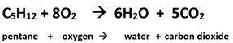
  - 1
  - 5
  - 6
  - 8
  - 10
- Refer to the diagram below. How many grams of carbon dioxide (CO₂) will be produced from 100 grams of pentane (C₅H₁₂)?
  - 305 g CO₂
  - 44 g CO₂
  - 220 g CO₂
  - 500 g CO₂
- Which reaction shows a conservation of mass?
  - 2KClO₃ → 2KCl + 3O₂
  - H₂ + O₂ → H₂O
  - Na + H₂O → NaOH + H₂
  - Fe + CuSO₄ → 2Cu + FeSO₄

Unit 6:
Carbon Cycling and
Climate Change
Return to Table of Contents
Except where otherwise noted, this work by Oak Harbor Public Schools is licensed under a Creative
Commons Attribution 4.0 License. All logos and trademarks are property of their respective owners.
Content purchased by Oak Harbor Public Schools and under All Rights Reserved copyright is referenced but not included in this document. It is marked with the $$ symbol.
Links to third-party websites are provided for your convenience only and do not constitute Oak Harbor Public Schools’ endorsement, sponsorship, warranty or approval of linked websites or any product, service or content offered on such linked websites. Please confirm the license status of these third-party resources and understand their terms of use
Unit 6: Carbon Cycling and Climate Change

Standards
HS-LS2-5: Develop a model to illustrate the role of photosynthesis and cellular respiration in the cycling of carbon among the biosphere, atmosphere, hydrosphere, and geosphere.
HS-ESS2-6: Develop a quantitative model to describe the cycling of carbon among the hydrosphere, atmosphere, geosphere, and biosphere.
HS-ESS3-5: Analyze geoscience data and the results from global climate models to make an evidence-based forecast of the current rate of global or regional climate change and associated future impacts to Earth systems.
HS-ESS3-6: Use a computational representation to illustrate the relationships among Earth systems and how those relationships are being modified due to human activity

Model
Question: Why is the sea ice melting so quickly?
Procedure:
- Show the following video once through before passing out the model and replay it while students have the model in front of them. “Watch 25 Years of Arctic Sea Ice Disappear in 1 Minute” video from NOAA
Learning Objective:
- I can communicate my existing ideas about effects of increasing CO2 levels.

Engage
Investigating Carbon Dioxide Activity
Materials
- Dry ice
- Beral pipettes with tips cut off
- Plyers
- Plastic container
- Water

Explore
CO2 Engineering Design Challenge
Procedure
- As a class, brainstorm processes/activities that generate CO2.
- Reduce list to processes that can be measured in a class period using the Vernier probes.
- Students will then conduct their investigation in groups and complete the challenge handout as a group.

Learning Objectives
- I can explain how the concentration of gases are measured. I can design a method to measure gas concentration.
Carbon and the Climate Activity Science4Inquiry.com | Romero, Thurman & Prevost
Learning Objectives
- I can describe the exchange of carbon between organisms and the environment. I can describe the role of storing carbon in organisms as part of the carbon cycle.
- I can describe the contribution of photosynthesis and cellular respiration to the exchange of carbon within and among the biosphere, atmosphere, hydrosphere and geosphere.
The Habitable Planet: Carbon Cycle
Learning Objectives
- I can identify how photosynthesis and combustion influence the amount of atmospheric carbon
- I can identify and describe the relevant components of each of the Earth systems modeled in a given computational model.
- I can use a computational representation of Earth systems to illustrate and describe relationships among at least two of Earth’s systems , including how changes in one aspect can drive changes in another
- I can use evidence from a computational model to describe how human activity could affect the relationships between Earth’s systems

Explain
- Reading: CK-12 The Carbon Cycle - Advanced
- Reading: CK-12 Carbon Cycle and Climate
- Reading: Carbon Cycle Notes
- Reading: Spheres Notes
- Reading: Carbon Cycling and Climate Change Stations
- Reading: EPA Ice Core Data Analysis – EPA Website
Learning Objectives:
- I can describe the exchange of carbon between organisms and the environment. I can describe the role of storing carbon in organisms as part of the carbon cycle.
- I can describe the contribution of photosynthesis and cellular respiration to the exchange of carbon within and among the biosphere, atmosphere, hydrosphere and geosphere.

Extend/Elaborate
- Revisit Model
Revise your explanation to including the following:
- Spheres
- Greenhouse gases
- Radiation
- temperature
Learning Objective:
- I can revise a model to add detail about the effects of increasing CO2 levels.
- Forecasting Practice
- Review
Learning Objective:
- I can analyze geoscience data and the results from the global climate model to make an evidence-based forecast of the current rate of global or regional climate change and the associated future impacts on Earth systems.

Evaluate: Carbon Cycling and Climate Change
Unit 6: Task
Unit 6: Test

Unit 6 – Carbon Cycling and Climate Change
Arctic Ice Model
Investigating Carbon Dioxide
CO₂ Engineering Challenge
The Habitable Planet: Carbon Cycle
Carbon Cycle Notes
Spheres Notes
Carbon Cycling and Climate Change Stations
Forecasting Practice
Review
Unit 6 Task: Carbon Cycling and Climate Change
Unit 6 Test: Carbon Cycling and Climate Change

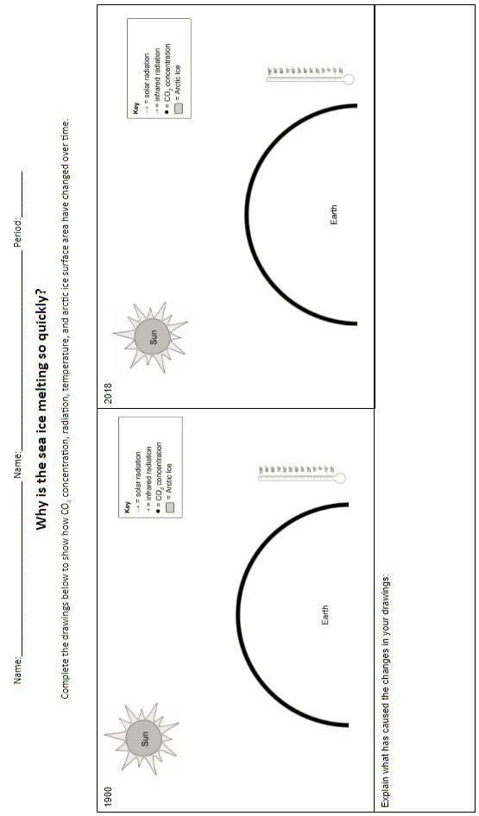
Arctic Ice Model

Investigating Carbon Dioxide
Carbon Dioxide (CO2) has been the focus of much of our learning this quarter. By now, you have learned that CO2 is a product of many combustion reactions that are important to humans. Later in this unit, we will also learn how CO2 plays a very important role in Earth’s atmosphere. However, what exactly is carbon dioxide? Can you smell it? Can you taste it? Can you see it? In this activity, you will begin to explore some of the properties of carbon dioxide.
Part 1: Thinking About CO2
✎Answer each of the following questions individually.
- What is CO2? Have you ever seen CO2? If so, what does it look like? If not, why not?
- What forms or physical states can CO2 exist in? Do these other forms have names?
- Is CO2 lighter than air, heavier than air or the same as air? How do you know?
Once all group members have answered the questions above, gather as a group and review your roles and responsibilities. Discuss your answers to the questions above within your group. On a whiteboard, summarize your group’s answers to each question. Prepare to share your answers with the class.

Part 2: Exploring Properties of CO2
Essential Question: What are some interesting properties of CO2?
Your teacher will demonstrate some properties of solid carbon dioxide and demonstrate how to handle the substance safely.
✎Record any observations you find interesting and any important safety notes here:
Part 3: Investigating Physical States of CO2
Essential Question: Is it possible to observe CO2 in all three physical states?
Your teacher will demonstrate how to conduct the experiment. Watch carefully and prepare to begin the procedure.
Conduct the experiment as instructed, performing the duties of your role in the group.
You must wear safety goggles during the entire experiment!
Reflection Questions
- Note what was happening in the pipet at the following moments during the demonstration.
✎a. When the solid CO2 was first enclosed in the pipet
✎b. When the pressure stabilized
✎c. When the solid CO2 was covered by the liquid carbon dioxide
✎d. When the pressure in the pipet was released
- Why is it rare to observe CO2 as a liquid?

CO₂ Engineering Challenge
Design and build a method/procedure/apparatus to measure an increase in CO₂ concentration caused by a CO₂ generating process.
The Task
- As a team, discuss and agree upon a process that will generate CO₂ (must be able to do within the confines of the classroom).
✎ Record the process:
- Think about how to protect the CO₂ sensor from flame/heat/fluid or any other entity that will damage it. What design difficulties does your process create?
✎ Record design difficulties
- As a team, design your method/procedure/apparatus that will be used to measure the increase in CO₂ concentration. On a whiteboard, draw a sketch of your design.
Insert a photo of your whiteboard sketch
- Build a prototype based on your design.
Insert a photo of your prototype
- Use the CO₂ sensor to get a baseline reading before you start your process. In Graphical Analysis, Export an image of your data.
Insert exported baseline (Before) graph:
- Start your CO₂ generating process. Use the CO₂ sensor to record the increase in CO₂ concentration. In Graphical Analysis, Export an image of your data.
Insert exported CO generating process (During/After) graph
- Did you measure an increase in CO₂? ╠ Yes/No ╣ Justify your answer using data from your Before graph and your During/After Graph
✎ Justification using data from graphs
- What areas/steps/materials would you change from your original design? Why?
✎ Design changes here with explanations for each change

The Habitable Planet: Carbon Cycle
This lab uses a robust model of the carbon cycle to give you an intuitive sense for how carbon circulates through the atmosphere, biosphere, oceans, and crust. This model is similar to ones presented by the Intergovernmental Panel on Climate Change. It allows you to experiment with how human input to the cycle might change global outcomes to the year 2100 and beyond. One particularly relevant human impact is the increase in atmospheric CO2 levels. Between the years 1850 and 2015, atmospheric concentrations have risen from 290 parts per million (ppm) to over 400 ppm - a level higher than any known on Earth in more than 30 million years.
Part 1: Play with simulation
Open up the simulation
Simulation: The Habitable Planet: A Systems Approach to Environmental Science | Harvard University Center for the Environment & Annenberg Media
Leave the scale sliders at the default settings
Run the simulation by clicking the Run Decade button.
- What year does the simulation indicate that we will run out of oil and gas?
- What year does the simulation indicate that we will run out of coal?
- What happens to the atmospheric CO2 concentration after this?
- Where does the simulation show all the carbon ends up in year 2500?

Part 2: Projecting Atmospheric Carbon using different rates of fossil fuel consumption.
Open up the simulation
Simulation: The Habitable Planet: A Systems Approach to Environmental Science | Harvard University Center for the Environment & Annenberg Media
Your group is assigned __________% change of fossil fuel use per year.
Leave the Net Deforestation rate at 1 GT per year
Run the simulation by clicking the Run Decade button. Record the numbers in the data table below:
Year | Total Atmospheric Carbon PPM
2010
2020
2030
2040
2050
2060
2070
2080
2090
2100
Place a screenshot of your graph here:

Part 3: Projecting Atmospheric Carbon using different Net deforestation rates
Open up the simulation
Simulation: The Habitable Planet: A Systems Approach to Environmental Science | Harvard University Center for the Environment & Annenberg Media
Your group is assigned a Net Deforestation Rate of __________GT.
Set the change in fossil fuel use per year to 0%
Run the simulation by clicking the Run Decade button.
Record the numbers in the data table below:
Year | Total Atmospheric Carbon PPM
2010
2020
2030
2040
2050
2060
2070
2080
2090
2100
Place a screenshot of your graph here:
Be ready to share out your results.

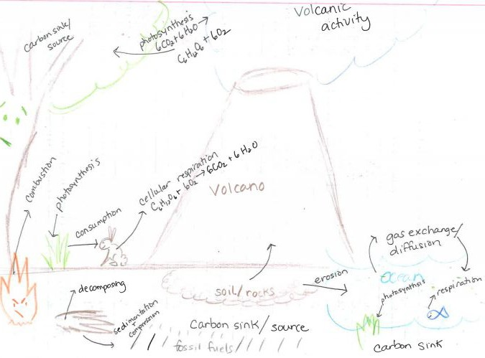
Carbon Cycle Notes
Image by Oak Harbor Public Schools | CC BY

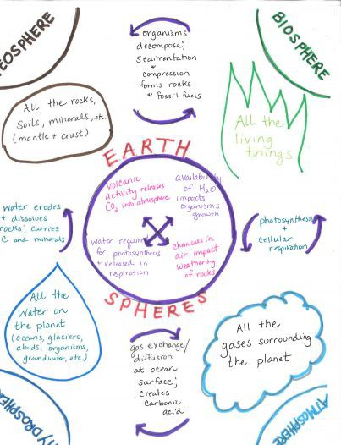
Spheres Notes
Image by Oak Harbor Public Schools | CC BY

Carbon Cycling and Climate Change Stations

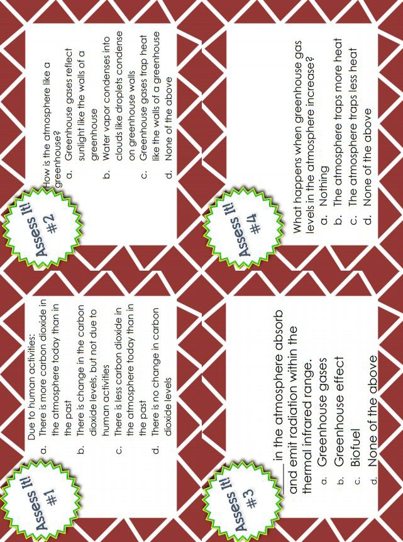

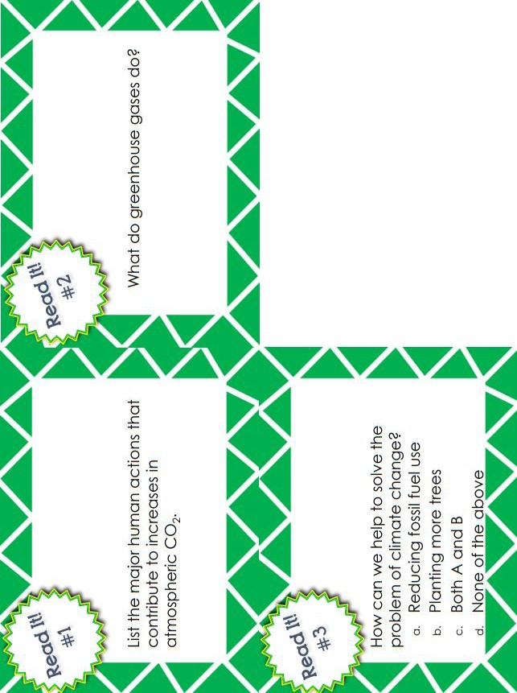

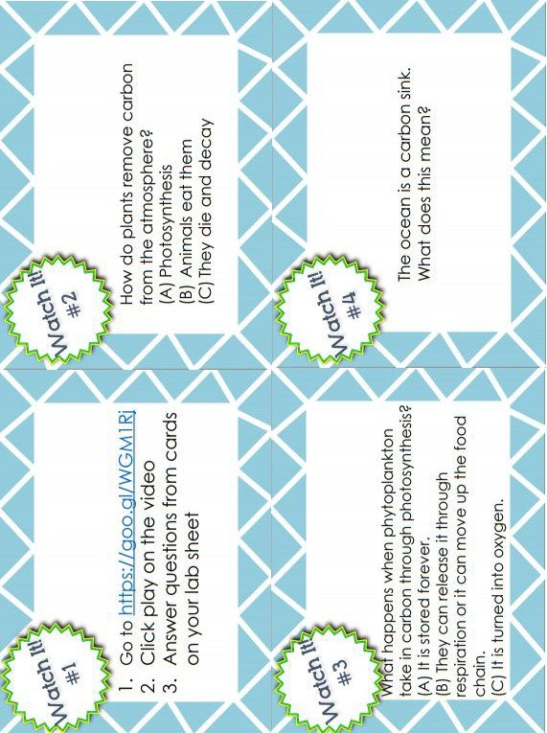

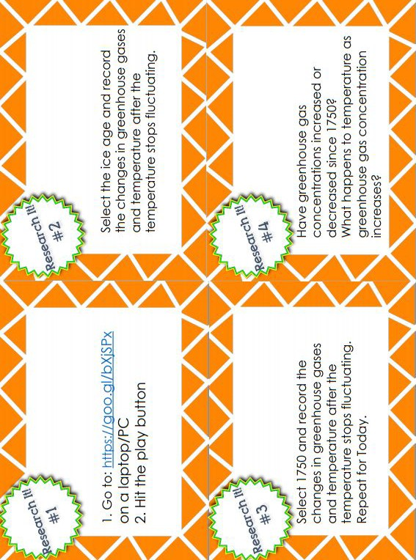

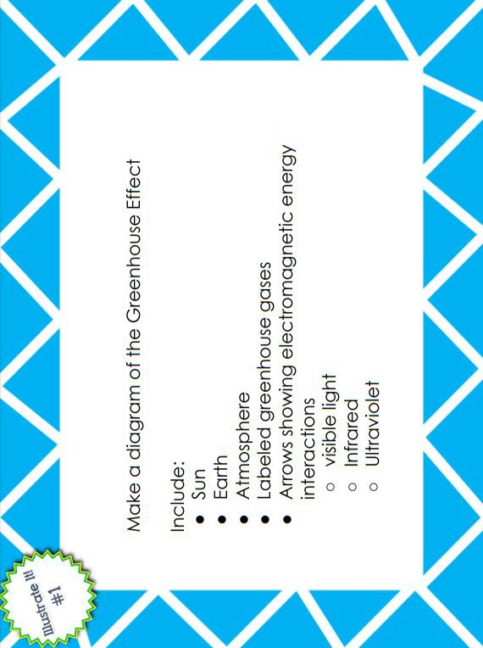

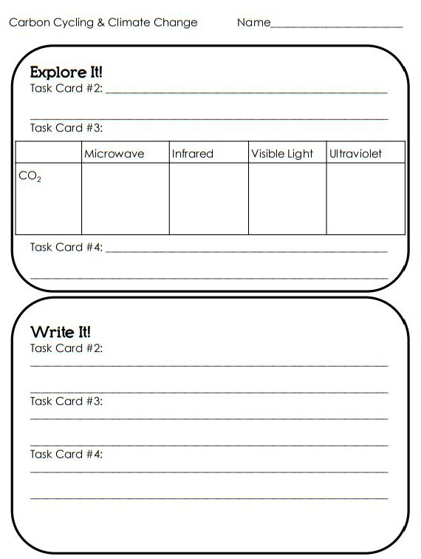

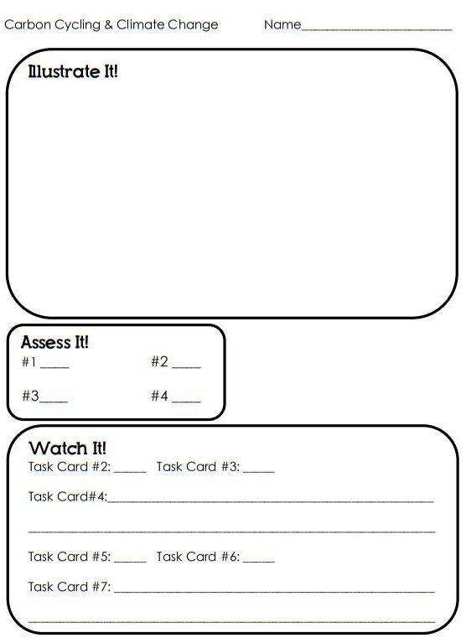

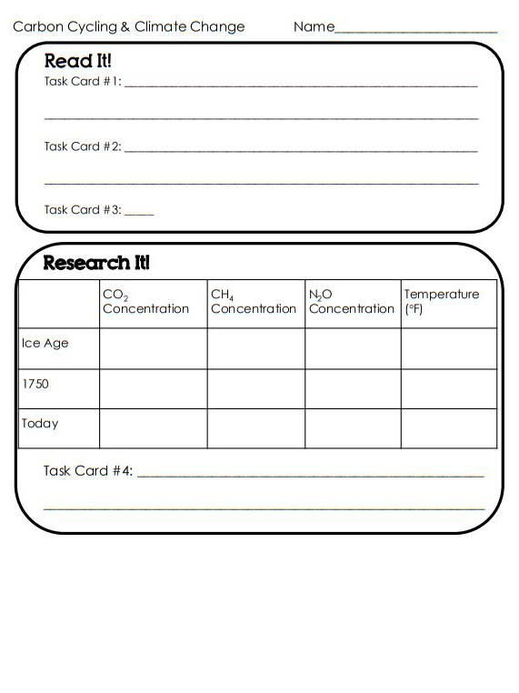

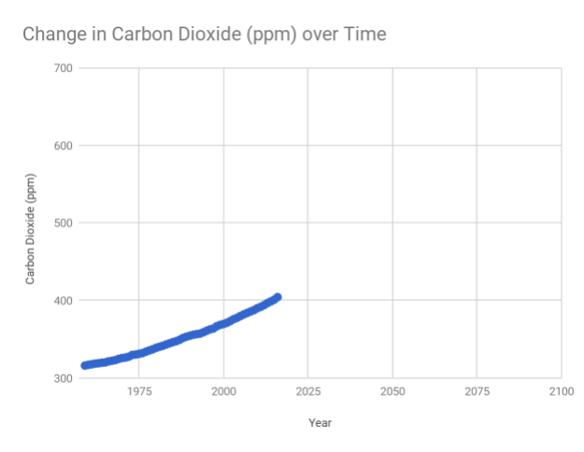
Forecasting Practice
- How has the amount of CO2 (ppm) changed over time? Include relevant data in your explanation.
- On the above graph, sketch what you think the line would look like if the trend continues.
- Based on your sketch, what will the CO2 (ppm) be in 2038?
- Based on your sketch, what will the CO2 (ppm) be in 2063?
- Based on your sketch, what will the CO2 (ppm) be in 2100?
- Explain the reasoning to justify your forecasts for questions 2-4.

Review
Vocabulary
Geosphere –
Atmosphere –
Hydrosphere –
Biosphere –
Fossil fuel –
Carbon sink -
Cellular respiration –
Photosynthesis –
Conservation of Mass Law –
Greenhouse effect –
Greenhouse gas -
Conceptual Questions
What role does the Conservation of Mass Law play in the carbon cycle?
What has happened to carbon dioxide concentration in the atmosphere changed over time?
What effect has this change had on the climate and why?
What processes move carbon from one earth system to another?

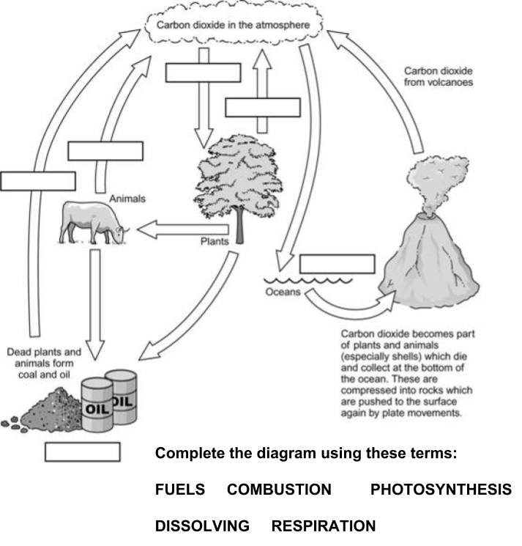

Task: Carbon Cycling and Climate Change
Technical Manual Chapter 5 - Carbon Cycling and Climate
For this task, you will write the fifth chapter of the Operator's Manual for the Steam-Powered Boat that your team will construct.
This chapter will include three parts described below:
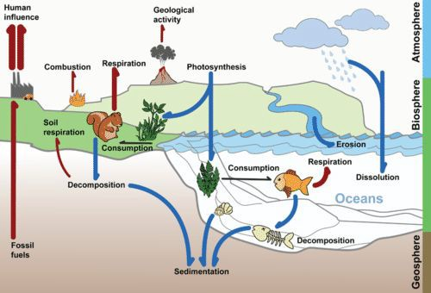

Part 1: Use the Carbon Cycle Diagram to show how carbon atoms in your combustion reaction move through Earth systems
A. Label all locations where the carbon in your fuel comes from
0 - Inadequate | 1 - Below | 2 - Approaching | 3 - Meets | 4 - Exceeds
Missing explanation and data on how chosen parameter has changed over time | Data that is irrelevant is presented/ data is missing completely  AND/OR  Explanation is incorrect /explanation is missing | Data presented without any explanation of what data represents or explanation is incorrect. | Explanation of how Earth system has changed over time.  Explanation includes data that is not applicable or data is missing. | Detailed explanation of how Earth system has changed over time. Explanation includes relevant data.
B. Label all locations that the carbon in your products goes.
0 - Inadequate | 1 - Below | 2 - Approaching | 3 - Meets | 4 - Exceeds
Missing where your carbon in your carbon-containing product goes | Incorrectly identifies at least one location that carbon from your carbon-containing product goes. |  | Correctly identifies at least one location that your carbon-containing product goes. | Correctly identifies more than one location that carbon from your carbon-containing product goes.
C. Explain how the diagram shows that your combustion reaction obeys the Law of Conservation of Matter.
0 - Inadequate | 1 - Below | 2 - Approaching | 3 - Meets | 4 - Exceeds
Missing explanation of how model demonstrates conservation of mass. | Incorrectly describes law of conservation of mass. | Law of conservation of mass is stated with no discussion of model. | Correctly explains how model demonstrates conservation of mass without giving specific examples from model. | Correctly explains how model demonstrates conservation of mass citing specific examples from model.

Part 2: Explain how an increase in CO2 in the atmosphere affects an Earth System
Choose one Earth system (other than the atmosphere):
- Hydrosphere/Cryosphere
- Biosphere
- Geosphere
A. Identify a component of that system that is affected by an increase of CO 2 in the atmosphere.
0 - Inadequate |  |  |  | 1 point
Missing the identification of a component of system that is affected by an increase of CO₂ |  |  |  | Identifies a component of a system that is affected by an increase of CO₂
B. Explain how the increase in CO2 in the atmosphere will affect the identified component
0 - Inadequate | 1 - Below | 2 - Approaching | 3 - Meets | 4 - Exceeds
Missing an explanation of how an increase in CO2 will affect the component | Incorrectly identifies how the increase in CO2 will affect the component | States how the increase in CO2 in the atmosphere will affect the component, does not include explanation  OR  States how the increase in CO2 will affect the component but the explanation is incorrect | Correctly explains how the increase in CO2 in the atmosphere will affect the component. | Correctly explains how the increase in CO2 in the atmosphere will affect the component citing specific examples/ locations for the affect

Part 3:
Choose one parameter:
- Temperature
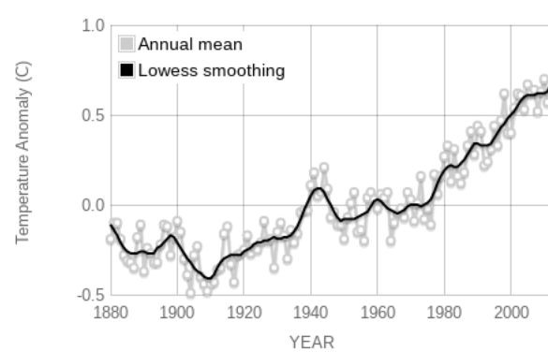
  - pH
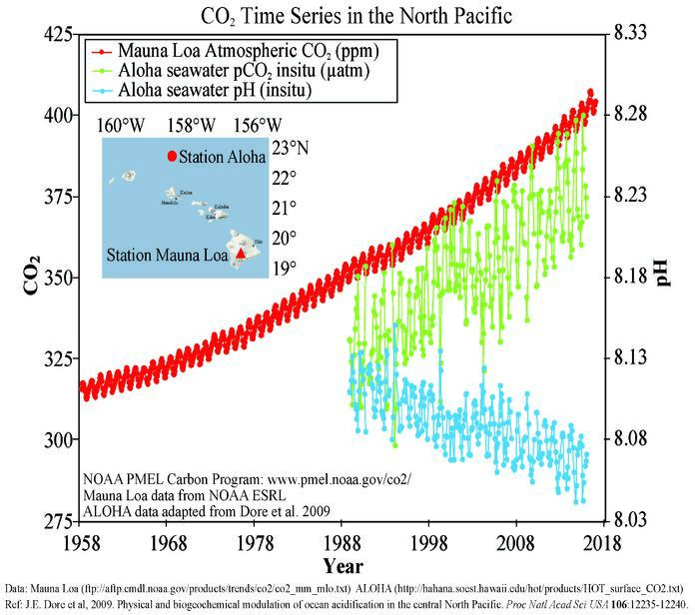

  - Sea level
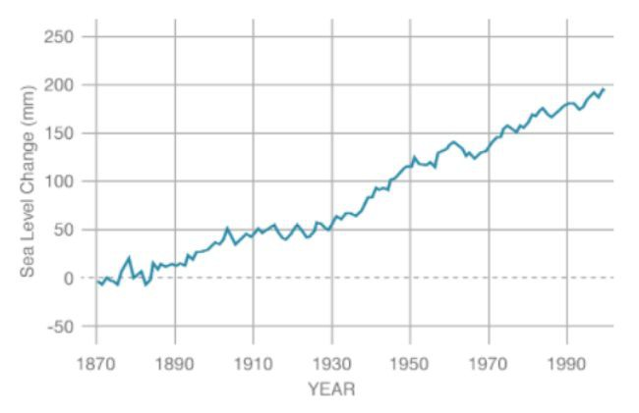
    - Ice Volume (choose only one: arctic, Antarctic, or Greenland)
    - Arctic Ice Volume
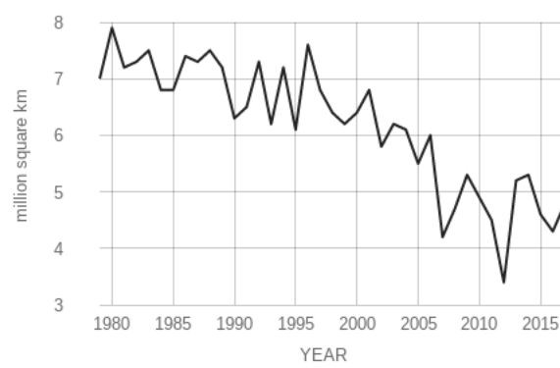
- Antarctic Ice Volume
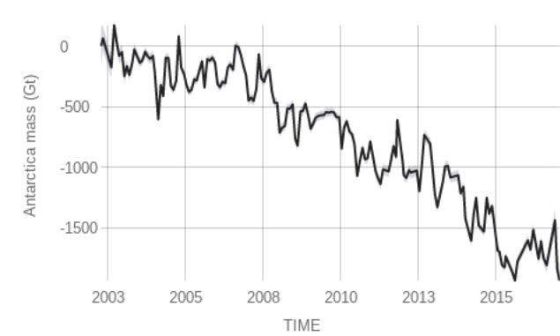
- Greenland Ice Volume
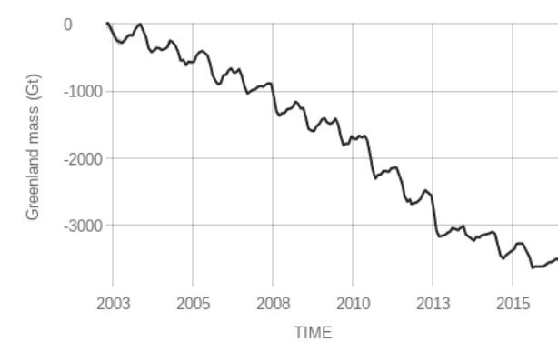

- Using the graph supplied with your chosen parameter, explain how your chosen parameter has changed over time.
0 - Inadequate | 1 - Below | 2 - Approaching | 3 - Meets | 4 - Exceeds
Missing explanation and data on how chosen parameter has changed over time | Data that is irrelevant is presented/ data is missing completely  AND/OR  Explanation is incorrect / explanation is missing | Data presented without any explanation of what data represents or explanation is incorrect. | Explanation of how Earth system has changed over time. Explanation includes data that is not applicable or data is missing. | Detailed explanation of how Earth system has changed over time. Explanation includes relevant data.
- Based on the graph, forecast what your chosen parameter will be in 20, 100, and 1000 years.
0 - Inadequate | 1 - Below | 2 - Approaching | 3 - Meets | 4 - Exceeds
Missing claim for the state of chosen parameter | Makes an inaccurate claim about the state of the chosen parameter in 20, 100, and 1000 years. | Makes an accurate claim about the state of the chosen parameter in one of the three time frames  (20, 100 or 1000 years). | Makes an accurate claim about the state of the chosen parameter in two of the three time frames  (20, 100 or 1000 years). | Makes an accurate claim about the state of the chosen parameter in 20, 100, and 1000 years.
- Explain the reasoning to justify your forecast.
0 - Inadequate | 1 - Below | 2 - Approaching | 3 - Meets | 4 - Exceeds
Missing reasoning to justify forecast | Includes a justification that is inaccurate or irrelevant to forecast | Includes vague reasoning to justify forecast | Includes logical reasoning, but only refers to general trends in data to justify forecast | Includes a mathematical or graphical basis (extrapolation) to justify forecast

- Describe how the effects on your chosen parameter are either reversible or irreversible.
0 - Inadequate | 1 - Below | 2 - Approaching | 3 - Meets | 4 - Exceeds
Missing description of whether the effects on parameter are reversible or irreversible. | Incorrectly identifies if the effects on the chosen parameter are reversible. | Correctly identifies if the effects on the chosen parameter are reversible. | Correctly identifies if the effects on the chosen parameter are reversible AND describes how. | Correctly identifies if the effects on the chosen parameter are reversible AND describes how using a major chemistry concept.

Test: Carbon Cycling and Climate Change
Name: Period:
- Which of the following are features of the biosphere?
  - solid, molten rock, sediment, continents, and mountains
  - rivers, lakes, oceans and glaciers
  - wind, air, oxygen
  - plants, animals
- Which earth system receives carbon dioxide from cellular respiration and has it removed by photosynthesis?
  - geosphere
  - hydrosphere
  - atmosphere
  - biosphere
- Where is carbon stored in the hydrosphere?
  - in plants as carbohydrates
  - in the earth as hydrocarbons
  - in oceans as dissolved carbon dioxide
  - in the air as a gas
- What was the source of carbon in the candle wax (hydrocarbon) that fueled the steam-powered boat?
  - from ancient decayed plants and animals
  - from carbon dioxide in the atmosphere
  - cellular respiration in animals
  - photosynthesis in plants
- How does mass conservation in the Carbon Cycle contribute to the Greenhouse Effect?
  - When carbon is removed from the geosphere, it enters the atmosphere.
  - When carbon atoms are destroyed heat energy on in the geosphere increases.
  - More carbon atoms are created in the atmosphere than can be destroyed in the hydrosphere.
  - Carbon atoms created during photosynthesis build up in the atmosphere.
- What is one way carbon is stored in Earth systems?
  - Carbohydrates in the biosphere are transformed into hydrocarbons that are trapped in layers of the geosphere.
  - Bacteria on the roots of plants move carbon from the atmosphere into the tissues of organisms in the biosphere.
  - Decomposition stores carbon in the rotten tissues of trees, plants, and other organisms.
  - Precipitation from the atmosphere deposits carbon into the hydrosphere in lakes and oceans.

- Why is carbon dioxide a greenhouse gas?
  - it transmits most solar radiation but reflects infrared.
  - it reflects most solar radiation but transmits infrared.
  - carbon dioxide is heavier than air.
  - carbon dioxide molecules release energy to the atmosphere.
- What variable does the graph most likely show changing over time?
  - Total mass of ice in glaciers and ice caps
  - Average global sea level
  - pH level of ocean water
  - Concentration of carbon dioxide in the atmosphere

Unit 7:
Reaction Rates
Return to Table of Contents
Except where otherwise noted, this work by Oak Harbor Public Schools is licensed under a Creative
Commons Attribution 4.0 License. All logos and trademarks are property of their respective owners.
Content purchased by Oak Harbor Public Schools and under All Rights Reserved copyright is referenced but not included in this document. It is marked with the $$ symbol.
Links to third-party websites are provided for your convenience only and do not constitute Oak Harbor Public Schools’ endorsement, sponsorship, warranty or approval of linked websites or any product, service or content offered on such linked websites. Please confirm the license status of these third-party resources and understand their terms of use

Unit 7: Reaction Rates

Standard
HS-PS1-5: Apply scientific principles and evidence to provide an explanation about the effects of changing the temperature or concentration of the reacting particles on the rate at which a reaction occurs.

Model
Question: How does temperature affect the reaction rate of a glow stick?
Materials:
- 2 glow sticks
- 2 thermometers
- Beaker of 80°C water
- Beaker of ice water
Learning Objective:
- I can communicate my existing ideas about effects of temperature on reaction rate.

Engage
Reactions Rates Demonstrations: whoosh bottle, cornstarch explosion, elephant toothpaste
Learning Objective:
- I can make careful observations of scientific demonstrations.

Explore
ADI Chemistry $$: Reaction Rates
Learning Objectives:
- I can collect and analyze data on reaction rates.
- I can infer factors that influence reaction rate of a chemical reaction from analyzing data.

Explain
- Reading: CK-12 - Temperature and Temperature Scales
- Reading: CK-12 - Chemical Reaction Rates
- Reading: CK-12 - Collision Theory
- Reading: CK-12 - Activation Energy
- Reading: CK-12 - Factors Affecting Reaction Rates
- Reading: CK-12 - Catalysts
- Simulation: CK-12: PLIX Factors Affecting Reaction Rate
- Reading: Chemical Reaction Notes
Learning Objectives:
- I can describe how the colliding of molecules can break and form new bonds. I can describe how changing temperature will affect reaction rate.
- I can describe how changing the surface area will affect reaction rate.
- I can describe how changing the concentration will affect reaction rate.
- I can describe the relationship between kinetic energy of molecules and rate of collisions.

Extend/Elaborate:
Revisit Model
Include the following in your revised explanation:
- Number and force of collisions of particles
- Rate of reactions in different temperatures
Learning Objectives:
- I can revise a model to add detail about the effects of temperature on reaction rate.

Evaluate: Reaction Rates
Unit 7: Task
Unit 7: Test

Unit 7 – Reaction Rates
Reaction Rates Model
Reaction Rates Demonstrations
Unit 7 Task: Reaction Rates
Unit 7 Test: Reaction Rate

Reaction Rates Model
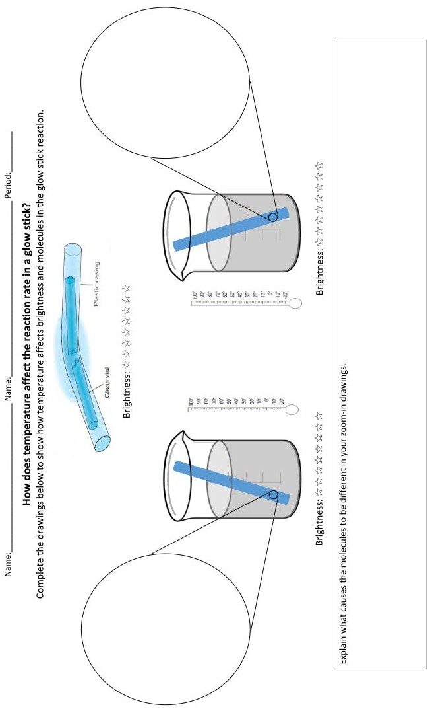

Reaction Rates Demonstrations
Elephant Toothpaste
Observations:
First Factor Impacting Reaction Rate =
Second Factor Impacting Reaction Rate =

Cornstarch Explosion
Observations:
Factor Impacting Reaction Rate =
Whoosh Bottles
Observations:
Factor Impacting Reaction Rate =

Chemical Reaction Notes
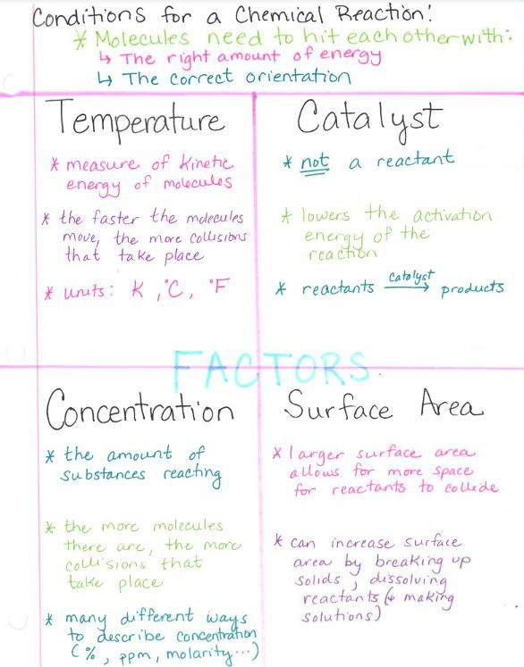

Image by Oak Harbor Public Schools | CC BY

Task: Reaction Rates
Reaction Rate Investigation
You will work in groups to investigate how to change the rate of a chemical reaction. Your teacher will provide you a list of reactions to choose from.
Select one of the following investigations:
Concentration Procedure | Temperature Procedure | Surface Area Procedure
Question: How does increasing the concentration of water affect the reaction rate of an effervescent tablet?  Materials  - effervescent tablets x9  - vinegar  - tap water  - 250 mL beaker  - timer  Procedure:  - Fill the beaker with 200 mL of tap water. Record the concentration of water to vinegar in the data table as 100% water.  - Using the timer, drop one effervescent tablet into the beaker and measure how long it takes the reaction to stop.  - Record the time of the reaction in the data table.  - Empty the beaker and repeat steps 1-3 two more times. Record the time of the reactions for trials 2 and 3.  - Fill the beaker with 150 mL of tap water and 50 mL of vinegar. Record the concentration of water in the data table as 75% water.  - Using the timer, drop one effervescent tablet into the beaker and measure how long it takes the reaction to stop.  - Record the time of the reaction in the data table.  - Empty the beaker and repeat steps 5-7 two more times. Record the time of the reactions for trials 2 and 3.  - Fill the beaker with 100 mL of tap water and 100 mL of vinegar. Record the concentration of water in the data table as 50% water.  - Using the timer, drop one effervescent tablet into the beaker and measure how long it takes the reaction to stop.  - Record the time of the reaction in the data table.  - Empty the beaker and repeat steps 9-11 two more times. Record the time of the reactions for trials 2 and 3. | Question: How does increasing the temperature of a solution affect the reaction rate of an effervescent tablet?  Materials  - effervescent tablets x9  - hot plate  - ice water  - tap water  - thermometer  - 250 mL beaker  - timer  Procedure:  - Fill the beaker with 200 mL of ice water. Record the temperature of the water in the data table.  - Using the timer, drop one effervescent tablet into the beaker and measure how long it takes the reaction to stop.  - Record the time of the reaction in the data table.  - Empty the beaker and repeat steps 1-3 two more times. Record the time of the reactions for trials 2 and 3.  - Fill the beaker with 200 mL of tap water. Record the temperature of the water in the data table  - Using the timer, drop one effervescent tablet into the beaker and measure how long it takes the reaction to stop.  - Record the time of the reaction in the data table.  - Empty the beaker and repeat steps 5-7 two more times. Record the time of the reactions for trials 2 and 3.  - Fill the beaker with 200 mL of tap water. Place the beaker on the hot plate and heat the water. Remove the beaker from the hot plate once it has reached 50 °C. Record the temperature of the water in the data table.  - Using the timer, drop one effervescent tablet into the beaker and measure how long it takes the reaction to stop.  - Record the time of the reaction in the data table.  - Empty the beaker and repeat steps 9-11 two more times. Record the time of the reactions for trials 2 and 3. | Question: How does increasing the surface area of the effervescent tablet affect the reaction rate of an effervescent tablet with water?  Materials  - effervescent tablets x9  - graduated cylinder  - tap water  - 250 mL beaker  - timer  Procedure:  - Fill the beaker with 200 mL of tap water.  - Using the timer, drop one unbroken effervescent tablet into the beaker and measure how long it takes the reaction to stop. Reaction has stopped once bubbles are no longer formed.  - Record the time of the reaction in the data table as trial 1.  - Empty the beaker and repeat steps 1-3 two more times. Record the time of the reactions for trials 2 & 3.  - Fill the beaker with 200 mL of tap water.  - Take one effervescent tablet and break into several pieces. Pieces should be larger, do not completely turn into a powder.  - Using the timer, drop one broken effervescent tablet into the beaker. Be sure to include all of the pieces from the effervescent tablet. Measure how long it takes the reaction to stop.  - Record the time of the reaction in the data table for trial 1.  - Empty the beaker and repeat steps 5-7 two more times. Record the time of the reactions for trials 2 &3.  - Fill the beaker with 200 mL of tap water.  - Using the mortar and pestle, completely grind one effervescent tablet. Once completely ground, the tablet should look like a fine powder.  - Using the timer, drop one completely ground effervescent tablet into the beaker. Make sure to have all of the powder from the tablet. Measure how long it takes the reaction to stop.  - Record the time of the reaction in the data table as trial 1.  - Empty the beaker and repeat steps 9-11 two more times. Record the time of the reactions for trials 2 & 3.

Part 1:
1A: Create a data table that includes the following conditions:
- Table includes three conditions
- Repeated trials present
- Averages for each condition correct
- Table includes labels with units
1B: Create a graph showing the relationship between the two variables that includes:
- Graph includes title
- X and Y axis labeled
- Scatterplot of manipulated vs responding variables (using average values)
- Best fit line
Part 2: Reaction Rate Explanation
Write the equation for the chemical reaction used in part 1 here:
Explain how you changed the rate of the reaction. In your explanation, be sure to do all of the following:
- Identify a variable that could change the reaction rate.
- Explain what has to happen for two molecules to react in terms of kinetic energy.
- Explain what has to happen for two molecules to react in terms of orientation.
- Explain the effect of changing the variable on collisions between atoms/molecules.
Draw a before and after picture of the atoms/molecules interacting.
Your after picture should include a representation of the effects of the changing variable.

Task Rubric
Learning Evidence | 1 point
Part 1A
Table includes three conditions
Repeated trials present
Averages for each condition correct
Table includes labels with units
Part 1B
Graph includes title
X and Y axis labeled
Scatterplot of averages
Best fit line
Part 2
Identify a variable that could change the reaction rate.
Explain what has to happen for two molecules to react in terms of kinetic energy.
Explain what has to happen for two molecules to react in terms of orientation.
Explain the effect of changing the variable on collisions between atoms/molecules.
Draw a before and after picture of the atoms/molecules interacting. Your after picture should include a representation of the effects of the changing variable.
Total | /13

Test: Reaction Rate
Name: Period:
- What effect does increasing the number of collisions between molecules have on the reaction rate?
  - the reaction rate increases
  - the reaction rate stays the same
  - the reaction rate decreases
- As the surface area of a solid reactant increases, what happens to the rate of reaction?
  - decreases because of a decrease in collision frequency
  - decreases because of an increase in the activation energy
  - increases because of an increase in collision frequency
  - increases because of a decrease in the activation energy
- The probability of bonds breaking during a collision of molecules depends on which of the following?
  - the kinetic energy of the collision must be sufficient to break the bond
  - the bond must be ionic so that electrons can be transferred
  - the thermal energy must be great enough to form the new bond
  - the molecules polarity must be opposite
- What factor(s) affect the rate of a chemical reaction? Select all correct responses.
- Size of reaction container
- Temperature of reactants
- Presence of a catalyst
- Molar mass of products
- Density of reactants
- Concentration of reactants
- How does a catalyst increase the rate of a chemical reaction?
  - creates more reactants
  - gets used up instead of a reactant
  - lowers the activation energy
  - increases the number of molecules colliding
- How can the frequency of collisions be increased? Select all correct responses.
- Decreasing the concentration of the reactant particles
- Increasing the concentration of the reactant particles
- Increasing the temperature of the reaction
- Decreasing the temperature of the reaction
- What is one way to increase the surface area of a reactant?
  - add heat energy to the reactants
  - add a catalyst
  - remove some reactant
  - crush solid reactant into smaller pieces

Unit 8:
Equilibrium
Return to Table of Contents
Except where otherwise noted, this work by Oak Harbor Public Schools is licensed under a Creative
Commons Attribution 4.0 License. All logos and trademarks are property of their respective owners.
Content purchased by Oak Harbor Public Schools and under All Rights Reserved copyright is referenced but not included in this document. It is marked with the $$ symbol.
Links to third-party websites are provided for your convenience only and do not constitute Oak Harbor Public Schools’ endorsement, sponsorship, warranty or approval of linked websites or any product, service or content offered on such linked websites. Please confirm the license status of these third-party resources and understand their terms of use
Unit 8: Equilibrium

Standard
HS-PS1-6: Refine the design of a chemical system by specifying a change in conditions that would produce increased amounts of products at equilibrium.

Model
Question: What happens when you shake the test tube?
Materials
- Test tubes with lids
- Methylene blue solution 1%
- Dextrose (8 g/300 mL water)
- Potassium hydroxide (10g)
- Distilled water
- Flask
- Balance
Procedure
To prepare the solution
- Add 8 g of potassium hydroxide to 300 mL of water in a 500-mL flask.
- Stir until the solid is dissolved.
- Add 10 g of dextrose and a few drops of methylene blue indicator solution.
- Fill to the 500-mL mark, stopper or cap the flask, and mix thoroughly.
- Pour into test tubes for each pair of students
Note: Solution will last a couple hours depending on number of times shook.
Learning Objective:
- I can communicate my existing ideas about modeling equilibrium reactions.

Engage
POGIL Activities for High School Chemistry$$: Equilibrium
POGIL Lab$$: Equilibrium Shift
Learning Objectives:
- I can describe a stress involving a change to one component of an equilibrium system affects the other components.
- I can describe how changing the concentration of one of the components of the equilibrium system will change the rate of reaction.

Explore
Equilibrium Virtual Activity
Living by Chemistry$$: How Dynamic Activity
Learning Objective:
- I can describe how both the forward and reverse reactions in a system at equilibrium are occurring at the same rate.

Explain
- Reading: CK-12 Reversible Reaction
- Reading: CK-12 Chemical Equilibrium
- Reading: CK-12 Le Châtelier's Principle
- Reading: CK-12 Effect of Concentration
- Reading: CK-12 Effect of Temperature
- Reading: CK-12 Effect of Pressure
- Reading: Equilibrium Notes
Learning Objective:
- I can describe stressors and effects to equilibrium systems.

Extend/Elaborate
Revisit Model
Use the words from the following word bank in your explanations of the phenomena:
- Equilibrium
- Shift
- Stressor
- Reactants
- Products
Answer the following as well:
If this was an endothermic reaction, heat as a reactant, how could you shift the equilibrium to the right?
Learning Objective:
- I can revise a model to add details about equilibrium reactions.

Evaluate: Equilibrium
Unit 8: Task
Unit 8: Test

Unit 8 – Equilibrium
Equilibrium Model
Equilibrium Virtual Activity
Equilibrium Notes
Unit 8 Task: Equilibrium
Unit 8 Test: Equilibrium

Equilibrium Model
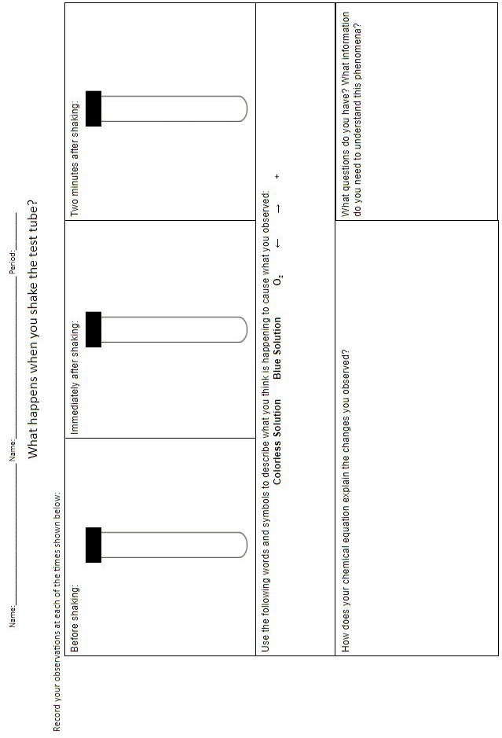

Equilibrium Virtual Activity
So far, we have learned that chemical reactions involve reactants turning into products, with the arrow in the chemical equation always pointing from left to right (⇒). We know that the reaction continues until all the reactants have been transformed into products. However, it turns out that many chemical reactions are actually reversible - meaning they go both directions. Reactants transform into products and products transform into reactants. These reactions have a arrows pointing both forward and backward (⇄). At the start of a reversible process, the reaction proceeds toward the formation of products. Then, as soon as some product molecules are formed, the reverse process begins to happen and reactant molecules are formed from product molecules.
A special state of back and forth reaction, called chemical equilibrium, happens when the rates of the forward and reverse reactions are equal. This process can be described like the movement of skiers at a busy ski resort where the number of skiers carried up the mountain on a chair lift is equal to the number coming down on the slopes. Although there is a constant transfer of skiers, the number of people at the top and the number at the bottom of the slope do not change once equilibrium is established.
However, when a stressor (changes to the system) is applied to a reaction, the equilibrium will be disrupted. The rates will no longer be equal and products or reactants will begin piling up in greater numbers. In response to this stress, the chemical reaction will proceed in such a way to adjust the rates and establish a new equilibrium.
Purpose
To explore the effects different stressors have on equilibrium.
Procedure
Each part on the following pages includes a chemical equation, a description of the colors of the reactants and products, and a drawing of the substances before and after some stressor has been applied. For each reaction:
      - Consider the effect of a stressor on chemical equilibrium.
      - Based on your observations, answer the question about the shift that the reaction undergoes in response to the stressor.

Example:
Cu+2 + 4 NH3 ⇄ Cu(NH3)4
+2
light blue dark blue
- How does increasing the Cu2+ concentration shift the chemical reaction?
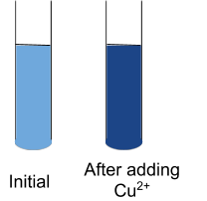
Answer:
Part 1: Concentration

HIN(aq) ⇄ H+ + IN-
Yellow Blue
- How does increasing the H+ concentration shift the chemical reaction?
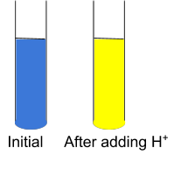
B.
Fe3++ SCN- ⇄ FeSCN2+
Pale yellow Red
- How does increasing the SCN- concentration shift the reaction?
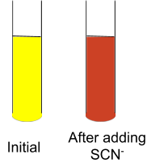
- How does increasing the Fe3+ concentration shift the reaction?
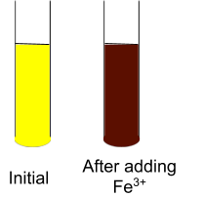
- How does decreasing the Fe3+ concentration shift the reaction?
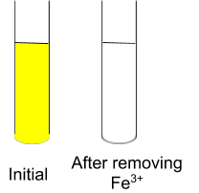
- When the concentration of a substance was increased, did equilibrium shift away or towards that side of the reaction?
- When the concentration of a substance was decreased, did equilibrium shift away or towards that side of the reaction?
Part 2: Temperature
A.
NO2 ⇄ N2O4 + heat
Brown Colorless
- How does increasing the heat shift the reaction?
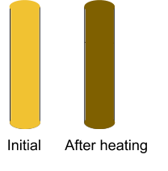
- How does decreasing the heat shift the reaction?
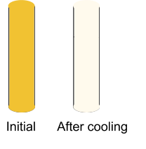

- When the temperature was increased, did equilibrium shift away or towards the side of the reaction that contains the heat?
- When the temperature was decreased, did equilibrium shift away or towards the side of the reaction that contains the heat?

Part 3: Application
- 2CrO4²⁻ + 2H⁺ ⇄ Cr2O7²⁻+ H2O
Yellow Red
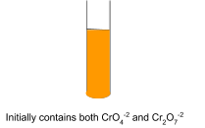
- Show what would happen if more H+ was added to the solution.
- Show what would happen if H+ was removed from the solution.

- Fe3++ SCN- ⇄ FeSCN2+ + heat
Pale yellow Red
- Show what would happen if the solution was heated:
- Show what would happen if the solution was cooled:
- Methanol, CH3OH, can be produced by the reaction of carbon monoxide with hydrogen gas:
CO + 2 H2 ⇄ CH3OH + heat
In an attempt to maximize the amount of methanol produced, a chemist would try to shift the equilibrium to the right. Which of the following would accomplish this?
- heating the mixture
- cooling the mixture
- adding more carbon monoxide
- adding more hydrogen
- removing the methanol as it is formed

Equilibrium Notes
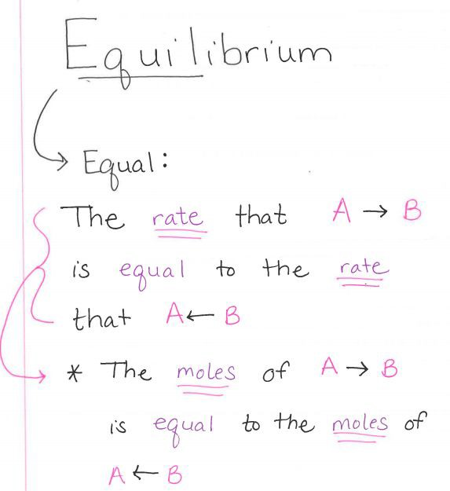
Image by Oak Harbor Public Schools | CC BY

Task: Equilibrium
You are hired as a chemical engineer for Wildcat Chemical Co. The company produces and sells the following chemicals:
- Ammonia, NH3, for use in cleaning products
- Calcium oxide, CaO, for making cement
- Hydrogen, H2, for welding
- Methanol, CH3OH, for use in antifreeze for vehicles

Your boss wants you to figure out a way to increase the amount of one of those chemical being produced without buying more reactants.
Your task:
- Choose one of the chemical reactions
- Ammonia: N2(g) + 3H2(g) ⇄ 2 NH3(g) + heat
- Calcium Oxide: CaCO3(s) + heat ⇄ CaO(s) + CO2(g)
- Hydrogen: CH4(g) + H2O(g) + heat ⇄ 3H2(g)+ CO(g)
- Methanol: CO(g) + 2H2(g) ⇄ CH3OH(g) + heat
- Describe a change in conditions (stressor) that will produce increased amounts of products at equilibrium.
- Explain how, on a molecular level, your proposed change will affect other components of the system and result in increased product.
- Explain why your proposed change is the best solution to increasing the amount of product. Your justification should include cost, energy consumption, or hazardous nature of chemicals.

Task Rubric: Equilibrium
Learning Evidence | 1 point
Identifies stressor that can produce more products
Correctly describes how stressor will impact reaction
Includes a description of change on the molecular level
Includes explanation of why the proposed solution is the best option in terms of either cost, energy consumption or hazardous nature of chemicals
Total | /4

Test: Equilibrium
Name: Period:
- Which of the following are stresses that can be applied to a chemical system? Select all correct responses.
- concentration of reactants and/or products
- temperature
- pressure
- time
- According to Le Châtelier's Principle, whenever a stress is applied to a system at equilibrium, the equilibrium shifts in such a way as to do what?
  - change the rate of reaction
  - resist the stress applied
  - undo the effect of the stress imposed
  - ensure all mass in the system is conserved
- Imagine starting with 100 molecules of B and no molecules of A. What will happen to the concentrations of A or B as the reaction proceeds?
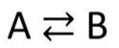
- The concentration of A will decrease.
- The reaction will not proceed because there are no molecules of chemical A.
- The concentration of B will increase.
- The concentration of B will decrease
- What is the significance of the double arrow in the equation below? Select all correct responses.
  - There will be equal amounts of A and B at all times.
  - The reaction can take place in both forward and backward direction.
  - The reaction is reversible.
  - When A runs out the reaction will end.

- The system below is a saturated solution of sugar in water. Sucrose molecules are leaving the sugar crystal and returning to the sugar crystal at the same rate.
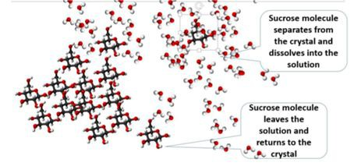
- There would be no visible sugar in the container.
- The sugar in the container would appear to dissolve and reappear.
- The solution would have undissolved sugar in the container that appeared to be doing nothing.
- The sugar in the solution would appear to get larger in volume
- Once equilibrium is reached, how do the number of moles of A lost and the number of moles of A gained in one minute compare?
- The number of moles of A lost will equal the number of moles of A gained.
- The number of moles of A will be zero in both cases.
- The reaction will not proceed because there are not any molecules of chemical A.
- The number of moles of A lost will be greater than the number of moles of A gained.
- Consider the reaction below. Which of the following can shift the reaction's position to the left?
- Adding product C
- Adding reactant A
- Decreasing temperature
- Removing product D

Unit 9:
Properties of Water
Return to Table of Contents
Except where otherwise noted, this work by Oak Harbor Public Schools is licensed under a Creative
Commons Attribution 4.0 License. All logos and trademarks are property of their respective owners.
Content purchased by Oak Harbor Public Schools and under All Rights Reserved copyright is referenced but not included in this document. It is marked with the $$ symbol.
Links to third-party websites are provided for your convenience only and do not constitute Oak Harbor Public Schools’ endorsement, sponsorship, warranty or approval of linked websites or any product, service or content offered on such linked websites. Please confirm the license status of these third-party resources and understand their terms of use.
Unit 9: Properties of Water

Standard
HS-ESS2-5: Plan and conduct an investigation of the properties of water and its effects on Earth materials and surface processes.

Model
Question: How can you make a cork float in the center of a cup of water for 1 minute without touching the sides?
Materials:
- Corks
- Water
- Plastic cups
Learning Objective:
- I can communicate my existing ideas about properties of water on the molecular level.

Engage
Properties of Water Stations and Directions
Learning Objective:
- I can identify different properties of water.

Explore
Kesler Stations$$: Properties of Water
Learning Objective:
- I can describe properties of water such as: heat capacity, polarity, and density.

Explain
- Reading: CK-12 - Structure of Water Note: You must register for a free account with CK-12 to access materials
- Reading: CK-12 -Structure of Ice
- Reading: CK-12 -Physical Properties
- Reading: CK-12 -Solute and Solvent
- Reading: CK-12 -Dissolving Process
- Reading: Water Properties Note Sheet and Notes
Learning Objective:
- I can describe properties of water and why they exist.

Extend/Elaborate
Revisit Model
For the zoom-in view include:
- Water molecules
- Polar
- H bonds
For the explanation, include:
- Cohesion
- Adhesion
- Surface tension
- Density
Learning Objective:
- I can revise a model to add details illustrating the properties of water.

Evaluate: Properties of Water
Unit 9: Task
Unit 9: Test

Unit 9 – Properties of Water
Water Model
Properties of Water Stations
Properties of Water Station Directions
Properties of Water Notes
Task: Properties of Water
Task Rubric: Properties of Water
Test: Properties of Water

Water Model
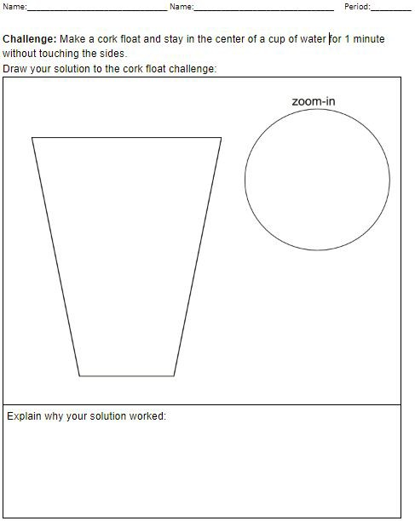

Properties of Water Stations
One Way Screen  Property | Solid vs Liquid Water  Property
Baby Oil and Water  Property | Water Layers  Property

Index Attachment  Property | Water Hat  Property
Tears in Space  Property | Liquid Mountaineering  Property

Properties of Water Stations Directions
One-Way Screen
CHALLENGE #1: Put water in the jar. Keep the water in the jar after turning it upside down.
CHALLENGE #2: Once you have the jar upside down, try to make a toothpick float to the top of the water without spilling it.
OBSERVATIONS SHEET: Explain how you accomplished the task and why your solution worked.
PROPERTY: What properties of water does this challenge emphasize? (List a minimum of two.)
Solid vs. Liquid Water
DIRECTIONS:
- Add 40 ml of water to a beaker, and then 30 ml of oil on top of the water. Allow the layers to separate.
- Add 8-10 drops of food coloring to the surface of the oil without touching the liquid in the beaker. Observe the motion of the food coloring.
- Place a small piece of blue ice cube gently onto the top of the oil. Observe the ice cube/liquid as it melts.
OBSERVATIONS SHEET: Describe what you are seeing and why.
PROPERTY: What properties of water does this demonstration emphasize? (List a minimum of two.)
Baby Oil and Water
DIRECTIONS:
- Gently shake the container with the baby oil and blue water. OBSERVATIONS SHEET: Describe what you are seeing and why.
PROPERTY: What properties of water does this demonstration emphasize? (List a minimum of two.)
Water Layers
CHALLENGE: Make 3 distinct, separate layers of water in the beaker - blue, clear and red. OBSERVATIONS SHEET: Explain how you accomplished the task and why the water does what we observe.
PROPERTY: What property of water does this demonstration emphasize?
Index Attachment
CHALLENGE: Using a cup, water, and an index card. Get the index card to stick to the opening of the cup while holding it upside down.
OBSERVATIONS SHEET: Explain how you accomplished the task. Explain why your solution works.
PROPERTY: What property of water does this challenge emphasize?
Water Hat
DIRECTIONS: Navigate to the Water Hat image on the Phenomena for NGSS website. Observe the image.
OBSERVATIONS SHEET: Describe what is happening and why.
PROPERTY: What property of water does this demonstration emphasize?
Tears in Space
DIRECTIONS: Watch the Tears in Space (Don't Fall) video from the Canadian Space Agency.
OBSERVATIONS SHEET: Describe what is happening and why.
PROPERTY: What property of water does this demonstration emphasize?
Liquid Mountaineering
DIRECTIONS: Watch the Walk on water (Liquid Mountaineering) video on YouTube.
OBSERVATIONS SHEET: Describe what is happening and why.
PROPERTY: What property of water does this demonstration emphasize?

Properties of Water Notes
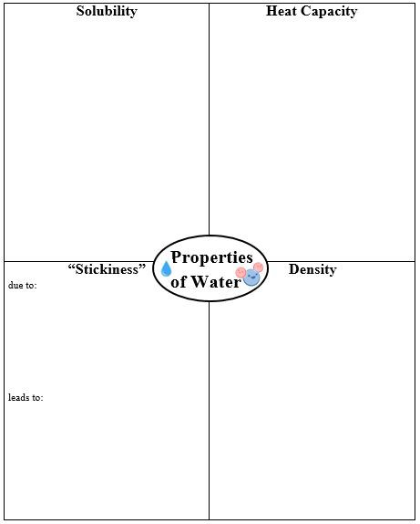
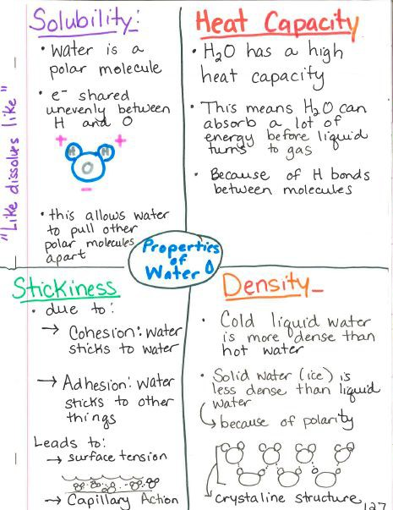

Task: Properties of Water
Properties of Water Investigation
- Choose a property of water to design and conduct an investigation on:
- Surface tension
- Density
- Heat capacity
- Solubility
- Identify a manipulated variable (what you are changing):
- Identify a responding variable (what you are measuring):
Question: How does [insert manipulated variable] affect [insert responding variable]? Hypothesis:
If the [insert manipulated variable] is [choose one - increased/decreased] then the [insert responding variable] will [choose one - increase/decrease] because [insert brief reason for your prediction].
Materials:
- [insert list of materials used in your investigation]
Procedure:
- [Insert a series of numbered steps describing the process used in your investigation]
Data:
[Insert a data table that includes trial data and averages]
Conclusion:
[Insert a conclusion to your investigation]

Task Rubric: Properties of Water
Learning Evidence | 1 point
Hypothesis includes manipulated and responding variables
Materials list includes all items necessary to conduct the investigation
Procedure includes one manipulated variable and one responding variable
Procedure includes logical steps that could be repeated and produce the same data
A data table shows the values of the responding variable for each condition of the manipulated variable and average values if multiple trials were conducted.
The conclusion includes a statement of how the manipulated variable affected the reaction rate.
The conclusion uses data (average data when available) to support the conclusive statement.
Total | /7

Test: Properties of Water
Name: Period:
- Which property of water allows for capillary action?
  - heat capacity
  - adhesion
  - solubility
  - density
- Water is called a "universal solvent" because it dissolves many compounds. Why does water dissolve so many substances?
  - because of its low specific heat capacity
  - because it is polar
  - because of its high specific heat capacity
  - because it is liquid
- Which of the following are special properties of liquid water? Select all correct responses.
  - low light transmission
  - strong surface tension
  - higher density than solid water
  - large heat capacity
- What causes water to form drops when falling from clouds?
  - cohesion
  - heat capacity
  - density
  - covalent bonding
- What is the temperature at which water reaches maximum density?
  - 100 °Celsius
  - 0 °Celsius
  - 4 °Celsius
  - 32 °Fahrenheit
- Cohesion occurs due to which type of bonding?
  - ionic
  - covalent
  - double
  - hydrogen
- Why is water classified as a polar molecule?
  - a water molecule has no charge
  - a water molecule has identical charges at opposite ends
  - a water molecule has an unequal number of protons and electrons
  - a water molecule has opposite charges at opposite ends
- The high heat capacity of water allows it to do what? Select all correct responses.
  - boil at higher temperatures than many liquids
  - absorb large amounts of heat energy before the temperature changes
  - float as a solid on its liquid form
  - form additional hydrogen bonds

Unit 10:
Managing Resources
Return to Table of Contents
Except where otherwise noted, this work by Oak Harbor Public Schools is licensed under a Creative
Commons Attribution 4.0 License. All logos and trademarks are property of their respective owners.
Content purchased by Oak Harbor Public Schools and under All Rights Reserved copyright is referenced but not included in this document. It is marked with the $$ symbol.
Links to third-party websites are provided for your convenience only and do not constitute Oak Harbor Public Schools’ endorsement, sponsorship, warranty or approval of linked websites or any product, service or content offered on such linked websites. Please confirm the license status of these third-party resources and understand their terms of use.

Unit 10: Managing Resources

Standards
HS-ESS3-2: Evaluate competing design solutions for developing, managing, and utilizing energy and mineral resources based on cost-benefit ratios.
HS-ETS1-1: Analyze a major global challenge to specify qualitative and quantitative criteria and constraints for solutions that account for societal

Engage
Question: What are the costs and benefits of open pit mining as seen in this photo?
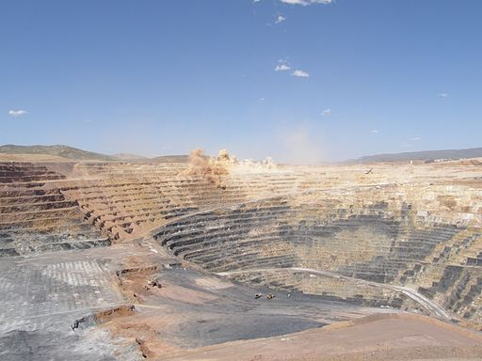
Twin Creeks gold mine, Nevada, USA from Wikimedia Commons by Geomartin | CC BY-SA 3.0
Materials:
- Photo of open pit mine
Procedure:
- Show students photo of mining operation and identify the natural resources coming from that mine. Students write and sketch their answers to the question
Learning Objective:
- I can communicate my existing ideas about developing, managing, and utilizing energy and mineral resources.

Explore
Cookie Mining Lab
Learning Objective:
- I can design solutions for developing and managing mineral resources based on cost benefit analysis.

Explain
- Reading: CK-12 - Finding and Mining Ore
- Reading: CK-12 - Environmental Impacts of Mining
- Reading: CK-12 - Availability of Natural Resources
- Reading: CK-12 - Renewable vs Nonrenewable Resources
Learning Objective:
- I can identify different types of resources and whether they are reusable.

Extend/Elaborate
NOVA Poisoned Water Flint Michigan Video | PBS
Learning Objective:
- I can describe water as a natural resource which is increasingly difficult to obtain.

Evaluate: Managing Resources
Unit 10: Task

Unit 10 – Managing Resources
Cookie Mining Lab
Global Challenge: Clean Water for Drinking

Cookie Mining Lab
Below are links to cookie lab options that may be downloaded and used for educational purposes.
Cookie Mining | American Geosciences Institute adapted from Women in Mining Education Foundation
Cookie Mining | Museum of Science and Industry, Chicago
Cookie Mining: Ore Production & Cost-Benefit Analysis | TeachEngineering: University of Colorado at Boulder; Colorado School of Mines, Duke University, Oregon State University, and Worcester Polytechnic Institute

Task: Global Challenge - Clean Water for Drinking
Water is a natural resource for many reasons. Water is used in virtually every human activity from manufacturing, to agriculture, to transportation, to energy production. Perhaps one of the most important uses of water is for drinking. A healthy human can survive no more than three days without drinking water.
In a growing number of places, water that is clean and safe is difficult to obtain. A major challenge for your generation will be designing ways to ensure all people have access to clean water for drinking.
In this activity, you will work in groups to evaluate competing design solutions for managing clean drinking water supplies. Your group will conduct research using the online resources listed at the end of this packet.
Part 1: Research
System & Natural Resource involved:
- What Earth systems are involved with obtaining water for drinking?
- How many people in the world live in areas where obtaining clean water is difficult? What are some of these locations?
- What are some reasons that clean water is difficult to obtain in the places you listed in question 2?
Costs and Risks:
- Describe 2 costs of obtaining clean water.
- Describe 2 risks of obtaining clean water.
- Describe 2 benefits of obtaining clean water.
Personal Connection:
- Where does your water supply come from for your home? (If your group members have different water supplies, list them all.)
- What are the potential risks to your water supply?
Part 2: Evaluating Solutions
Two solutions to providing clean water are reverse osmosis and recycling wastewater. Your group will research each of these possible solutions. You will then choose which solution is the best and conduct a Claim, Evidence, Reasoning process to defend your choice.
Pros and Cons
Identify at least two pros and two cons of reverse osmosis.
Identify at least two pros and two cons of recycling wastewater.

Claim, Evidence and Reasoning
Make a claim for which solution is “best”.
Defend your claim using three cited pieces of evidence from your research, pros and cons.
Explain the scientific reasoning for your choice.
Prepare to present the argument for your choice to the class.

Unit 11:
Properties of Substances and intermolecular Forces
Return to Table of Contents
Except where otherwise noted, this work by Oak Harbor Public Schools is licensed under a Creative
Commons Attribution 4.0 License. All logos and trademarks are property of their respective owners.
Content purchased by Oak Harbor Public Schools and under All Rights Reserved copyright is referenced but not included in this document. It is marked with the $$ symbol.
Links to third-party websites are provided for your convenience only and do not constitute Oak Harbor Public Schools’ endorsement, sponsorship, warranty or approval of linked websites or any product, service or content offered on such linked websites. Please confirm the license status of these third-party resources and understand their terms of use.

Unit 11: Properties of Substances and Intermolecular Forces

Standards
HS-PS1-3: Plan and conduct an investigation to gather evidence to compare the structure of substances at the bulk scale to infer the strength of electrical forces between particles.
HS-PS2-6: Communicate scientific and technical information about why the molecular-level structure is important in the functioning of designed materials.

Model
Question: Why does ice melt at different rates if placed on different surfaces?
Materials:
- Flinn ice melting blocks
- Ice
- Infrared thermometer
Learning Objective:
- I can communicate my existing ideas about different properties of different materials.

Explore
Structure of Substances Stations and Answer Key
Materials and their uses Stations and Answer Key
Learning Objectives:
- I can identify why particular substances are used for specific purposes based on their properties. I can differentiate between properties of metals and nonmetals.
- I can describe why materials conduct electricity.

Extend/Elaborate
Revisit Model
Include the following terms:
- Conductor
- Insulator
- Polymer
- Heat capacity
Learning Objective:
- I can revise a model to add details about materials and their properties.

Unit 11 – Properties of Substances and Intermolecular Forces
Properties of Substances Model
Structure of Substances Stations
Materials and their Uses Stations

Properties of Substances Model
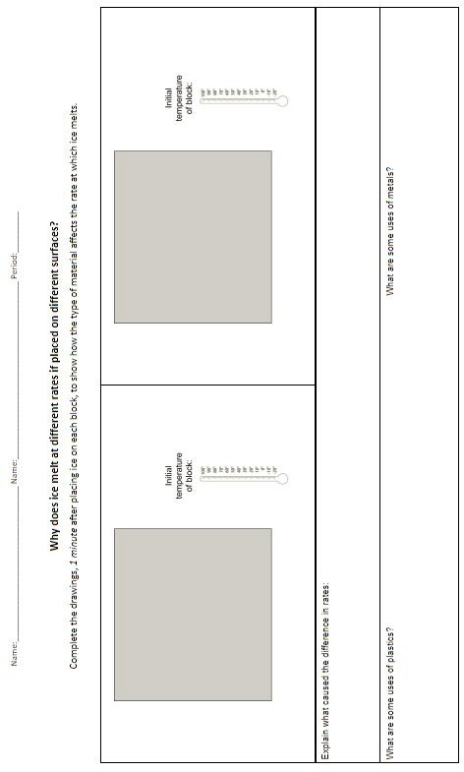

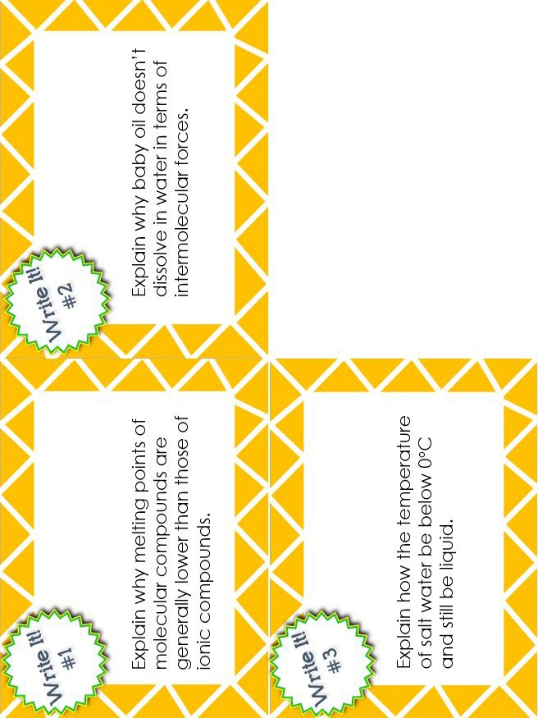
Structure of Substances Stations

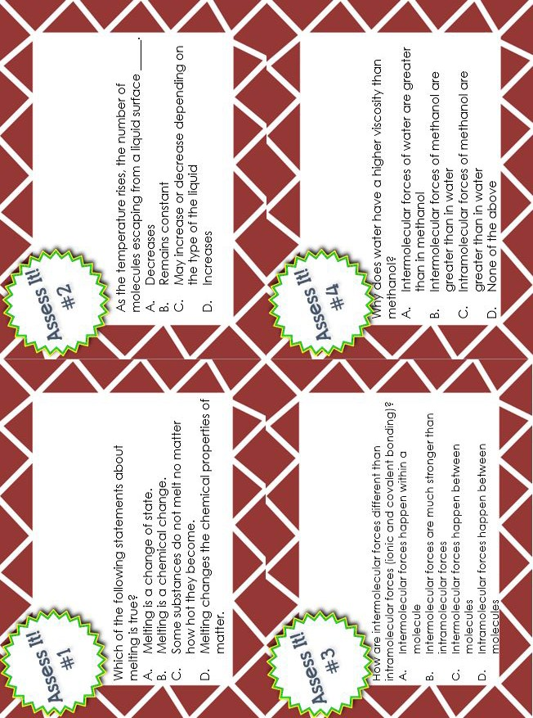

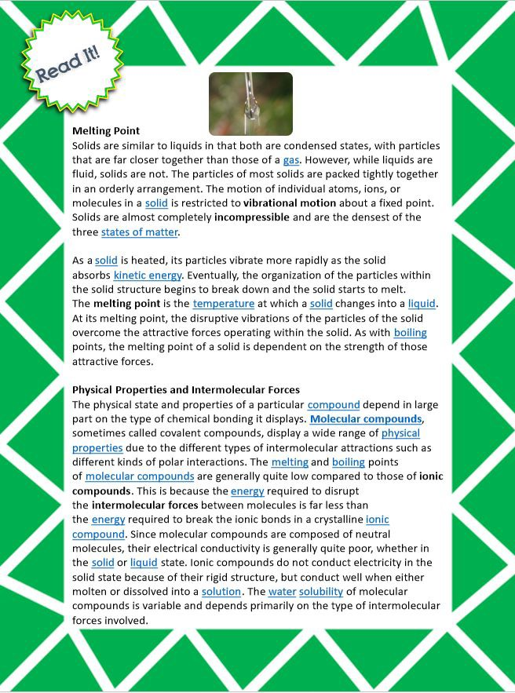

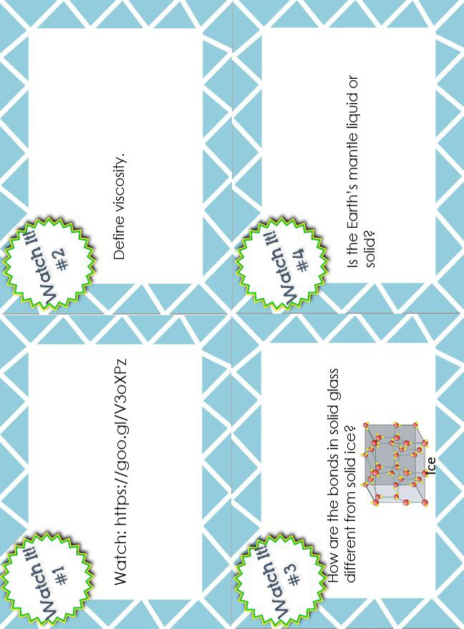

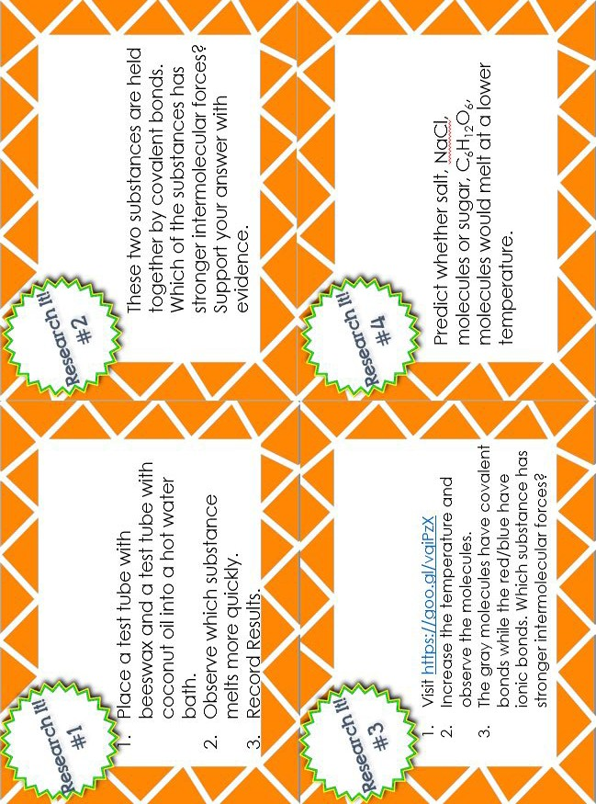

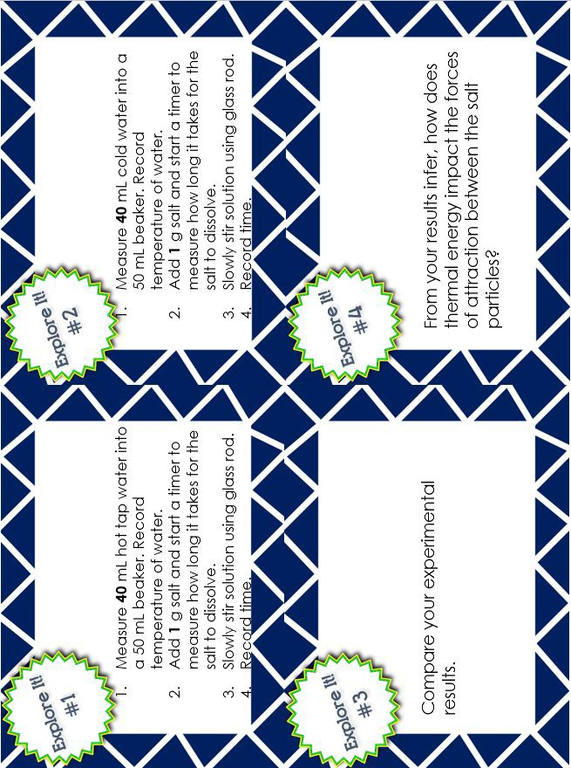

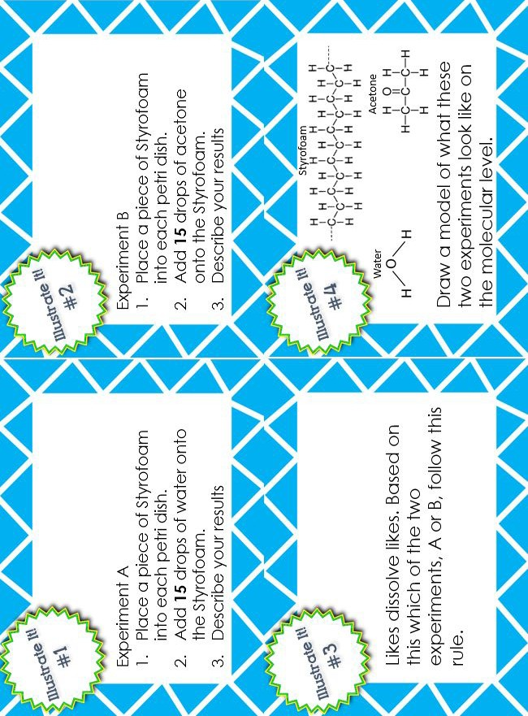

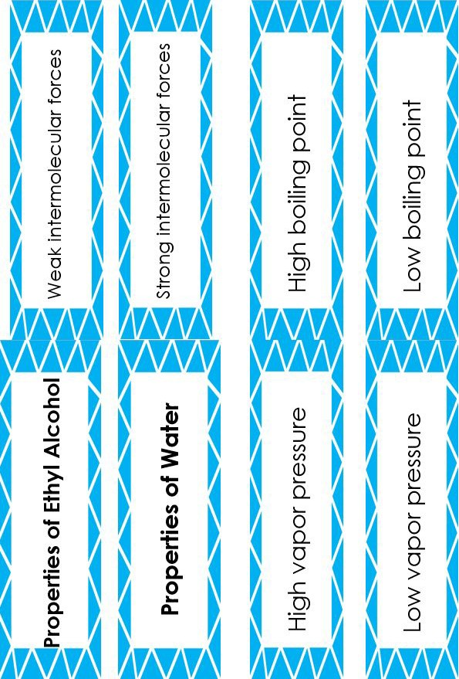
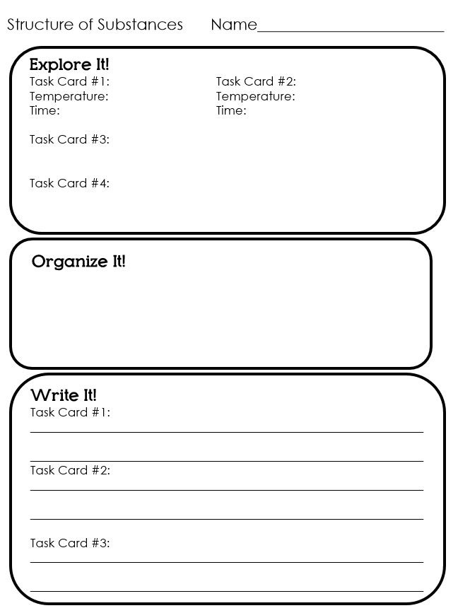

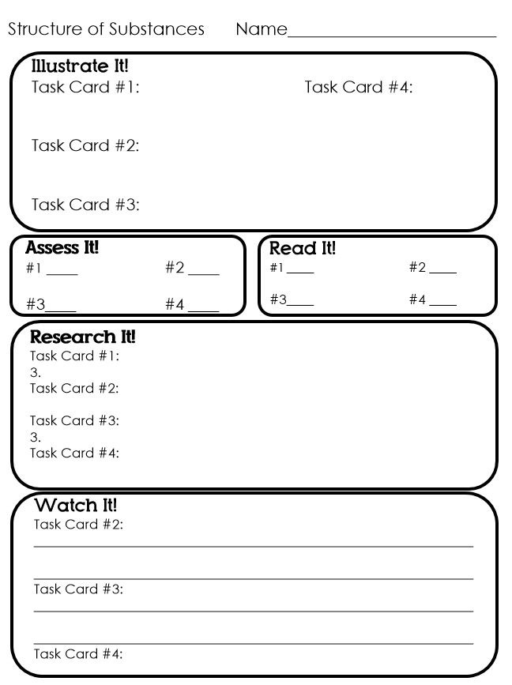

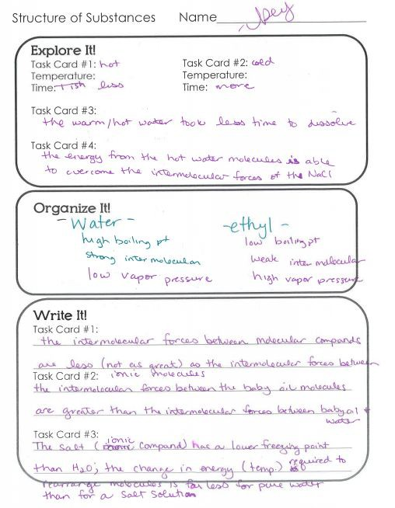

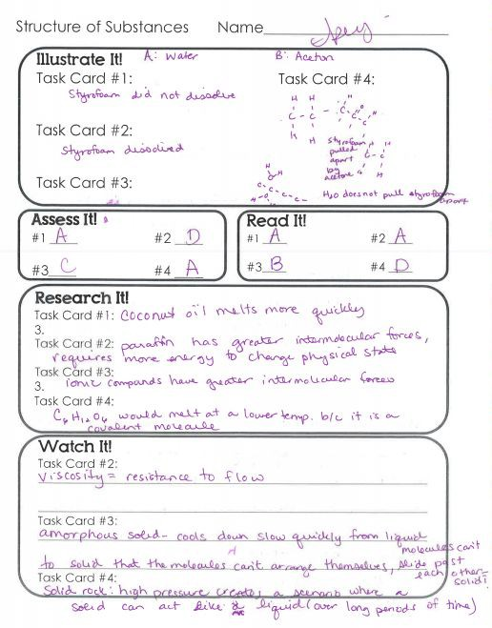

Materials and their Uses Stations
