Kahoot Mobile APP
How to download the app
Go to the APP Store on your apple device (iPad or iPhone).

IMPORTANT: Go to search and type Kahoot it. Select the icon with the K!

Click Get and then Install. Wait until the installation process is complete. Then click OPEN and Get started.

A screen asking for personal information will appear.
Question 1: How do you want to use Kahoot?
Question 2: How old are you?

IMPORTANT: To select the correct option, click on the shape with your answer.

Go to the bottom of the Kahoot app and click on Enter PIN. The game pin refers to numbers. Then type in your nickname if available.

How to play
Steps:
- Read each statement or question.
- Click on the shape with the answer on it.
Note: If you see a check mark (√) that means your answer is correct. If you see an X that means your answer is incorrect.
- Go to the next question and repeat.
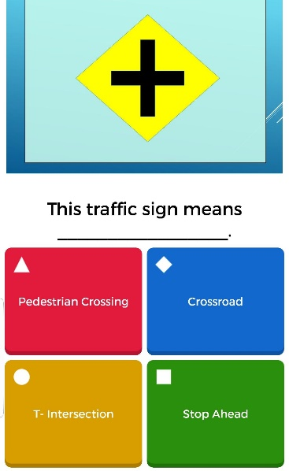

Note: When playing on your mobile device in the classroom, the questions and answers will be displayed on the board. On your phone, you will only see the colored shapes.

