Kahoot Mobile APP

How to download the app
Go to the Play Store on your android device.

IMPORTANT: Type Kahoot it. Select the icon with the K!

Click INSTALL and wait until the installation process is complete. Then click OPEN.

A screen asking for personal information will appear.
Question 1: How do you want to use Kahoot?
Question 2: Which best describes your current workplace?

IMPORTANT: To select the correct option, click on the shape with your answer.

How to create an account

Click on Sign up. Select if you prefer to sign up with Google, Microsoft, or with your email.

Type in your account details and then click on Join Kahoot!
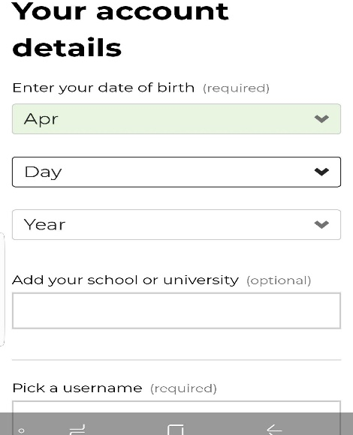

Click Continue for Free on the bottom of the screen.

Look at the bottom of your screen. You can create your own Kahoots, see Kahoots already created by others or the ones you created, and even see game reports.

Searching Kahoots

To search Kahoots go to the upper right corner and type the topics of choice. You can share, duplicate and play the Kahoots selected.

Note: The Kahoot for this lesson is titled: Traffic Signals and Road Signs

After selecting the Kahoot, click PLAY from your computer when playing in the classroom with students. The questions or statements will be displayed on the board and students will have the answers on their Kahoot app (a projector is needed). However, when assigning students to play and practice at home; select Challenge so students can view both the prompt and answers on their mobile devices.

IMPORTANT: Give students the quick reference guide that corresponds to their mobile device.

Instructions to play Kahoot

Go to the bottom of the Kahoot app and click on Enter PIN. The game pin refers to numbers you will provide.

Type in your nickname if available.

How to play
Steps:
- Read each statement or question.
- Click on the shape with the answer on it.
Note: If you see a check mark (√) that means your answer is correct. If you see an X that means your answer is incorrect.
- Go to the next question and repeat.

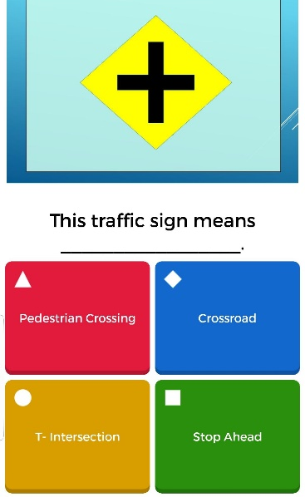

Note: When playing on your mobile device in the classroom, the questions and answers will be displayed on the board. On your phone, you will only see the colored shapes.

