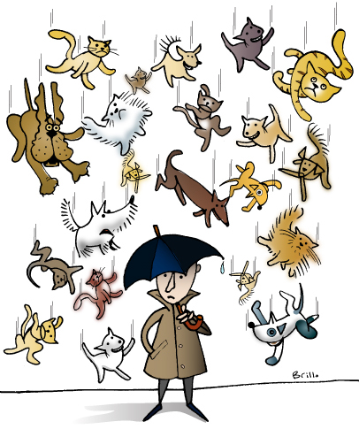
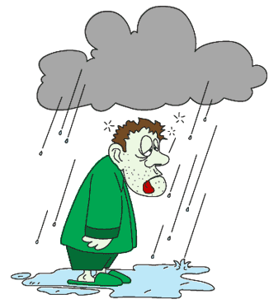
Weather idioms
Take a raincheck
Under the weather
On cloud nine
Got wind of
Brightened my day
Raining cats and dogs

- The police _______________________ a drug deal and arrested two people.

- I can’t come to class this week because I’m _______________________. I have a headache and I feel nauseous.

- Look at the rain outside! It’s _________________________________________!

- Sam has to work tonight, but he will _______________________. He wants to have dinner with us next week.

- It _______________________ to see you today! You make me smile

- My aunt was _______________________ when she saw she was pregnant. She was very happy to have a baby.

Weather idioms
Take a raincheck
Under the weather
On cloud nine
Got wind of
Brightened my day
Raining cats and dogs

- The police _______________________ a drug deal and arrested two people.

- I can’t come to class this week because I’m _______________________. I have a headache and I feel nauseous.

- Look at the rain outside! It’s _________________________________________!

- Sam has to work tonight, but he will _______________________. He wants to have dinner with us next week.

- It _______________________ to see you today! You make me smile

- My aunt was _______________________ when she saw she was pregnant. She was very happy to have a baby.

