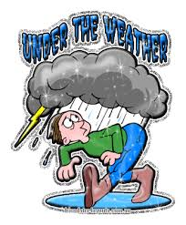
I am under the weather today. I want to sleep!

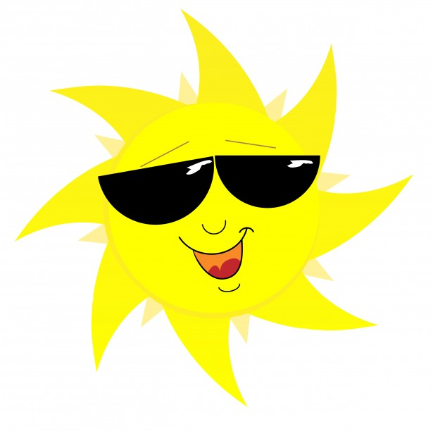
I am so happy to see you! You brightened my day.

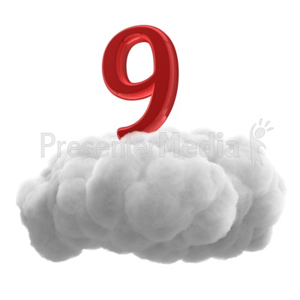
I am on cloud nine because I have a new job!

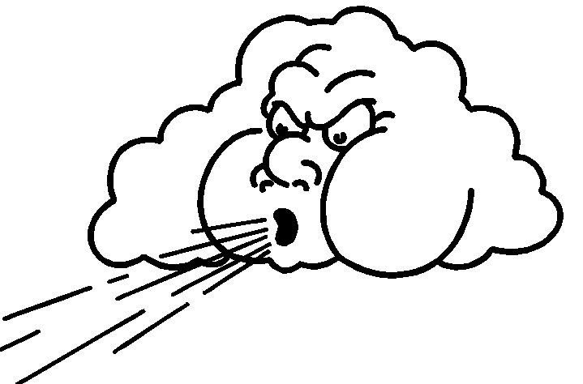
I got wind of the surprise party. Now it is not a surprise!

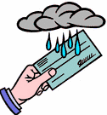
I cannot come to dinner tomorrow. I’ll take a raincheck.

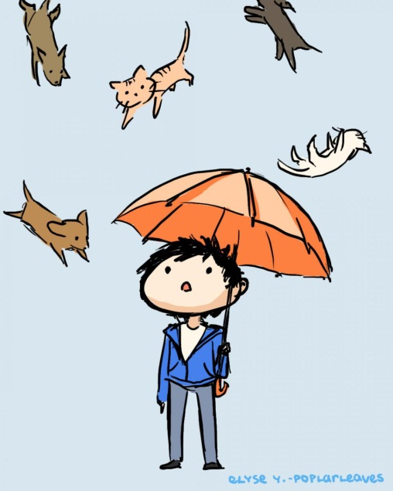
It’s raining cats and dogs! I need an umbrella!

