Teaching Notes
for
Shakespeare and the Nature of Science: Examining Scientific Inquiry Through Time
by
Kyle Sebastian Vitale, Poorvu Center for Teaching and Learning, Yale University
Tracie Marcella Addy, Center for the Integration of Teaching, Learning, and Scholarship, Lafayette College

A key providing sample answers to resource questions is available upon request. Please contact us at kyle.vitale@yale.edu or addyt@lafayette.edu.

Introduction / Objectives
This undergraduate case study explores the cultural context of scientific inquiry through an interdisciplinary lens. Students follow two characters from William Shakespeare’s play King Lear who debate the cosmos with various scientists from the 17th – 20th centuries. The interdisciplinary lens models the ways intellectual questions often draw from interrelated traditions of thought and practice. Case objectives familiarize students with several disciplines while they reflect on the contexts of their own education and intellectual inquiry.

Objectives
- Analyze how knowledge about the cosmos is mediated through cultural texts and beliefs
- Articulate shifting norms and beliefs of scientific inquiry in the last 500 years
- Identify and explain core tenets of the nature of science
- Compare representations of scientific knowledge in Shakespeare and modern culture

To answer these questions, students will deploy skills and strengthen their familiarity with approaches and frameworks from the humanities, the sciences, and history. Joined together, this interdisciplinary approach assumes the following about its linked disciplines:

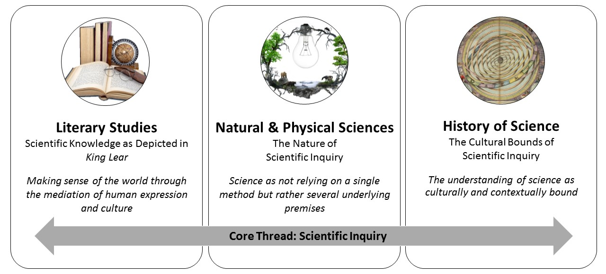
Figure 1. Interdisciplinary Aspects of Case Study
Case Description and Background
The case opens by introducing the Earl of Gloucester and his illegitimate son, Edmund, through a pre-assignment and brief passage from Shakespeare’s King Lear (we include a simple prose translation of the passage at the end of these teaching notes). In the play, Gloucester and Edmund express their thoughts about the cosmos and its effects on family relationships through references to nature that are rooted in real scientific beliefs of Shakespeare’s day. The case imagines a follow-up sequence where the play’s famous storm blows in scientists from the 17th – 20th centuries, including Galileo Galilei, Edmond Halley, Isaac Newton, Niels Bohr, and Marie Curie. This sequence is divided into four dialogues, where characters and scientists debate various ways of inquiring about the cosmos. Each dialogue features comments about historical contexts that defined major attributes of scientific inquiry, favored ways of finding meaning in the universe, and attributes of the nature of science.

This case study is not meant to be a full analysis of King Lear, as students engage with a short passage of the play. Instead, the case samples the literary qualities of the play, while using it to stage imaginative dialogue that promotes conversation with students about inquiry. We have endeavored, drawing on our own disciplinary expertise, to respect both the original qualities of the play and the beliefs of figures we represent. In a series of questions following each dialogue, students are invited to analyze the dialogue, compare it to field-wide tenets for the nature of science, and reflect on their own cultural assumptions regarding scientific inquiry. Questions regularly ask students to visit and revisit their conceptions of scientific inquiry, formally defined and as understood in culture, and to revise common misconceptions about science (the idea of a single scientific method, historical progress towards positivism) and literature (its lack of relevance, its disassociation from popular cultural beliefs).

The case study is appropriate for undergraduates of all levels, and the dialogue is rich enough for instructors to alter the focus of conversation towards more historical, scientific, or literary purposes. The case requires no previous knowledge of Shakespeare or the history of science, and students need only a preliminary understanding of scientific inquiry. Following the sections on Classroom Management and Blocks of Analysis, these Teaching Notes include:
- Brief historical background on King Lear;
- Brief profiles of each scientist included in the case;
- Brief overview of tenets associated with the nature of science;
- A prose translation of the passage from Shakespeare included in the case

Classroom Management
If completed in one session, the case includes a 10-15- minute homework pre-assignment, followed by roughly 110 – 150 minutes of dialogue and questions. Each of 3 dialogues take 25 minutes to complete. If splitting across classes, we suggest completing Parts I-II together, then Parts III-IV, and V.

Each Part is designed to be completed in any variety of ways, including:
- Acting out the dialogue in front of the entire class with a few volunteer students, then breaking to answer questions together;
- Having student groups of 3-4 assume a character (or 2), read aloud their parts while in their groups, then answer questions within their groups;
- Silent reading of dialogue, followed by group or independent answering of questions;
- Completing Parts in a “flipped” setting, where students meet outside of class (either physically or digitally) to familiarize themselves with the dialogue and ideas. The instructor might supply basic questions like “what are characters talking about?” or “what are this dialogue’s main ideas?”, following by in-class discussion of the case questions;
- Completing Parts as at-home assignments, which can accompany additional research or reading as the instructor desires.
In each of these methods, the participation goal remains largely the same, namely helping students understand how people think and thought in the past, with an eye to what we have gained and lost today. In detail, this means that:
- Students will work to share the perspective of each character and consider the nature of science and the cosmos from their point of view in a critical but nonjudgmental way;
- Students will use the dialogue as a vehicle to explore complex ideas;
- Students should be reminded that the dialogues are written to be informative and fun.
Blocks of Analysis
Each part seeks to render shifting representations of scientific belief through different historical periods. It is crucial that students understand the revisionist movement in History of Science that rejects the idea of a “march of scientific progress,” where successive periods strip away erroneous spiritual beliefs in favor of more and more positivism. Rather, History of Science seeks a) to respect the beliefs found in given historical, cultural contexts, and b) to identify attributes of scientific inquiry that postmodernity has lost, either to its advantage or detriment.

Part I – Shakespeare, Cosmology, and Belief

This section of the case study immerses students in a dialogue from William Shakespeare’s King Lear (published circa 1605) between the Earl of Gloucester and Edmund, his illegitimate son. Edmund and Gloucester have differing views regarding the relationships between human choice and the natural world. Gloucester uses observations of the natural world to predict future events related to the human condition, and believes human will to be bound by nature. In this scene, Gloucester describes how observations of solar and lunar eclipses foretell impending calamity for his family. Edmund, in contrast, does not consider himself or the events of life bound by nature. Meaning in life, for Edmund, is found solely in himself.

Students are asked to form preliminary thoughts on how and whether scientific knowledge emerges within this dialogue. Students should ultimately recognize that within the cultural context of the time, observations of nature were made not necessarily to understand why particular scientific phenomena occurred, but as a way to make sense of the world’s events. As noted above, such observations were often used to makes sense of influences on the human will.

Tips for Teaching Part I:

Instructors might stoke class discussion about the ways that Edmund speaks as a literary creation of the 17th century, while also presaging what we understand as the “modern” mind – more positivist and self-made. Describing Edmund as a "skeptic," as someone who does not necessarily hold any of the creedal confessions of his day, is a perfectly reasonable claim in Shakespeare studies, and suggests the seeds of modern secularism.

Instructors might also use this opportunity to help students differentiate early modern astrology from modern astrology, which are vaguely related but different practices. Whereas 17th-century astrology was a pervasive and complex practice likening historical events to the cosmos, modern astrology remains a niche practice for self-characterization.

Finally, instructors may also be aware of deep complexities in the word “necessity” used throughout the passage. The word belongs to the philosophical vocabulary of the time: “necessity, or “necessary” in natural philosophy, implies an inescapable conclusion or consequence that is not the result of choice. So for example, theologians often remarked that God created the world out of free choice, not of “necessity” as Aristotle maintained (think of projecting a shadow while you are walking in the Sun; in a certain sense you “create” a shadow, but not because you wanted or cared. That would be Aristotle’s idea). As an additional exercise, students might look up “necessary” and “necessity” in the Oxford English Dictionary to consider its historical growth.
Part II – Competing Claims
This part of the case study offers a review of Gloucester and Edmund’s argument. The characters engage in a heated disagreement with one another during which their contrasting viewpoints, described above, become even more apparent. Instructors should note that Aristotelian thinking was predominant at the time: individuals largely consider “the heavens” (the stars and planets) to be pure and consistent, while the fallen, imperfect nature of Earth’s atmosphere allows for change and imperfection. Further, the Church held strong views against certain forms of astrology that seemed to explain away human will to changeable atmospherics or heavenly positions.

Instructors may also ensure that students realize the language in this and all subsequent Parts is not Shakespeare’s, but the work of the case authors.

Tips for Teaching Part II:

“It is the stars, / The stars above us, govern our conditions” is a later line from a different character in King Lear. Instructors might use this line as a way to clarify the beliefs of Gloucester and others in the play.

Also, Gloucester’s line about “impish humors” is an opportunity to introduce details about early modern science. Although the tide of ideas was changing, people still clung to belief in the four “bodily humours” surmised by the classical physician Galen: blood, phlegm, yellow bile, and black bile, each of which were believed to be biological causes for certain emotions and attitudes.

Part III – Galileo Enters

Galileo enters the dialogue and critiques the Aristotelian thinking of Gloucester, introducing his own views of how observations of the natural world can provide great insight into why certain scientific phenomena are observed. Galileo is a proponent of scientific inquiry but maintains a respect for human existence within the cosmos. Students are introduced to the major tenets of the nature of science in the questions within this section, and are asked to describe which tenets have emerged in the dialogue thus far. Students should recognize Galileo’s focus on empirical evidence; the historical, cultural and social influences on science; and Galileo’s belief that science and its methods cannot answer all questions. Galileo’s rebuttal of Edmund offers an opportunity to ask students about the nature of science.

Tip for Teaching Part III:

Galileo’s final comment about “you are not an island” comes from a written meditation by John Donne in 1624, about twenty years after this play was first performed, but only 1 year after it was first published. Donne’s line could easily criticize the self-made attitudes of Edmund and other characters like Hamlet.

Part IV – Halley and Newton Enter

In this section, Halley and Newton engage in dialogue with Gloucester and Edmund in ways that further critique the modernist narrative of secular scientific progress. This dialogue represents further cultural shifts occurring during the 17th and 18th centuries. Newton’s belief in God as the ultimate designer of a universe that can be understood scientifically dovetails with some of Gloucester’s beliefs. Newton’s beliefs contrast the less mystical beliefs of Halley and Edmund.

Tips for Teaching Part IV:

This Part is critical for belying the popular cultural notion of Isaac Newton as the Father of Modern Science, or the “secular scientist saint” we have inherited in Bill Nye the Science Guy. Author John Henry describes Newton through a quote by J. M. Keynes in A Short History of Scientific Thought: “Newton was not the first of the age of reason. He was the last of the magicians . . . the last wonder child to whom the Magi could do sincere and appropriate homage” (155). We see Gloucester in this dialogue initially balk at Newton’s mathematical formulas for planetary motion, but eventually find common ground in Newton’s talk of a Creator, forces, and the musical of the spheres.

Gloucester speaks of the Octavium Firmamentum, or the “Eighth Firmament,” believed to be the sphere wherein the stars are fixed (note the concentric circle just beyond “Saturni” below). This worldview includes the belief that “changeable” elements of the sky, like comets and eclipses, must be atmospheric, while the higher celestial firmament where the star reside is perfect and unchangeable.
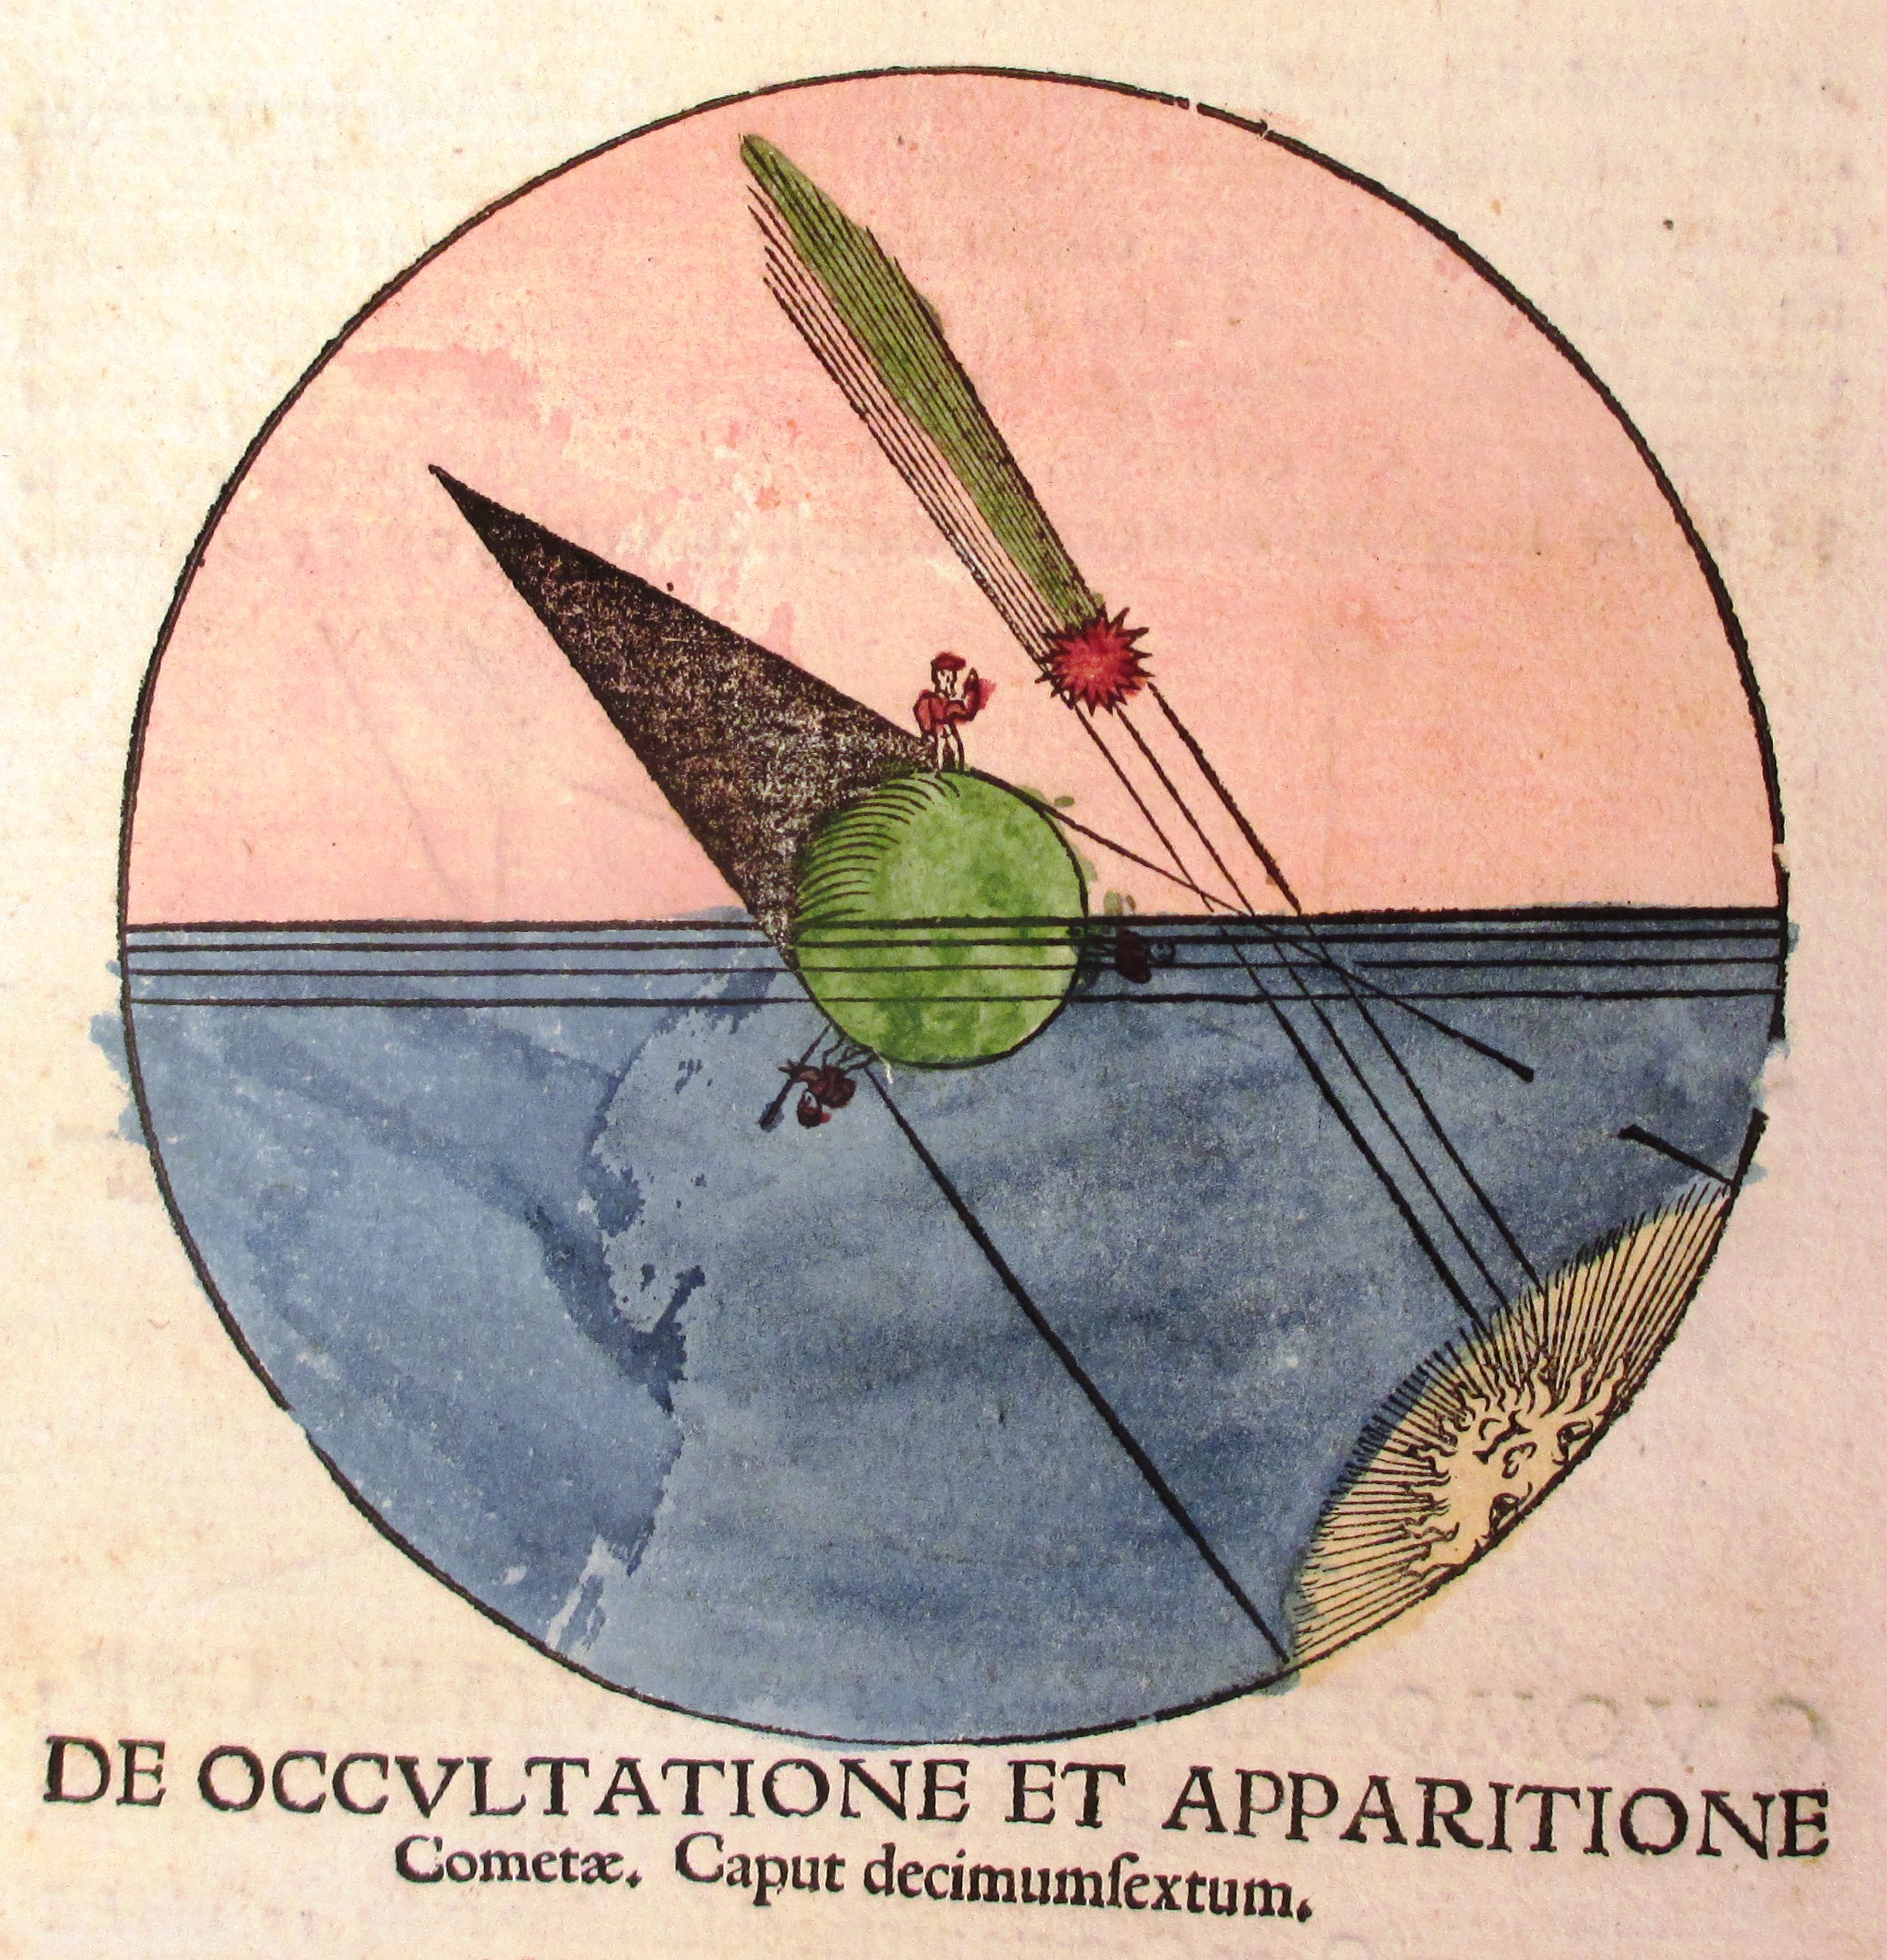

Figure 1: Image of a comet as an atmospheric, rather than celestial, phenomenon. From Peter Apian, Astromomicon Caesareum ["The Astronomy of the Emperors"] (Ingolstadt, 1540)

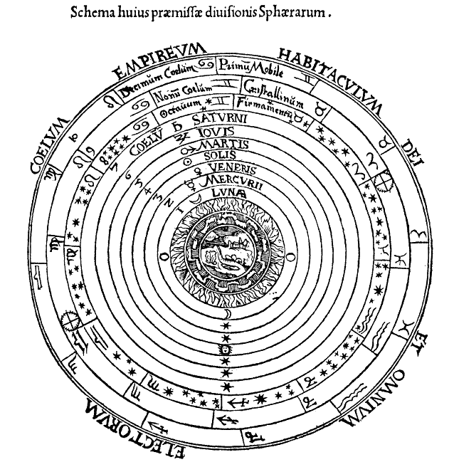

Figure 2: Geocentric Celestial Spheres, Peter Apian’s Cosmographia (Antwerp, 1539); image courtesy Wikipedia, “Celestial spheres”

Part V – Bohr and Curie Enter

In the last part of the case study, Gloucester is not in agreement with the ideas of Bohr and Curie, however, students should recognize that he does start to see some middle ground.

Rather than provide a comprehensive history of science, the case study explores the early centuries of modern science, and then shifts to our immediate scientific intellectual ancestors. This approach stages conversation about threads of ancient, early modern, and modern thought that remain in modern thinking, and elements that we have lost. In short, Part VI, though it does not exist, would be “today.”

Historical Background

King Lear

William Shakespeare’s play The Tragedy of King Lear was first performed in London, England in 1606, and first published in various forms in 1608 and 1623. This historical period saw significant scientific advances in the works of William Harvey, Galileo Galilei, and others; although set in the ancient British past, Lear contains references to scientific beliefs, cultural practices, and courtly frictions of Shakespeare’s time. The play draws from a variety of historical and fictional sources, many of which were familiar to popular and aristocratic audiences alike in Renaissance England.

King Lear is considered a “tragedy” because its structure and plot work differently from other dramatic genres like “comedy” and “history.” For the most part, King Lear follows traditional tragic expectations like the fall of the protagonist, the dissolution of relationships, and the inescapability of consequences issuing from poor human choices. These dramatic norms, particularly the latter, inform how the play’s characters make sense of causation and human will in their lives.

Profiles of Featured Scientists

This case study features several prominent scientists including Galileo Galilei, Edmond Halley, Sir Isaac Newton, Niels Bohr and Marie Curie. Within the case, these scientists engage in dialogue with the main characters Gloucester and Edmund. Below is basic information on each scientist that will be useful for instructors to know while their students are completing the case. These scientist profiles can also be shared with the students.

Galileo Galilei, Professor of Mathematics at the University of Pisa
[1564-1642] Born in Italy, Galileo was a scholar of philosophy, mathematics and astronomy. He had numerous contributions to science, including the early development of the scientific method, advanced telescopic findings and discoveries related to motion. He embraced the heliocentric system, that the sun was the center of the universe. The latter led to his indictment under the Inquisition.

Edmond Halley, Astronomer Royal of Britain
[1656-1742] Perhaps most famous for the comet bearing his name, Edmond Halley was a British astronomer and mathematician who made several contributions to astronomy including describing the orbits of several comets and confirming the location of the southern stars. He was a member of the scientific research group, the Royal Society of London. Halley had personal interactions with Isaac Newton, which led to his contributions on the theory of gravitation described in Newton’s Mathematical Principles of Natural Philosophy.

Sir Isaac Newton, Professor of Mathematics at the University of Cambridge
[1642-1727] Newton was a British physicist and mathematician who contributed greatly to the Scientific Revolution, and had interests in religion and theology. He had several discoveries in the fields of optics, mechanics including the three laws of motion, as well as calculus. His publication Mathematical Principles of Natural Philosophy was a seminal work in modern science.

Niels Bohr, Director, Institute of Theoretical Physics
[1885-1962] Bohr was a Danish physicist who received the Nobel Prize for Physics in 1922 for his findings in quantum physics related to the structure of the atom. He is recognized for the Bohr atomic model, bearing his name, which contrasted the conceptual views of the physicists of his time but explained relevant scientific data.

Marie Curie, Professor Physics, University of Paris
[1867-1934] Marie Curie, born in Poland, was a French physicist renowned for discovering two radioactive elements, polonium and radium. Curie won two Nobel Prizes, one in physics with Henri Becquerel and her husband Pierre Curie, and another in chemistry as the sole awardee. She was the first woman to win a Nobel Prize and is the only woman to have won in more than one discipline.

Nature of Science

Contrary to what is often portrayed in science teaching and learning, there is no single method through which science is conducted, however there are several premises that characterize the nature of science. Using the character dialogue in the case study, students identify tenets of the nature of science starting with Part III of the case onward. These premises include (from McComas, 2004):
- Science demands and relies on empirical evidence.
- Knowledge production in science includes many common features and shared habits of mind.
- Scientific knowledge is tentative but durable.
- Laws and theories are related by distinct kinds of scientific knowledge.
- Science is a highly creative endeavor.
- Science has a subjective element.
- There are historical, cultural and social influences on science.
- Science and technology impact each other, but they are not the same.
- Science and its methods cannot answer all questions.
Prose translation of Shakespeare’s text:

Edmund stands alone on the heath, watching a storm approach across the sea while he plots to destroy his legitimate, older brother Edgar and steal his father’s (the Earl of Gloucester) fortune. He ponders why his illegitimate status should make him different:

Edmund (alone)
I serve only my own nature*, living solely by my natural disposition, power, and cunning. Why should I let myself be plagued by social customs that ignore “bastards” and give inheritance only to legitimate heirs, depriving me of status and privilege just because I was born second, and out of wedlock? Why am I called “base,” when I am just as strong, think just as well, and look as much like a man as any other man?

Edmund, enraged that his legitimate, older brother Edgar will receive their father’s inheritance, convinces their father Gloucester that Edgar wants to overthrow him. Angry and planning to banish Edgar, Gloucester reflects on this unexpected turn of events:

Gloucester
I just knew these recent solar and lunar eclipses meant bad news for us. Although easily explained through natural causes, they always precede disaster and scourging for natural relationships – families and friends fall apart and love seems to die. There are mutinies in the cities, discord in the countries, treason in the queen’s court, and even fathers and sons fall away from each other . . .

Edmund:
This is how foolish we are, that when we face misfortune (usually our own fault), we blame the sun, the moon, and stars instead of ourselves, as if they forced our villainous and poor actions upon us. We think ourselves fools by heavenly influence alone; ignoramuses, thieves, and murderers by planetary forces; drunkards, liars, and adulterers because of how the stars are arranged; and generally fallen by some requirement from God. A clever evasion, for us to blame the stars for our own natural weaknesses. (sarcastically:) I know! My mother conceived me when the Dragon constellation was rising, and I was born under Ursa Major – that must mean I am rough and lustful! (serious again:) I am who I am, and always would have been, no matter if the purest star was twinkling when my parents conceived me out of wedlock.

* Students may be confused in the original text by the apparent contradiction when Edmund begins by lauding “Nature,” but immediately ridicules Gloucester for blaming social disaster on nature. Instructors should clarify for students that when Edmund refers to “Nature” in the first line of Shakespeare’s text (note the upper- case N), he refers more to himself – his disposition, personality, and how he was born (in modern parlance, we say things like “it’s not in his nature to be so nasty”). Later, however, Gloucester and Edmund both refer to “nature” as we typically understand it – the natural world and the universe. However, there are interesting and foggy overlaps between Edmund’s use of these terms that might warrant rich discussion.

References:
Encyclopedia Britannica. Galileo. Retrieved from: https://www.britannica.com/biography/Galileo-Galilei [4/18/18]
Encyclopedia Britannica. Edmond Halley. Retrieved from: https://www.britannica.com/biography/Edmond-Halley [4/18/18]
Encyclopedia Britannica. Sir Isaac Newton. Retrieved from: https://www.britannica.com/biography/Isaac-Newton [4/18/18]
Encyclopedia Britannica. Niels Bohr. Retrieved from: https://www.britannica.com/biography/Niels-Bohr [4/18/18]
Encyclopedia Britannica. Marie Curie. Retrieved from: https://www.britannica.com/biography/Marie-Curie [4/18/18]
McComas WF. (2004). Keys to Teaching the Nature of Science. Science Teacher, 71 (9): 24-27.

