Shakespeare and the Nature of Science: Examining Scientific Inquiry Through Time
by
Kyle Sebastian Vitale, Poorvu Center for Teaching and Learning, Yale University
Tracie Marcella Addy, Center for the Integration of Teaching, Learning, and Scholarship, Lafayette College
Ivano Dal Prete, History of Science/Medicine, Yale University (Case Study Science Advisor)

Pre-class Assignment

Overview:
In class, you will complete an interdisciplinary case study that explores the nature of scientific inquiry through time. Why interdisciplinary? Academic disciplines tend to form when specific questions require unique theories, vocabularies, and practices to answer them. Sometimes, questions are too complex and multifaceted for one discipline’s toolkit. For instance, how do changing cultural contexts and the nature of scientific inquiry inform one another? How do science, story, and belief form our perceptions of the world? These are vital questions that inform knowledge and our own modes of thought, and they require skills practiced in literary studies, natural and physical science, and the history of science.

To begin answering these questions, you will travel through the history of science with characters from William Shakespeare’s The Tragedy of King Lear. Scientists across time will challenge and inform these characters’ beliefs about the cosmos as they talk about the fundamentals of the universe. Throughout this case, your collaborative analysis and discussion will: employ strategies from the sciences to consider the nature of science; employ strategies from the humanities to consider how artistic texts mediate the nature of science in public forms; and employ strategies from the history of science to articulate different modes of scientific inquiry across historical periods.

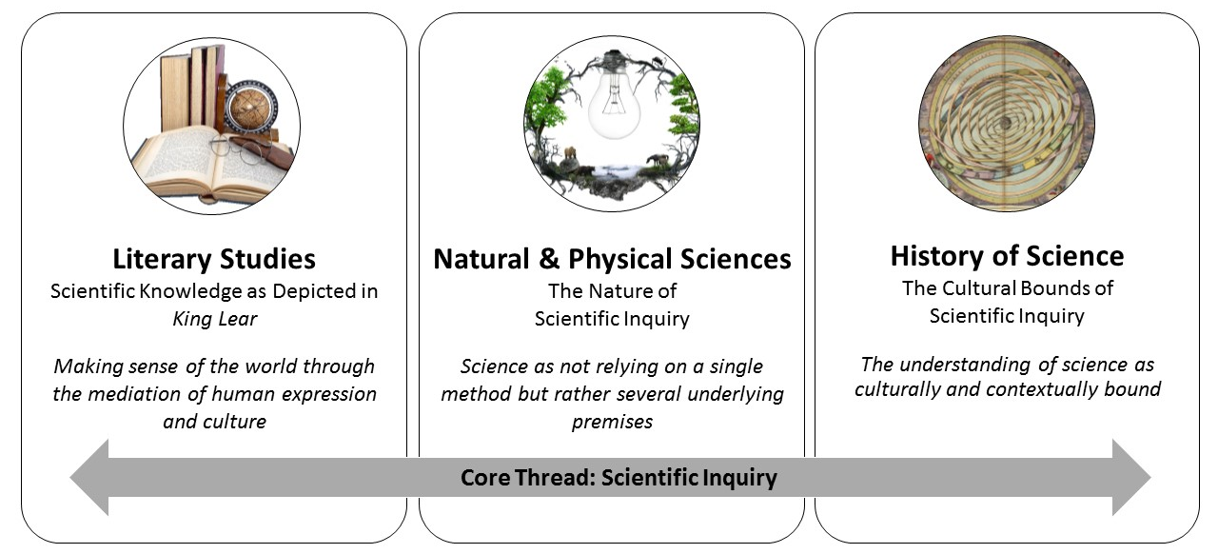
Figure 1. Interdisciplinary Aspects of Case Study
The case study is divided into this pre-assignment and 5 short parts, featuring dialogue and follow-up questions. At the end of this case study, you will be able to:

- Analyze how knowledge about the cosmos is mediated through cultural texts and beliefs
- Articulate shifting norms and beliefs of scientific inquiry in the last 500 years
- Identify and explain core tenets of the nature of science
- Compare representations of scientific knowledge in Shakespeare and modern culture

Case Background:

It is early seventeenth-century England. You stand on a dark heath in Shakespeare’s The Tragedy of King Lear, as bloody family strife unfolds. The aged Earl of Gloucester has two sons: the older, legitimate Edgar, heir to Gloucester’s noble title, lands, and fortune, and the younger, illegitimate Edmund, who wishes to destroy his family in order to claim the Gloucester earldom.

Uneven developments in scientific inquiry are framing this struggle. Natural phenomena and human experience have long been explained through Aristotle’s ideas that nature and action contain inherent qualities that motivate their behavior (i.e., the quality of “heat” makes a pot “hot”). This approach seeks to identify the primary cause, or why, of phenomena, rather than the mechanics of how. Through the common cultural practice of astrology in England, it also helps rationalize human experience. Astrology ties the why of human events and feelings to the motion of planets and stars. Individuals look to the sky, deducing that the circular movements of the stars and planets indicate layers of surrounding spheres - where planets and stars are set - that influence disease and famine, motion, and human fortune. The ups and downs of these events are often ascribed to eclipses, or comets, or the position of planets as they pass through certain constellations in the night sky.

But increasingly, scholars and craftsmen push against Aristotelian natural philosophy through the practice of experimental philosophy, which seeks not to uncover causes through higher forms and purposes, but to describe natural phenomena: the what of natural events.

This inquiry does not neatly replace Aristotelian norms; in many minds, mechanical description can still recognize immaterial forces and astral influences, and long-held assumptions about nature. The classical and the modern hold together, sometimes peaceably, sometimes not.

Family and ideas contend as you watch Edmund standing alone on the heath, staring across the sea where thunder rumbles and a storm approaches.

(See next page for questions)

Questions

- In the Tragedy of King Lear, you meet the Earl and his two sons. State the names of these characters and describe the nature of the relationships among them.

- Early seventeenth-century England hosted a variety of beliefs about the cosmos, including Biblical cosmology, Aristotelian natural philosophy, astrology (forms of which were condemned by the state Church), and mechanical philosophy. Note some major similarities and differences among these modes of inquiry. To answer this question, perform research with reputable sources (encyclopedias, library holdings, peer reviewed articles), in addition to the background above. Get creative: in addition to jotting down definitions and comparing terms, construct a Venn diagram or visually represent the relationship among ideas.

- List 1 way in modern society that we use natural phenomena to explain or characterize behaviors and events. How are these methods similar to or different from early modern ways?

PART I –Shakespeare, Cosmology, and Belief

Edmund stands alone on the heath, watching a storm approach across the sea while he plots to destroy his legitimate, older brother Edgar and steal his father’s (the Earl of Gloucester) fortune. He ponders why his illegitimate status should make him different:

Edmund (alone)
Thou, Nature, art my goddess. To thy law
My services are bound. Wherefore should I
Stand in the plague of custom, and permit
The curiosity of nations to deprive me
For that I am some twelve or fourteen moonshines
Lag of a brother? why “bastard”? Wherefore “base,”
When my dimensions are as well compact,
My mind as generous and my shape as true
As honest madam’s issue? [...]

Edmund, enraged that his legitimate, older brother Edgar will receive their father’s inheritance, convinces their father Gloucester that Edgar wants to overthrow him. Angry and planning to banish Edgar, Gloucester reflects on this unexpected turn of events:

Gloucester
These late eclipses in the sun and moon
portend no good to us. Though the wisdom of
nature can reason it thus and thus, yet nature finds
itself scourged by the sequent effects. Love cools,
friendship falls off, brothers divide; in cities, munities;
in countries, discord; in palaces, treason; and
the bond cracked ‘twixt son and father [...] He exits

Edmund
This is the excellent foppery of the world, that
when we are sick in fortune (often the surfeits of
our own behavior) we make guilty of our disasters
the sun, the moon, and stars, as if we were villains
on necessity; fools by heavenly compulsion; knaves,
thieves, and treachers by spherical predominance;
drunkards, liars, and adulterers by an enforced
obedience of planetary influence; and all that we
are evil in, by a divine thrusting on. An admirable
evasion of whoremaster man, to lay his goatish
disposition on the charge of a star! My father
compounded with my mother under the Dragon’s
tail, and my nativity was under Ursa Major, so that it
follows I am rough and lecherous. Fut, I should
have been that I am, had the maidenliest star in the
firmament twinkled on my bastardizing.

----------------------
Questions
- Go searching in Shakespeare’s dialogue above for references to astronomy, astrology, and nature. What references can you find?

- How do the references you found help Edmund and Gloucester express their thoughts? (Exploring the detailed ways a text works is called “close reading” in literary criticism. Among other things, close reading explores the ways that cultural ideas are expressed and structured in literary expression.)

- Define the terms “nature” and “influence” as Gloucester and Edmund use them. How are these terms similar and different in modern use?

- Can you describe the ways that Shakespeare is using scientific knowledge in this dialogue?

----------------------

(see next page for Part II)

PART II – Competing Claims

Gloucester re-enters. In the distance the storm strengthens, roiling the sea as it creeps toward land with dark towers of cumulonimbus clouds.

Edmund: Father, why do you ponder last year’s eclipse and the stars above while Edgar plots to steal your money and your life? The letter I gave you is proof enough of his deceit and malice. Look to your own nature as a powerful Earl, and banish him!

Gloucester: Edmund, this letter is indeed damning, and I will likely do so. But we must weigh our actions with the signs we are given – acting on your own ideas is short-sighted. The stars and planets pour their influence upon us and govern our condition. The sun gives heat, which controls our seasons even if we cannot see it, does it not? If heat and light influence our world, why not the actions of man?

Edmund: I need no lectures, Earl. You have proof enough. You strip your own willpower and responsibilities by letting the planets spin out your condition and your actions.

Gloucester: My son –

Edmund: (Aside) Your illegitimate son, according to society. (To Gloucester) I do not live by what society says, nor by what immaterial influences supposedly do. I live by what I know: my own nature, and the mischievous nature of others. I seek to aid your cause, Father, not to harm it!

Gloucester: Edmund, you speak insanity. Would you relieve impish humors by bleeding without consulting the right time first? The great John Dee advises her royal Highness on planetary influence. Even our own physicians consult the positions of the planets when advising us to act on our bodies!

Edmund: Yes, and her Grace and your Church also denounce this foppery when it explains away your sins and your misbehaviors – even yours, adulterous old man. You are a walking contradiction, Father.

Gloucester: Son, the proof is in the way of things: our sun was eclipsed last year, and this year, my sons fall away from each other.

Edmund: Our family was never that close. And your prognosticators get it wrong all the time. What about the great flood of our forefathers, the Deluge of 1524? Wasn’t the whole of Europe gripped by fear then, because of some supposed conjunction of all the planets in the Fish? Noah’s flood come again and all that? All those populist fears unleashed, and yet we’re all still here, aren’t we? Terror, for nothing. And yet you say your Earldom is at risk.

Gloucester: My son, my son . . .

----------------------

Questions

- Summarize the disagreement that Gloucester and Edmund are having. What are they arguing about, what evidence does each use, and what is at stake in each character’s claims?

- Using circles, connecting lines, or any other visual approach, draw two concept maps that relate the following ideas: social norms, the Church, Nature, planetary influence, human nature, personal choice. One map should represent Edmund’s thinking, and the other should represent Gloucester’s thinking. Refer to your research in Pre-Assignment Question #2 as necessary.

- How would you define science and scientific inquiry as they are understood and used today?

- Do you see any overlaps between modern scientific inquiry and the knowledge shown by Gloucester and Edmund?

----------------------

(see next page for Part III)

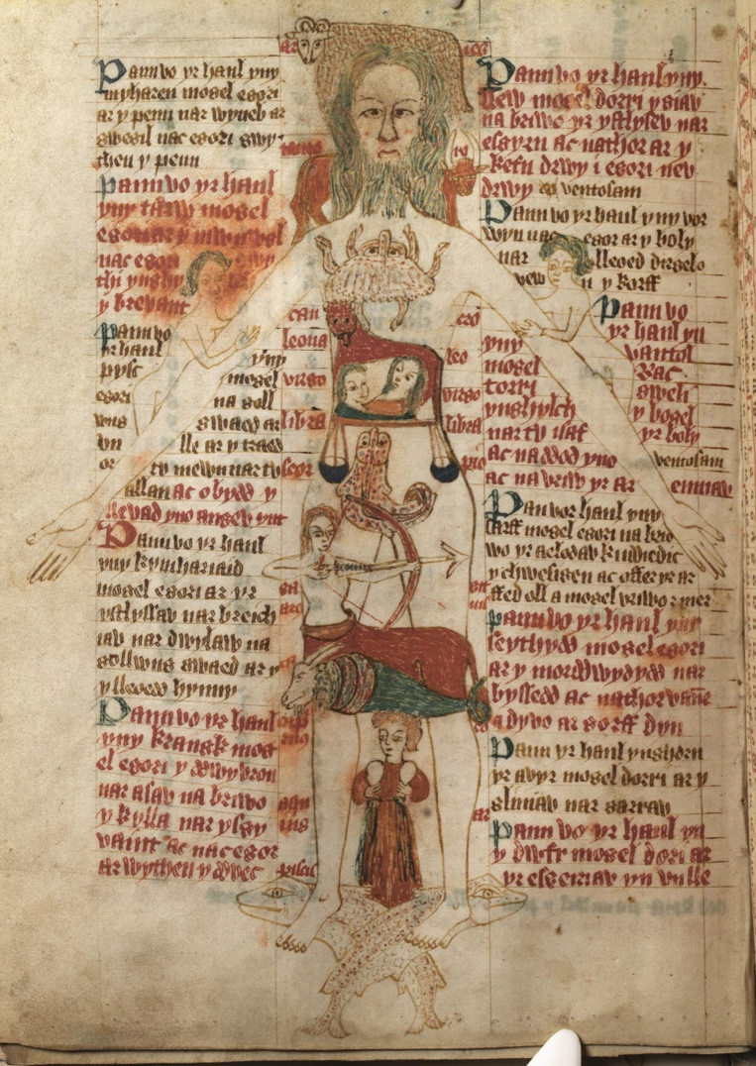
Figure 2: From Wikipedia, “Astrology”: “The Zodiac Man a diagram of a human body and astrological symbols with instructions explaining the importance of astrology from a medical perspective. From a 15th-century Welsh manuscript”

PART III – Galileo Enters

The storm approaches. Galileo wanders around nearby as if lost, interrupting Edmund and Gloucester.

Galileo: Excuse me gentlemen. I am grateful to have arrived in England before the nasty storm, but I have lost my way. Might I say, I am also intrigued by your conversation.

Gloucester: Greetings Professor, we are happy to direct your path. And if I may, what intrigues you so?

Galileo: Well, it strikes me that you both are right and wrong, in certain ways. You, sir –

Gloucester: The Earl of Gloucester, sir, and my son, Edmund.

Galileo: Well Gloucester, your vision of the cosmos seems a bit too tied to the occult and unknowable forces. The heavens are not the semi-divine, incorruptible realm you think. I myself have observed black spots forming and dissolving on the face of the sun, and seen the lovely face of Venus cast in shadow. There are more material, worldly causes for the ways things are than we have thought. In fact, I have been working lately to describe motion with mathematics!

Gloucester: (Angrily) Why, these notions are preposterous! The perfect heavens help us to understand our world. (Pauses) Wait, I know you. You are that professor at Pisa. You speak of our created earth as some shifting, moving chunk in the cosmos. You know nothing of human fortune.

Galileo: (Adamantly) This you assume.

Gloucester: I assume nothing. I know Aristotle, who tells us that the nature of things on earth draw from their causes in the heavens. Your mathematical explanations for the heavenly bodies are utterly erroneous – even Ptolemy’s work on mathematical astronomy did not go so far as you. Why, Lord Jesus Christ became known when the Great Star told of His coming. Our past shapes our understanding of our present.

Galileo: I cherish that Star, noble Earl, and read and know the antique philosophers. I have even been denounced to the Inquisition for prognostication. But new tools that enhance our sight can show us, in more depth, how things work, not just why they work or what they could mean!

Edmund: Professor, I apologize for my father, but I am a bit confused. How can a learned man like yourself submit your mind to the stars? What about our natural-born gifts, our willpower and intellects?

Galileo: Edmund, you speak some truth – perhaps celestial study need not implicate our human will. But you seem to derive your reality solely from your experience of yourself. I strive to comprehend the cosmos so as to know how and why our universe, and ourselves within it, operate and believe as we do. You say you “should have been that I am” no matter what? Does that not excuse your misbehavior the same way your father’s theories do? You are not an island – we all interact with the cosmos.

The storm arrives and blows Galileo away.
Questions

- Galileo and Shakespeare were contemporaries. In the dialogue above, how are Galileo’s viewpoints on nature similar to those of Gloucester and Edmund? How are they different?

- Edmund is struggling over the relationship between astral influence and human will. How does he want to view the world, and what do his viewpoints suggest about his character?

- Consider the tenets of the nature of science as defined for the 21st century from McComas (2004) shown in Figure 1. Which of these tenets have emerged in the dialogue thus far? Explain.

Figure 3. Tenets of the Nature of Science

References

McComas (2014). Keys to Teaching the Nature of Science. National Science Teachers Association. Retrieved from: http://www.nsta.org/publications/news/story.aspx?id=49929

(see next page for Part IV)

Part IV – Halley and Newton Enter

Gloucester and Edmund are surprise when the storm suddenly blows two individuals over to them.

Edmond Halley: Bloody winds, they’ve blown us clear away! Gentlemen, why stand you in this downpour?

Gloucester: Ah sir, a family squabble about the stars which this storm hath masked.

Halley: The stars, you say! We know a thing or two of that! Wasn’t long ago I completed my expedition to St. Helena and calculated the celestial positions of over 300 stars! And I just discovered that the same comet streaks across our skies every 76 years from the very depths of the cosmos!

Gloucester: Here’s more madness. Sir, the stars rest fixed in the heavenly firmament, the Octavium Firmamentum. And comets are not celestial – as Aristotle says, they move through our atmosphere.

Isaac Newton: Sir, you speak of the heavenly spheres! How interesting. We should converse – I am Isaac Newton, and my companion is the great astronomer Edmond Halley. I must say, he does not share our knowledge of the elegant proportions underlying the universe. I too follow how the grand influence of numbers, planets, and cosmos informs our earthly perceptions. I am currently working out a mathematical theorem explaining the color spectrum through the geometric proportions of the planets.

Gloucester: Ah! So you seek into the causes and forces, the very nature of things.

Newton: When and as I can. It’s not always possible – but why cannot natural philosophy, the pursuit of how things work, be informed by revelation, the things revealed to us by God, law, and our intellects? I write about this towards the end of some mathematical equations for the attraction and orbit of the planets to the sun that I recently published.

Gloucester: Interesting! Could you explain sir, what is the point of knowing these equations without also knowing their nature, the forces and prime movement behind them?

Newton: Oh an excellent question! To clarify, I of course continue to ponder the causes. But the designs of the universe that our natural philosophy reveal can in turn reveal the designs our Creator intends for our moral philosophy. The light of nature reveals our duty and our bounded interests to each other.

Edmund: My fellow Edmond, surely you are as baffled as I. I, a bastard, have only the cards dealt to me.

Halley (exasperated): I do not share my colleague’s more . . . mystical beliefs in the craft we share, but his inimitable mind has revealed much about the cosmos. [storm blows them away]

Gloucester: Indeed. Edmund, Mr. Newton strikes a balance I thought not possible.

Edmund: Perhaps, father, perhaps. Yet with every minute, Edgar is conniving against you . . .
Questions

- Newton and Halley represent different approaches to scientific inquiry existing at the same time. What tenets of the nature of science can you identify in their dialogue?

- How does each character’s knowledge and belief complement and contradict with others?

- Gloucester and Newton stumble upon similar language, which describes some similar and dissimilar things in their knowledge. Discuss how the nature of scientific inquiry has changed from Part I to Part IV, and explore how Gloucester and Newton found common ground.

- Think back to Gloucester’s initial metaphors, like eclipses signaling trouble ahead for the family, and Edmund’s repudiation of them. Having completed four modules in this case study, what more can you say about the importance of these metaphors to Gloucester’s life, and their importance to Shakespeare’s way of building characters?
----------------------
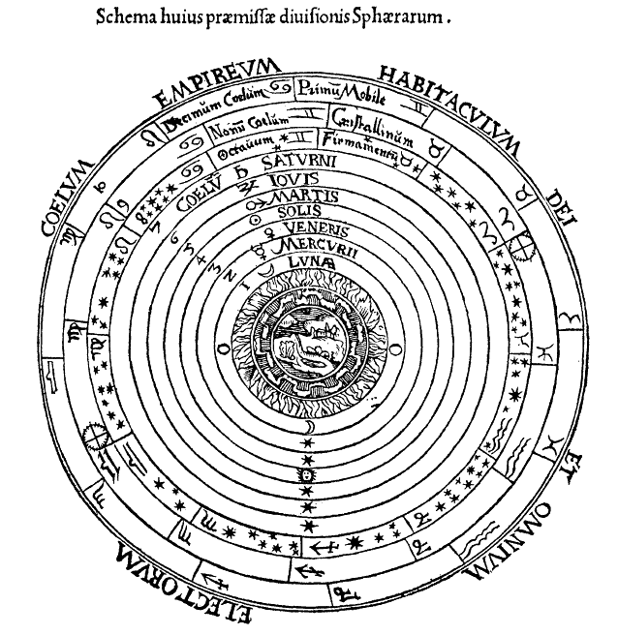

Figure 4: Geocentric Celestial Spheres, Peter Apian’s Cosmographia (Antwerp, 1539); image courtesy Wikipedia, “Celestial spheres”

Part V – Bohr and Curie Enter

Gloucester and Edmund are less surprised when the storm drops two more individuals beside them.

Bohr: Don’t let them diminish you, with your Nobel prizes and university degrees. Hey, where are we?

Edmund: England, sir and madam. I am Edmund, and this is the Earl of Gloucester.

Curie: Marie Curie, and my colleague, Niels Bohr. We were just at the Solvay Conference, discussing quanta and atoms. Quite a storm to have dropped us so far away!

Gloucester (cautiously): Indeed madam. How . . . surprising, to meet such a university educated woman! You say you were speaking of the atom?

Bohr: Yes! I have spent my life describing the structure of the atom, down to electrons and protons, and my colleague here explores their decay.

Gloucester: Oh. You speak of Lucretius and Democritus, and their theories of atoms speeding constantly through the void.

Bohr: I suppose. Our evidence is from observation though, and hypotheses and experiment. We are discovering the smallest level of things, where particles bounce and combine and burst all the time. It is difficult, though – that rascal Heisenberg just proved that even the location of molecules can be elusive.

Gloucester: Some of what you say is blasphemous, but some is intriguing – I think we share the truth that human knowledge is too limited to comprehend the entirety of the cosmos.

Edmund: Finally, he realizes.

Gloucester: Yet if your marvelous inventions can see into the order and chaos, surely you are interested in the Prime Mover, who gives atoms and planets their force? You can perceive the nature of things?

Curie: The nature of things? As in the ways they move and operate? Yes, that is our work. But I do not see why scientific inquiry should come so close to metaphysics. The languages and aims are too different.

Gloucester: ‘Zounds! You confirm my suspicions, sir and ma’am: atheists! You speak that all is just atoms, with no larger purpose, just like Lucretius. What about the question of why?

Bohr: Why must what Lucretius believed dictate my approaches?! You diminish my work, sir. I will admit: science is not a straightforward process. There’s no one method or understanding. There are laws of nature, but it takes creativity to make new findings, and who knows what is out there to be known!

Curie: Yes, and our study has led to marvelous discoveries for human benefit I myself have used atoms for x-rays – a kind of energy transfer – to help medics find shrapnel from bullets in soldiers’ bodies.
Gloucester (sighing deeply): I have had a long day, my clothes are quite soaked through, and I have some ugly business to attend to with my eldest son. I see the value of observation. But I understand inquiry to be a practice that seeks to comprehend the Order of the universe through observation, tradition, and belief. If your inquiry is just for data and mechanics, haven’t you written yourself out of your own universe? To be lost in the details is to fail to comprehend how interconnected we are with the world. Our earlier visitor, Mr. Newton, spoke best when he was awed and intrigued by the ways that natural philosophy and morality harmonize so elegantly with divine, revealed truth.

Curie and Bohr (surprised and excited): NEWTON?! Where is he! [storm blows them away]

End

----------------------

Questions

- Gloucester encounters significant differences of opinion with Bohr and Curie. Identify 1 or 2 areas of severest disagreement.

- What tenets of the nature of science can you identify in this dialogue?

- How does Gloucester’s conversation reveal blind spots or forgotten sensitivities in modern public perceptions of science?

- How has your comprehension of the nature of science changed through this case study? Articulate and explain the tenets of NOS with a partner, noting developments in your thinking.

- Where in culture and education do you see the nature of science appearing today? Consider Shakespeare’s use of science and consider: how is scientific knowledge mediated by texts and art today?
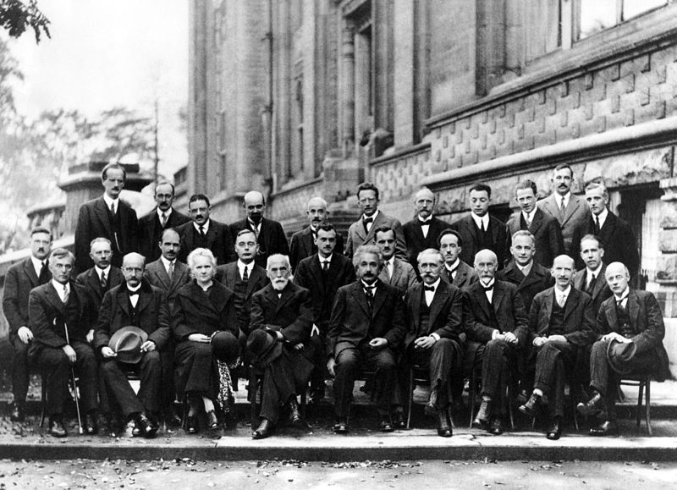
Figure 5: Image from the 5th Solvay Conference of 1927, famous for its emphasis on quantum theory and density of notable physicists. Marie Curie is in the first row, third from the left, and Niels Bohr is in the second row, last on the right.

Solvay conference 1927 (Courtesy Wikipedia, “Solvay Conference)

King Lear actually takes place in the distant British past, but it makes reference to scientific and cultural issues that were popular in Shakespeare’s time (the time of writing), so we have updated the era.
Part I text quoted from William Shakespeare, The Tragedy of King Lear, Folger Digital Texts (text eds. Mowat, B. and Werstine, P.; digital eds. Poston, M., Niles, R., and Johnson E.) http://www.folgerdigitaltexts.org/html/Lr.html
Traditional laws and assumptions in society dictating familial relationships, power, and inheritance. See also “curiosity of nations” in following line.
Married or chaste.
The Dragon’s Tail and Ursa Major are both constellations in the night sky. The Dragon’s tail stand for Draco, and the bear Ursa Major is more commonly known today by a portion of his body, the Big Dipper.

