Name:________________________________________________________Date:______________________Period:_____
STORMWATER MANAGEMENT INTRODUCTION NOTES
Warm Up: The Chesapeake Bay, located in Maryland and Virginia, suffers from complex problems including excess nutrients and sediment that pollute waters, to invasive species that crowd out native plants and animals, to a changing climate that has already impacted our land, air, and water. Laws have been passed in Pennsylvania to help restore the Chesapeake Bay.
Explain. How is it possible for your small community in Pennsylvania to have a negative effect on the Chesapeake Bay located in Maryland and Virginia?
_____________________________________________________________________________________________________________________________________________________________________________________________________________________________________________________________________________________________________________________________________________________________________________________________________________________________________________________________________________________________________________________________________________________________________________________________________________________________________________________________________________________________________________________________________________________________________________________________________________________________________________________________________Directions: Follow along with the Stormwater Management Introduction PowerPoint and Save It! Lancaster video to complete your notes below.
- Look at the two pictures below. What is the difference between both of the pictures?

This picture is showing …
__________________________________________________________________________________________________________________________________________________________________________________________________________________________________________________________________________________________________________________
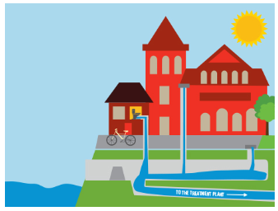

river
to the treatment plant

This picture is showing …
__________________________________________________________________________________________________________________________________________________________________________________________________________________________________________________________________________________________________________________
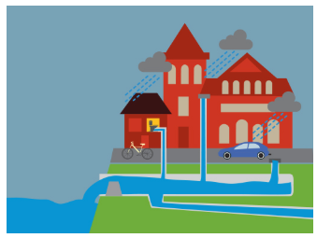

river

- Why is stormwater pollution a problem?
__________________________________________________________________________________________________________________________________________________________________________________________________________________________________________________________________________________________________________________________________________________________________________________________________________________________________________________________________________________________________________________________________________

- How many gallons of water does the City of Lancaster discharge into the river that they can’t capture at the treatment plant?
_____________________________ gallons

Is this water going into the river clean or dirty? Circle

- How much money would it cost if they stored all of the water and then treated/cleaned it when they had room at the treatment plant?
________________________________ a year

- There are two alternatives. Describe the characteristics of each below.

 | Green Infrastructure | Gray Infrastructure
Description | -uses _______________ systems to manage rainwater  -manages the rainwater from where it falls, allowing it to...  _____________ into the ground  _____________ into the air  _____________ in a rain barrel or  cistern | - __________________________  - holds the combined stormwater and wastewater in huge  ____________________________  -when you have room, you clean it up and then put it in the  _____________________________.
Estimated Cost
Energy | - requires _____________ energy | - requires _____________ energy

- List 3 examples of Green Infrastructure below:

- _______________________________________________________________________
- _______________________________________________________________________
- _______________________________________________________________________

