Name:_____________________________________________Date:________________Period:_____ #:_____

Stormwater Management STEM Project Description and Timeline

**Introduction:** After reading over the letter from *Save It! Lancaster,* it is time to collaborate with your group on a possible answer to this real-world problem. It is important that you apply what you have learned from both the introduction lesson and your own personal research to solve the problem. Each group must have their **proposal ready to present to the board by** **December 19th.**

**Objective:** Develop a plan to decrease the amount of runoff on your current residential property and increase the amount of biodiversity. Get the Save It! Lancaster board to approve your proposal.

**Model Overview**: Each group will be given a plastic container that represents their “home” and a food tray that represents their property lines. Rainwater will be represented by 500 mL of water that is poured right on top of your house. Your job is to work through the engineering design process and build a model showing how you plan to implement Green Infrastructure at your residence in order to decrease runoff and increase biodiversity. The foundation of your roof will be provided. You may modify it as you see necessary.

***Please note that nothing can be permanently attached to the tray (property) or plastic container (house).***

***The “house” will need to be returned at the end of each period.***

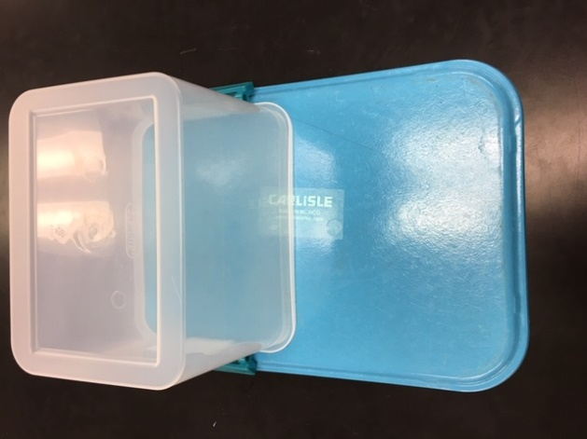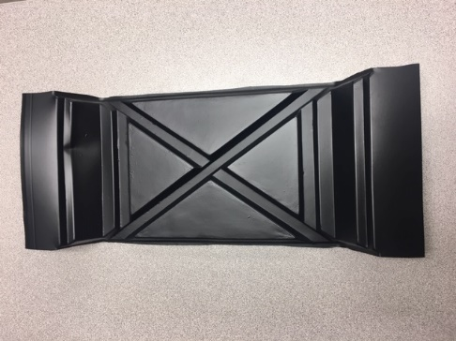

**Materials:**

Plastic container (house)

Tray (property lines)

Beaker with 500 mL of Water (rain)

ADO Products – Rafter Vent (roof)

**Optional:**

plastic water bottles - soil - sand - pebbles – straws – popsicle sticks

***Lab groups can bring in their own supplies to add to their models.***

**House**

**Picture of Roof Above**

**Property**

**Project Requirements:**

* Use Green Infrastructure (GI) to decrease stormwater runoff
* Use Green Infrastructure to increase biodiversity
* Create a realistic model to show how your plan will decrease the amount of runoff in your community
* Provide data and evidence to support your project
* Present your plan to the board using technology
* Explain the advantages of using GI
* Work through each step of the engineering design process and record information in a Google Slides presentation.

**Evaluation:**

* Engineering Design Rubric & Final Approval by Board

|  |  |
| --- | --- |
| **Schedule Breakdown** | |
| **Day 1**  Introduction  Ask | * Review Stormwater Pollution * Complete Stormwater Management Introduction Notes * Watch Save It! Lancaster Video: City of Lancaster – Green Infrastructure * Get into lab groups. * Open up letter from Save It! Lancaster committee member. * Review the Slides Presentation that you will collaborate on as a group. * Complete step 1 – ASK on slides presentation. |
| **Day 2**  Research | * Watch the “demo” showing the current amount of runoff for each residence. Record data on slides presentation. * Assign each lab group member a number. Complete Jigsaw by going to your expert group for Green Infrastructure.  1. Rain Barrel 2. Rain Garden 3. “Green: Roof 4. Vegetated Swale 5. Pervious Pavement  * Research using the information provided. * Complete Graphic Organizer for your specific section. |
| **Day 3**  Research | * Return to lab group. * Teach your group members about your GI. * Complete graphic organizer for each type of green infrastructure. * Record overview of research in slides presentation. * Complete the Edpuzzle video to review GI. * Discuss possible solutions to the challenge as a group. |
| **Day 4**  Plan | * Each group will select an approach and develop a design. * You must have at least two different plans that involve two separate sketches. * Take a picture of your sketches. * Upload them to the slides presentation. |
| **Day 5 and 6**  Create | * Gather the materials needed and construct your prototype. * Take a picture of design. * Record any problems you run into in your slides presentation. |
| **Day 7**  Test | * Test and evaluate you solution based on the established criteria. * Collet data on runoff and upload after pictures. * Record what worked well and what did not work as well as you planned. |
| **Day 8**  Improve | * Take the time to make adjustments where needed. * Upload new pictures into slides presentation. |
| **Day 9**  Retest | * Test and evaluate your modified solution. * Collect data and upload pictures. |
| **Day 10 and 11**  Share | * Prepare the presentation to the board. * Look over the letter and rubric to make sure you meet all of the requirements. * If needed, do additional research to provide evidence for your solution. |
| **Day 12 and 13**  Present | * Present to the board. * Complete an evaluation for each group that presents. * Complete a self-evaluation and rate your other group members. |