Expectations for Students
Name:___________________
Pd:_______ Hr:_______
This Journal is a daily collection of all the activities covered in the Engineering Design Class. This journal should be a complete log of everything done during the class and kept in the class bin outside of class time. If this journal is found by any student or teacher it should be returned to the person whose name is on the cover or the Technology & Engineering Education Classroom!

Engineering Journal
Technology & Engineering
8th Grade

- You are expected to report to class on time and report to your assigned seat immediately

- If you report to class late, you must bring a written excuse. A yellow slip or, if continual, detention will be provided.

- Be prepared for class – BRING A PENCIL

- Your are responsible for any work you miss when absent from class

- It is the responsibility of ALL students to help with clean-up duties

- Safety rules and regulations must be followed at all times. Violations of safety rules and regulations will result in:

  - Warning
  - Parental Contact
  - Yellow Slip
  - One Hour Detention/ Office Referral

- Students will be dismissed by the teacher at the end of the period. Wait at your assigned seat to be dismissed

- Guest/Substitute teachers will be treated with the same respect as the regular classroom teacher. Violations will result in a one hour detention and parental contact.

- Students will show respect for: themselves, other students, and the school.

- Students are expected to do their best work at all times

Grading

Your class grades will be based on:
- Test and quizzes
- Written Assignments
- Final Projects & Presentations

All work must be turned in on time, except where students have received advanced permission from the teacher

Technology & Engineering General Student Safety

This is to certify that I, _____________________, have been instructed in and understand the following safety components of the Technology & Engineering classrooms.

Safety Rules:
1. ______ Use lab only when directed by the teacher.
2. ______ Report any accident, incident, or unsafe situation to the teacher.
3. ______ Secure long hair and loose clothing whenever working with equipment.
4. ______ Clean up after yourself.
5. ______ Use tools / equipment after instruction and receiving passing quiz score.
6. ______ Use eye protection when using hand and /or power tools.
7. ______ No running or “playtime”, nor throwing of any materials allowed
Location and use of the following safety equipment:
8. ______ Fire extinguisher/ alarm locations
9. ______ Safety glasses
10. ______ Emergency shut-offs for electricity
11. ______ First-aid kit
12. ______ Electrical circuit breaker panels
13. ______ Emergency telephone listing & location
Safety procedures for the following situations:
14. ______ Fire
15. ______ Intruder Alert
16. ______ Weather Alert
Use of Power Tools and Safety Infractions:
17. ______ You must receive a passing Safety Test score to use each power tool
18. ______ Safety infractions will be dealt with by requiring student to retrain themselves through safety handout.

I agree to observe all safety rules and procedures for safe tool use/ operation and conduct in the Technology & Engineering Labs.

Student Signature: ____________________________ Date: _____________
Engineering Design Process- Notes

What is the Engineering Design Process?
_________________________________________________________________________________________________________________________________________

Step 1- ________________________

What ____________________are you trying to ______________?

Step 2- ______________ __________________ and _________________

Criteria = __________________ Constraints = ___________________

What restrictions will you have? (your project criteria & constraints)
-
-
-
-
-

Step 3- ________________________ ______________ Solutions
Generate ____________solutions.
Rough Sketch –
Final Sketch -

Gather Research
Research several possibilities that could solve the problem.
-
-
-

Step 4- __________________ a Solution

Based on the rough sketches and ideas you develop, choose the ________ solution you think has the most potential to solve the problem.

Step 5 -_____________the solution

__________ it!

A prototype is _______________________________

Step 6 - ____________ and ________________ the solution

Why is testing and evaluation important?________________________
_______________________________________________________________

Step 7- _______________

Look at the data you collected while evaluating.
Make any necessary ________________that will make the solution better next time it is tested or go back and choose a different solution to solve the problem

Step 8- ___________________________ Results

_____________ you findings with the intended audience
What are some ways to communicate?
-
-
-

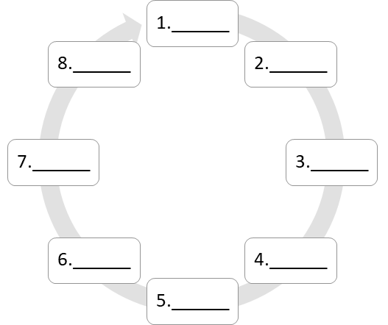

Simple Machines- Notes

What is a Simple Machine?

Simple Machines are ______________ parts of complex _______________ that perform different types of work using _________________ energy.

What is a Complex Machine?

What are the 6 different Simple Machines?

1. _____________________
2. _____________________
3. _____________________
4. _____________________
5. _____________________
6. _____________________

Define each of the following Terms:

Inclined Plane:

A Simple Machine that ________________________________ __________________________________________________.

Screw:

A Simple Machine _______________ of a very long __________ ___________ wrapped around a ___________.

Wedge:

An object ____________ at least __________ slanting side _____________ in a sharp ___________, which _____ materials apart.

Wheel and Axle:

A ____________diameter wheel and its ____________ diameter ________ are attached to each other to _____________ as ___________ unit.

Pulley:

A _________ __________ that rotates around a center ______.
It usually has a ________________ around the _____________ edge that allows ______________ or ______________ to easily ________ around them.

Lever:

A Simple Machine that ________________________________ __________________________________________________.

Define the Following Terms:

Fulcrum:

Load:

Effort:

A First Class Lever is…

A lever that has the ______________________ positioned between the ______________________ and the ______________________.

A Second Class Lever is…

A lever that has the ______________________ positioned between the ______________________ and the ______________________.

A Third Class Lever is…

A lever that has the ______________________ positioned between the ______________________ and the ______________________.

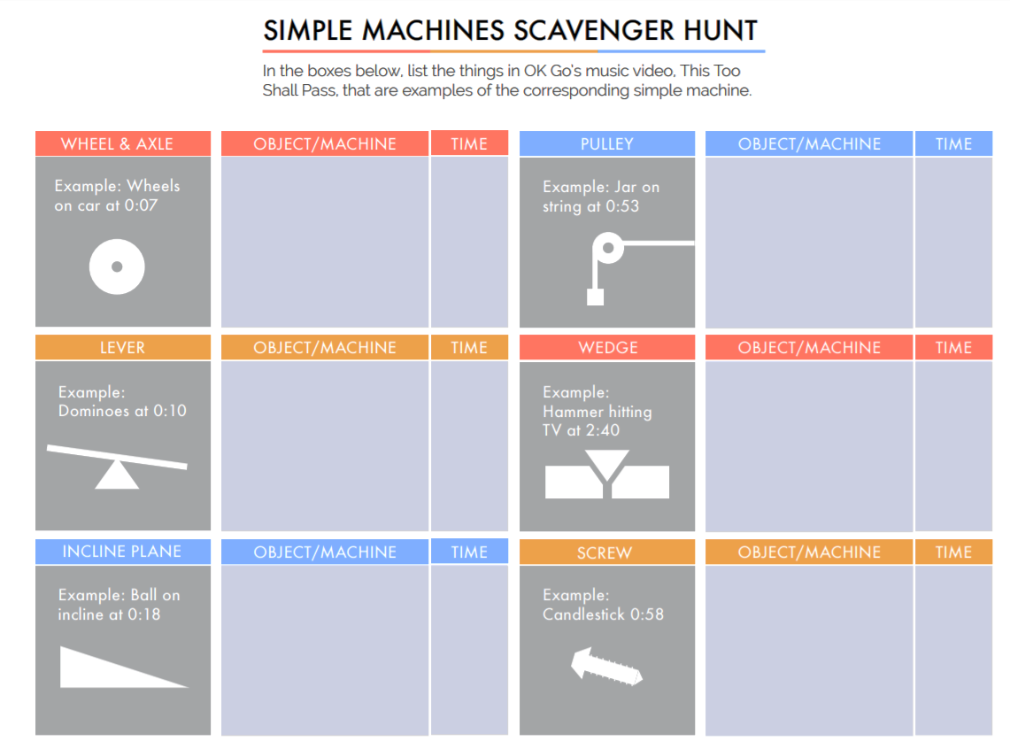
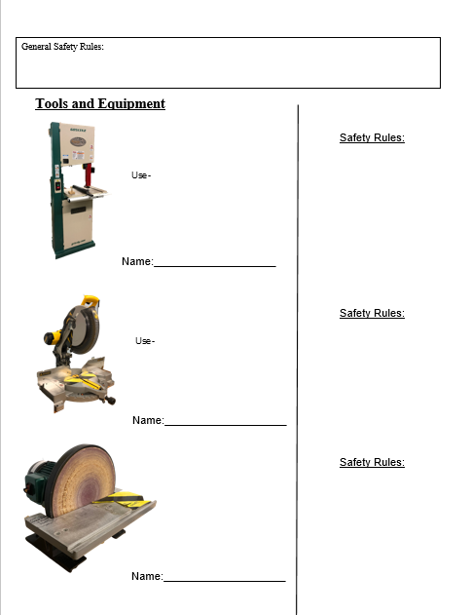

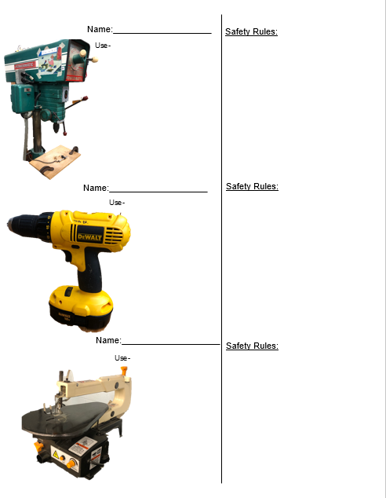The Challenge

Olympic Sporting Event: Basketball
Catapult Basketball will be our class Olympic event. You will design a device that will launch a small rubber ball and land in a designated target (Basketball Net). At the conclusion of this unit, you and your partner will compete against your classmates to see who can get the best record of getting the ball through the net in 3 tries.
Good Luck!

1.Define the Problem
In your own words, describe the problem that needs to be solved.
________________________________________________________________________________________________________________________________________________________________________________________________________________________________________

2. Identify Criteria & Constraints
What restrictions will you have?
∙ The rubber ball may not be thrown
∙ Your body (arms, legs, etc.) may NOT be used as a power source
The device cannot be larger than a 2’ x 2’ area
∙ The base of the device needs to be placed firmly in the specified location
∙ You must use at least one Simple Machine in your design

Time- How long do you have to solve the problem?
Due Date: Your project must be completed by ___________________________

What materials/tools are available for you to use?

Materials: Tools/Machines:
Wood from Labeled Bin Any teacher approved tools in Tool Cabinet
Multiple Screws/Nails Scroll Saw
String Band Saw
Rubber Bands (Max. 5) Belt Sander
Paper Clips Drill Press
Sheet Metal Box & Pan Brake
Rivets Spot Welder

You may bring in objects from home to use on your project. These items must be approved by the instructor prior to bringing them in the building.

Please list any objects you used to build your project that are in addition to the items listed above:
1. _____________________ 3. _____________________
2. _____________________ 4. _____________________

What Simple Machine(s) will you use in your device? ____________________________________
________________________________________________________________________________

3. Brainstorm Multiple Solutions - Draw any ideas you think will work in the spaces provided below
Rough Sketch #1
Rough Sketch #1

Rough Sketch #2

Teacher Check:_________

4. Select a Solution

Final Sketch - This sketch can be copied from one rough sketch, or can combine several rough sketches to formulate one idea.

Materials Listing:

Teacher Check:_________
5. Prototype Your Solution! Remember to follow all safety rule! Don’t forget the Due Date: Your project must be completed by ___________________________

6. Test and Evaluate the Solution
Did your solution work like it was intended to?

Test Trial | In Hoop | Observations
#1 | Yes / No
#2 | Yes / No
#3 | Yes / No
#4 | Yes / No
#5 | Yes / No

7. Iterate
Did your solution work like it was intended to?
ThinThings you did well: | ThinThings you need to work on:

Did you have to go back and make any design changes?
_____________________________________________________________________________________________________________________________________________________________________________________________________________________

Does the solution solve the problem? Why or why not?
_____________________________________________________________________________________________________________________________________________________________________________________________________________________

8. Communicate Results
Prepare for the presentation of your findings and final solution. Be sure to retrieve a rubric and create a presentation to share all of your findings!

Unit Test Review

- Know the parts of a lever.
- _______________

- _______________

- _______________

- Know the three different types of levers & examples

  - First Class Lever-

  - Second Class Lever-

  - Third Class Lever-

- How do simple machines allow us to accomplish work with less force?

- Identify the six Simple Machines

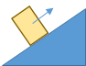 | 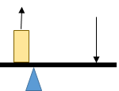 | 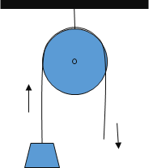
- Know the following terms:

  - Prototype-

  - Criteria-

  - Constraints-

  - Iterate-

- List the following steps in the Engineering Design Process in the correct order (Starting with the first step).

1._________ A. Define the Problem
2._________ B. Prototype the Solution
3._________ C. Iterate
4._________ D. Communicate Results
5._________ E. Test & Evaluate
6._________ F. Brainstorm Multiple Solutions
7._________ G. Select a Solution
8._________ H. Identify Criteria & Constraints

- Know the difference between a simple machine and compound/complex machine.

- Explain a few safety rules about different machines in the lab.

-

-

-

9. What are the two options for fastening our wood together?

-
-

Ink Zone
Please use this section to write any ideas or extra notes (Don’t forget to add the date)
________________________________________________________________________________________________________________________________________________________________________________________________________________________________________________________________________________________________________________________________________________________________________________________________________________________________________________________________________________________________________________________________________________________________________________________________________________________________________________________________________________________________________________________________________________________________________________________________________________________________________________________________________________________________________________________________________________________________________________________________________________________________________________________________________________________________________________________________________________________________________________________________________________________________________________________________________________________________________________________________________________________________________________________________________________________________________________________________________________________________________________________________________________________________________________________________________________________________________________________________________________________________________________________________________________________________________________________________________________________________________________________________________________________________________________________

