Name ____________________ Period ______ HR:___

Problem Solving Unit Test
Please read each question carefully to determine the best answer. Fill in the blanks and open-ended questions to the best of your ability.

Part A- Simple Machines

- The point around which a lever rotates is known as a(n) __________
  - Input Force
  - Output Force
  - Fulcrum
  - Load

- The three items needed to define a lever include:
  - Effort, Load, Fulcrum
  - Effort, Output Force, Load
  - Load, Fulcrum, Friction
  - Friction, Effort, Mechanical Advantage

- Explain how a simple machine is different than a compound machine
_____________________________________________________________________________
_____________________________________________________________________________
_____________________________________________________________________________
_____________________________________________________________________________

Match the following levers with the definitions given below:

- _____ First Class Lever A. The load is placed between the
fulcrum and the effort.(E L F)

- _____ Second Class Lever B. The effort is positioned between
the fulcrum and the load. (F E L)

- _____ Third Class Lever C. The fulcrum is positioned between
the effort and the load. (E F L)

Identifying Class & Parts of a Lever
Interpret the following objects and distinguish which class lever is shown and where the placement of the three main parts of all levers should be.

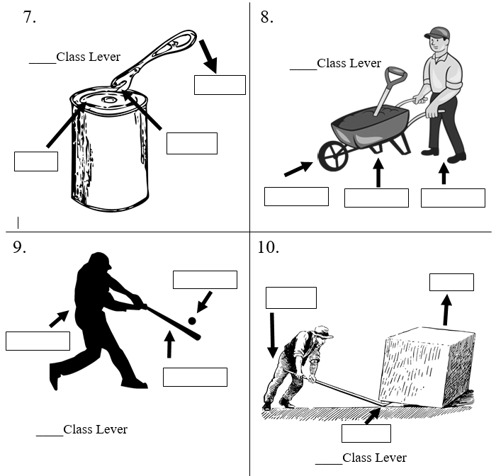

11. Imagine that you want to put a bicycle into the back of a van. It’s easier to roll the bike up a ramp into the van than to lift the bike up into the van. Does the ramp allow you to do less work or does it change the effort or distance instead? Explain your answer with detail and draw a sketch to help.

___________________________________________________________________________________________________________________________________________________________________________________________________________________________________________________________________________________________________________________________________________________________________________________________________________________________________________________________________________________________________________________________________________________________________________________________________________________________________________________________________________________________________________________________________________________________________________________________________________________________________________________________________________________________________________________________________________________________________________________________________________________________________________________________________________________________________________________________________________________________________________________________

Part B- Safety/Equipment
12. Looking at the picture below point out three safety rules that would apply while using this machine and write in the blanks what these rules would be. If it is helpful draw arrows to the area you are referring to for each blank

Safety Rule 1:
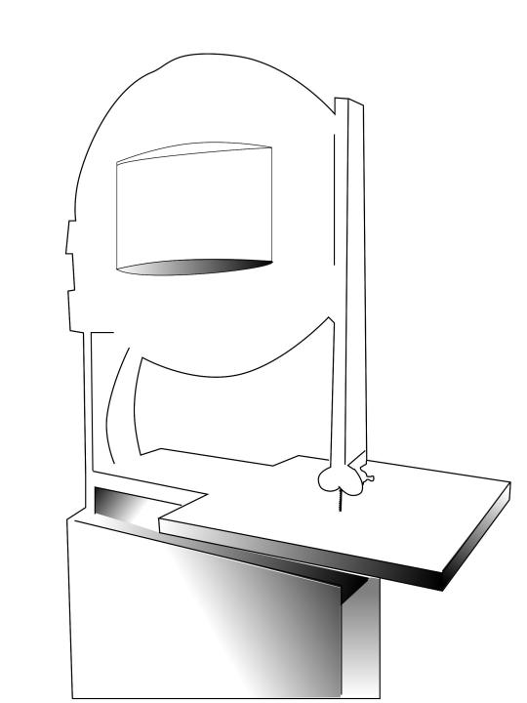

BAND SAW

Safety Rule 2:

Safety Rule 3:

13-14. Read the following scenario. For each safety rule that is broken give 1 example of what possible danger could occur AND what the correct safety procedure is.

In the classroom, two students are playing baseball with a piece of scrap wood and wadded-up duct tape. Another student is chipping glue off the table with a screwdriver. The large vacuum is parked in front of the back door exit where the fire extinguisher is hanging on the wall. Another student is gossiping with her friend as they are using the scroll saws.

WHAT IS THE DANGER? HOW TO CORRECT IT
__________________________________________________________________________________________________________________________________________________________________________________________________________________________________________________________________________________________________________________________________________________________________________________________________________________________________________________________________________________________________________________________________________________________________________________________________________________________________________________________________________________________________________________________________________________________________
______________________________________________________________________________________________________________________________________________________________________________________________________________________________________________________
Part C- The Engineering Design Process

List the step of the Engineering Design Process the correct order

15. Step #1. __________ A. Identify Criteria & Constraints
16. Step #2. __________ B. Communicate Results
17. Step #3. __________ C. Test and Evaluate
18. Step #4. __________ D. Define the Problem
19. Step #5. __________ E. Prototype the Solution
20. Step #6. __________ F. Select a Solution
21. Step #7. __________ G. Iterate
22. Step #8. __________ H. Brainstorm Multiple Solutions
23. Please read the following problem below and use the Engineering Design Process to explain in detail what you would do at each step to solve the problem.

Step 1: Define the Problem- How do I develop a scooter that travels only on solar power and a backup battery?

Step 2:____________________________________________________________
_________________________________________________________________
_________________________________________________________________

Step 3: ___________________________________________________________
_________________________________________________________________
_________________________________________________________________

Step 4: ___________________________________________________________
_________________________________________________________________
_________________________________________________________________

Step 5:___________________________________________________________
_________________________________________________________________
_________________________________________________________________
Step 6:___________________________________________________________
_________________________________________________________________
_________________________________________________________________
Step 7:___________________________________________________________
_________________________________________________________________
_________________________________________________________________
Step 8:___________________________________________________________
_________________________________________________________________
_________________________________________________________________

Name:_______________________________ Date:____________________ PD:_______

Engineering Design Process Final Exam
Feedback Form
Functions
Question | Concepts | D.O.K. | Correct | Final Grade
1 | Simple Machines | Type I
2 | Simple Machines | Type I
3 | Simple Machines | Type II
4 | Simple Machines | Type I
5 | Simple Machines | Type I
6 | Simple Machines | Type I
7 | Classes of Levers | Type II
8 | Classes of Levers | Type II
9 | Classes of Levers | Type II
10 | Classes of Levers | Type II
11 | Simple Machines | Type III
12 | Safety | Type II
13-14 | Safety | Type III
15-22 | Engineering Design Process | Type I
23 | Engineering Design Process | Type III

After reviewing your test:
- What specific concepts do you need to relearn or practice more?

- On a scale of 1 to 10, how well did you prepare yourself for this exam? _______
1 = “I didn’t review any notes /study guide”……….10 = “I studied throughout the unit and could not have prepared myself anymore”

- After reviewing my test, I am going to :
  - Get 1 on 1 help with my teacher in the morning (7:15 AM – 8:05 AM)
  - Continue doing what I am doing!
  - Other:

