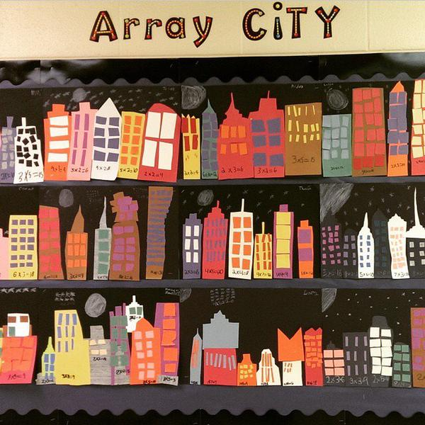Array City

Situation: The City of Lebanon is redesigning its space and would like to build more skyscrapers. The city wants to light up the night sky by constructing buildings that have many windows. This will give the illusion that there are many stars in the sky when people have their lights turned on in the evening. The skyscrapers will also help create more open space for parks. The Mayor is looking for a new architect and has heard about the amazing things you are doing in class. Mayor Capello wants to assign you as her new lead architect! Good luck and help the city shine as bright as the stars!

Your Purpose: Create a design for 4-5 buildings that include an array of windows.

Audience: You must display this design outside your classroom so you can showcase your work to the community. The Mayor must also be aware of how many windows each building will have. Be sure to write an equation to answer this problem.

Form: Building Design

FCAs:
Building design must include:
- Building with an array of windows (1 pts.)
- Written number of rows (2 pts.)
- Written number in each row (2 pts.)
- Repeated addition sentence with answer (3 pts.)
- Multiplication Sentence with answer (3 pts.)

Procedure:
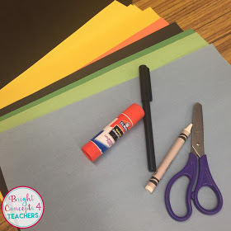1) Gather your materials:
- One sheet of black, colored construction paper, glue sticks scissors, black marker, and a white crayon or colored pencil.

2) Cut out 4 – 5 different size buildings. Be sure all buildings fit on the black construction paper.

3) Cut out windows using the colored construction paper. Use the window cut-outs to create an array for each building. Be sure each building has a different array before gluing. Also, be sure to line the windows up into rows and columns.

4) Complete the “Addition and Multiplication Equations” form for each building.

5) Glue the “Addition and Multiplication Equations” form beneath each building.

Addition and Multiplication Equations  Number of rows: ________  Number in each row: ______  _______ groups of ________  Repeated addition equation:  _________________________________  Multiplication Equation:  _________________________________ | Addition and Multiplication Equations  Number of rows: ________  Number in each row: ______  _______ groups of ________  Repeated addition equation:  _________________________________  Multiplication Equation:  _________________________________

Addition and Multiplication Equations  Number of rows: ________  Number in each row: ______  _______ groups of ________  Repeated addition equation:  _________________________________  Multiplication Equation:  _________________________________ | Addition and Multiplication Equations  Number of rows: ________  Number in each row: ______  _______ groups of ________  Repeated addition equation:  _________________________________  Multiplication Equation:  _________________________________

Addition and Multiplication Equations  Number of rows: ________  Number in each row: ______  _______ groups of ________  Repeated addition equation:  _________________________________  Multiplication Equation:  _________________________________ | Addition and Multiplication Equations  Number of rows: ________  Number in each row: ______  _______ groups of ________  Repeated addition equation:  _________________________________  Multiplication Equation:  _________________________________

