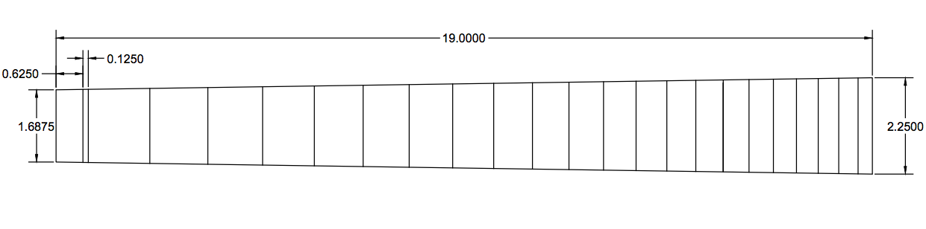
Step 1: Open AutoCAD and create a new document. Use the template downloaded from Schoology.
Step 2: Draw a rectangle using the LINE tool that is 2.25” wide by 19” long.
Step 3: On the left side of the rectangle, use the LINE tool, then type MID, click on the triangle that appears and draw a line that is .84375” long. From the end point of that rectangle, draw a line back that is 1.6875” long
Step 4: Delete the top and bottom of the triangle by clicking on the line and pressing the delete key. Leave all lines on the left side of the triangle.
Step 5: Use the LINE tool to draw lines from the left to right at an angle instead of a rectangle (Trapezoid).
Step 6: Use the OFFSET command to offset each line the appropriate distance. Type in OFFSET, hit enter, type in the correct distance (.3310), hit enter, then click on the line you want to offset. Click on the side you want to offset it to. To complete the command, hit the ESC button.
Step 7: Repeat for all of the frets. To calculate the correct Fret spacing, visit: http://www.stewmac.com/FretCalculator.
Number of frets: 21
Scale Length: 25.5
Select Inches
Select Electric Guitar
Step 8: Use the TRIM command. Select all lines. Click on each line that goes over the edges of the fret board to delete them.

