Nouns  (Person, Place, Thing or Idea) | Sight | Smell  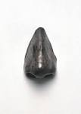 | Sound  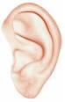 | Taste  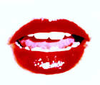 | Touch  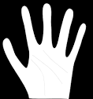

Five Senses Chart for Descriptive Writing

