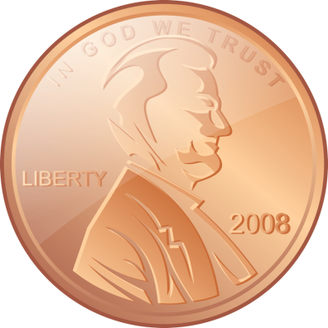
The Penny
Why should we keep the penny?

- Prices will go up: If we eliminate the penny, everything will be rounded to the nickel. Stores will probably round everything up, so we will pay more for everything we buy.
- The poor will pay the most: The poor usually make smaller purchases more often, so they will pay more over time.
- Charities need pennies: Small charities need pennies to make money. People give a lot of pennies to charities, but think about giving away larger coins.
- Nickels cost even more to make: Each penny cost 1.26 cents to make, but every 5 cent nickel cost 7.7 cents to make. Without pennies, we would need to make more nickels. Making money would become more expensive for the government.
- Pennies are sentimental: Americans love pennies and don’t like to change things!

What do you think? Should the United States keep or eliminate the penny? Why? _______________________________________________________________________________________________________________________________________________________________________________________________________________
The Penny
Why should we eliminate the penny?

- Pennies are worthless: Unless you have a lot of them, you cannot buy anything with pennies.
- They waste a lot of time: Americans spend 2.4 hours every year counting, using, and waiting for pennies to be used or counted.
- They waste a lot of time to make: The government makes almost 21 million pennies each year, so they would save time by eliminating the penny.
- They waste a lot of money to make: It costs 1.26 cents to make one penny, so each penny costs .26 more cents than it is worth.
- Round up prices won’t matter: Some people say eliminating pennies would cost us a lot of money because store owners would round up prices. However, even if this happened it would only cost 3 to 4 cents every day. This is not a large amount.

What do you think? Should the United States keep or eliminate the penny? Why? _______________________________________________________________________________________________________________________________________________________________________________________________________________

