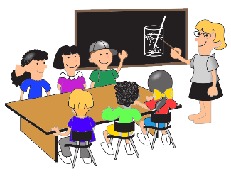Teacher Report
Teacher Name
Student Names

What did students learn today?

Teacher Report
Teacher Name
Student Names
_________________________________

What did students learn today?

