Class 4- Order List and Un-order List
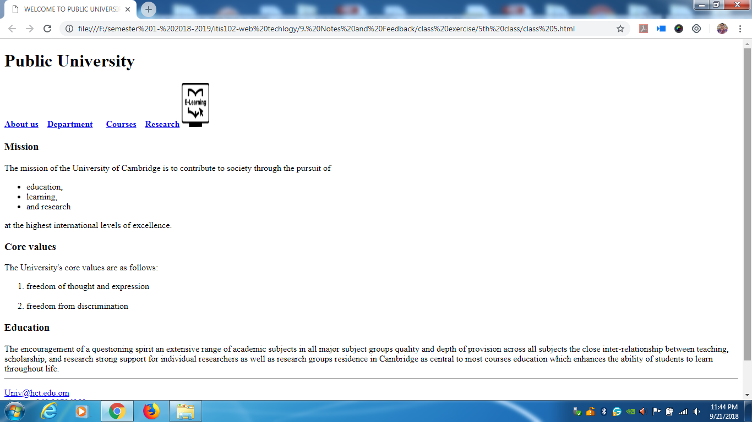

- Apply unordered list in “Mission” as given in screen shot

- Apply ordered list in “core values” as given in screen shot.

