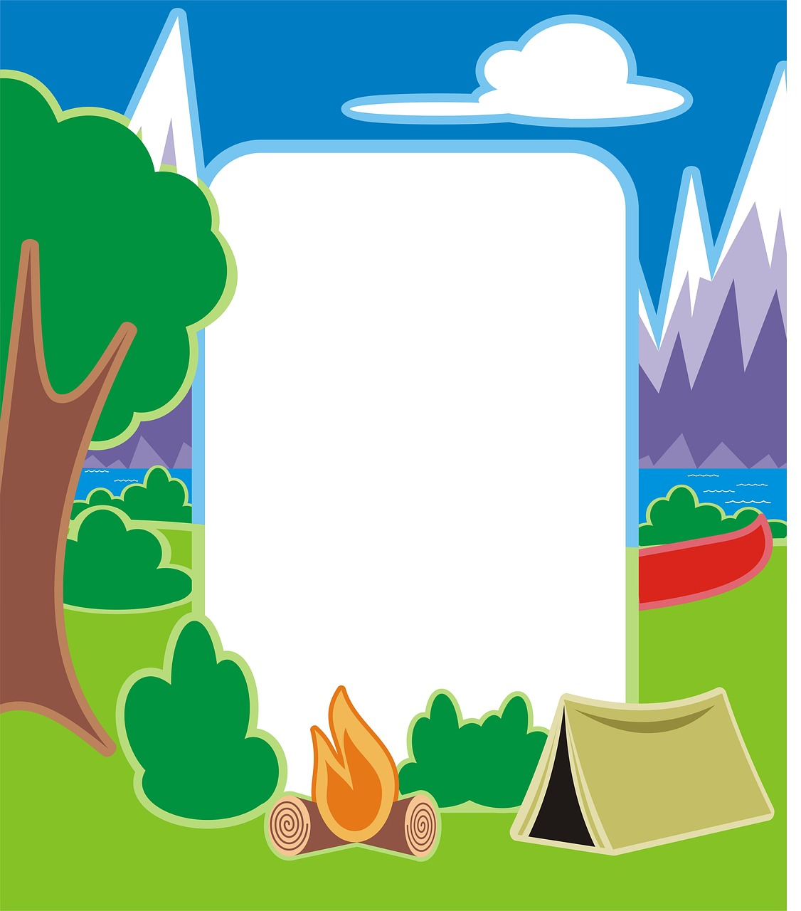

CAMP
PreK

CAMP
Kindergarten

Today’s Camp Activities
Time | Activity

