Camp Activities 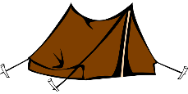

Today at camp I:

Camper’s Name:

Camp Activities 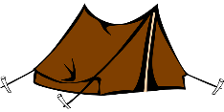

Today at camp I:

Camper’s Name: