3.NF.A.2 Represent A Fraction on A Number Line
Running Miles

Part A

Alexandro ran $\frac{7}{2}$ miles.

Plot how far Alexandro ran on the number line below

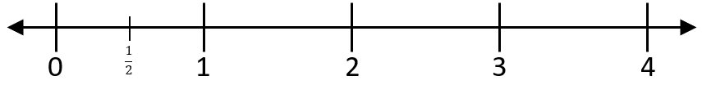

Haley ran $\frac{9}{3}$ miles.
Plot how far Haley ran on the number line below
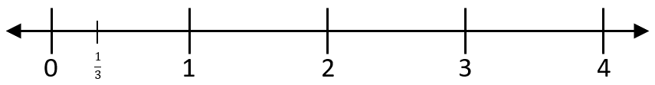

Part B
Use the number lines above to explain who ran farther, Alexandro or Haley
Write your explanation and answer in the space provided.

Scoring Rubric

Total Score Points- 4 points
Part A- Score 2 points
Student response includes the following elements.
- The student provides correctly plotted Alexandro’s distance on the number line.
( $\frac{7}{2}$ is plotted at 3 $\frac{1}{2 }$ point on the number line)

- The student correctly plotted Haley’s distance on the number line. ( $\frac{9}{3 }$ is plotted at the “3” on the number line)

Score 1- Student response includes one of the elements.
Score 0- Student response is incorrect.

Part B- Score 2 points
Score 2
Student response includes the following elements.

Reasoning Component
- The student correctly identifies who ran farther, (Alexandro)
- The student provides a valid explanation using the number lines.

Student Sample Response: Alexandro ran farther because 7/2 is placed on the number line at 3 ½ . I counted 2/2 equal 1, 4/2= 2, 6/2= 3 and I had one ½ left over so I marked the number like at 3 ½. Haley’s distance was 9/3. Three thirds equal 1 whole so on the number line I count 3/3= 1, 6/3=2, and 9/3= 3. So I put a dot on the 3 Alexandro’s mark was at 3 ½ and Hanleys was a 3. 3 ½ is further than 3 so Alexandro ran farther.

Or other valid method to explain how to use the number line to decide which person ran further.

Score 1- Student response includes one of the elements.

Score 0-Student response is incorrect.

