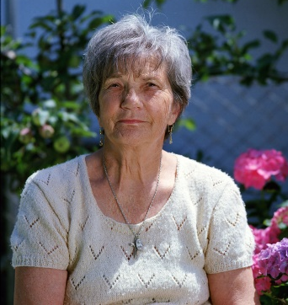
SUSAN STONE

I’m a retired teacher of 40 years. I taught science and math to 5th and 6th graders. I miss the joy of being around children, watching them learn, and babysitting lets me make some extra income in retirement.

WORK HISTORY

2013 - present various families
Babysitter
I babysit on an as needed basis for around 8 different families. I’m available to drop off and/or pick up from school, prepare meals, and do general housekeeping as well. I will make sure children follow their same routine that they normally follow.

08. 1972 – 06. 2012 jefferson elementary school
Math and Science Teacher
During my time at Jefferson, I taught math and science at the 5th and 6th grade levels. This included planning lessons and experiments, chaperoning school field trips, grading assignments, creating tests, and many other activities.

EDUCATION

09.1968 – 05.1972 sTATE UNIVERSITY
BS in Elementary Education
- Focus on math and science teaching
- Minored in Biology

RELATED SKILLS

I raised my own 3 kids and taught for 40 years. I’m well-versed in all of the tricks that kids try to pull. I’m very effective with discipline and will not allow your children to misbehave simply because you aren’t there.

HOBBIES & INTERESTS

Reading
Gardening
Cooking
Knitting

RATE & AVAILABILITY

RATE | MONDAY - THURSDAY | FRIDAY | SATURDAY
$15/hr | Before 10PM | 2PM – 8PM | Before 2PM and 5-8PM

I will provide my own transportation.

