Maricela Lopez
> Babysitter

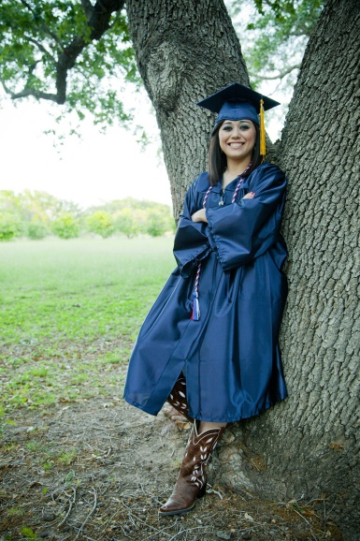

PERSONAL STATEMENT
I’m a freshman in college majoring in early childhood development. I absolutely love caring for children and have looked after kids of all ages and abilities, including tutoring a special needs child after school.

EDUCATION
state university
Freshman
Major: Early Childhood Development
Minor: Special Education

KING HIGH SCHOOL GPA: 3.2

EXPERIENCE
the jordan family 2012-2016
Four kids ranging in age from 3-13 years old

tHE PEREZ FAMILY 2014-2016
After school tutoring of 12 year old boy with developmental needs

THE DAVIDSON FAMILY 2013-2015
Two kids, 6 month old and two year old

RELATED SKILLS
- Bilingual (English and Spanish)
- Cooking
- Cleaning
- Friendly attitude
- Keeping children engaged
- Tutoring in language arts, math (through geometry) and Spanish

HOBBIES & iNTERESTS
- Reading
- Drawing
- Dancing

RATE
$15/hour

TRANSPORTATION
I require transportation to and from jobs because I live on campus and am not allowed a car.

AVAILABILITY*
SUNDAY | MONDAY | TUESDAY | WEDNESDAY | THURSDAY | FRIDAY | SATURDAY
All day | After 5PM | 9AM – 3PM | After 5PM | 9AM – 3PM | After 2PM | All day
*Please check back as my schedule changes each semester.

