The Paz Family’s Garden

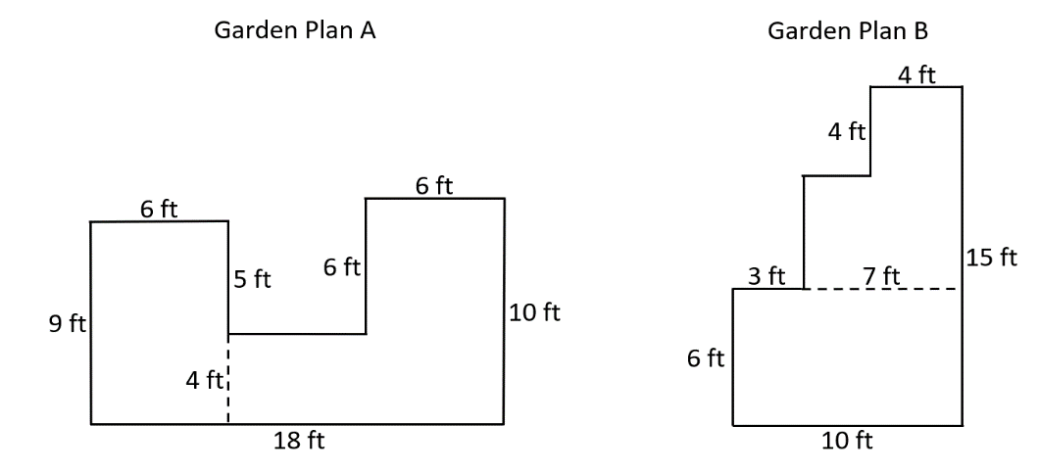

The Paz family is building a garden in their backyard. The two plans they are choosing between are shown below. They want to build the garden with the largest area

Part A
What is the total area, in square feet, of Garden A?
- Write and equation or equations to represent the total area of Garden A.
Enter your equation or equations in the space provided.

Part B
What is the total area, in square feet of Garden B?
- Write an equation or equations to represent the total area of Garden B.
Enter your equation or equations in the space provided.

Part C
Which garden plan should the Paz family choose? Explain your answer using > or <.
Enter your answer and explanation in the space provided.

