Rosina’s Reasoning

Rosina was explaining how to compare 2/6 and 3/6 her friend. She drew the rectangles below to help her explain.
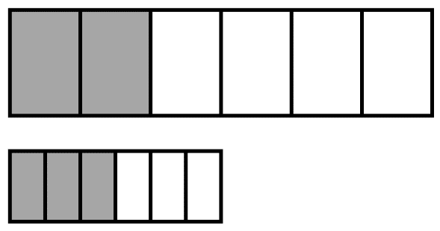
Rosina tells her friend that 2/6 > 3/6.
- Explain why Rosina’s thinking is incorrect.
- Explain how to correct Rosina’s thinking.
- Write the correct comparison for 2/6 and 3/6 using < or >.
Enter your explanation and answer below.

