The Dog Park

A model of a dog park is shown.
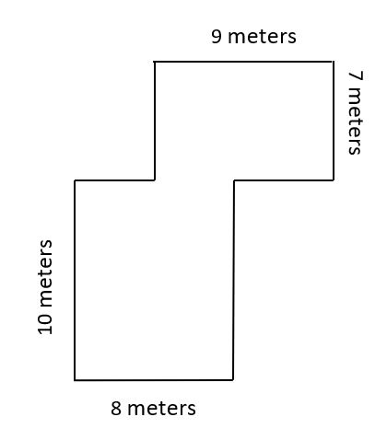
Find the area, in square meters, of the dog park.
Explain your answer using an equation or equations.
Enter your answer and your explanation using your equation or equations in the space provided.

