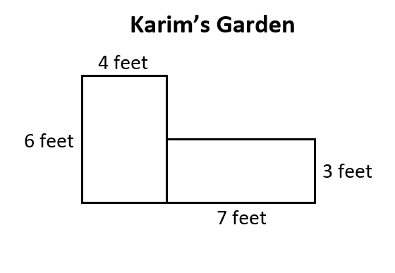

What is the area, in square feet, of both parts, of Karim’s Garden?

Show all your work or explain how you found the total area of Karim’s garden.

Enter your answer and work or your explanation in the space provided.

